
A CONTEXTUAL ARTS AND CULTURE EDUCATION BASED ON LOCAL WISDOM AT SMA NEGERI 18 SURABAYA


E-ISSN 2338-6770

Date of submission :-
Date of revision :-
Date received :-

Correspondence Address:
Universitas Negeri Surabaya, Surabaya, Indonesia.Email: Rizky.22014@mhs.unesa.ac.id
Rizky Arinka Dwi Cahya¹ Warih Handayaningrum²

1Surabaya State University, Surabaya, Indonesia
2Surabaya State University, Surabaya, Indonesia

Rizky.22014@mhs.unesa.ac.id¹, Warihhandayaningrum@unesa.ac.id²

Abstract: This article aims to describe how SMA Negeri 18 Surabaya integrates local culture into arts and culture learning, to explain the synergy between teachers and students in its implementation, and to analyze the learning outcomes as an effort to preserve local culture. The research employed a descriptive qualitative approach. Data were collected from March to April 2026 through classroom observations in classes X-7 and XI-3, in-depth interviews with the vice principal for curriculum affairs, two arts teachers, one regional language teacher, and two students, as well as documentation of lesson plans and school documents. Data were analyzed through reduction, display, and conclusion drawing using source and technique triangulation. The findings show that local culture is integrated through Remo dance material, ceramic crafts, karawitan, digital learning media, learning facilities, and P5 exhibitions themed on local wisdom. Teacher–student synergy becomes stronger when learning moves toward practice, demonstration, and project work, although cultural meaning is not yet evenly internalized. Learning outcomes are reflected in visual artworks, dance performances, and the emergence of students’ initial appreciation of local culture. The main challenges include the dominance of popular culture, limited practice time, and the incomplete integration between arts education and regional language learning. The study concludes that arts and culture learning at SMA Negeri 18 Surabaya has become a medium for preserving local culture, although stronger reflection and interdisciplinary integration are still needed.

Keywords: arts and culture learning, local culture, Merdeka Curriculum, arts education, senior high school

1. INTRODUCTION
Indonesia possesses a highly diverse cultural heritage, encompassing languages, dances, music, theater, and oral traditions deeply rooted within its various communities. However, globalization, the expansion of popular culture, and the intense consumption of digital media have increasingly marginalized many local cultural expressions from the lived experiences of the younger generation. In this context, schools cannot merely function as sites for knowledge transfer; they must also serve as spaces for cultural transmission, appreciation, and actualization. Arts and culture education holds a strategic position, as it bridges aesthetic experiences, character building, and the strengthening of students' identities.

Under Phase E of the Kurikulum Merdeka (Emancipated Curriculum), arts subjects emphasize the connection between artistic creation and cultural roots as a primary objective. In Visual Arts, students are expected to create artworks based on their emotions, interests, reasoning, and the cultural heritage of their society. In Dance, students are encouraged to explore the meanings and symbols within traditional and contemporary dances, translating them into performance pieces (Ministry of Education, Culture, Research, and Technology, n.d.-a, n.d.-b). Therefore, arts and culture education is not solely focused on technical mastery, but also on the ability to comprehend cultural significance and reinterpret it creatively.

The policy regarding the Project to Strengthen the Pancasila Student Profile (P5) also provides a highly relevant framework for local culture-based arts education. The Ministry emphasizes that P5 is a cross-disciplinary, collaborative learning approach that allows students to observe, explore, and formulate alternative solutions to real-world issues. The emphasis lies on the learning process, collaboration, and character development (Kemendikbudristek, 2024). These characteristics align seamlessly with the pedagogical needs of arts education, which requires direct experience, practical application, reflection, and a strong connection to the students' real-life contexts.

Several previous studies have demonstrated that integrating local culture into arts education enhances the quality of learning. Proborini, Rochmah, and Suhartiningsih (2024) showed that embedding local wisdom values through songs in arts classes improves students' academic performance, artistic skills, and social competencies. In the context of secondary education, Pralampito (2023) found that Project-Based Learning (PjBL) in music education encourages students to collaboratively plan, manage, and produce performances. Similarly, Rahmawati (2023) indicated that PjBL in contemporary dance classes fosters student engagement and broadens their vocabulary of movement. Furthermore, Putri (2024) asserted that learning designs based on local wisdom make the educational process more relevant to the students' socio-cultural contexts.

Despite these findings, studies specifically examining the implementation of local culture-based arts education in urban high schools remain relatively limited. Urban schools, however, face distinct challenges: students are deeply immersed in digital popular culture, their interest in traditional arts is often weak, and pedagogical approaches must negotiate with the visual preferences and learning habits of the current generation. SMA Negeri 18 Surabaya presents a compelling case study because, institutionally, it integrates cultural preservation into its educational goals, develops web-based learning platforms, and organizes P5 exhibitions themed around local wisdom (SMAN 18 Surabaya, n.d.; SMAN 18 Surabaya, 2019; SMAN 18 Surabaya, 2024).

Given this context, this study aims to: (1) describe the efforts of SMA Negeri 18 Surabaya in integrating local culture into arts and culture education; (2) examine the synergy between educators and students in implementing local culture-based arts education; and (3) analyze the learning outcomes as well as the challenges that arise in the effort to preserve local culture within the school environment.

2. METHODS

This article is derived from undergraduate thesis research employing a qualitative descriptive approach. The study was conducted at SMA Negeri 18 Surabaya from March to April 2026. The research subjects included the Vice Principal of Curriculum, two arts and culture teachers, one regional language teacher, and two students. Observations were carried out during arts and culture lessons in class XI-3, which focused on ceramic crafts, and class X-7, which focused on the Munali Fatah-style Remo Dance. Additional data were gathered through document analysis, encompassing teaching materials, digital learning media, school records, and official school publications.

Data collection techniques comprised direct observation, in-depth interviews, and document analysis. Observations were utilized to examine the learning process, student participation, media utilization, and classroom dynamics firsthand. Interviews were conducted to explore the teachers' instructional strategies, institutional support from the school, students' experiences, and the correlation between arts education and the preservation of local culture. Meanwhile, document analysis was employed to review the school's vision, publications related to the P5 project exhibitions, learning facilities, and the digital teaching materials utilized by the educators.

Data analysis was performed in three stages: data reduction, data display, and conclusion drawing. The validity of the data was ensured through source and methodological triangulation by cross-verifying the results from observations, interviews, and document reviews. The analytical focus was directed toward three primary aspects: the forms of local culture integration within the learning process, the synergy between educators and students, and the learning outcomes alongside the challenges of preserving local culture in a school environment.

3. RESULTS AND DISCUSSION

3.1 Results

The operationalization of local culture-based arts education at SMA Negeri 18 Surabaya reflects a structured pedagogical adaptation of regional cultural capital into formal schooling within an urban educational ecosystem characterized by strong exposure to globalized visual and performing arts. This institutional initiative demonstrates a deliberate curricular engineering process in which traditional artistic knowledge is not merely preserved as cultural artefact, but actively transformed into a teachable, assessable, and contextually relevant learning experience. Within this framework, local cultural elements function as both instructional content and identity-building instruments, aligning with broader educational objectives embedded in the Indonesian national curriculum, particularly the Merdeka Curriculum and the Projek Penguatan Profil Pelajar Pancasila (P5).

From a curriculum implementation perspective, the visual arts program in class XI-3, under the facilitation of Ibu Umi Faradillah, S.Pd., Gr., illustrates a shift from conventional craft-based instruction toward culturally situated design thinking. The pedagogical focus centers on the construction of three-dimensional representations of the Sura and Baya mascots, which serve as symbolic icons of Surabaya’s urban identity and local mythology. Rather than treating these figures as decorative outputs, the instructional design positions them as semiotic objects through which students engage with spatial reasoning, cultural historiography, and material experimentation.

The learning process is structured around core principles of paper engineering and spatial transformation. Students are required to translate two-dimensional conceptual sketches into volumetric forms using accessible materials such as cardboard, paper, and watercolor media. The technical competencies developed include cutting accuracy, folding precision, and structural joining techniques (teknik potong, lipat, dan sambung), which collectively constitute a foundational skill set in low-cost three-dimensional construction. These techniques are not taught in isolation but embedded within iterative design cycles that emphasize problem-solving, proportional calibration, and aesthetic balance. Through this process, students acquire not only manual dexterity but also spatial cognition skills that align with constructivist learning theory, particularly Piagetian notions of operational thinking and experiential knowledge formation.


Figure 1. The "Goresan Warnaku" Digital Art Portfolio Website

Complementing this hands-on studio practice, the institution integrates digital pedagogy through the implementation of a web-based learning platform titled “Goresan Warnaku.” This platform functions as a hybrid learning ecosystem that bridges synchronous classroom instruction and asynchronous digital engagement. As a centralized repository, it hosts instructional modules, contextual learning videos, and formative assessment instruments designed to reinforce conceptual understanding. Simultaneously, it operates as a dynamic digital archive showcasing student-produced artifacts, including digital self-portraits, ecoprint textile works, architectural conceptual drawings, and advanced paper-based structural designs.

The presence of this digital infrastructure indicates a strategic alignment with 21st-century learning frameworks, particularly those emphasizing blended learning environments and learner autonomy. By enabling students to access instructional materials beyond classroom constraints, the platform supports differentiated learning pathways and reinforces metacognitive engagement. Moreover, the archival function of the platform introduces an element of performative visibility, whereby student work becomes publicly documented and institutionally recognized, thereby enhancing motivational structures through social validation mechanisms.

In parallel with visual arts instruction, the traditional dance curriculum led by Ibu Tauriska Candra K, S.Pd. in classes X-7 and XII-3 focuses on embodied cultural transmission through Tari Remo Gagrak Anyar, specifically the Munali Fatah stylistic variation. This dance form, characterized by assertive movements, rhythmic precision, and expressive martial aesthetics, serves as a medium for transmitting Javanese performative values and regional identity codes. The pedagogical approach employed relies heavily on demonstration-based instruction, where complex choreographic sequences are deconstructed into incremental kinetic units to facilitate motor learning and muscle memory acquisition.
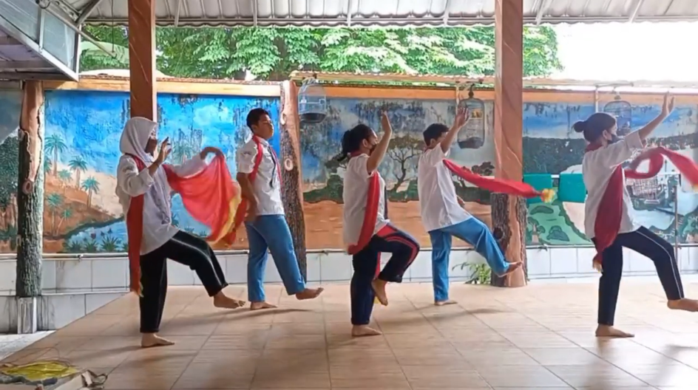
Figure 2. Performance Presentation of the Gagrak Anyar Remo Dance by Class XI-3

The instructional environment is materially supported by a dedicated karawitan studio equipped with a full set of gamelan instruments. This infrastructural presence plays a critical role in reinforcing the synesthetic relationship between movement and sound, allowing students to internalize rhythmic structures through direct auditory-kinesthetic synchronization. The integration of gamelan accompaniment ensures that dance learning is not abstracted from its musical ontology, but remains embedded within its original cultural performance system. Furthermore, the co-location of dance and regional language instruction strengthens interdisciplinary cultural literacy, particularly in relation to linguistic etiquette and performance context embedded in Javanese cultural traditions.

The pedagogical tensions identified in SMA Negeri 18 Surabaya must be further interpreted through the lens of post-digital cultural ecology, wherein educational spaces are no longer insulated from the logic of platform capitalism and algorithmic mediation. In such ecology, students’ aesthetic cognition is increasingly structured by what could be termed attention economization, namely the compression of perception into short-cycle, high-intensity visual stimuli governed by engagement-driven algorithms. This condition fundamentally reconfigures the epistemic foundations upon which artistic meaning is constructed, particularly in relation to embodied and performative traditions such as Tari Remo Gagrak Anyar.

Within this framework, traditional dance instruction encounters a structural mismatch between pedagogical temporality and digital temporality. The former relies on slow acquisition, iterative embodiment, and repetitive muscle memory formation, while the latter privileges immediacy, discontinuity, and affective intensity. This temporal disjunction produces what may be theorized as embodied epistemic lag, where students’ corporeal learning systems require longer adaptation cycles than their digitally conditioned cognitive expectations permit. Consequently, resistance toward traditional dance does not merely reflect attitudinal rejection but constitutes a symptom of misaligned temporal regimes of learning.

This condition is further intensified by the transformation of aesthetic authority in adolescent culture. Drawing from cultural capital theory, particularly Bourdieu’s framework, legitimacy of taste is no longer primarily derived from institutional schooling but increasingly from platform-mediated peer validation. TikTok, Instagram Reels, and similar algorithmic platforms function as informal pedagogical infrastructures that continuously normalize specific movement grammars characterized by fluidity, hybridity, and trend-driven repetition. In contrast, Remo dance, with its codified gestures, disciplined stances, and historically embedded symbolism, is positioned outside the dominant regime of aesthetic legitimacy. This displacement produces what may be conceptualized as symbolic devaluation of traditional performative knowledge within youth cultural hierarchies.

Empirical observations from the instructional setting indicate that this symbolic devaluation manifests in three interrelated affective-psychomotor constraints. First, affective inhibition, where students suppress expressive bodily engagement due to fear of peer evaluation and perceived aesthetic inadequacy. Second, kinetic unfamiliarity, where lack of prior exposure to codified traditional movement systems results in reduced proprioceptive confidence. Third, performative self-surveillance, where students internalize external gaze structures shaped by digital visibility, thereby constraining spontaneous bodily expression. These constraints collectively constitute a psychosomatic barrier that must be addressed through pedagogical mediation.

In response, educators deploy a form of culturally responsive scaffolding that aligns with socio-constructivist learning theory, particularly Vygotsky’s concept of mediated learning within the zone of proximal development (ZPD). However, in this context, scaffolding extends beyond cognitive mediation into embodied recalibration. Instruction begins with decomposed kinesic units, focusing on postural alignment, weight distribution, and rhythmic anchoring before advancing toward choreographic synthesis. This decompositional pedagogy functions as a somatic translation mechanism, allowing students to gradually internalize culturally specific movement grammars that are not native to their everyday bodily repertoire.

The presence of gamelan-based accompaniment within the karawitan studio further reinforces what may be described as multimodal cultural embedding. Rather than serving a merely acoustic function, gamelan operates as a temporal structuring device that stabilizes embodied rhythm and regulates kinetic synchronization. From an ethnomusicological perspective, this integration ensures that dance pedagogy remains embedded within its original ontological soundscape, preserving the interdependence between movement, rhythm, and cultural meaning. This is particularly significant in resisting the decontextualization of traditional arts within modern schooling systems.

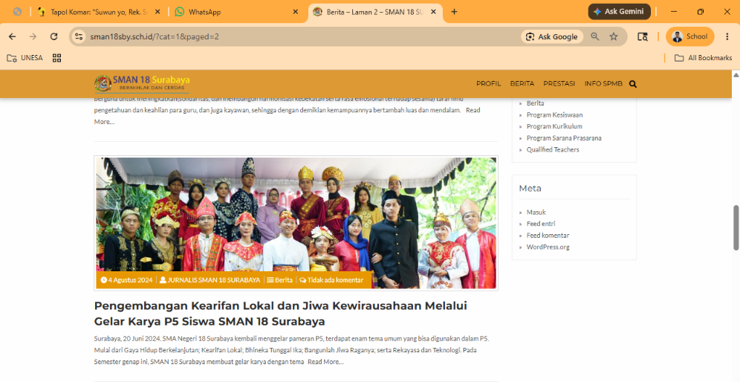

Figure 3. Public Exhibition of the P5 Project at SMAN 18 Surabaya on August 4, 2024

At the institutional level, cultural reinforcement mechanisms such as P5 exhibitions, art showcases, and talent bazaars operate as what could be conceptualized as institutionalized symbolic accumulation. These events transform individualized artistic production into collectively legitimized cultural capital, thereby reinforcing the school’s epistemic authority in cultural transmission. However, such institutional visibility also produces what may be termed performative institutional pressure, wherein students engage in artistic production primarily for external validation rather than intrinsic cultural internalization.

This duality reflects a broader contradiction in contemporary arts education policy, where performative outputs are often prioritized over affective-cultural depth. While exhibitions successfully enhance visibility and recognition of local culture within the school ecology, they simultaneously risk reinforcing outcome-oriented learning dispositions that align with audit culture in education systems. In such regimes, artistic learning is increasingly evaluated through measurable artifacts rather than embodied transformation.

The persistence of academic transactionalism among students must therefore be interpreted not merely as motivational deficiency but as a rational adaptation to neoliberalized educational structures. Within such structures, students develop instrumentally rational orientations toward learning, optimizing effort allocation based on perceived academic utility rather than cultural meaning. This results in what can be described as shallow procedural mastery, where students achieve technical compliance without affective assimilation of cultural values such as rasa (aesthetic sensibility) and unggah-ungguh (ethical-cultural comportment).

This fragmentation between cognitive acquisition, psychomotor execution, and affective internalization reveals a breakdown in holistic learning integration. From a Bloomian perspective, while cognitive and psychomotor domains are partially achieved, the affective domain remains underdeveloped, indicating incomplete educational attainment. Such imbalance suggests that current pedagogical interventions, while structurally coherent, lack sufficient mechanisms for deep cultural subjectification.

Theoretically, this phenomenon can be situated within the framework of cultural reproduction under late modernity, where schools function simultaneously as agents of cultural preservation and sites of cultural contestation. However, unlike earlier formulations of reproduction theory, contemporary contexts are characterized by intensified transnational cultural flows that destabilize the monopoly of local cultural institutions. As a result, cultural transmission becomes increasingly hybridized, negotiated, and contingent upon student subjectivities shaped by digital infrastructures.

Furthermore, the case demonstrates that cultural pedagogy in urban Indonesian schools operates within a condition of epistemic pluralization, where multiple knowledge systems coexist and compete for cognitive and affective legitimacy. Traditional arts education must therefore be understood as operating within a contested epistemological field rather than a stable cultural continuum. In this field, pedagogical success depends not only on instructional quality but also on the ability to reconfigure meaning systems in ways that resonate with students’ lived digital experiences.

From a policy and curriculum design perspective, these findings suggest the necessity of integrating what may be termed translational cultural pedagogy, wherein traditional knowledge systems are not merely preserved but actively recontextualized within contemporary semiotic environments. This may involve hybrid pedagogical strategies that bridge analog embodiment with digital mediation, thereby reducing epistemic distance between students’ cultural lifeworlds and institutional learning objectives.

Ultimately, the case of SMA Negeri 18 Surabaya illustrates that local culture-based arts education is not a linear transmission of heritage but a complex negotiation of meaning, embodiment, and identity within digitally mediated urban contexts. The sustainability of such educational initiatives depends on their capacity to navigate structural tensions between institutional cultural preservation, student digital subjectivities, and evolving regimes of aesthetic legitimacy. Without addressing these multilayered dynamics, arts education risks remaining functionally effective yet existentially detached from students’ lived cultural consciousness..

3.2 Discussion
3.2.1 Theoretical Reframing: Education Through Art vs. Education in Art
The empirical evidence gathered from SMA Negeri 18 Surabaya provides a concrete illustration of how urban secondary education institutions can operate as active sites of cultural transmission and transformation, rather than merely passive recipients of curricular mandates. This positioning reflects a broader epistemological shift from an “education in art” paradigm toward an “education through art” framework, wherein artistic practice is not confined to disciplinary skill acquisition but embedded as a medium for holistic human development. In this configuration, art functions as a pedagogical infrastructure that mediates cognitive, affective, and psychomotor development simultaneously, particularly within school environments characterized by strong exposure to digital culture and standardized academic pressures.
When interpreted through classical arts education frameworks advanced by Soehardjo and Ismiyanto, the role of arts within formal schooling is fundamentally reoriented from vocational specialization toward general human formation. The institutional objective is not to produce professional artisans, commercial designers, or stage-oriented performers, but to cultivate multidimensional competencies that support broader educational outcomes. Within this interpretive lens, artistic tasks such as constructing three-dimensional Sura and Baya mascots or executing the structured kinetic grammar of Tari Remo Gagrak Anyar function as mediated learning devices. These practices operate as structured encounters with form, rhythm, materiality, and symbolism, enabling students to develop interpretive sensitivity toward cultural sign systems while simultaneously strengthening procedural and perceptual intelligence.
In operational terms, the pedagogical deployment of spatial construction and embodied choreography serves as a diagnostic mechanism for identifying and developing latent student capacities that are often underactivated in conventional academic subjects. The manipulation of cardboard structures through cutting, folding, and assembling processes introduces students to principles of spatial reasoning, structural logic, and material constraint negotiation, which are transferable to broader cognitive domains such as problem-solving and systems thinking. Similarly, engagement with structured movement vocabularies in traditional dance facilitates the refinement of proprioceptive awareness, motor coordination, and rhythmical synchronization, all of which contribute to embodied cognition and sensorimotor integration. Within this framework, artistic practice becomes a measurable yet also affectively rich site of developmental observation.
Furthermore, the integration of these artistic modalities into the school ecosystem functions as a counterbalancing pedagogical strategy against the cognitive overload associated with urban academic environments. The structured engagement with materials and bodily movement introduces a regulated form of experiential learning that disrupts the dominance of abstract, text-based instruction. This creates a pedagogical equilibrium in which aesthetic experience and emotional articulation are positioned as essential components of educational formation. Consequently, arts education in SMA Negeri 18 Surabaya can be understood as a systemic intervention that cultivates emotional sensitivity (sensivitas), critical interpretive capacity, psychomotor refinement, and civic-oriented empathy, thereby reinforcing the broader mandate of education as humanistic formation rather than merely cognitive accumulation.
3.2.2 Digitalization of Tradition and Socio-Cultural Convergence
Furthermore, the strategic deployment of the “Goresan Warnaku” digital infrastructure can be interpreted as a deliberate pedagogical response to the shifting semiotics of knowledge production in digitally mediated societies. The platform does not merely function as a repository of instructional content, but rather as an epistemic interface that reorganizes how cultural knowledge is accessed, circulated, and legitimized within the school ecosystem. In this sense, digitalization is not treated as an auxiliary tool, but as an integral layer of curriculum architecture that enables continuity between embodied cultural practice and mediated representation. This alignment reflects an emerging logic of educational digitization in which cultural heritage is sustained through iterative documentation, visualization, and interactive engagement rather than static preservation.
From a theoretical standpoint, this model resonates with contemporary discourses on hybrid cultural pedagogy and digitally extended ethnography, where local knowledge systems are reconfigured through technological mediation without losing their contextual grounding. The approach also substantiates Rohidi’s proposition regarding the necessity of situating arts education within the lived socio-cultural environment of learners, while simultaneously extending it into virtual environments that reflect current patterns of cultural consumption. In this configuration, digital platforms function as a secondary cultural ecology that coexists with physical classroom practice, enabling recursive feedback loops between production, reflection, and dissemination of artistic outputs. Put differently, the digital infrastructure operates as both an archive and a performative stage, where cultural artifacts gain renewed interpretive value through visibility and circulation.
Moreover, the integration of student portfolios into a publicly accessible digital space generates a form of distributed cultural authorship that reshapes student subjectivity in relation to artistic production. Students are no longer positioned solely as passive recipients of cultural heritage, but as active contributors to a continuously evolving digital archive of local culture. This shift is further reinforced by institutional mechanisms such as P5 exhibitions and sustained participation in inter-school competitions, which collectively function as validation infrastructures that bridge digital representation and social recognition. Within this system, cultural artifacts acquire dual ontological status: they remain rooted in local tradition while simultaneously gaining symbolic capital within contemporary peer networks, thereby transforming heritage into an active medium of identity formation and social differentiation.
3.2.3 Deconstructing the Transactional Barrier: Pedagogical Implications
Nevertheless, the persistent presence of grade-oriented motivation and academic utilitarianism among urban students requires a more rigorous theoretical interrogation within the sociology of education and contemporary character education discourse. Behavioral compliance observed in studio-based tasks, whether in visual construction or embodied performance, cannot be simplistically equated with internalization of cultural values. Within a performative learning context, students often engage in what may be conceptualized as surface-level instrumental participation, where the primary objective is task completion aligned with assessment rubrics rather than meaning-making or value absorption. This condition reveals a structural gap between procedural achievement and dispositional transformation, indicating that cultural education outcomes cannot be fully captured through output-based evaluation alone.
In practical classroom settings, this gap becomes evident when students replicate the kinetic vocabulary of Tari Remo or execute spatial construction tasks such as cardboard-based Sura and Baya figures without demonstrating interpretive engagement with the cultural narratives embedded within these practices. The learning process thus risks being reduced to mechanical reproduction of forms, where motor execution is decoupled from historical consciousness and philosophical understanding. Such fragmentation suggests that while psychomotor competencies may be attained, the affective and axiological dimensions of learning remain underdeveloped. From a pedagogical standpoint, this reflects an imbalance across Bloom’s taxonomy domains, particularly the underactivation of evaluative and internalizing processes.
This condition further exposes the limitations of episodic pedagogical interventions such as P5 exhibitions, talent showcases, or other performative assessment events. While these initiatives successfully generate institutional visibility and provide structured opportunities for student expression, they often operate within a temporally bounded framework that prioritizes product over process. As a result, students may experience these events as culminating obligations rather than sustained reflective experiences. Without continuous interpretive reinforcement, the symbolic meaning of cultural artifacts risks being overshadowed by their function as evaluative deliverables, thereby weakening their capacity to cultivate long-term cultural disposition.
Addressing this structural limitation requires a more integrated and cross-curricular pedagogical design that transcends disciplinary compartmentalization. Arts education must be explicitly connected to regional history, literature, and language studies in order to reconstruct the socio-historical depth of artistic practices. For instance, the movement vocabulary of Remo dance can be contextualized through narratives of Javanese performative tradition, while visual construction projects such as Sura and Baya can be linked to urban mythology, civic identity, and local historiography. This integrative approach enables students to perceive artistic practice not as isolated technical activity but as a culturally embedded knowledge system with interrelated symbolic, historical, and ethical dimensions.
Ultimately, the transformation of arts education from procedural compliance to meaningful cultural internalization requires sustained reflective pedagogy that prioritizes interpretive depth over output accumulation. Such transformation cannot be achieved through isolated interventions but demands continuous reinforcement through dialogic instruction, critical reflection sessions, and embodied cultural inquiry. Only through this layered pedagogical ecosystem can students move beyond transactional engagement and develop a genuine sense of cultural ownership. In this sense, traditional art education in urban contexts must evolve into a recursive learning process in which practice, reflection, and contextual understanding mutually reinforce one another, thereby enabling the emergence of authentic cultural subjectivity among learners.

4. CONCLUSION

The implementation of local culture-based arts and culture education at SMA Negeri 18 Surabaya demonstrates a systematic and strategic effort to preserve East Javanese cultural heritage within a modern urban school environment. Through the integration of ceramic crafts in the visual arts domain and the Tari Remo Gagrak Anyar (Munali Fatah style) in the dance domain, the curriculum successfully transitions from a rigid technical framework toward a holistic model of character development. The bidirectional pedagogical synergy between educators and students establishes a highly participatory space, although it requires continuous instructional adjustments to bridge the aesthetic gap faced by urban youth. While the learning outcomes indicate substantial advancement across cognitive, psychomotor, and affective domains—extensively validated by institutional platforms such as the P5 (Projek Penguatan Profil Pelajar Pancasila) exhibitions—the empirical data uncovers a persistent challenge in the form of academic transactionalism among students. To ensure that artistic practices transcend mere grade-oriented compliance and transform into authentic, lifelong cultural ownership, secondary institutions must implement deeper cross-curricular synthesis that explicitly links physical aesthetic production with the deeper historical, philosophical, and linguistic foundations of the region.

AUTHOR'S CONTRIBUTION

Rizky Arinka Dwi Cahya holds sole and complete responsibility for all stages of the research and the preparation of this manuscript. The author conceptualized the research framework, designed the descriptive qualitative methodology, and conducted all fieldwork, including classroom observations and in-depth interviews with informants. Furthermore, the author executed data analysis through data reduction, verification, and triangulation, interpreted the findings, and drafted, revised, and finalized the manuscript for publication.

REFERENCE
Ismiyanto, P. S. (2014). Metodologi Penelitian Pertunjukan Seni dan Pendidikan Seni. Semarang: Cipta Prima Nusantara.

Miles, M. B., Huberman, A. M., & Saldaña, J. (2014). Qualitative Data Analysis: A Methods Sourcebook (3rd ed.). Thousand Oaks, CA: SAGE Publications.

Puteri, A. R. (2024). Digitalization of cultural heritage in secondary education: Opportunities and structural barriers. Journal of Urban Arts Education, 12(2), 145-159.

Rohidi, T. R. (2014). Pendidikan Seni: Isu dan Paradigma. Semarang: Cipta Prima Nusantara.

Soehardjo, A. J. (2012). Pendidikan Seni: Strategi Penataan dan Pengembangan Kurikulum. Malang: Universitas Negeri Malang Press.

