
SMKN 1 DLANGGU’S STRATEGY IN DEFELOPING STUDENTS’ INTEREST IN INDONESIAN TRADITIONAL ARTS AMIDST THE INFLUENCE OF THE KOREAN WAVE


E-ISSN 2338-6770

Tanggal pengajuan : -
Tanggal revisi : -
Tanggal diterima : -

Alamat Korespondensi:
Studi Thailand, Fakultas Seni, Universitas Chulalongkorn 254 Phaya Thai Rd, Wang Mai, Pathum Wan, Bangkok 10330. E-mail: 6688031022@student.chula.ac.th

Amanda Putri Violita¹, Anik Juwariyah²

1Universitas Negeri Surabaya, Surabaya, Indonesia
2Universitas Unesa, Surabaya, Indonesia
Surel: amanda.22067@mhs.unesa.ac.id, anikjuwariyah@unesa.ac.id

Abstract: This study aims to describe the resilience strategies employed by SMKN 1 Dlanggu to preserve Indonesian traditional arts in the era of the influx of foreign cultures, including the Korean Wave. It also describes how students maintain Indonesian traditional arts so they can compete with the proliferation of foreign cultures. This study uses a qualitative descriptive approach with the aim of analyzing resilience strategies at SMKN 1 Dlanggu. This approach begins with collecting, processing, and presenting data objectively to address the problem formulation. The data sources used were primary and secondary data sources. Data collection techniques used in this study included observation, interviews, documentation, and questionnaires. The collected data were then analyzed through three stages: data reduction, data presentation, conclusion drawing, and verification. The analyzed data were then validated using several data checks, research results show that the majority of students at SMKN 1 Dlanggu still maintain their love for Indonesian traditional arts despite the influx of foreign cultures. This demonstrates that SMKN 1 Dlanggu's strategy to preserve Indonesian including source triangulation and technique triangulation, to ensure data validity.The culture has been successful, and that students can develop Indonesian arts through the support provided by the school.

Keywords: Korean Wave, Indonesian Tradisional Art, Survival Strategy

INTRODUCTION

The Korean wave is a term given to the spread of South Korean popular culture. The Korean wave spread through entertainment products including dramas/films, music, fashion styles, and food. The Korean wave itself began to spread in Indonesia in the early 2000s and peaked in 2018. The spread of the Korean wave spread so quickly through dramas and music. Korean dramas became very popular because Korean dramas have several supporting aspects of the story that make it interesting, and stunning cinematography that makes the audience want to follow the story until the end. Some of these aspects include unique and unexpected storylines, visuals displayed, fashionable clothing worn by actors and actresses. The Korean Wave, which is currently popular among teenagers, has forced artists to strategize to preserve Indonesian traditional arts. At SMK Negeri 1 Dlanggu, many teenagers are members of art studios.

Indonesian arts and culture constitute a cultura; heritage that holds historical value, identity, and national character. Cultural diversity from Sabang to Merauke is a treasure that must be preserved and passed on to the younger generation to ensure is sustainbility amidst changing times. The develompent of technology and digital media has accelerated the influx of foreign culture, particularly the korean wave, wich has had significant influence on lifestyle, entertainment, music, fashion, and consumption patterns among young people. This situation presents a challenge in maintaining the exsistence of traditional Indonesian arts.
Based on research at SMK Negeri 1 Dlanggu, the school has implemented various strategies to maintain students' love of traditional arts. These strategies include providing art learning spaces, mentoring by teachers, providing performance opportunities, and supporting student participation in various arts competitions. With a strong foundation in preserving Indonesian culture, students of SMKN 1 Dlanggu are more passionate about Indonesian traditional arts. Support is given to children who want to learn more about the arts, extracurricular facilities that recruit experienced art teachers in their fields, comfortable places, and adequate tools make students more interested.
A questionnaire distributed to 200 respondents showed that Indonesian culture is still better known and sought after than Korean culture. 87% of students were more familiar with Indonesian culture, while 67% were familiar with Korean culture. Furthermore, 51.9% of students preferred Indonesian films, while 17.3% preferred Korean films. This proves that despite the influx of many foreign cultures, traditional arts can still exist today.
Overall, the strategies implemented at SMK Negeri 1 Dlanggu have proven quite effective in maintaining the existence of traditional arts among students. Despite the continued growth of foreign cultural influences, ongoing development and school support have fostered a love for Indonesian culture, ensuring that traditional arts remain well-known, sought after, and have the potential to be preserved by the younger generation.

2. METHOD
This study uses a qualitative descriptive approach to examine the survival strategies for loving Indonesian traditional arts at SMK Negeri 1 Dlanggu amidst the influence of the Korean Wave. This approach was chosen because it provides an in-depth overview of the phenomena occurring within the school environment without manipulating the conditions under study. The research focuses on the school's efforts to maintain the existence of traditional arts through various strategies applied to students, thus gaining a comprehensive understanding of the real-world conditions
The research data sources consist of primary and secondary data. Primary data were obtained directly through interviews with Arts and Culture teachers as the main sources involved in the development and implementation of traditional arts preservation strategies. Meanwhile, secondary data were obtained from various supporting documents, such as official school publications through social media (Instagram, TikTok, and YouTube), which were used to complement and strengthen the research findings. The research location is SMK Negeri 1 Dlanggu, Mojokerto Regency, which was chosen because it has various active arts and cultural activities and supports the preservation of traditional arts.
Data collection was conducted through observation, interviews, documentation, and questionnaires. Non-participant observation was used to directly observe arts activities at the school without the researcher's involvement in the activity. Interviews were conducted in both structured and unstructured ways to obtain systematic and in-depth information regarding the strategies implemented by the school. Documentation was used as supporting evidence through the collection of photos, videos, and documents from social media and the results of the researcher's documentation. In addition, a questionnaire distributed via Google Forms to 200 students was used to determine their level of knowledge, interest, and enthusiasm for Indonesian culture and the Korean Wave.
The obtained data was then analyzed using the Miles and Huberman data analysis model, which involves three stages: data reduction, data presentation, and conclusion drawing. In the data reduction stage, researchers select and categorize information relevant to the research focus. Next, the data is presented systematically in the form of descriptive descriptions, tables, and documentation to facilitate interpretation. The final stage involves drawing conclusions based on the verified analysis results, resulting in scientifically justifiable findings. To ensure data validity, this study applies source triangulation and technical triangulation. Source triangulation is carried out by comparing information obtained from various sources, while technical triangulation is carried out by matching the results of interviews, observations, documentation, and questionnaires. By applying these various techniques, the data obtained becomes more accurate, credible, and valid. Therefore, the research method used is considered capable of providing a comprehensive picture of the survival strategy in loving traditional arts at SMK Negeri 1 Dlanggu and serves as a strong basis in answering the research problem formulation.

3. RESULTS AND DISCUSSION

3.1 Results

The Korean Wave has had a significant influence on the lifestyles and cultural interests of the younger generation. However, research at SMKN 1 Dlanggu shows that traditional Indonesian arts are still more well-known and sought after. Of the 200 respondents, 87% were familiar with Indonesian culture, 44.3% had participated in traditional arts activities, while the majority of students were less familiar with Korean culture.To preserve traditional arts, SMKN 1 Dlanggu implements three main strategies: cultural protection and security, development and utilization, and collaboration. These strategies are implemented through the provision of arts extracurricular activities, coaching by professional trainers, the implementation of P5 activities themed around local wisdom, and collaboration on Indonesian dance with PLP students from Surabaya State University (UNESA).
This success is supported by various strategies implemented by SMKN 1 Dlanggu in preserving traditional arts. The school provides facilities in the form of extracurricular dance, gamelan, and choir guided by professional coaches, and provides support for students to participate in various arts competitions. In addition, the school utilizes the Pancasila Student Profile Strengthening Project (P5) activities with the theme of local wisdom and Bhinneka Tunggal Ika as a means to introduce Indonesian culture through dance, music, and theater performances. These efforts are strengthened through collaboration with PLP students from Surabaya State University (UNESA) in performing archipelago dances that not only improve students' artistic abilities, but also instill the values of discipline, cooperation, responsibility, and pride in the nation's culture. With these strategies, SMKN 1 Dlanggu has succeeded in maintaining the existence of traditional arts while fostering a love of Indonesian culture among the younger generation amidst the strong influence of Korean Wave. These strategies have proven effective in increasing student interest, appreciation, and participation in traditional arts. With the support of schools, teachers, and various arts programs, traditional arts are maintained and developed despite the influence of global culture, particularly the Korean Wave.

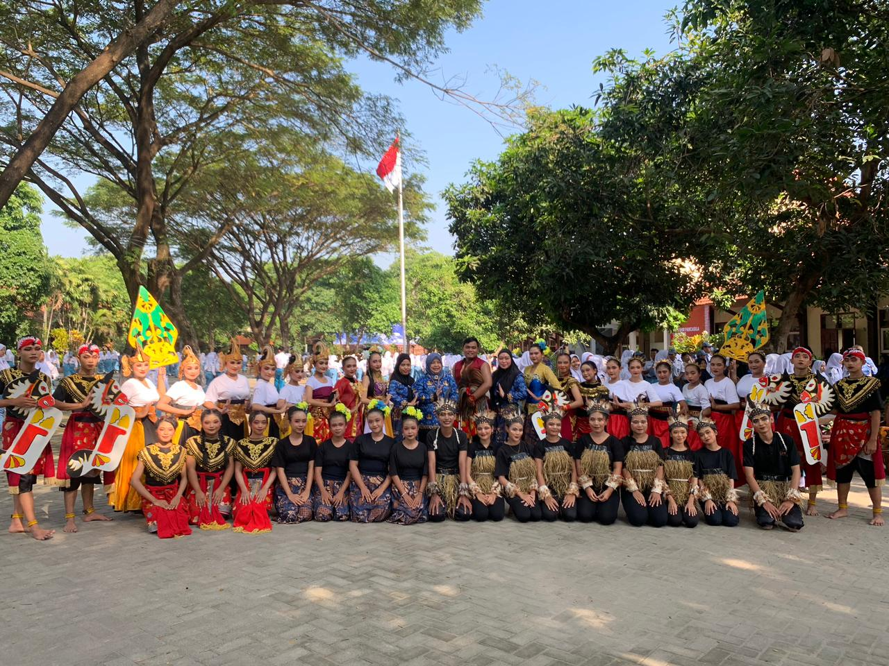

Figure 1. Students of SMKN 1 Dlanggu collaborated in the arts with student from UNESA

Amidst the rapid flow of globalization and the rise of foreign cultures such as the Korean Wave, students at SMKN 1 Dlanggu are making various efforts to preserve Indonesian traditional arts so they remain relevant and competitive. One such effort is actively participating in school arts activities through extracurricular activities such as traditional dance, gamelan, theater, and traditional music. Furthermore, students demonstrate their pride in local culture by participating in various arts performances, such as class meeting performances, P5 work exhibitions, and a collaborative Indonesian dance performance with students from the PLP (Education and Development Program) of Surabaya State University (UNESA). These activities not only enhance their artistic abilities but also foster a sense of patriotism, togetherness, and an awareness of the importance of preserving the nation's culture.
The impact of the Korean Wave itself was also felt by students at SMKN 1 Dlanggu, according to a google form filled out by 200 respondents of SMKN 1 Dlanggu students, it showed that 33% of students knew Korean culture and 67% did not know Korean culture. Of the 200 respondents, most knew Korean culture through films/dramas, the rest through music, dance, fashion and food. According to the google form filled out by students at SMKN 1 Dlanggu, they knew several public figures from South Korea, most of them wrote BTS, Blackpink, Cha eunwoo, Byeon wooseok, NCT, Ma Dongseok and hwang in yeop, while the food they had tried mostly included Topokki, Ramyeon, Odeng, and Kimchi.
Here is the survey description written in a cohesive narrative paragraph format:
A comprehensive survey was recently conducted among 200 students at SMKN 1 Dlanggu to assess their cultural preferences, specifically contrasting their engagement with traditional Indonesian culture against the rising global popularity of contemporary Korean culture. Distributed as a structured questionnaire across various grade levels and academic programs, the study aimed to evaluate how deeply students connect with their own national heritage amidst international trends like K-Pop, K-Dramas, and the broader Korean Wave. The most striking finding from this research reveals that an overwhelming majority of 85% of the respondents expressed a stronger interest in and a deeper love for Traditional Indonesian Arts over Korean culture. This significant outcome demonstrates a profound appreciation for local traditions, reflecting a strong sense of national pride and identity among the students of SMKN 1 Dlanggu. Furthermore, these results suggest that while global entertainment is highly accessible, the roots of Indonesian cultural heritage remain deeply meaningful to the younger generation, providing valuable insights for the school to further support and nurture traditional arts programs.

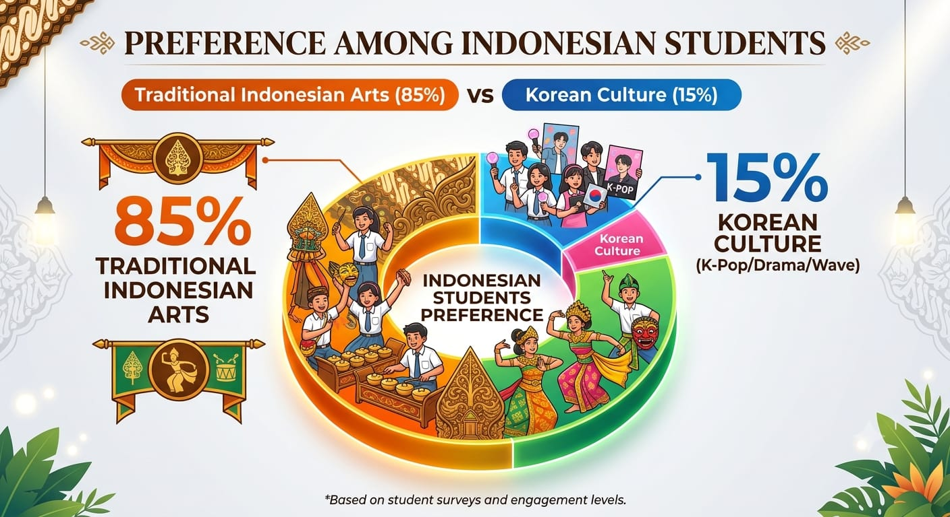

Figure 2. Diagrams preference among SMKN 1 Dlanggu student

In addition to participating in arts activities, students also utilize technological advances to support cultural preservation by creating creative cultural-themed content through social media, thereby increasing the awareness of traditional arts among the younger generation. They also develop innovations by combining traditional and modern elements, such as combining traditional dance with modern music or wearing batik in a more contemporary style without losing its cultural value. Furthermore, school learning not only emphasizes artistic practice but also provides an understanding of the history, philosophy, and values inherent in each traditional art form. Through these efforts, students at SMKN 1 Dlanggu demonstrate that cultural preservation involves not only maintaining traditional forms but also developing and adapting them to current trends, ensuring they remain attractive, relevant, and competitive amidst the influence of foreign cultures.
The spread of the Korean wave at SMKN 1 Dlanggu apparently did not have much impact on interest in Indonesian arts, most students were more interested in Indonesian culture than Korean culture. This caused cultural acculturation to not occur much. Several factors also influence why students are less interested in Korean culture and prefer to learn Indonesian culture, from several respondents who have filled out the Google form, some wrote that they prefer to learn Indonesian culture because it is more diverse, culture and language have their own uniqueness in each region. There are also those who said they enjoy learning Korean culture because of curiosity about foreign cultures and following several Korean pop idols such as Jisoo Blackpink.

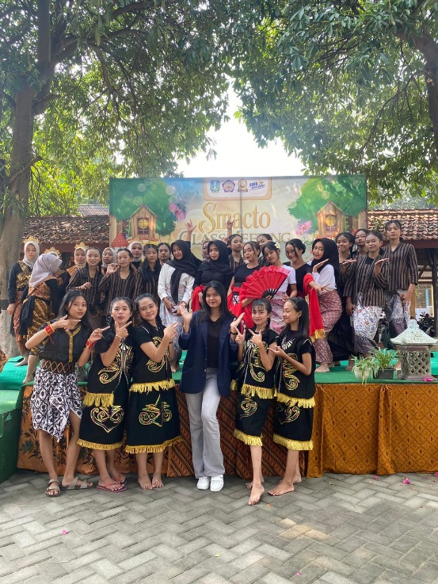
Figure 3. An art stage held so that students can channel their talent in the art

Some extracurricular activities at SMKN 1 Dlanggu include dance, gamelan, and choir. Through these extracurricular activities, the school hopes that students at SMKN 1 Dlanggu will also develop non-academic achievements.Extracurricular activities aim to develop students' potential, talents, interests, personality, and social skills outside of school hours, and these activities remain under the guidance of the school. In an interview with a resource person, Mr. Rio Teguh stated that "these children need guidance and direction so they don't just go on a rampage in class, uploading videos on TikTok, and doing pointless things. If someone provides guidance, it can be a place for them to learn about culture." (Interview, May 22, 2025). With the arts extracurricular program at SMKN 1 Dlanggu, it is hoped that students can develop their potential in the arts. This is evidenced by the work they have learned and the various competitions they have participated in. This can also foster character development, build personality, and enhance teamwork if the competitions are held in groups.
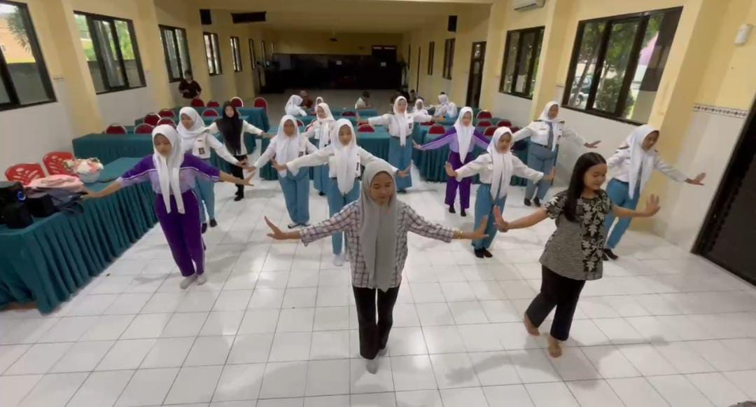

Figure 4. Extracuricular dancing at SMKN 1 Dlanggu

Efforts to preserve culture amidst the proliferation of foreign cultures today:

a. Actively Participating in Traditional Arts Activities at School

Students of SMKN 1 Dlanggu participate in extracurricular activities such as traditional dance, karawitan, regional theater, or traditional music to better understand and appreciate their own culture. This way, Indonesian traditional arts will continue to be studied and their existence will be maintained.

b. Proudly Showcasing Local Culture

Boldly presenting traditional arts in school performances, competitions, or farewell events. This sense of pride helps maintain the existence of culture within the student community. This is evident in the students' collaborations with PLP UNESA students and the arts performances during P5 activities.

C. Creating Creative Culturally Themed Content

Students can utilize TikTok, Instagram, or YouTube to create traditional dance content, cultural tutorials, or modern-traditional collaborations to make local culture appear cool and relevant. Not being aware of current technological advances requires students to develop their knowledge and skills by uploading cultural learning experiences on social media.

D. Combining Tradition with Modern Trends

For example, combining traditional dance with modern music, wearing batik in a contemporary style, or creating covers of modern songs with traditional musical instruments. Wearing batik is also a way to preserve Indonesian culture, as it is a UNESCO-certified cultural heritage. Students of SMKN 1 Dlanggu always wear batik or traditional clothing from various regions of Indonesia when commemorating Indonesian holidays

e.Learn the Meaning Behind Art

Not only practice, students also need to understand the value of philosophy, history and moral messages in traditional arts in order to grow a sense of belonging. This is done by teachers who teach in class, teachers provide knowledge about Indonesian culture so that students can not only practice but also know the philosophy, history and moral messages that exist in the culture.

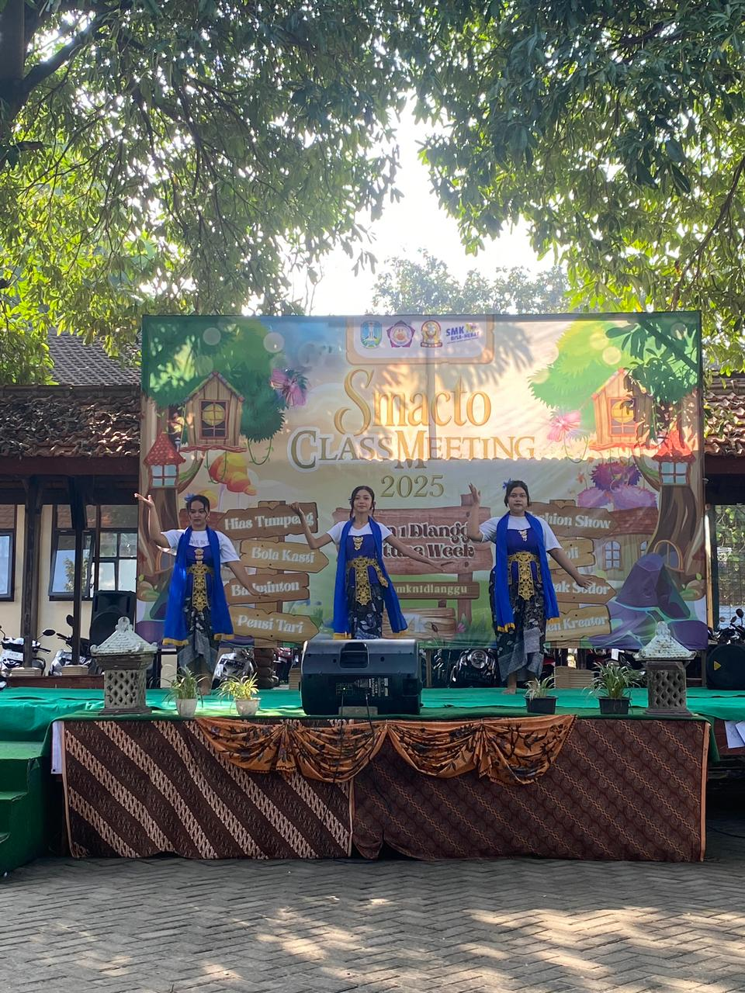

Figure 5. combination traditional and modern dance at arts stage

The cultural dance collaboration between students of SMKN 1 Dlanggu and students from the PLP (Physical and Applied Arts) program at Surabaya State University (UNESA) created a colorful and meaningful performance. This activity was not merely an artistic performance, but also a tangible manifestation of unity in Indonesia's cultural diversity. With the theme "From Sabang to Merauke," they presented a variety of Indonesian dances reflecting the rich traditions of various regions across Indonesia.

Preparations were carried out with enthusiasm and collaboration. UNESA PLP students acted as mentors and guides, assisting with movement development, technique mastery, and floor plan design and expression. According to informant Bertha Septiayu Wilujeng, a member of PLP UNESA who participated in this collaboration process, said that "Children's knowledge of this traditional art is still said to be minimal, children tend to understand more about velocity. With this collaboration, it also opens up space for children who have never been selected to perform before who feel lacking in dancing, as long as they are willing to learn and are disciplined, everyone can participate in this collaboration" (Interview, February 20, 2026) Meanwhile, students of SMKN 1 Dlanggu showed high enthusiasm in learning every detail of the dance movements, starting from the softness of the Saman Dance from Aceh, the elegance of the Piring Dance from West Sumatra, the agility of the Jaipong Dance from West Java, to the spirit of the Cendrawasih Dance from Papua.

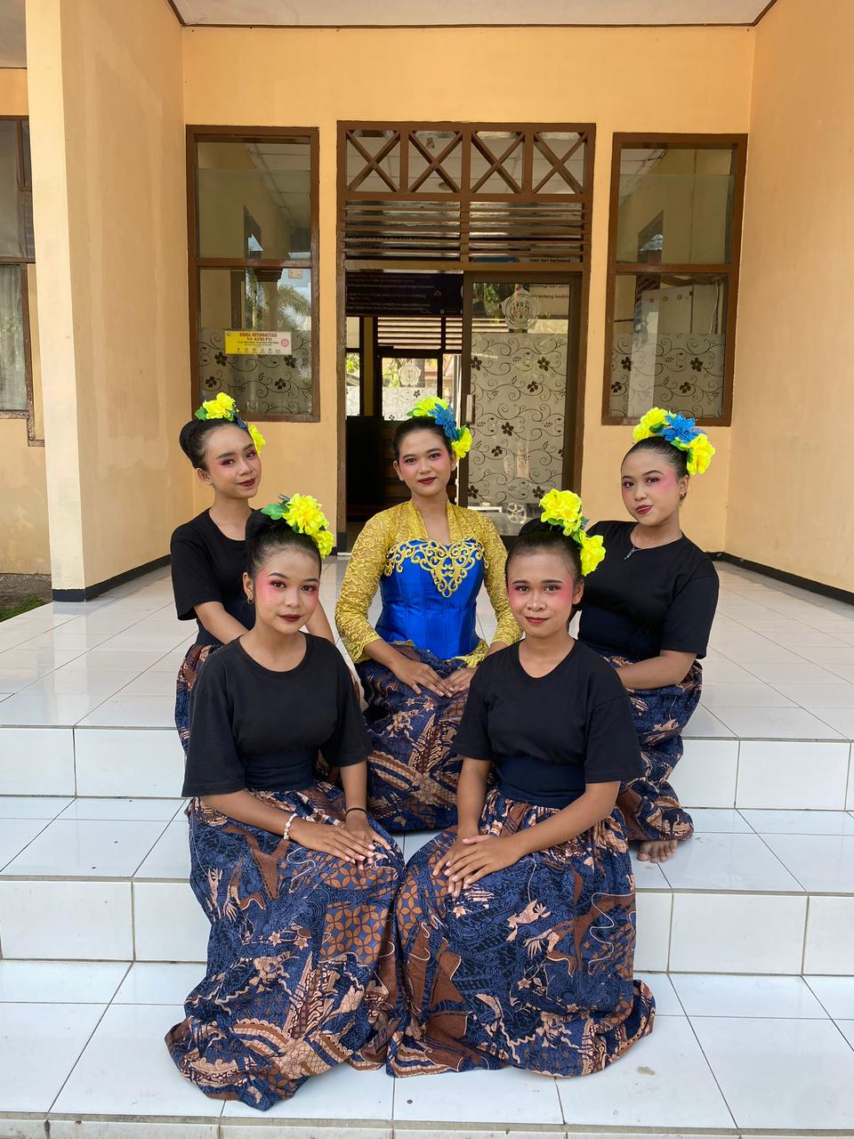

Figure 6. collaboration with collage student Surabaya State University

3.2 Discussion

Based on research findings, the efforts of students at SMKN 1 Dlanggu to preserve Indonesian traditional arts amidst the rise of foreign culture demonstrate that the younger generation still cares about preserving the nation's culture. This is evident in their involvement in arts and culture lessons, extracurricular activities, regular practice, art performances, and collaborations with various parties. These activities not only improve artistic skills but also foster a sense of love, pride, and responsibility for local culture.

The influx of foreign culture through social media and technological developments has significantly influenced the interests of the younger generation. Phenomena such as K-pop, Western music, films, and various digital trends have become part of students' daily lives. However, research findings indicate that foreign cultural influence is not always negative. When approached wisely, foreign culture can actually inspire creativity in packaging traditional arts to make them more appealing without losing their cultural values and identity. Thus, cultural preservation does not mean rejecting foreign culture, but rather filtering and adapting positive elements that align with Indonesian cultural values.

The results of this study also demonstrate that schools play a crucial role as environments that support the preservation of traditional arts. Through Arts and Culture subjects, the provision of extracurricular arts programs, and opportunities to participate in various performances and competitions, schools provide a platform for students to learn about, study, and develop traditional arts. Teacher support and collaboration with students and artists further enhance students' learning experiences in the arts and culture field.Beyond the school environment, the use of digital media is a relevant strategy for maintaining the existence of traditional arts. Students can use social media platforms to document, promote, and introduce traditional arts to the wider community. This step demonstrates that technology is not only a medium for the dissemination of foreign culture but can also be used as a means of preserving local culture if used creatively and responsiblyThe findings of this study align with Koentjaraningrat's (2009) opinion, which states that culture will survive if it is passed down and learned by each generation. Furthermore, in accordance with Law Number 5 of 2017 concerning the Advancement of Culture, cultural preservation is a shared responsibility, including that of educational institutions and the younger generation. Therefore, active student involvement in various arts activities is one concrete form of implementing cultural advancement efforts within the school environment. Overall, this study demonstrates that the strategy for the survival of traditional arts at SMKN 1 Dlanggu relies not only on formal learning but is also influenced by individual awareness, school support, collaboration with various parties, and the use of digital technology. The combination of these factors is an important asset for ensuring that Indonesian traditional arts remain sustainable, develop, and are able to compete amidst the rapid flow of global culture without losing their identity and cultural values.

4. CONCLUSION

The Korean Wave has significantly influenced the interests of the younger generation through music, film, dance, fashion, and culinary arts, all readily accessible through technological advancements and social media. However, research at SMKN 1 Dlanggu indicates that this influence has not yet displaced students' love of traditional Indonesian arts. A questionnaire survey of 200 respondents revealed that the majority of students still recognize, appreciate, and are interested in learning about Indonesian culture.

This success is supported by various strategies implemented by the school, such as providing arts facilities, dance and gamelan extracurricular activities, mentoring by competent teachers, support for competitions, collaboration with local artists, and the implementation of the Pancasila Student Profile Strengthening Project (P5). Furthermore, students are encouraged to introduce Indonesian culture through various forms of creativity, including utilizing social media and combining traditional elements with contemporary developments.Thus, the preservation of traditional arts amidst the rapid influx of foreign culture can be achieved through synergy between schools, teachers, the community, the government, and the younger generation. Continuous support for arts education and the positive use of technology can maintain the existence of Indonesian culture so that it continues to be loved, preserved, and developed as a national identity in the era of globalization.

AUTHOR CONTRIBUTIONS

The first author served as the principal investigator and was responsible for all stages of the research, including conceptualization, methodology development, data collection and analysis, and manuscript preparation from initial draft to final revision. The second author served as the supervisor, providing guidance and oversight throughout the research process, validating the results, and contributing through review and editing of the manuscript.

ACKNOWLEDGMENTS

The researcher would like to express his sincere gratitude for the completion of this research to:

1. Prof. Dr. H. Nurhasan, M.Kes., Rector of Surabaya State University, who has provided comprehensive facilities to his students.

2. Syafiul Anam, Ph.D., Dean of the Faculty of Languages ​​and Arts, Surabaya State University, for his support.

3. Dr. Welly Suryandoko, S.Pd., M.Pd., Coordinator of the Drama, Dance, and Music Education Study Program, Surabaya State University, for his support.

4. Prof Dr. Anik Juwariyah, M.Si., my thesis supervisor, who always made time for my guidance, criticism, and constructive input.

5. Dr. Sn, Retnayu Prasetyanti Sekti, M.Si., my academic supervisor and first examiner, who provided support, guidance, and direction throughout the study process.

6. Dr. I Nengah Mariasa, M.Hum. as the second examiner, who willingly provided direction, input, suggestions, and guidance to the researcher.

7. Rio Teguh Prakoso, S.Sn Teachers of SMKN 1 dlanggu who where willing to be resource persons and provide very valueable information for tis reseacrh.

8. All lecturers and friends from the Bachelor of Dance and Performing Arts Education study program, class of 2022, who have shared their struggles during their studies and shared the new experiences they have gained throughout their journey and even their travels in Surabaya.

REFERENCE
Alfanani, R. J. (2019). Hegemoni Budaya dalam Novel Merpati Kembar di Lombok Karya Nuriadi: Kajian Hegemoni Antonio Gramsci. Genta Bahtera: Jurnal Ilmiah Kebahasaan Dan Kesastraan, 5(1), 56–66.
Anandani, H. P., Amalah, N., Tussadiah, N. R., & Yuliana, N. (2025). Fenomena Hallyu: Tantangan dalam Akulturasi pada Kalangan Remaja di Indonesia. Jurnal Dinamika Sosial Budaya, 27(2), 23–33.
Hadiyanto, A. R. P., & Warih Handayaningrum. (2024). UPTD SMP Negeri 2 Bangkalan Dance Extracurricular Management Strategy in Achieving Student Achievements. Indonesian Journal of Contemporary Multidisciplinary Research, 3(4), –794. https://doi.org/10.55927/modern.v3i4.10489
Hasanah, U. (n.d.). Pengaruh Penerapan Project Based Learning terhadap Keterampilan Berpikir Kritis dan Kreatif serta Prestasi Menulis Siswa. 1– 12.
Hikmasari, D. N., Susanto, H., & Syam, A. R. (2021). Konsep Pendidikan Karakter Perspektif Thomas Lickona dan Ki Hajar Dewantara. Al-Asasiyya: Journal Basic of Education (AJBE), 6(1), 19–31.
Irianto, A. M. (2017). Kesenian tradisional sebagai sarana strategi kebudayaan di tengah determinasi teknologi komunikasi. Nusa: Jurnal Ilmu Bahasa dan Sastra, 12(1), 90–100.
Irawan, B. S. (2023). Strategi Guru Dalam Pembelajaran Ekstrakurikuler Seni Tari Pada Peserta Didik Disabilitas Rungu Di SMPLB Negeri Jember. Jurnal Pendidikan Sendratasik, 12(1), 124–138.
Jannah, S. R., Khoirunnisa, Z., & Faristiana, A. R. (2023). Pengaruh Korean wave dalam fashion style remaja Indonesia. Jurnal Ilmiah Pendidikan Kebudayaan Dan Agama, 1(3), 11–20.
Japar, M., Zulela, M. S., & Mustoip, S. (2018). Implementasi pendidikan karakter.Jakad Media Publishing.
Kristianti, A. (2012). Akulturasi Budaya Korea Selatan Dengan Budaya Indonesia Pada Komunitas Pecinta Korea Sbsquad Di Kota Malang (Doctoral dissertation, Universitas Brawijaya).
Kustiawan, W., Efendi, E., Candra, W., & Zein, P. R. (2023). Dampak Korean Wave (Hallyu) Bagi Budaya Indonesia Sebagai Dampak Dari Globalisasi Media. Jurnal Ilmiah Wahana Pendidikan, 9(4), 561–569.
Loloagin, G., Rantung, D. A., & Naibaho, L. (2023). Implementasi pendidikan karakter menurut perspektif Thomas Lickona ditinjau dari peran pendidik PAK. Journal on Education, 5(03), 6012–6022.

Ningrum, A. D. (2023). Strategi Pembelajaran Seni Tari Pada Kegiatan Ekstrakurikuler Di SMK Antartika 2 Sidoarjo. Jurnal Pendidikan Sendratasik, 12(2), 357–367. https://doi.org/10.26740/jps.v12n2.p357-367
Penatas, T. L. (2023). Strategi Pembelajaran Dalam Ekstrakurikuler Kompeni Esemkada Di SMK Negeri 2 Kota Probolinggo. Jurnal Pendidikan Sendratasik, 12(2), 340–356. https://doi.org/10.26740/jps.v12n2.p340-356
Pramitasari, A. W. (2021). Penanaman Nilai-Nilai Nasionalisme Melalui Pertunjukan Seni dan Budaya. Jurnal Education and Development, 9(4), 23– 27.
Pratama, A. B. (2025). Strategi Kebertahanan Grup Orkes Keroncong Pentatonik Di Ruslan, I. (2015). Penguatan ketahanan budaya dalam menghadapi derasnya arus budaya asing. Journal Tapis: Journal Teropong Aspirasi Politik Islam, 11(1), 1–18.
Widia, O. F. (2021). Strategi pelaku seni teater lenong dalam mempertahankan kesenian tradisional Betawi (studi kasus Sanggar Seni Budaya Betawi Oentoeng CS Kelurahan Pisangan, Kecaman Ciputat Timur, Kota Tangerang Selatan Provinsi Banten) (Doctoral dissertation, Andalas University). Kabupaten Pamekasan. Repertoar Journal, 193–205.
Pratikno, A. S., & Hartatik, A. (2023). Pudarnya eksistensi kesenian tradisional ludruk akibat globalisasi budaya. Civis: Jurnal IlmiahIlmu Sosial Dan Pendidikan, 12(2), 56–70.

