
Cooperative Learning Method of the Group Investigation Type in the Esteem Voice Drum Band Extracurricular Program at SMKN 1 Nganjuk


E-ISSN 2338-6770

Date of submission :-
Date of revision :-
Date received :-

Correspondence Address:
Thai Studies, Faculty of Arts, Chulalongkorn University 254 Phaya Thai Rd, Wang Mai, Pathum Wan, Bangkok 10330. Email: 6688031022@student.chula.ac.th

Fahim Putri Oktaviana ¹, Trisakti ²

1 Unversitas Negeri Surabaya, Surabaya, Indonesia
2 Universitas Negeri Surabaya, Surabaya, Indonesia
Email: fahim.22062@mhs.unesa.ac.id, trisakti@unesa.ac.id

Abstract: Drum band is a collective activity involving many participants. There is a division of instruments based on their respective roles and functions within the drum band ensemble. The learning materials delivered to each instrument group differ according to these roles. The varying levels of human resource capability among drum band members, combined with the complex harmonization and teamwork required in drum band performance, present challenges in the learning process. Therefore, this study aims to describe the implementation of the Group Investigation type of cooperative learning method in the Esteem Voice Drum Band extracurricular program.
This study employed a descriptive qualitative research method. Data were collected through interviews with the instructor and students, passive participant observation during training sessions, and documentation as supporting data. The data analysis techniques included data reduction, data presentation, and data verification.
The implementation of the Group Investigation type of cooperative learning method in the Esteem Voice Drum Band extracurricular learning activities consisted of six stages: (1) selecting topics and organizing students, (2) planning learning procedures, (3) implementing the learning process, (4) analyzing and synthesizing the material, (5) presenting the final results, and (6) conducting evaluation.

Keywords: Group Investigation Cooperative Learning, Extracurricular, Drum Band

1. INTRODUCTION
Extracurricular activities support the learning process by providing opportunities to accommodate students’ talents, interests, and skills outside intraclass learning activities. Extracurricular activities enable students to gain learning experiences that are practical and contextual, thereby helping them develop personal, social, and collaborative skills more effectively. This is in line with the principles of learning implementation in vocational high schools, which emphasize practical learning activities aimed at preparing graduates who are ready to enter the workforce.
One of the extracurricular activities that facilitates the development of students’ talents, interests, and skills in organizational activities, musical performance, and the cultivation of discipline through marching exercises is the drum band extracurricular program. Initially, drum band was a musical corps established during the Dutch East Indies period for state ceremonial purposes. Over time, the function of drum band has expanded beyond ceremonial activities and has developed into a musical ensemble that is performed in various drum band competitions and can be enjoyed by the general public (Kirnadi, 2011 : 134).
Drum band is a collective activity in nature. This is reflected in its implementation, which generally involves a large number of participants, each holding specific responsibilities and roles within a drum band performance. In a complete drum band performance, instruments are divided into several sections according to their functions and responsibilities. These sections include the brass section, which is responsible for performing the melodic elements of the musical presentation; the percussion section, which functions to maintain rhythm; and the colour guard section, which performs using props such as flags and rifles to enhance visual performance in competitions and drum band exhibitions.
In addition to these three sections, there is a guiding role during the performance known as Paramananda, or more commonly referred to as the majorette. In drum band performances, the majorette is responsible for leading the formation of all members while presenting attractive baton performances with varied movements. Furthermore, there is also a Field Commander or conductor, whose responsibilities include controlling the tempo, giving performance cues, and coordinating the formation and harmonization of all personnel. Each section carries different learning materials and requires specific instructional approaches; therefore, selecting an appropriate learning method becomes an important factor in supporting the achievement of learning objectives.
One of the vocational high schools that offers drum band as an extracurricular activity is SMKN 1 Nganjuk. The school’s drum band group is known as Esteem Voice Drum Band. This drum band group has successfully achieved various championship titles in drum band competitions at both local and regional levels. Among its consistent achievements over four consecutive years is winning the overall championship title in the Nganjuk Regency Drum Band Competition. These achievements are inseparable from the implementation of the learning process applied within the extracurricular activities. One of the learning aspects that contributes significantly to these outcomes is the instructional method employed during the learning process.
The instructional method applied in the Esteem Voice Drum Band extracurricular program is the cooperative learning method, particularly the Group Investigation type. This is reflected in the learning process, which organizes participants into groups based on their respective instrument sections. Grouping members according to their sections is considered to facilitate instructors in managing participants’ behavior and addressing the learning difficulties experienced by each member. In addition, this method is considered to contribute to improving students’ focus during the process of understanding and mastering the learning materials.
Based on the aforementioned background, the researcher is interested in examining more specifically the implementation of the Group Investigation type of cooperative learning method in the Esteem Voice Drum Band extracurricular program. Therefore, the research question addressed in this study is: How is the learning process implemented in the Esteem Voice Drum Band extracurricular program at SMKN 1 Nganjuk through the Group Investigation type of cooperative learning method? Accordingly, this study aims to describe the implementation process of learning using the Group Investigation type of cooperative learning method applied in the Esteem Voice Drum Band extracurricular program at SMKN 1 Nganjuk. The theoretical contribution of this study is to enrich academic discourse in the field of Arts and Culture Education, particularly in relation to music learning. Meanwhile, the practical contributions of this study are as follows: (1) for schools, this study may serve as a reference for managing and developing drum band extracurricular activities in a more structured and systematic manner; (2) for drum band instructors, this study provides an overview of the implementation of the Group Investigation type of cooperative learning method as a reference for planning and conducting learning activities in drum band extracurricular programs; and (3) for future researchers, this study may serve as an initial reference for examining the Group Investigation type of cooperative learning method in drum band extracurricular activities or other forms of collective arts-based learning activities.
Several previous studies relevant to this topic were used as references in the preparation of this article. The first study was conducted by Sanusi and Wijayanto (2025), which examined the contribution of drum band extracurricular learning to improving musical arts abilities among elementary school students. The findings of Sanusi and Wijayanto indicated that drum band extracurricular learning activities support the development of creative and cooperative thinking skills. In addition, such activities contribute to the development of cognitive, affective, and psychomotor domains; therefore, drum band extracurricular learning can be considered aligned with the objectives of national education. The research gap between their study and the present study lies in the research focus. Sanusi and Wijayanto concentrated on improving musical abilities among elementary school students through drum band extracurricular learning, whereas the present study focuses on the learning method implemented in drum band instruction.
The second study was conducted by Mas, I. E. S. (2019), which focused on the implementation of the Group Investigation cooperative learning method to improve song arrangement skills among Grade XI Science 1 students at SMA Negeri 1 Bulu Taba. The difference between that study and the present research lies in the learning object under investigation. Mas (2019) examined song arrangement learning activities, whereas this study focuses specifically on drum band extracurricular activities. Therefore, this study is expected to provide empirical findings regarding the implementation of the Group Investigation type of cooperative learning method in different learning contexts, particularly in drum band extracurricular activities.
The third study was conducted by Rohanida and Sella (2023), which investigated the implementation of training strategies employed by Bandung Drum Corps in the Indonesian Drum Corps Championship. The findings demonstrated that the achievement and success of Bandung Drum Corps were closely associated with the application of structured, systematic, and disciplined training strategies, particularly through the division of training based on instrument groups. The gap between their study and the present study lies in the research object. Rohanida and Sella (2023) focused on drum band training strategies, whereas this study examines the learning method implemented in drum band extracurricular activities.

2. METHODS
An appropriate research method is necessary to serve as a foundation for researchers in conducting a study in order to obtain systematic and well-directed results. Research methodology is a conceptual framework used by researchers to understand, examine, and explain phenomena in a structured and systematic manner in accordance with the objectives of the study. According to Sugiyono (2017:2), research methods are employed as a means of obtaining data that reflect the actual conditions in the field based on the purposes and intended use of a particular study. This study employed a descriptive qualitative approach to describe the implementation of the Group Investigation type of cooperative learning method based on the findings, conditions, and meanings emerging from the observed events.
The data collection techniques employed in this study consisted of interviews, observation, and documentation. According to Sugiyono (2017:231–232), an interview is an activity involving question-and-answer interaction and information exchange between two parties regarding a specific topic and objective in an open and detailed manner. In this study, interviews were conducted with Moh. Rizal Sayful Hamid as the instructor of the Esteem Voice Drum Band and with students participating in the extracurricular program. These interviews aimed to obtain comprehensive data regarding the implementation of learning activities in the Esteem Voice Drum Band through the Group Investigation type of cooperative learning method.
The second data collection technique was observation. This study applied passive participant observation, which enabled the researcher to observe and understand phenomena occurring in the field without becoming directly involved in the activities. The observation process was conducted at the location where the extracurricular activities took place, namely SMKN 1 Nganjuk, in order to obtain empirical and naturalistic data without manipulation.
The final data collection technique was documentation in the form of written records, images, and monumental works as records of events that had occurred (Sugiyono, 2017:240). Documentation such as photo archives, videos of extracurricular activities and competitions, evaluation records, and achievement records served as supporting data to enrich understanding and strengthen the validity of the phenomena under study. The research process using these techniques was conducted over a period of three months, from February to April 2026.
The subjects of this study focused on students of SMKN 1 Nganjuk who participate in the Esteem Voice Drum Band extracurricular program. Data obtained through observation and interviews served as the primary data sources in this study. Meanwhile, documentation in the form of photo archives, videos of extracurricular activities and competitions, evaluation records, achievement records, and musical scores used as training materials served as secondary data sources to complement the primary data collected.
The next stage after all data had been collected was data analysis. According to Miles and Huberman (1984), qualitative data analysis consists of three stages, namely data reduction, data display, and conclusion drawing/verification. In the data reduction stage, the researcher selected and organized data obtained from interviews and observations based on their relevance to the research topic, namely the implementation of the Group Investigation type of cooperative learning method in the Esteem Voice Drum Band extracurricular learning activities.
The next stage was data display, which involved analyzing and aligning the theoretical framework with the data obtained in the field in order to produce accountable findings. Based on the analysis conducted, the researcher then presented the data in the form of descriptive text containing all information related to the implementation of learning activities in the extracurricular program using the Group Investigation type of cooperative learning method.
All data in this study were validated through data triangulation. All data collection techniques and data sources were combined and compared at different times to test the credibility of the data obtained (Sugiyono, 2017:330). This study applied both technique triangulation and source triangulation. Technique triangulation was used to examine the consistency of data related to the learning methods used in the Esteem Voice Drum Band extracurricular program based on interviews, observations, and documentation evidence. Meanwhile, source triangulation was conducted by involving both the drum band instructor and the students of the extracurricular program to compare the data provided and ensure its consistency with actual conditions in the field.

3. RESULTS AND DISCUSSION

3.1 Implementation of the Group Investigation Type Cooperative Learning Method in the Esteem Voice Drum Band Extracurricular Program
Reigeluth and Merrill (1978), as cited in Uno (2006), define a learning method as an instructional technique designed to achieve specific learning objectives. They classify learning methods into three categories: (1) organizational strategies, which include selecting topics, organizing content, and related activities; (2) delivery strategies; and (3) management strategies, which involve scheduling, recording students' learning progress, and providing motivation. This view is consistent with Zainiyati (2010), who states that a learning method is a technique or procedure applied in the learning process to deliver instructional materials from educators to students in order to achieve specific learning objectives. Zainiyati further emphasizes the importance of aligning learning methods with the learning context and conditions to optimize learning outcomes.
The Esteem Voice Drum Band extracurricular program at SMKN 1 Nganjuk implements the Group Investigation type of cooperative learning method. The selection of this method is adjusted to the characteristics of drum band learning, which involves the division of instrumental sections within the ensemble, each having specific duties, functions, and roles. This method is considered appropriate because the learning process is conducted collaboratively in groups. Trianto (2007:57) states that Group Investigation learning is implemented through heterogeneous group work formed based on friendship, shared interests, or common topics.
Sharan et al. (1992) propose six stages in the implementation of the Group Investigation cooperative learning model: (1) selecting topics and organizing students into heterogeneous groups based on their interests; (2) planning learning procedures, tasks, and specific objectives related to the selected topics; (3) conducting investigations within groups; (4) analyzing and synthesizing the information obtained and preparing presentations; (5) presenting the final results; and (6) evaluating the learning process and outcomes.
The learning stages proposed by Sharan et al. (1992) are applied in the Esteem Voice Drum Band extracurricular program through adjustments to the characteristics of drum band instruction. The following section describes the implementation of the Esteem Voice Drum Band learning activities using the Group Investigation cooperative learning method based on the stages developed by Sharan et al. (1992).

3.1.1 Selecting Topics and Organizing Students
There are three main sections in drum band learning: the percussion section, the brass section, and the color guard section. Each section consists of several instruments or performance components that are learned and practiced collaboratively within their respective groups. The percussion section includes pit percussion, snare drum, quint tom, bass drum, and cymbals. The brass section consists of trumpet, mellophone, and trombone. Meanwhile, the color guard section involves various props performed in accordance with the musical transitions and storyline of the repertoire. These props include flags, rifles, and other supporting equipment used to enhance the visual presentation based on the selected theme and musical composition.
The topic selection and student organization stage begins when junior members choose their preferred instruments through a Google Form. In this form, students may select up to three instrument preferences. These choices are then evaluated by senior members to identify students' talents, interests, and skills related to their selected instruments. The assessment criteria vary according to the characteristics of each instrument section.
For the percussion section, the assessment focuses on students' ability to understand rhythm, perform simple striking patterns, and apply proper techniques for holding and playing percussion instruments. In the brass section, the assessment emphasizes the accuracy of embouchure formation and breathing techniques when playing the instrument. Students are also required to perform a musical note using the appropriate playing techniques. If the note can be produced correctly through proper embouchure and breathing control, the student is considered to have passed the brass instrument selection process. Figure 1 presents the implementation of the brass instrument selection activity.

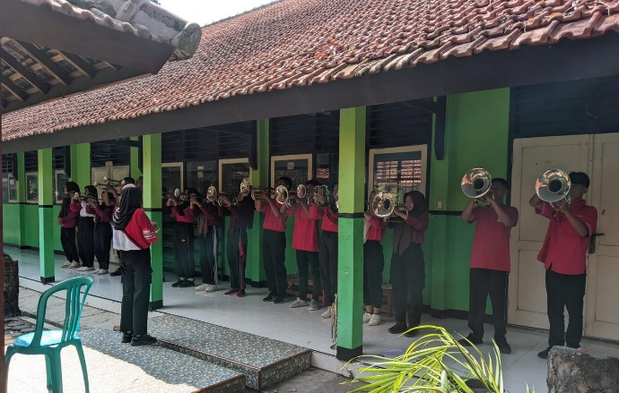
Figure 1. Brass Instrument Selection Activity
The results of the instrument selection process determine the learning topics that students will study further during the drum band extracurricular program. These results serve as the basis for organizing students in the learning process. Topic selection and student organization are intended to ensure that drum band instruction is conducted in a more focused and structured manner, allowing students to coordinate effectively within their respective instrument groups. In addition, organizing students according to their instrument sections is expected to optimize the delivery of instructional materials.
Student organization in the drum band extracurricular program is conducted heterogeneously based on the results of the instrument selection process. In this context, heterogeneity refers to the grouping of students according to their interests and abilities related to the selected learning topic. This heterogeneous grouping aims to provide equal learning opportunities for students with varying levels of ability, enabling both high-achieving and less experienced students to study their chosen instrument section and participate equally in the learning process. This finding is consistent with Trianto (2007:57), who states that the implementation of the Group Investigation cooperative learning model is carried out through heterogeneous groupings based on friendship, common interests, or shared topics of study.
3.1.2. Learning Procedure Planning
The planning of learning procedures is conducted collaboratively between the instructor and students through discussion sessions. During these discussions, several aspects are addressed, including the theme and training materials, meeting schedules, and learning targets. This planning stage aims to ensure that students understand the materials to be learned and can determine the amount of practice required to achieve the expected outcomes within the established timeframe. Furthermore, learning procedure planning provides long-term orientation toward upcoming performance events and establishes target levels of material mastery for each training session.
The learning procedure planning implemented by Esteem Voice also includes discussions regarding the technical organization of group practice according to instrument sections, namely the percussion, brass, and color guard sections. The implementation of this group-based training method is supervised by instructors whose expertise corresponds to each instrument section. All aspects determined during the planning stage function as preventive measures to anticipate potential challenges that may arise during the learning process. Through clearly defined goals and schedules, potential obstacles can be identified earlier and addressed more effectively, thereby supporting the achievement of learning objectives.
3.1.3. Implementation of the Learning Process
The implementation of the Group Investigation cooperative learning method in the Esteem Voice Drum Band extracurricular program is conducted through group-based learning activities. Drum band members participating in the training are divided into their respective sections, namely the percussion, brass, and color guard sections. The assignment of members to each section is based on the results of the instrument selection and organizational process conducted previously. This sectional grouping is intended to facilitate the delivery of learning materials by the coaching team and to enable more effective monitoring of students' learning progress. Consequently, students who encounter learning difficulties can receive timely and appropriate guidance from the instructors.
Within each section, the learning focus and instructional content differ despite all groups learning the same musical repertoire. In the percussion section, the learning materials emphasize the understanding of rhythmic patterns in the musical score and the application of proper playing techniques on percussion instruments. According to Kirnadi (2011:20), percussion instruments not only function as rhythmic musical instruments but also serve as a communication medium within marching formations. Drum beats act as tactical signals that guide changes in formation and regulate tempo during parade performances.
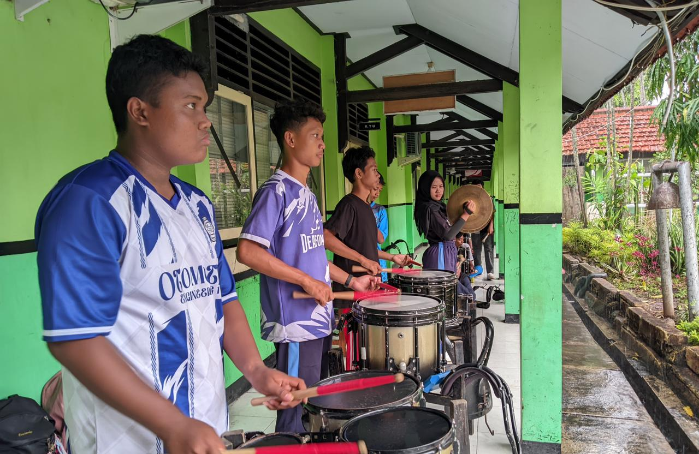
Figure 2. Percussion Section Training Activity
Due to the differences in roles and functions among instrument sections, the learning materials delivered to each section also differ. In the brass section, the instructional focus is on the melodic aspects of the musical repertoire. This is because brass instruments are responsible for performing the melody, which serves as the primary musical identity of a composition. Therefore, students in this section concentrate on pitch accuracy, tone production, musical expression, and the interpretation of melodic passages.
In the color guard section, the learning materials focus on choreography and the exploration of props based on predetermined movement patterns. Students are trained to synchronize body movements, prop manipulation, and musical accompaniment to create a cohesive visual performance. According to Kirnadi (2011: 24), the color guard section functions to add color and enhance the visual effects of a drum band performance. Consequently, the instructional activities in this section emphasize both technical movement skills and artistic expression to support the overall visual presentation.
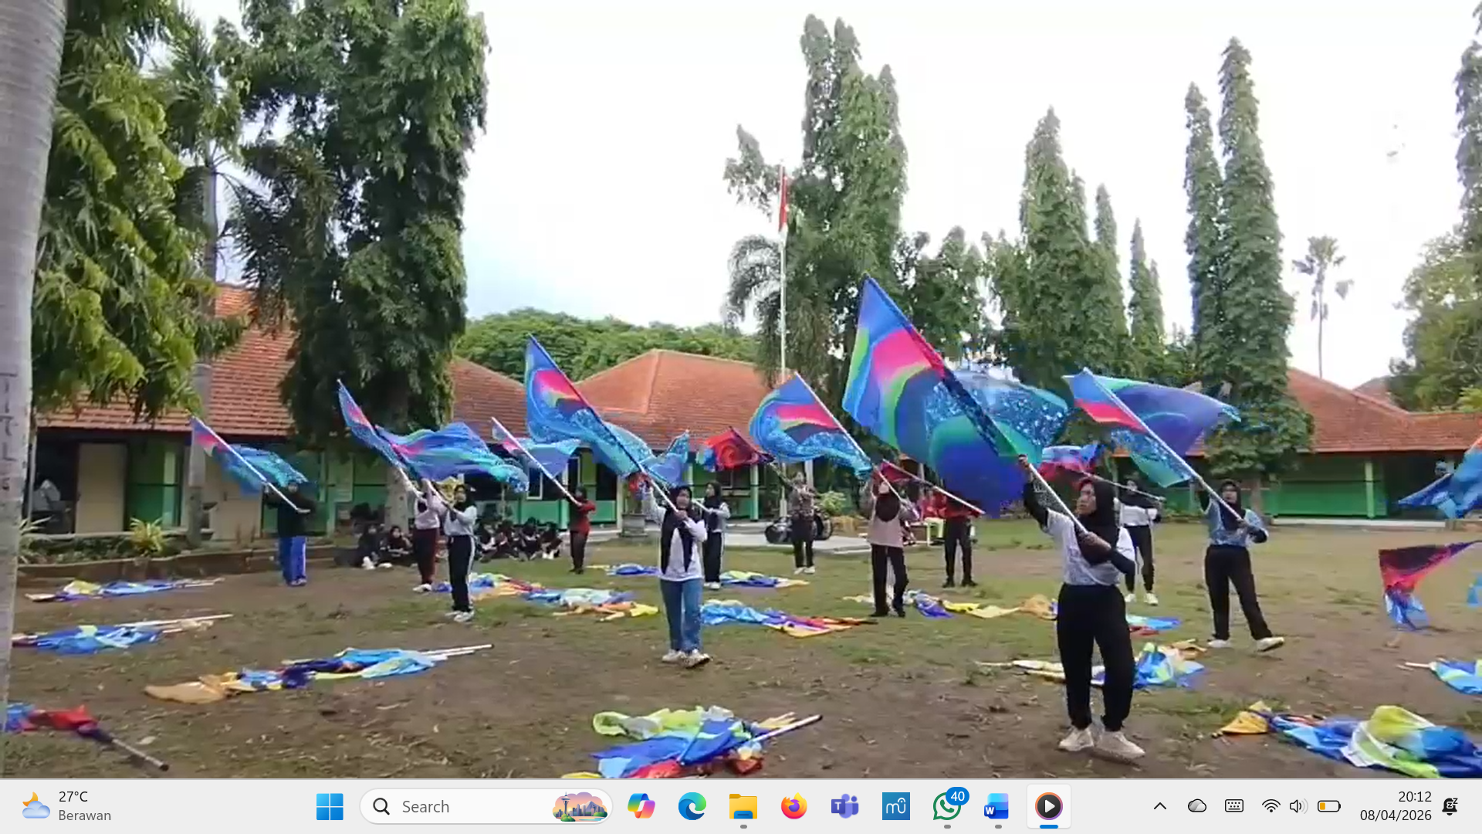
Figure 3. Colour Guard Section Training Activity
The implementation of section-based training in drum band learning enables students to focus more effectively on the specific materials and skills required within their respective sections. Through this approach, students can develop a deeper understanding of the learning content and practice the technical competencies relevant to their assigned roles. As a result, the learning process becomes more structured and efficient, increasing the likelihood of achieving the predetermined learning targets.
Furthermore, this section-based training approach contributes directly to the improvement of the final performance quality. By mastering the materials and responsibilities associated with their respective sections, students are better prepared to perform cohesively as a unified ensemble. This preparation ultimately supports the effectiveness of the final presentation and positively influences performance evaluations during competitions.
3.1.4. Analysis and Synthesis of Learning Materials
The analysis and synthesis stage in the Esteem Voice Drum Band extracurricular program demonstrates a strong tendency toward collaboration and discussion among members within the same section. These interactions commonly occur when students experience difficulties in understanding or performing the learning materials being studied. Such situations indicate that students engage in processes of analysis and synthesis to solve the problems they encounter during practice.
These collaborative interactions encourage the development of critical thinking skills as students analyze the materials they are required to master. The analytical process is also evident when students attempt to integrate their theoretical understanding of the material into practical musical performance. This integration requires a balance between cognitive abilities, which enable students to comprehend theoretical concepts, and psychomotor skills, which allow them to apply this knowledge effectively in musical practice.
The materials analyzed and synthesized by students primarily relate to the musical scores assigned to their respective instrument sections. These materials include rhythmic and melodic patterns, tempo, dynamics, and an understanding of the overall structure of the musical composition. In addition to mastering these musical elements, students are also required to understand the marching formations and visual arrangements performed during the drum band presentation. Such understanding is essential because musical performance and visual formation must be coordinated to create a cohesive and effective presentation. Figure 4 presents an excerpt from the musical score of OST Troy, Movement 1. The score illustrates the notation performed by several instruments in measures 109–115 and serves as one of the learning materials analyzed and synthesized by students during the training process.
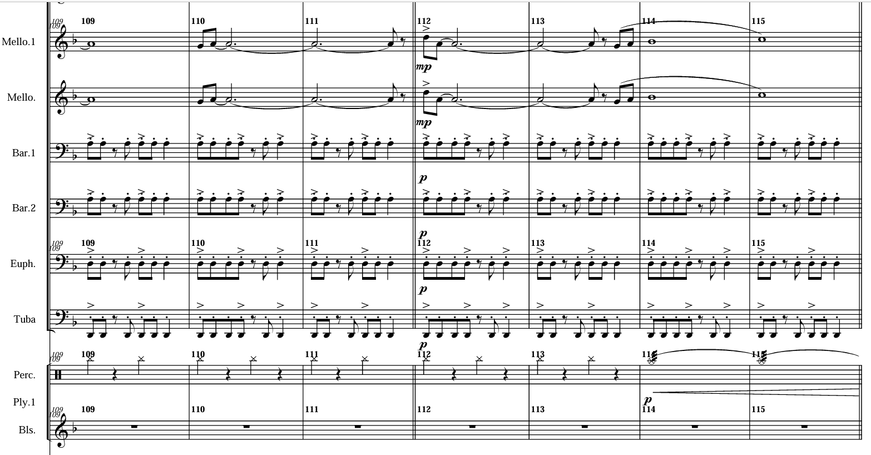
Figure 4. Score of OST Troy, Movement 1
3.1.5. Final Presentation
In the Esteem Voice Drum Band extracurricular program, the final presentation refers to participation in drum band competitions. During these events, all drum band sections perform collectively in a complete field show presentation. The performance is evaluated by judges and observed by spectators, making it the culminating stage of the learning process.
The evaluation criteria encompass various aspects, ranging from the overall cohesiveness and harmony demonstrated by the ensemble to the individual ability of members to apply technical skills and perform the assigned materials accurately. Therefore, the competition performance serves as a tangible representation of the outcomes achieved through the group investigation process conducted throughout the training period.
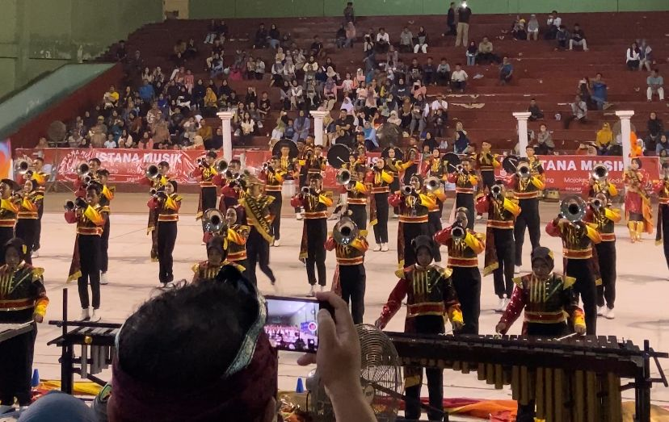
Figure 5. Drum Band Championship Competition of Nganjuk Regency 2025
Figure 5 illustrates the participation of the Esteem Voice Drum Band in the 2025 Nganjuk Regency Drum Band Championship, held at Gedung Juang 45, Nganjuk Regency. All members involved in the performance contributed to the creation of musical and visual harmony throughout the presentation. To achieve a high-quality performance, each participant was required to understand and fulfill their responsibilities regarding the materials and routines that had been prepared during the training process. The successful integration of these individual contributions resulted in a cohesive and synchronized drum band presentation.
3.1.6. Evaluation
The evaluation stage is conducted after the completion of the entire competition series and the announcement of the competition results. During this stage, all members gather with the advisor and instructors to participate in a group discussion. The discussion focuses on identifying the strengths and weaknesses demonstrated by the team during the performance.
Several aspects are commonly evaluated, including the accuracy of playing techniques and musical materials, ensemble cohesiveness, musical and visual harmony, and the overall quality of the team's performance. Through this evaluation process, participants are encouraged to reflect on their performance and identify areas that require improvement.
The evaluation stage serves to assess the extent to which the learning objectives have been achieved and provides valuable feedback for future development. Furthermore, the results of the evaluation function as a basis for reflection and continuous improvement, enabling the team to prepare more effectively for subsequent performances and competitions.

4. CONCLUSION

Based on the findings of this study, the implementation of the Group Investigation cooperative learning method in the Esteem Voice Drum Band extracurricular program at SMKN 1 Nganjuk is consistent with the instructional stages proposed by Sharan et al. (1992). The implementation consists of six stages: (1) topic selection and student organization, (2) learning procedure planning, (3) implementation of the learning process, (4) analysis and synthesis of learning materials, (5) final presentation, and (6) evaluation

The application of this method enables students to learn musical materials in a more focused manner because training activities are conducted collaboratively within their respective instrument sections. This approach also facilitates the delivery of learning materials by instructors and allows them to identify and address students' learning difficulties more effectively. Furthermore, the implementation of the Group Investigation method enables instructors to monitor students' learning progress more closely and systematically throughout the training process.

Based on the conclusions above, several recommendations can be proposed to support the development of drum band extracurricular learning activities at SMKN 1 Nganjuk: (1) For students and instructors, greater attention should be given to time discipline during training activities. Improving punctuality and attendance reflects a sense of responsibility that should be continuously cultivated, as these aspects significantly influence the achievement of learning objectives and overall team performance. (2) For future researchers, studies on the implementation of the Group Investigation cooperative learning method should be expanded to other forms of collective arts education. Such investigations would enrich the body of knowledge regarding the application of cooperative learning methods within Arts and Culture Education and provide broader insights into their effectiveness across different artistic contexts.

AUTHOR'S CONTRIBUTION

The first author contributed to data collection, data presentation, and the interpretation and conclusion of the research findings. The second author served as the supervisor and provided guidance throughout the preparation and writing of this article.

REFERENCE
Kirnadi (2011). Dunia Marching Band. Jakarta: PT Citra Intirama.
Mas, I. E. S. (2019). Penerapan metode pembelajaran group investigation untuk meningkatkan Keterampilan mengaransemen lagu pada siswa kelas XI IPA 1 SMA Negeri 1 Bulutaba (Doctoral dissertation, Universitas Negeri Makassar).
Nababan, D., Sihaloho, L., & Tambunan, L. S. (2023). Penerapan Strategi Pembelajaran Kooperatif dan Pengimplementasiannya dalam PAK. Jurnal Pendidikan Sosial dan Humaniora, 2(2), 542-556.
Rohanida, S., & Sella, F. Strategi Pelatihan Bandung Drum Corps dalam Persiapan Lomba Indonesian Drum Corps Championship. SWARA, 3(2), 29-34.
Sanusi, U. A. A., & Wijayanto, W. (2025). Progam Ekstrakulikuler Drumband dalam Menunjang Kemampuan Seni Musik Siswa Sekolah Dasar. Imajinasi: Jurnal Ilmu Pengetahuan, Seni, dan Teknologi, 2(4), 12-18.
Sharan, S., Kussel, P., Hertz-Lazarowitz, R., Bejarano, Y., Raviv, S., and Sharan, Y. (1984) Cooperative Learning in the Classroom: Research in desegregated schools. Hillsdale, Nj: Erlbaum.
Slavin, (2005). Cooperative Learning Teori, Riset dan Praktik. Bandung: Penerbit Nusa Media.
Trianto, (2007). Metode-metode Pembelajaran Inovatif Berorientasi Kontruktivivtik. Jakarta: Prestasi Pustaka Publisher.
Uno, H. B. (2023). Perencanaan pembelajaran. Bumi Aksara.

