Ginting, Journal of Sendratasik Education (2026)
https://doi.org/10.26740/vt.v1n1.p1xx-1xx






E-ISSN 2338-6770

Date of submission :-Date of revision :-Date received :-

Correspondence Address:
Pendidikan Sendratasik, Fakultas Bahasa dan Seni, Universitas Negeri Surabaya, Jl. Ketintang, Surabaya 60231. Email: egy.22077@mhs.unesa.ac.id

Development of Web-Based Learning Video Media for Lima Serangkai Dance of the Karo Ethnic Group to Improve Dance Knowledge and Skills of Youth Members of Batak Karo Protestant Church in Surabaya

Egy Sry Ulina Br Ginting 1, I Nengah Mariasa.2

1Universitas Negeri Surabaya, Surabaya, Indonesia 2 Universitas Negeri Surabaya, Surabaya, Indonesia
Email: egy.22077@mhs.unesa.ac.id , inengahmariasa@unesa.ac.id

Abstract: This study aimed to develop a web-based learning video media for the Lima Serangkai Dance of the Karo ethnic group and to determine the feasibility and effectiveness of the developed media in improving dance knowledge and skills among youth members of the Batak Karo Protestant Church (GBKP) in Surabaya. This research employed the Research and Development (R&D) method using the ADDIE model (Analysis, Design, Development, Implementation, and Evaluation). The research subjects were 15 youth members of GBKP Surabaya aged 20–28 years. Data were collected through observation, interviews, documentation, questionnaires, and tests, then analyzed using quantitative descriptive and N-Gain analysis. The results showed that the developed media received validation scores ranging from 83.33% to 95.76%, all categorized as Very Feasible. The effectiveness test showed that the average pretest score of 63.33 increased to 94.00 in the posttest, with an N-Gain score of 0.85 (high category). Students’ dance skills also improved from the Adequate to the Very Good category. Therefore, the developed web-based learning video media for Lima Serangkai Dance is feasible and effective in improving the knowledge and skills of GBKP Surabaya youth. Penelitian ini bertujuan mengembangkan media pembelajaran video berbasis web tari Lima Serangkai Suku Karo dan mengetahui kelayakan serta keefektifannya dalam meningkatkan pengetahuan dan keterampilan tari pemuda GBKP Surabaya. Metode R&D dengan model ADDIE digunakan dengan 15 subjek penelitian usia 20–28 tahun. Hasil validasi ahli menunjukkan skor 83,33%–95,76% (Sangat Layak). Nilai rata-rata pretest 63,33 meningkat menjadi 94,00 pada posttest dengan N-Gain 0,85 (kategori Tinggi). Keterampilan tari meningkat dari kategori Cukup menjadi Sangat Baik.
Keywords: learning media, web-based video, Lima Serangkai Dance, ADDIE model, learning outcomes

INTRODUCTION

Indonesia is a country with extraordinary cultural diversity, encompassing more than 300 ethnic groups with their respective customs, languages, and arts. This cultural wealth is not only a source of national pride but also a strategic asset in building national character (Sugiyono, 2019). One of the most significant expressions of this cultural richness is traditional dance, which serves as a living testimony of community values, history, and collective identity. Among the many traditional dance forms in Indonesia, the Lima Serangkai Dance of the Karo ethnic group stands out as a culturally meaningful and symbolically rich performing art.
Lima Serangkai Dance is a traditional dance originating from the Karo ethnic group of North Sumatra. The name ‘Lima Serangkai’ refers

© 2023 Author. This open access article is distributed under a Creative Commons Attribution (CC-BY-NC-SA)
4.0 license.

to five pairs of male and female dancers who perform together, symbolizing the meeting, courtship (ertutur), and bonding of young people toward marriage. This dance is accompanied by Gendang Lima Sendalanen, a traditional Karo percussion ensemble, and performed at various traditional ceremonies, cultural events, and community celebrations. The costumes worn by the dancers are elaborate Karo traditional attire, including uis gara fabric, headpieces (bulang-bulang for women, teger-teger for men), and various ornamental accessories that reflect the aesthetic sensibility of Karo culture.

Preliminary observations at GBKP Surabaya revealed that dance training was conducted only incidentally before events, without supporting media. Participants had difficulty retaining movement sequences and practicing independently, indicating a critical need for accessible learning media.
Video-based learning media is particularly effective for psychomotor domains such as dance, as it presents visual demonstrations, auditory cues, and narrative explanations simultaneously (Arsyad, 2017; Daryanto, 2016). Audiovisual media also enables repeated viewing, crucial for mastering complex movement sequences (Sadiman et al., 2014). Web-based platforms further enhance accessibility, allowing learners to study anytime and anywhere (Riyana, 2007).

Previous studies confirmed the effectiveness of video learning media for traditional dance: Eldi & Mariasa (2025) for Tiba Meka Dance, Istigfaria & Wahyudiarto (2022) for Suramadu Dance, and Widiastuti & Harpang (2018) for Cendrawasih Dance — all receiving Very Feasible ratings. However, no prior study developed web-based video media for Lima Serangkai Dance in a non-formal church community, indicating a clear research gap.
This study used the ADDIE model (Branch, 2009) to develop web-based video learning media for Lima Serangkai Dance and addresses three questions: (1) How is the development process? (2) How is the media feasibility based on expert validation? (3) How effective is the media in improving GBKP Surabaya youth’s dance knowledge and skills?

METHODS

This study employed the Research and Development (R&D) method, which aims to produce a specific product and evaluate its effectiveness (Borg & Gall, 1983; Sugiyono, 2019). The development model used was the ADDIE model proposed by Branch (2009), which consists of five stages: Analysis, Design, Development, Implementation, and Evaluation. This model was chosen for its systematic and iterative framework, which ensures that the developed product meets learner needs and quality standards through expert validation before full implementation.

Research Setting and Participants
The research was conducted at GBKP Surabaya, East Java, Indonesia, from March to May 2026. The research subjects were 15 youth members of Permata GBKP Surabaya aged 20–28 years, consisting of both male and female participants with diverse educational backgrounds (undergraduate students and working professionals). Participant selection was based on purposive sampling, targeting active members of the youth organization who had at least minimal prior exposure to Karo cultural activities. All participants provided informed consent for their involvement in the research.

Development Procedure (ADDIE Model)
The development followed five stages of the ADDIE model. Table 1 summarizes the activities and outputs of each stage.
Table 1. ADDIE Model Implementation Stages
Stage | Activities | Output
Analysis | Observations, interviews with GBKP Surabaya youth and dance trainer; identification of learning needs, participant characteristics, and technology access | Needs analysis report; learning objectives
Design | Designing video content structure (11 content items), selecting CapCut as editing tool, designing assessment instruments (knowledge test and skill rubric) | Video storyboard; content outline; assessment instruments
Development | Video production and editing using CapCut; uploading to Canva Sites; expert validation by 4 validators; product revision based on feedback | Web-based learning video media on Canva Sites; validated and revised
Implementation | One-session implementation with 15 GBKP Surabaya youth; pretest before media use; posttest and skill assessment after learning | Pretest-posttest data; skill assessment data
Evaluation | Analysis of validation scores, N-Gain, and skill assessment data; formative and summative evaluation | Feasibility and effectiveness conclusions

Video production used CapCut for editing and Canva Sites as the web-based hosting platform, selected for its cross-device accessibility without software installation requirements.

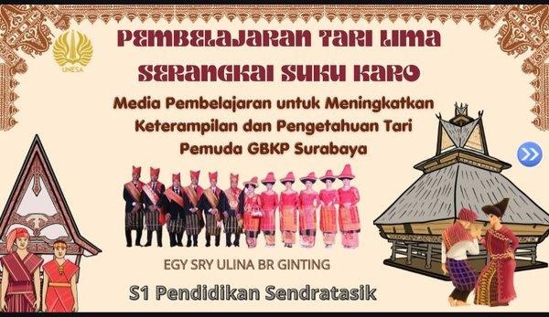
Figure 1. Display of Lima Serangkai Dance Learning Video on Canva Sites

Data Collection Instruments
Data collection employed multiple instruments to ensure comprehensive and valid data. Table 2 presents a summary of all research instruments used in this study.

Table 2. Research Instruments and Their Functions
No | Instrument | Indicator | Data Source
1 | Observation Sheet | Learning process, participant engagement, media usage | Researcher observation during implementation
2 | Interview Guide | Learning needs, prior knowledge, dance training history | GBKP youth and dance trainer
3 | Validation Questionnaire (Material) | Content accuracy, material depth, learning objectives alignment | Material expert
4 | Validation Questionnaire (Media) | Visual quality, audio, navigation, platform compatibility | Media expert
5 | Validation Questionnaire (Language) | Language clarity, grammar, vocabulary appropriateness | Language expert
6 | Validation Questionnaire (Dance Trainer) | Movement accuracy, sequencing, pacing, tradition alignment | Dance trainer
7 | Knowledge Test (Pretest-Posttest) | 10 multiple-choice questions on Lima Serangkai Dance knowledge | 15 GBKP Surabaya youth participants
8 | Skill Assessment Rubric | Wiraga, Wirama, Wirasa — scored 1-4 scale | Dance trainer assessment

The knowledge test consisted of 10 multiple-choice questions covering the history, definition, cultural meaning, costume, musical

Data Analysis
accompaniment, and movement vocabulary of Lima Serangkai Dance. The skill assessment rubric evaluated three core dimensions of dance competence: Wiraga (body movement accuracy and technical correctness), Wirama (synchronization between movement and musical tempo), and Wirasa (expressiveness, interpretation, and emotional engagement with the dance). Each dimension was scored on a 1–4 scale corresponding to categories: 1 = Less Adequate, 2 = Adequate, 3 = Good, 4 = Very Good.

Validation data from the four expert validators were analyzed using a Likert scale (1–4) converted to percentage scores using the formula: P = (∑score / ∑maximum score) × 100%. Feasibility categories were: ≥85% = Very Feasible, 70–84% = Feasible, 55–69% = Less Feasible,
<55% = Not Feasible (Riyana, 2007).
Knowledge improvement was analyzed using the normalized gain (N-Gain) formula proposed by Hake (1999): N-Gain = (posttest score − pretest score) / (maximum score − pretest score). N-Gain categories: >0.70 = High, 0.30–0.70 = Moderate, <0.30 = Low. Skill improvement was analyzed descriptively by comparing pre- and post-assessment category distributions across all three skill dimensions.

Instrument validity was ensured through pilot testing with five youth from a different GBKP community prior to main implementation. The final 10-item test demonstrated satisfactory internal consistency (Cronbach’s alpha = 0.78), confirming its reliability for assessing knowledge of Lima Serangkai Dance.
All participants provided written informed consent prior to data collection. Confidentiality was maintained using participant codes. The research was conducted in accordance with Universitas Negeri Surabaya ethical standards.

RESULTS AND DISCUSSION

Development Process Using the ADDIE Model
The development of web-based learning video media for Lima Serangkai Dance followed five systematic stages of the ADDIE model. Each stage produced specific outputs that informed subsequent stages, ensuring a coherent and needs-responsive development process.
Analysis Stage: Preliminary field observations at GBKP Surabaya revealed that dance training was conducted without any structured supporting media and occurred only incidentally before specific events. Interviews with the dance trainer and youth members confirmed that participants struggled to retain movement sequences between training sessions, lacked knowledge of the cultural context of Lima Serangkai Dance, and had no means of independent practice. A technology readiness assessment showed that all 15 participants were smartphone users with regular internet access, indicating that a web-based media approach was both technically feasible and contextually appropriate.
Design Stage: The researcher designed an 11-item video content structure progressing from theory (definition, history, costume, music) to practice (movement vocabulary, technique, complete performance). Assessment instruments including the 10-item knowledge test and skill rubric were also designed at this stage.

Development Stage: Video was produced over four weeks using CapCut with background music, text overlays, and slow-motion demonstrations, then uploaded to Canva Sites with integrated evaluation QR Code. Expert validation was subsequently conducted leading to several revisions.
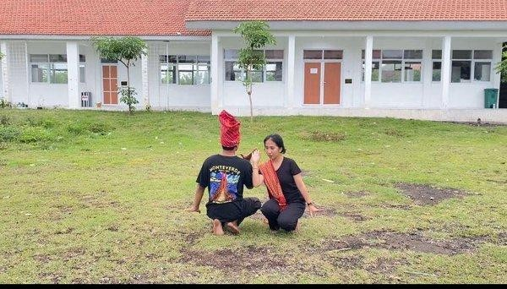
Figure 2. Video Recording Process of Lima Serangkai Dance Movement Demonstration

Implementation Stage: On April 20, 2026, participants completed the pretest, accessed the Canva Sites media independently via WhatsApp link for 60 minutes, then completed the posttest and skill assessment.
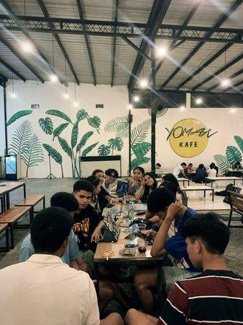
Figure 3. Implementation Session — Participants Using Web-Based Learning Media

Evaluation Stage: Quantitative analysis confirmed both feasibility (all validation scores Very Feasible) and effectiveness (N-Gain High category).

Media Feasibility Results
Expert validation was conducted by four validators with relevant
domain expertise: (1) a material expert with specialization in Karo traditional dance, (2) a media expert with specialization in educational technology and video production, (3) a language expert

with specialization in Indonesian language education, and (4) the GBKP Surabaya dance trainer who regularly teaches Lima Serangkai Dance. Table 3 presents the complete validation results.

Table 3. Expert Validation Results
No | Validator | Aspect Assessed | Score (%) | Category
1 | Material Expert (Ahli Materi) | Content accuracy, material completeness, movement vocabulary, dance history and meaning, learning objectives alignment | 87.50% | Very Feasible
2 | Media Expert (Ahli Media) | Visual quality, audio clarity, video editing transitions, platform compatibility, navigation ease, and screen display | 95.76% | Very Feasible
3 | Language Expert (Ahli Bahasa) | Language clarity, appropriateness, grammatical accuracy, and suitability for target learners | 83.33% | Very Feasible
4 | Dance Trainer (Guru Pelatih) | Movement presentation accuracy, sequencing, pacing, and alignment with Karo dance tradition | 91.67% | Very Feasible
 | Average |  | 89.57% | Very Feasible

The material expert (87.50%) confirmed accurate and comprehensive content coverage. Feedback to add philosophical meaning of each movement was incorporated in the revision.
The media expert (95.76%) praised visual quality, audio clarity, smooth transitions, and cross-device compatibility. Minor subtitle timing corrections were made.
The language expert (83.33%) noted that technical terms needed clearer explanations, which were simplified in the final revision. The dance trainer (91.67%) confirmed technically accurate demonstrations in appropriate pedagogical order. A side-view angle
for complex movements was added to the final version.

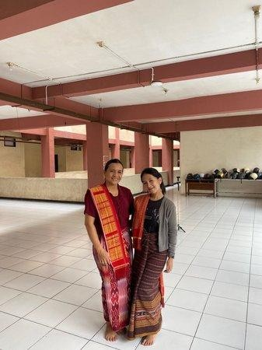
Figure 4. Expert Validation Process by Material Expert

Media Effectiveness Results
Effectiveness was assessed through two measures: knowledge outcomes (pretest-posttest with N-Gain analysis) and dance skill outcomes (pre- and post-assessment using the Wiraga-Wirama-Wirasa rubric).
Knowledge Outcomes: Table 4 presents individual pretest, posttest, and N-Gain scores for all 15 participants.

Table 4. Individual Pretest, Posttest, and N-Gain Scores
No | Participant | Pretest | Posttest | N-  Gain | Category
1 | Solista Sembiring | 40 | 100 | 1.00 | High
2 | Stefania Desika Br Nasution | 70 | 90 | 0.67 | Moderate
3 | Odilia Eufrasia Br Purba | 80 | 100 | 1.00 | High
4 | Nina Br Ginting | 50 | 100 | 1.00 | High
5 | Ano Hasibuan | 50 | 100 | 1.00 | High
6 | Friska Febina Br Sembiring | 60 | 90 | 0.75 | High
7 | Siska Refa Br Surbakti | 60 | 80 | 0.50 | Moderate
8 | Rehan Sinuhaji | 70 | 90 | 0.67 | Moderate
9 | Rifki Karo-Karo | 60 | 90 | 0.75 | High
10 | Eni Br Purba | 80 | 100 | 1.00 | High
11 | Nike Br Sembiring | 50 | 80 | 0.60 | Moderate
12 | Alan Sembiring | 70 | 100 | 1.00 | High
13 | Debi Ginting | 50 | 90 | 0.80 | High
14 | Desti Anjelina Br Ginting | 80 | 100 | 1.00 | High
15 | Ricky Jaka Putra Tarigan | 80 | 100 | 1.00 | High

 | Average | 63.33 | 94.00 | 0.85 | High

As shown in Table 5, all 15 participants showed improvement from pretest to posttest. The average pretest score of 63.33 increased to 94.00 in the posttest, yielding an average N-Gain of 0.85, which falls in the High category (>0.70). Of the 15 participants, 11 (73.3%) achieved High N-Gain scores, and 4 participants (26.7%) achieved Moderate N-Gain scores (Stefania: 0.67, Siska: 0.50, Rehan: 0.67, Nike: 0.60). No participant achieved a Low N-Gain score. The participants with Moderate N-Gain scores generally had higher pretest scores, indicating a ceiling effect consistent with research on normalized gain measurement (Hake, 1999).
Dance Skill Outcomes: Table 5 presents the pre- and post-assessment results for dance skills across the three assessed dimensions.

Table 5. Dance Skill Assessment Results (Pre- and Post-Assessment)
No | Skill Aspect | Pre-Assessment Category | Post-Assessment Category | Improvement
1 | Wiraga (Movement Accuracy) | Adequate (C) | Very Good (A) | Significant
2 | Wirama (Music Synchronization) | Adequate (C) | Very Good (A) | Significant
3 | Wirasa (Expressiveness) | Less Adequate (D) | Good (B) | Significant
4 | Overall Dance Performance | Adequate (C) | Very Good (A) | Significant

As shown in Table 6, significant improvement was observed across all three skill dimensions. In Wiraga (movement accuracy), participants progressed from Adequate to Very Good, demonstrating improved body posture, arm positioning, and footwork precision. In Wirama (music synchronization), the majority improved from Adequate to Very Good, showing better understanding of the Gendang Lima Sendalanen rhythm and its relationship to movement timing. In Wirasa (expressiveness), participants improved from Less Adequate to Good, reflecting increased confidence and cultural engagement with the dance’s emotional narrative.
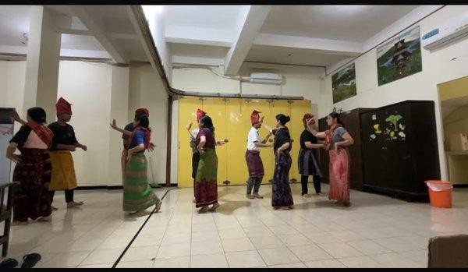
Figure 5. Post-Assessment Dance Performance by GBKP Surabaya Youth Participants

Discussion

The high feasibility ratings (83.33%–95.76%) confirm rigorous quality standards across content, technical, language, and pedagogical dimensions, consistent with Eldi & Mariasa (2025), Istigfaria & Wahyudiarto (2022), and Widiastuti & Harpang (2018).
The N-Gain of 0.85 (High) confirms significant knowledge improvement, supporting Arsyad’s (2017) assertion that well-designed media improves cognitive outcomes through multiple sensory channels. The structured content progression aligns with Bloom’s (1956) taxonomy, ensuring both conceptual and procedural competence.
The moderate N-Gain scores observed for four participants (Stefania, Siska, Rehan, and Nike) warrant additional discussion. These participants all had higher pretest scores (60–80) compared to those who achieved High N-Gain, suggesting that the ceiling effect inherent in normalized gain calculations rather than limited media effectiveness accounts for their Moderate category placement. All four participants still achieved posttest scores of 80–90, which are objectively high absolute scores indicating significant knowledge mastery. This observation is consistent with Hake’s (1999) analysis of N-Gain as a measure of individual learning gain relative to each participant’s own pre-existing knowledge level.
The skill assessment results demonstrate that the media was effective not only in the cognitive domain but also in the psychomotor domain (Wiraga and Wirama) and the affective dimension of dance performance (Wirasa). The improvement in Wirasa from Less Adequate to Good is particularly noteworthy, as expressiveness is generally considered the most challenging dimension to develop through mediated learning (Simpson, 1972). This result suggests that the complete dance performance video in the media, which provided participants with a holistic aesthetic model to emulate, was effective in cultivating expressive quality alongside technical accuracy.
Canva Sites offers universal device accessibility without installation, real-time content updates, and QR Code-based remote evaluation — significant advantages over DVDs or Android apps used in previous studies (Istigfaria & Wahyudiarto, 2022; Widiastuti & Harpang, 2018).
This study demonstrates that digital learning media can effectively transmit Karo cultural knowledge to diaspora youth, bridging the cultural gap for communities like GBKP Surabaya that lack regular access to traditional learning environments (Tarigan, 2020; Mulyani, 2021).
Consistent with Wulandari and Purnomo (2021)’s systematic review, this study confirms three key patterns: audiovisual demonstration outperforms text-based instruction for psychomotor skill acquisition; learner engagement increases when cultural context is integrated alongside technical instruction; and web-based platforms outperform offline formats in accessibility and self-directed learning support.
The non-formal community context presents both challenges and opportunities for media-based learning. The self-paced nature of Canva Sites is particularly suited to this context, allowing participants to engage at flexible times. Significant learning gains despite the

CONCLUSION
single-session implementation suggest that brief, well-designed media-supported interventions can produce meaningful outcomes in non-formal settings (Mulyani, 2021; Prasetyo & Hartono, 2022).
This study has several limitations. The single-group design without a control group limits causal attribution of learning gains. The single-session implementation does not assess long-term retention. The sample size of 15 participants, while appropriate for R&D research, limits generalizability. Future research addressing these limitations would strengthen the evidence base for web-based video learning media in traditional dance education.

This study successfully developed web-based learning video media for Lima Serangkai Dance using the ADDIE model, covering cultural history, theoretical knowledge, and practical movement demonstrations hosted on Canva Sites.
Expert validation yielded scores of 83.33%–95.76% (average 89.57%, Very Feasible). Knowledge improvement showed N-Gain of
0.85 (High), with scores increasing from 63.33 to 94.00. Dance skills improved from Adequate to Very Good across Wiraga, Wirama, and Wirasa dimensions.
These findings confirm that the developed media is both feasible and effective, and contributes to Karo cultural preservation in the diaspora through a sustainable, accessible model for non-formal traditional arts education.
Future research is recommended to examine long-term retention effects, expand the media to include additional Karo dances, conduct comparative studies with face-to-face instruction, and adapt this model for other Karo diaspora communities across Indonesian cities.

ACKNOWLEDGMENT

The author expresses sincere gratitude to Dr. I Nengah Mariasa, M.Hum. as thesis supervisor; all expert validators; youth members of Permata GBKP Surabaya; the dance trainer; and Universitas Negeri Surabaya, Pendidikan Sendratasik, for institutional support.

REFERENCES

Arsyad, A. (2017). Media pembelajaran. Rajawali Pers.
Bloom, B. S. (1956). Taxonomy of educational objectives: The classification of educational goals. David McKay.
Borg, W. R., & Gall, M. D. (1983). Educational research: An introduction (4th ed.). Longman.
Branch, R. M. (2009). Instructional design: The ADDIE approach.
Springer.
Cahyo, A. A. R., & Sulistyo, E. T. (2025). Pengembangan media video pembelajaran kesenian Ludruk untuk mahasiswa BIPA. Jurnal Pendidikan Bahasa dan Sastra, 25(1), 33–47. https://doi.org/10.17509/bs_jpbsp.v25i1.33
Daryanto. (2016). Media pembelajaran: Peranannya sangat penting dalam mencapai tujuan pembelajaran. Gava Media.

Eldi, R. P., & Mariasa, I. N. (2025). Development of Tiba Meka Dance learning video media using ADDIE model for junior high school students. Jurnal Pendidikan Sendratasik, 14(1), 45–58. https://doi.org/10.26740/jps.v14n1.p45-58
Gerlach, V. S., & Ely, D. P. (1971). Teaching and media: A systematic approach. Prentice-Hall.
Hake, R. R. (1999). Analyzing change/gain scores. American Educational Research Association.
Istigfaria, K. W., & Wahyudiarto, D. (2022). Pengembangan video pembelajaran tari kreasi Suramadu untuk meningkatkan keterampilan peserta didik SMP. Jurnal Pendidikan Sendratasik, 11(2), 112–124. https://doi.org/10.26740/jps.v11n2.p112-124
Mulyani, S. (2021). Traditional dance education in diaspora communities: Challenges and strategies for cultural preservation. Journal of Arts Education, 15(2), 88–102. https://doi.org/10.21831/jae.v15i2.88
Prasetyo, A., & Hartono, R. (2022). Effectiveness of web-based media in non-formal arts education: A systematic review. Jurnal Ilmu Pendidikan, 29(1), 55–68. https://doi.org/10.17977/um048v29i1p55
Richey, R. C., & Klein, J. D. (2007). Design and development research: Methods, strategies, and issues. Lawrence Erlbaum Associates.
Riyana, C. (2007). Pedoman pengembangan media video. P3AI UPI.
Sadiman, A. S., Rahardjo, R., Haryono, A., & Rahardjito. (2014). Media pendidikan: Pengertian, pengembangan, dan pemanfaatannya. Rajawali Pers.
Simpson, E. J. (1972). The classification of educational objectives in the psychomotor domain. Gryphon House.
Sudjana, N. (2016). Penilaian hasil proses belajar mengajar. Remaja Rosdakarya.
Sugiyono. (2019). Metode penelitian pendidikan: Pendekatan kuantitatif, kualitatif, dan R&D. Alfabeta.
Tarigan, B. (2020). Karo traditional dance in diaspora: Identity, transmission, and preservation strategies. Jurnal Kajian Seni, 7(1), 12–26. https://doi.org/10.22146/jks.v7i1.12
Utami, R. D., & Setiawan, B. (2023). The ADDIE model in developing digital learning media for performing arts: A meta-analysis. Jurnal Teknologi Pendidikan, 25(2), 101–115. https://doi.org/10.21009/jtp.v25i2.101
Widiastuti, N. M. D., & Harpang, Y. (2018). Pengembangan video pembelajaran tari Cendrawasih berbasis android untuk penari remaja putri. Jurnal Pendidikan Seni dan Musik, 6(2), 78–89. https://doi.org/10.26740/jpsm.v6n2.p78-89
Wulandari, F., & Purnomo, A. (2021). Video-based learning media for traditional Indonesian dance: Impact on student motivation and skill acquisition. Jurnal Pendidikan dan Kebudayaan, 6(2), 145–
159. https://doi.org/10.24832/jpnk.v6i2.145

