

Jamuran Dance Instruction as a Means of Stimulating Gross Motor Skills in the “Cinta ABK” Community at the Sukomulyo Community Health Center in Gresik Regency

E-ISSN 2338-6770

Tanggal pengajuan : -
Tanggal revisi : -
Tanggal diterima : -

Alamat Korespondensi:
Gedung T11 lt 2 Prodi Pendidikan Sendratasik, Fakultas Bahasa dan Seni, Universitas Negeri Surabaya, Jl. Raya Kampus Unesa, Lidah Wetan, Kec. Lakarsantri, Surabaya, Jawa Timur 60213
Rachel Tahta Maulida¹, Welly Suryandoko²

1Universitas Negeri Surabaya, Surabaya, Indonesia
2Universitas Unesa, Surabaya, Indonesia
Surel: racheltahta.21043@mhs.unesa.ac.id . wellysuryandoko@unesa.c.id

Abstract : Children with Special Needs (ABK) require comprehensive treatment that is not only limited to medical aspects but also encompasses psychosocial and motor dimensions. At the Sukomulyo Community Health Center, Gresik Regency, there is a forum called the "ABK Love Community" which accommodates parents and special children. The partner's problem is the lack of variety in therapeutic activities that are recreational and preserve local culture, where activities are often focused on monotonous medical therapy. This community service offers a solution through learning the "Jamuran" traditional dance. The Jamuran Dance was chosen because it contains elements of gross motor movements (walking in circles, holding hands, squatting, standing) and intense social interaction. The implementation method of this community service includes: (1) Preparation and location survey, (2) Socialization to parents/community, (3) Training and mentoring of dance movements (fieldwork), and (4) Evaluation and simple performances. The learning process is carried out with a joyful learning approach and repetition considering the diverse characteristics of ABK (Autism, Down Syndrome, Intellectual Disability). The results of this community service show an increase in children's enthusiasm for movement, gross motor skills that are more stimulated through the dynamic movements of the Jamuran dance, as well as increased emotional bonds between children, parents, and peers. The Jamuran dance has proven effective as a fun, local culture-based alternative therapy medium for the ABK Love Community at the Sukomulyo Community Health Center.
Keywords: ABK, Jamuran Dance, Gross Motor Skills, Sukomulyo Community Health Center, Gresik.

1. INTRODUCTION
Education and health services are fundamental rights for every citizen, including children with special needs (ABK). Law No. 8 of 2016 on Persons with Disabilities affirms that persons with disabilities have the right to receive quality health and educational services. However, in practice, services for children with special needs often focus solely on clinical or academic aspects, neglecting recreational and artistic elements that actually play a crucial role in children’s emotional and motor development.
The Sukomulyo Community Health Center (Puskesmas) in Gresik Regency places special emphasis on disability care. This is reflected in the existence of the “Komunitas Cinta ABK” (Community of Love for Children with Special Needs), a support group initiated by health workers at the community health center and parents of children with special needs. This community serves as a platform for sharing information, group therapy, and mental support for parents. The characteristics of the children with special needs in this community are highly diverse, ranging from Down syndrome, autism, and cerebral palsy to intellectual disabilities. This diversity requires flexible yet focused intervention methods.
Initial observations and interviews with community facilitators at the Sukomulyo Community Health Center revealed that routine activities tended to be static (sitting, listening to educational sessions, or table-based occupational therapy). The children often felt bored by the rigid therapy routines. In fact, children need enjoyable physical activities to channel their energy and stimulate their gross motor development. Gross motor skills are the body’s ability to move using large muscles, involving most or all of the body’s limbs, and are influenced by a child’s physical maturity (Sunardi & Sunaryo, 2007).
The art of dance, particularly traditional dance based on games (dolanan), holds great potential as a therapeutic medium. One traditional Javanese game rich in dance movements is “Jamuran.” The Jamuran dance is not merely a performance dance but a communal social dance. According to Dharmamulya (2008), traditional games contain noble values and movement elements that can develop agility. In Jamuran, there are movements such as walking in a circle, holding hands, squatting, standing, and following song instructions. These movements indirectly serve as physical therapy exercises packaged in the form of art.
Dance instruction for children with special needs is certainly different from that for typical children. Modified methods and a personalized approach are required. While in mainstream schools the focus is on the aesthetics of movement, at the Cinta ABK Community the primary goals are the willingness to move, responsiveness to rhythm, and social interaction. The challenge faced by our partner is a shortage of teachers or instructors capable of transforming these traditional games into systematic dance instruction materials for children with special needs.
Therefore, the community service team stepped in to provide a solution through the “Jamuran Dance Learning” program. This program aims to: (1) Reintroduce local culture to the younger generation with special needs, (2) Use the Jamuran dance as a fun medium for gross motor stimulation, and (3) Boost the self-confidence of children with special needs through artistic activities in the public space of the Community Health Center. Through an audio-kinesthetic approach (listening to music and moving), it is hoped that children with special needs at the Sukomulyo Community Health Center can experience the benefits of holistic art therapy.

2. METHOD
The method used in this study was descriptive qualitative research within the framework of a community service program. The activities were conducted in the Sukomulyo Community Health Center auditorium, Gresik Regency, and lasted for 4 months. The partner in this activity was the Cinta ABK Community, which operates under the guidance of the Community Health Center. The implementation method was systematically designed using a modified Participatory Action Research (PAR) approach tailored to the needs of art-based support, divided into four stages.
The first stage involved preparation and a survey, during which the service team coordinated with the Head of the Sukomulyo Community Health Center and the Coordinator of the Cinta ABK Community. Activities included observing the physical and psychological conditions of the participants (children with special needs), analyzing space requirements for dancing, scheduling practice sessions to avoid conflicts with medical therapy schedules, and mapping the types of disabilities to adapt dance movements accordingly. The second stage involved outreach to the students’ parents and guardians. This was crucial because the success of children with special needs’ learning depends heavily on parental involvement. The team explained the benefits of Jamuran dance for the children’s motor and social skills, motivating parents to support their children throughout the practice process. The third stage was the implementation phase (dance training), which was the core of the program. The teaching methods used were drill (repeated practice) and imitation. This process was divided into several sessions: rhythm introduction, analysis of basic movements, floor pattern formation, and intensive coaching. The fourth stage was evaluation and appreciation, which involved observing changes in behavior and motor skills. The activity concluded with a “Small Performance” in the courtyard of the Sukomulyo Community Health Center to instill a sense of pride and self-confidence in the children.

3. HASIL DAN PEMBAHASAN

This community service program was carried out according to the agreed-upon schedule. The following is a detailed description of each stage and the results achieved in teaching the Jamuran dance to the Cinta ABK Community at the Sukomulyo Community Health Center.

3.1 Preparation and Participant Profiling
The initial steps began with an in-depth discussion with the midwife who coordinates services for children with special needs at the Sukomulyo Community Health Center. Based on the data collected, there are approximately 15–20 children actively participating in the community. The volunteer team conducted a simple assessment to categorize the children’s abilities. It was found that most children (especially those with Down syndrome and mild intellectual disabilities) responded well to music but had short attention spans, averaging between 5 and 10 minutes per concentration session. Meanwhile, children with cerebral palsy have limited leg movement but can still move their hands and upper bodies. Based on this data, the volunteer team adapted the “Tari Jamuran” dance. Movements that were originally performed while standing were modified so that children in wheelchairs could still participate in the circle with the assistance of a caregiver.
This initial assessment is important because each type of disability has different motor and sensory characteristics. Children with Down syndrome, for example, generally have low muscle tone (hypotonia), so their movements tend to be slow and they require greater physical support. Children with autism often exhibit sensitivity to touch and sound, so the approach used must take these sensory aspects into account. Children with cerebral palsy have limitations in motor control that require significant modifications to their movements. An understanding of the diversity of these conditions forms the basis for developing adaptive learning strategies.
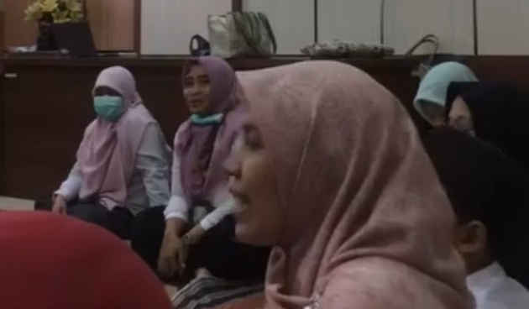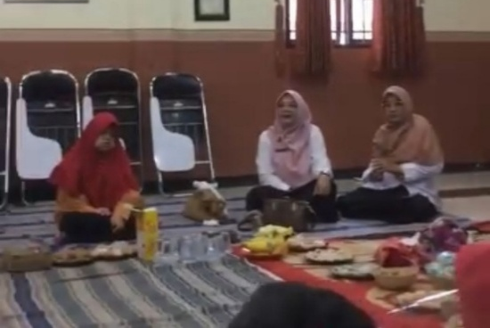
Figure 1: Photo of a Discussion/FGD Between the Community Service Team and the Head of the Community Health Center

3.2 Educational Outreach
The outreach session was held in the community health center’s meeting room. Parent enthusiasm was very high, as evidenced by a 100 percent attendance rate among all invited parents. Many parents who were initially skeptical about whether their children could dance became optimistic after being told that the goal was not a “perfect dance,” but rather “joyful movements.” The team emphasized that the Jamuran Dance embodies a philosophy of togetherness. The lyrics “Jamuran, jamuran, ya ge ge thok...” encourage children to gather and move together, not to perform perfectly on stage. The session also established that parents must join the dance circle if their child feels scared or anxious, creating a strong bond between parent and child.
During this outreach session, the theoretical framework underlying the selection of the Jamuran Dance as a therapeutic medium was also explained. Parents were informed that the movements in traditional dance, as described by Dharmamulya (2008), embody noble values and include elements that can develop agility and social skills. This explanation is crucial for fostering parents’ long-term commitment to the program, as the success of interventions for children with special needs heavily depends on parental support outside of formal practice sessions.

3.3 The Jamuran Dance Learning Process
The learning process takes place every Saturday morning over a two-month intensive period, for a total of eight sessions. There are four key points to consider when beginning the learning process, as follows.

a. Conditioning
Before moving on to the dance lesson, the children are guided through a light warmup (stretching) while listening to cheerful Javanese gamelan music. The goal is to loosen stiff muscles and mentally prepare the children. This warm-up session lasts 10–15 minutes and is an integral part of every session. Based on the team’s observations, children who previously seemed restless or tended to keep to themselves began to engage as the gamelan music played. This indicates that auditory stimulation plays a crucial role in preparing children for physical activity.

b. Basic Movement Activities
The lesson began with the simplest movement: holding hands to form a circle. For children with autism who are sensitive to touch (tactile sensitivity), this presented a unique challenge. The volunteer team used scarves as a medium to help the children stay connected without direct skin-to-skin contact at first. This strategy proved effective; by the third session, most of the children were willing to hold hands directly without the scarves. The core movements of the Jamuran Dance taught include:
1) Mubeng (Spinning)
The children walk to the right (counterclockwise) while holding hands. This movement helps develop foot coordination and balance. In the early stages, many children lose their way or walk out of sync with the group. Student and parent assistants play an active role in guiding the children by providing light physical guidance on their shoulders or backs. By the sixth session, most children are able to perform the turning movement with a more coordinated rhythm.
2) Squatting-Standing
Following the cues in the song, the children are encouraged to squat when the song reaches a certain part and stand back up at the next cue. This movement is excellent for strengthening the leg muscles. Children with Down syndrome who have low muscle tone seem to have more difficulty performing this movement; they tend to need assistance to stabilize their bodies during the transition from squatting to standing. Caregivers provide support by holding the child’s arms or waist. Meanwhile, children with cerebral palsy who use wheelchairs perform a modified version of this movement, which involves leaning forward and then straightening up again.
3) Pancer Instruction
One child (or instructor) becomes the “leader” in the center of the circle. The other children respond to the leader’s guesses or commands. For example, if the leader says “umbrella mushroom,” the children form their hands like an umbrella over their heads; if the leader says “ear mushroom,” the children hold their ears. These movements are a favorite among participants because they involve elements of play and surprise. Children who were previously passive begin to show enthusiasm when it’s their turn to be the leader. This interaction not only trains their ability to listen to instructions but also builds their confidence in being the center of attention.

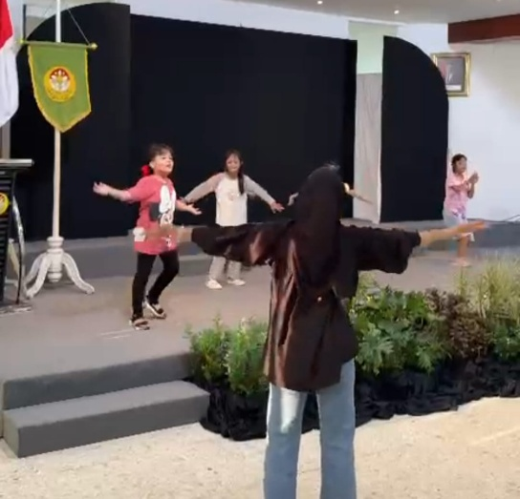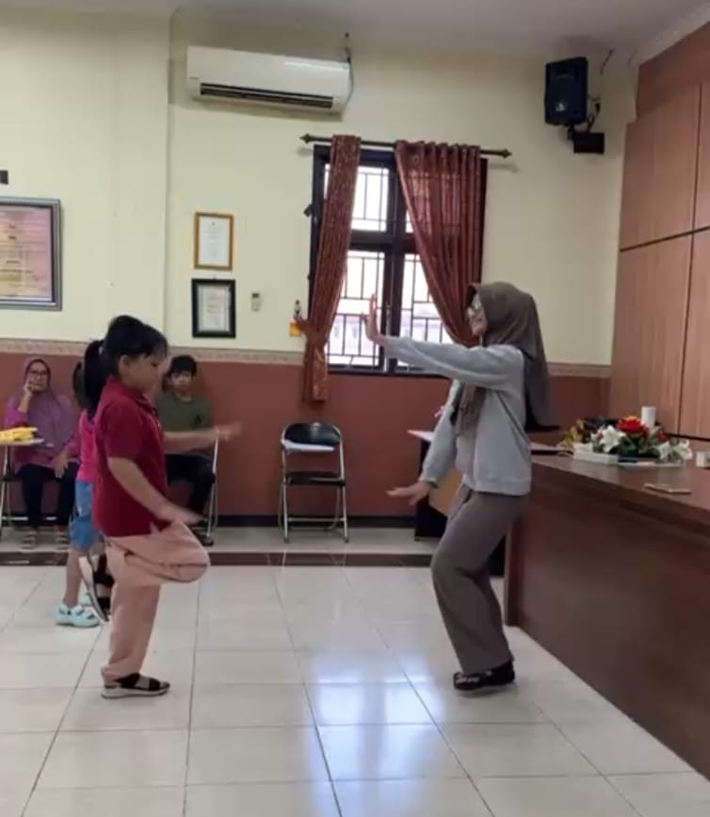
Figure 2: Basic Movement Exercises by Students with Special Needs

c. Use of a Audio Visual Media
In addition to direct demonstrations by the instructor, the team also used an active speaker to play the song “Jamuran.” The rhythmic and repetitive beat helps children with intellectual disabilities remember the sequence of movements. For children with hearing impairments, the instructor used sign language and foot stomps on the wooden floor or tiles to provide a sense of tempo. This multimodal approach aligns with learning principles for children with special needs, which emphasize the importance of stimulation through various sensory channels. The use of audiovisual media also helps children who have difficulty following verbal instructions to remain engaged in the activity.

d. Challenges and Solutions in the Field
During the learning process, certain situations arise that require quick and appropriate handling. Sometimes a child suddenly has a tantrum in the middle of an activity, usually triggered by fatigue or sensory overload. The solution we use is the “Quiet Space,” where the child is guided to step aside for a moment, calmed by a parent, and then invited back in when the music slows down. This approach does not punish the child for their behavior but provides a space for the child to regulate their emotions before rejoining the group.
Another challenge is coordinating movements. Child A may already be spinning, while Child B is still standing still or moving in a different direction. This is where the role of the facilitators (students and parents) comes in; they stand between the children to guide the direction of their movements. Facilitators serve not only as physical guides but also as sources of encouragement. The consistent presence of facilitators from one session to the next helps build a sense of security in the children, as they recognize the faces of those supporting them.

3.4 Learning Evaluation Results
After a series of sessions, significant changes were observed in the students (children with special needs) at the Cinta ABK Community at the Sukomulyo Community Health Center. The evaluation was conducted through participatory observation, which tracked the children’s progress in four key areas: gross motor skills, social interaction, auditory response, and emotional development.
No | Assessment Aspect | Initial Condition | Final Condition
1 | Gross Motor Skills | The child’s body is stiff, reluctant to move, and has poor leg coordination | The child’s body is more active; the child is able to walk in a circle while maintaining balance
2 | Social Interaction | The child is withdrawn, absorbed in their own world | The child is able to hold hands and make eye contact with friends while dancing
3 | Audio Response | The child behaves indifferently toward music | The child is able to nod or sway to the song “Jamuran” when it plays
4 | Emotional | The child gets anxious easily in crowded places | The child is able to nod or sway to the song “Jamuran” when it plays
Table 1. Observation of Participants’ Development
The table above shows that, in terms of gross motor skills, there has been a shift from a stiff, inactive posture to a more active one, with improved balance when walking in circles. This shift is evident not only in physical ability but also in the children’s willingness to participate in physical activities . Children who tended to remain still at the beginning of the program are now willing to follow the group’s movements.
In terms of social interaction, the most noticeable change was the children’s willingness to hold hands. Eye contact with peers also increased, which is an important indicator of a child’s social development, especially for children with autism who often avoid eye contact. This is consistent with research findings showing that the traditional game Jamuran is effective in developing the social skills of children with intellectual disabilities.
The audio response aspect showed an improvement from indifference to music to the ability to respond with body movements when the song “Jamuran” was played. This response is important because it indicates that the child is beginning to establish a connection between auditory stimuli and motor responses, which is the foundation for sensorimotor coordination.
On an emotional level, reduced anxiety in crowded settings and increased expressions of joy indicate that a pleasant learning environment successfully reduces stress in children. Children who previously appeared tense and on guard began to laugh and show expressions of joy during the practice sessions. This supports the assertion that dance for children with special needs can serve as a therapeutic medium due to its enjoyable nature through body movement.
The table above demonstrates that learning the traditional creative dance “Jamuran” effectively stimulates motor and social skills. The movements, which resemble playful activities (dolanan) and do not require a high degree of precision, ensure that children do not feel burdened. They feel as though they are playing, even though they are actually undergoing physical therapy. As revealed in a study on the influence of the traditional Jamuran game on the gross motor skills of young children, this game is effective in developing gross motor skills because it involves physical movement and the joy of play.

3.5 Discussion (Theoretical Analysis)
The success of this program aligns with the theory of Dance Movement Therapy. According to Payne (1992), dance movements can promote an individual’s cognitive, emotional, and physical integration. Jamuran dance specifically facilitates this through its circular structure. In social psychology, a circular formation creates a sense of equality and inclusivity. No one is in front or behind; everyone is equal. In the context of children with special needs, this sense of equality is important because many of them experience stigma or feel different from other children. By being in the same circle, the children feel that they are part of a cohesive group.
More specifically, these findings can be analyzed through several complementary theoretical frameworks. First, from a motor learning perspective, the repetition of movements in the Jamuran dance—such as walking in a circle, squatting, and standing— strengthens the neural pathways connecting the brain to the large muscles. Schmidt and Lee (2011), in their schema theory of motor learning, explain that the repetition of movements in varying contexts helps form generalized motor programs that enable children to perform similar movements in different situations. In this program, the weekly repetition of basic movements helps children internalize movement patterns so that by the final sessions, they are able to perform them with less assistance.
Second, from a developmental psychology perspective, Vygotsky (1978) emphasized the importance of the zone of proximal development (ZPD)—the gap between a child’s current abilities and the potential abilities they can achieve with guidance from adults or more capable peers. In this program, support from parents, college students, and instructors serves as scaffolding that helps children go beyond the limits of their current abilities. Over time, this support is gradually reduced (fading) as the child begins to demonstrate independence in performing movements.
Third, from an occupational therapy perspective, engagement in meaningful and enjoyable activities—in this case, dancing—can enhance participation and quality of life. This approach aligns with the Person-Environment-Occupation model (Law et al., 1996), which emphasizes the interaction between the individual, the environment, and activities. The supportive environment at the Sukomulyo Community Health Center, combined with culturally meaningful dance activities, creates optimal conditions for children’s development.
The strong local cultural elements of the Cinta ABK Gresik (East Java) community, as reflected in the song “Jamuran,” also help the children adapt, as the rhythm may already be familiar to them from their home environments. Research on the traditional game of Jamuran shows that it embodies noble values and moral lessons for life, and encourages children to be more active while playing, fostering interaction that helps them understand the rules of the game. The modifications to the movements made by the volunteer team demonstrate that traditional art is flexible and adaptable to the needs of inclusion. This is important because it shows that cultural preservation does not have to be rigid and exclusive, but can be accessible to all segments of society, including those with special needs.
In addition, parental involvement in the practice process strengthens the three pillars of education (family, school/community, and society). Parents who were previously passive—simply waiting for their children to undergo therapy—are now actively engaged in the learning process. This reduces stress levels among parents of children with special needs. Parental involvement also creates continuity between activities at the community health center and at home, as parents can continue simple movement stimulation exercises at home. As found in a study on the cooperative game “Jamuran” for children with intellectual disabilities, this game is effective in stimulating children’s interpersonal intelligence.
Furthermore, these findings reinforce the evidence that traditional dance instruction is effective in improving gross motor skills in children with intellectual disabilities. A study on Bedana dance as a gross motor therapy for children with autism showed an increase in the average score from 58.6 in the pretest phase to 86.4 in the posttest phase. Although this program did not employ measurements as rigorous as those in that study, the observed pattern of improvement—from an initial state characterized by stiffness and reluctance to move toward active participation and more coordinated movements—indicates a direction consistent with previous findings.
Research on the impact of adaptive dance programs on children with cerebral palsy also shows that participation in movement-based dance programs provides opportunities for physical activity and socialization, leading to meaningful changes in physical abilities and psychosocial well-being. These findings are relevant to the Tari Jamuran program, in which three children with cerebral palsy were able to participate through movement modifications and showed improvements in participation and self-confidence.
From the perspective of inclusive education, this program demonstrates that traditional arts can serve as a bridge between children with special needs and the wider community. Joyful dance learning not only benefits children’s motor development but also their social and emotional development. As noted in a study on dolanan dance instruction for children with special needs, dolanan dance—which is adapted from children’s play—is expected to serve as a medium that is both enjoyable and educational.
The success of this program is also closely tied to the approaches used, namely the drill (repeated practice) and imitation methods. Both of these methods align with the learning characteristics of children with special needs, who require repetition and concrete examples. Repetition helps children internalize movements, while imitation allows them to learn through observation before trying on their own. This approach aligns with the principle of observational learning proposed by Bandura (1977), in which children learn by observing a model and then imitating it.
Overall, the Jamuran Dance learning program at the Cinta ABK Community at the Sukomulyo Community Health Center demonstrates that traditional arts have great potential as a holistic therapeutic medium. Not only are the children’s motor skills stimulated, but their social, emotional, and cognitive development is also fostered through enjoyable and culturally meaningful activities. These findings contribute to the development of a contextual and inclusive arts-based therapy model, and reinforce the argument that cultural preservation and inclusive education can go hand in hand.

4. CONCLUSION
Based on the implementation of the community service activities at the Sukomulyo Community Health Center, it can be concluded that Jamuran dance instruction can be applied as an alternative method of gross motor therapy for the community of children with special needs, with adjustments or modifications to the movements. Furthermore, this instruction effectively enhances social interaction among children with special needs and builds their self-confidence to perform in public spaces. Meanwhile, collaboration between health workers (Community Health Center), academics (Community Service Team), and families (Community) is key to the success of non-formal inclusive education. This collaboration can foster a positive mood among the children after participating in dance practice sessions that incorporate games.
To ensure the sustainability of this Jamuran dance program at the Sukomulyo Community Health Center in Gresik, it is recommended that it be incorporated as a regular weekly or monthly activity in the “Posyandu for People with Disabilities” program or community meetings. In addition, parents are also encouraged to practice these simple songs and movements at home to help children retain their motor memories. Nevertheless, it is hoped that future research can explore variations of other traditional children’s dances, such as “Cublak-Cublak Suweng” or “Gundul-Gundul Pacul,” to diversify the material and prevent children from getting bored, as well as develop visual guide modules that parents can take home.

AUTHORS’ CONTRIBUTIONS

Briefly and clearly describe the contributions and responsibilities of each member of the research team. This section is not required for single-author studies or studies with no research team members.

The researchers would like to express their gratitude to:

1. Surabaya State University for supporting this community service activity.

2. The Head of the Sukomulyo Community Health Center, Gresik Regency, along with the medical staff who facilitated the venue and obtained the necessary permits.

3. All the parents and wonderful children in the “Komunitas Cinta ABK” for their enthusiasm and active participation throughout the activity.

REFERENCES
Astuti, K. (2018). Play Therapy for Children with Special Needs. Yogyakarta: Pustaka Pelajar.
Dharmamulya, S. (2008). Traditional Javanese Games. Yogyakarta: Kepel Press.
Hadis, F. A. (2006). Child Developmental Psychology. Jakarta: Gadjah Mada University Press.
Kurniawan, H. (2016). Dance Creativity in Inclusive Education. Journal of Dance Arts, 5(2), 112–120.
Lestari, W. (2019). The Influence of the Traditional Game “Jamuran” on Children’s Social Skills. Journal of Early Childhood Education, 3(1), 45–55.
Payne, H. (1992). Dance Movement Therapy: Theory and Practice. London: Routledge.
Rahayu, T. (2015). Gross Motor Stimulation Through Creative Dance. Journal of Special Education, 7(1).
Sunardi, & Sunaryo. (2007). Early Intervention for Children with Special Needs. Jakarta: Ministry of National Education.
Law of the Republic of Indonesia No. 8 of 2016 on Persons with Disabilities.
Widyastutik, R. (2020). Empowering the Community of Parents of Children with Special Needs Through Art Therapy. Abdimas Mahakam Journal, 4(1), 22–30.
Yulianti, R. (2017). Dance as a Therapeutic Medium for Children with Intellectual Disabilities. Jurnal Sendratasik, 6(3).

