
Karawitan Learning in Regular Class C at Cakra Aji Karawitan Studio Tulungagung Regency


E-ISSN 2338-6770

Date of submission :-
Date of revision :-
Date received :-

Correspondence Address:
Gedung T11lt 2 Prodi. Pendidikan Sendratasik, Fakultas Bahasa dan Seni Universitas Negeri Surabaya, Kampus Unesa Lidah Wetan, Kecamatan Lakarsantri, Surabaya, Jawa Timur 60213
Ega Asanta Ferananda¹, Bambang Sugito²

1 Universitas Negeri Surabaya, Surabaya, Indonesia
2 Universitas Negeri Surabaya, Surabaya, Indonesia
Email: egaasanta19@gmail.com, bambangsugito@unesa.ac.id

Abstract: Cakra Aji Karawitan Studio is an institution established to provide a platform for the younger generation of Tulungagung to develop their traditional Javanese karawitan skills through a structured and progressive learning process. By implementing culture-based learning, the studio also offers opportunities for artistic expression, particularly in Regular Class C, an advanced-level class focusing on the study of gendhing ladrang. This study aims to describe comprehensively the implementation of learning in Regular Class C in studying gendhing ladrang, including the instructional methods employed. This research employed a descriptive qualitative approach. Data were collected through interviews, observations, and documentation of the learning activities in Regular Class C. The validity of the data was ensured through source, technique, and time triangulation. The data sources consisted of both primary and secondary data. The collected data were analyzed using three stages: data reduction, data presentation, and conclusion drawing. The findings indicate that the learning process in Regular Class C at Cakra Aji Karawitan Studio applies a formal instructional system supported by three learning stages: preliminary activities, core activities, and closing activities. Throughout the learning process, the instructor implements lecture, demonstration, and drill methods to facilitate students' mastery of gendhing ladrang.

Keywords: karawitan learning, gendhing ladrang, cakra aji karawitan studio

1. INTRODUCTION
Education is a fundamental necessity that every individual has the right to obtain as a means of developing personal potential and improving quality of life. In the modern era, various forms of education are available to meet diverse learning needs. Learning resources can be easily accessed through technological advancements, including websites, blogs, and the internet. In today's educational context, learners are expected to develop critical, creative, and innovative thinking skills while maintaining an awareness of their cultural identity. One way to achieve these objectives is through arts education, both in formal schools and non-formal educational settings. Arts education encourages students to develop sensitivity to aesthetic and artistic values, thereby fostering creativity, critical thinking, and a deeper appreciation of art and culture.
According to Law No. 20 of 2003, non-formal education is an educational pathway outside the formal education system that is structured and tiered. It functions as a substitute for, supplement to, or complement of formal education in developing learners' potential through the mastery of knowledge, skills, and professional character. In general, art studios have diverse learning materials and forms of activities in each class that function as a place for children and the community to develop their potential and skills. Based on the results of the observation process, it was found that there are various characteristics of learning and studio training, each of which has a different instructional structure.
Among the several karawitan studios in the Tulungagung area, one studio demonstrates distinctive characteristics through a structured learning system based on the understanding of gendhing concepts and varuous learning programs, namely Cakra Aji Karawitan Studio, Tulungagung Regency. This studio not only provides karawitan learning materials but also offers contemporary music classes as part of its curriculum for children and adolescents. Cakra Aji Karawitan Studio has a structured learning system consisting of two types of classes, namely private and regular classes. The regular program is divided into four class levels, each with different core learning materials according to its level.
In addition, Cakra Aji Karawitan Studio has achieved various accomplishments in karawitan competitions and has actively participated in numerous cultular arts events. The urgency of this research lies in the fact that previous studies have not ectensively discussed the karawitan learning process in a comprehensive manner. Therefore, this study aims to complement the existing body of scientific literature. Based on the description above, this study aims to describe the learning proces in Regular Class C. The selection of this class is based on the consideration that the students in Regular Class C have previously acquired the fundamental theoritical and practical knowledge of karawitan in the preceding class levels, enabling them to passess sufficient prior knowledge and competencies.
The learning process in Regular Class C emphasizes the understanding of concepts, theory, and musical sensivity through the performance of gendhing ladrang. This study describes the learning process implemented in Regular Class C using gendhing ladrang as the instructional material, with the aim ef explaning the teaching methods, learning stages, and instructional dynamics applied by the instructor to enable students to achieve the competencies required for the next level.

2. METHODS
The study employed a descriptive qualitative method to investigate the research object. The data analysis consisted of theree stages: data reduction, data presentation, and conclusion drawing. During the data reduction stage, the data collected by the researcher were still broad and covered various aspects of the studio’s conditions. To summarize the findings, the researcher sorted and classified the data obtained from interviews, observations, and documentation so that the data became well-organized and focused. In the next stage, the data were presented in the form of descriptive explanations, narrative descriptions, figures, and tables to provide a comprehensive overview of the information obtained, particularly regarding the learning process in Regular Class C. Finally, conclusions were drawn by repeatedly verifying the collected data through careful ecxamination, enabling the researcher to formulate detailed, evidence-based answers to the research questions concerning the learning process in Regular Class C.
In addition, the researcher employed research instruments as supporting tools during the data collection process, including field note sheets and a mobile phone voice recorder used to record interviews with resource presons and informants. Documentation instrumen included a mobile phone for taking photographs and recording videos of the learning activities as well as the conditions of the research site.
During the data collection process, the researcher employed three data collection techniques: observation, interviews, and documentation. In the observation stage, the researcher acted solely as an independent observer and conducted observations on three occasions at Cakra Aji Karawitan Studio, specifically in Regular Class C. During the interview process, the researcher selected resource presons and informants to obtain first-hand information regarding the learning activities in Regular Class C. Furthermore, the documentation in this study consisted of archival documents obtained from the studio as well as documentation collected by the researcher, including photographs of studio activities, the learning process, intructional media, audio and video recordings of the learning activities. The documentation collected enable the researcher to present the findings in written form based on empirical evidence from the field, thereby supporting the formulation of answers to the research questions.

3. RESULTS AND DISCUSSION

3.1 Results
The findings of this study indicate that the learning proces in Regular Class C is implemented in a gradual manner, as reflected in the distribution of learning materials for the 2025/2026 academic year. During the first semester, from August to January, students study the irama dadi drumming pattern using Ladrang Slamet in Pelog Barang and Ladrang Ela-Ela Gandrung in Pelog Nem. In the second semester, from February to June, students learn the ciblon irama dadi drumming pattern through Ladrang Mugi Rahayu and Ladrang Ayun-Ayun. These materials serve as the core learning content and are intended to deepen students’ understanding of ladrang before they proceed to study other ladrang compositions. Regular Class C is conducted routinely every Wednesday and Sunday from 3:00 p.m to 5:00 p.mn with a total instructional time of 120 minutes per session. The class consists of ten male and female students ranging in age from 7 to 15 years. During the learning process, the instructor applies several teaching methods as instructional approaches to facilitate students' learning. These methods are essential competencies that must be mastered by the studio instructor to achieve optimal learning outcomes.
The lecture method was implemented by the studio instructor at the beginning of the learning process to deliver theoritical material orally. According to Widan, during the initial meetings and at the beginning of each semester, approximately within the first one to theree weeks of the learning process at Cakra Aji karawitan Studio, the instructor applied the lecture method to explain the theories and concepts of the gendhing material to be taught. Through the implementation of the lecture method, which covered theory, techniques, patterns, and the structure of gendhing, it was expected that in subsequent meetings all students would possess a comprehensive initial understanding of the material to be studied.
In Regular Class C, during the initial stage of understanding, the instructor explained the playing techniques, playing patterns for each instrument, the transitions of irama dadi and ciblon irama dadi, as well as the musical flow within the gendhing ladrang. Another function of the lecture method was to provide information regarding the learning material that would be covered in subsequent sessions of Regular Class C, enabling students not only to practice technical skill but also to understand ladrang peformances comprehensively.
Although the lecture method provided students with an initial undersanding, errors and inconsistencies in maintaining the same tempo among students were still observed during practice sessions. To address this issue, Widan (the instructor) consistently provided solutions by emphasizing tempo synchronization and reiterating that each beat must follow the rhythm of the kendang. Based on the implementation of the lecture method, it can be concluded that its application in Regular Class C was highly effective as an initial step in providing a theoritical fundation and technical understanding. In addition, students were able to develop closer communication with the instructor. The lecture method was adapted to the instructional needs of each class, supporting both practical skill development and preparation for final peformances as well as karawitan events.

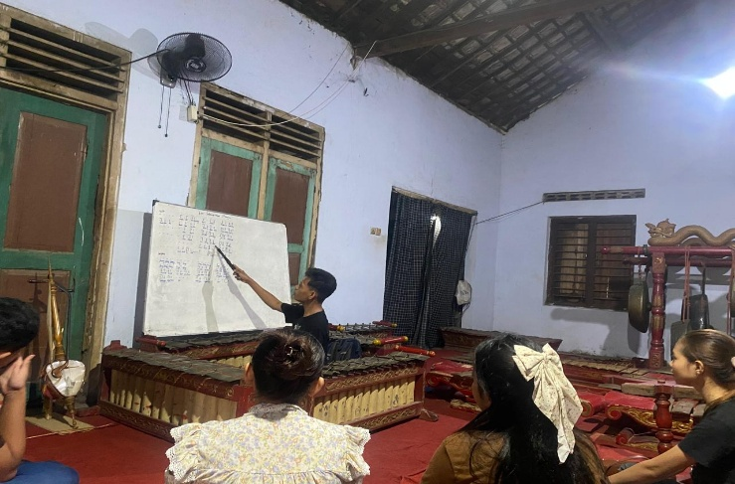
Figure 1. Implementation of the Lecture Method

The demonstration method was implemented by the instructor when instroducing practical learning materials by providing direct examples of gamelan playing techniques. According to Widan, the instructor, the demonstration method applied in Regular Class C was highly effective in supporting the learning process before practical sessions. Through this method, students were able to observe the instructor directly while demonstrating gamelan playing techniques, proper hand positioning, and vocal pitch accuracy prior to group practice. During the kendang demonstration, the instructor demonstrated membrane-striking techniques using the tak, bhem, dhe, dlak, tong, and ket strokes, which the students then followed. For the balungan and structural instrument groups, the instructor demonstrated playing techniques, hand speed, proper mallet grip, as well as the mithet/loss and imbal techniques. In addition, the instructor demonstrated vocal techniques, including pitch accuracy, cengkok, and ngelik. These demonstrations of karawitan techinques provided students with an initial understanding and stimulated their motor skills before engaging in ensemble practice.
Based on the implementation of the demonstration method, it was beneficial in providing students with an initial understanding of technical skills before participating in group practice. Therefore, the use of the demonstration method strongly supported the practical learning materials, which emphasized the direct application of gamelan as the primary learning medium in Regular Class C.

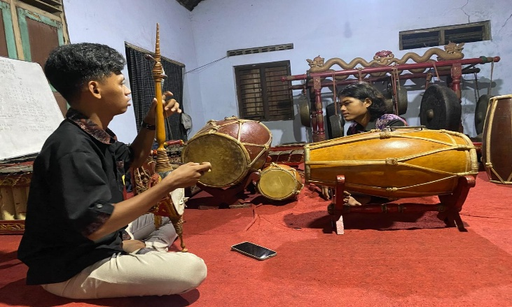
Figure 2. Implementation of the Demonstration Method

The drill method is a practice-based learning method that develops skills by emphasizing systematic and repetitive exercises trhoughout the learning process. In the context of karawitan learning, the implementation of the drill method is useful for familiarizing students with playing patterns and memorizing notation so that it can be more easily remembered and understood. On the kendang instrument, this method is applied to understand the transitions of irama 1, irama dadi, and wiled, which are practiced repeatedly until students are able to understand the sequence of the ladrang sections. In addition to understanding rhythmic transitions, this method also strengthens kendang playing techniques with greater accuracy and stability. For the balungan instrument group, souch as the demung, saron, and other instruments, the drill method functions to strengthen coordination skills and the memorization of ladrang notation, while also being applied to sindhen vocal techniques, particulary in acheiving accurate pitch and memorizing the lyrics.
In general, the implementation of the drill method in Regular Class C helps students develop ensemble musicality by emphasizing coordination and a high level of concentration on their respective instrumental parts, as each instrument has different playing patterns and notation that must be understood. Whenever one instrument makes a mistake, the ensemble performance becomes unsynchornized. Therefore, the instructor repeats the learning material approximately 10-15 times in each meeting to strengthen students’ abilities and improve ensemble cohesion. In additon, students are trained to rhythmic accuracy and to maintain both fast and slow tempos appropriately, particularly by following the kendang, which functions as the controller of tempo and rhythm.
The implementation of the drill method in the ladrang material for Regular Class C begins with repetitive practice. For example, the buka section of Ladrang Mugi Rahayu is repeated approximately five to ten times. Once the students have demosntrated sufficient proficiency, the practice continues with the umpak section following the buka. According to Widan, the instructor, the ciblon irama dadi section requires considerably more repetition because the techniques are more complex, including denser rhythmic patterns and the incorporation of the imbal technique on the bonang, which requires adjustment and coordination among the instruments. Subsequently, the entrie gendhing structure is repeated approximately five to ten times. The primary ebjective os to develop strong memory, accuracy, and consistency as the fundation before proceeding to other ladrang materials.
Based on the implementation of the lecture and demonstration methods, these methods do not need to be applied in every learning session. Once students have achieved sufficient competence and understanding of the material, the drill method can support the monitoring of students’ progress in mastering the learning material while serving as a temporary indicator of their achievement during each meeting. Prior to the final performance, the lecture method is used only briefly, and the demonstration method is also minimized, allowing the instructor to directly implement the drill method so that students become accustomed to memorizing and understanding ladrang performances. Overall, the drill method enhances students’ technical skills, gradually improves ensemble cohesion, and fosters discipline as well as a high level of concentration.

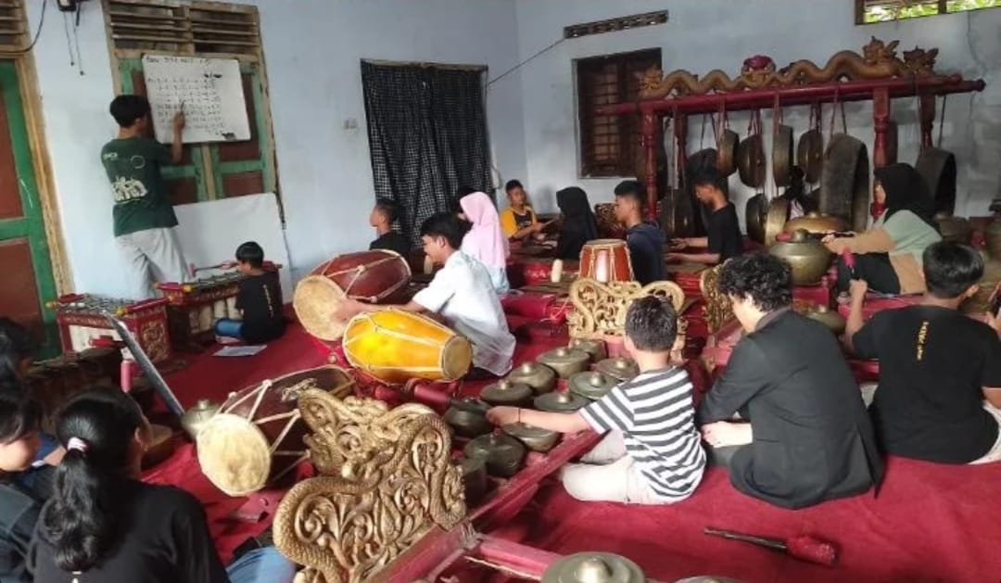
Figure 3. Implementation of the Drill Method

As a non-formal education institution, Cakra Aji Karawitan Studio implements structured stages of the learning process to organize instructional activites in a systematic and well-directed manner during both theoritical and practical session. These learning stages consist of preliminary activities, core activities, and closing activities, with a total instructional time allocation of 120 minutes.
The preliminary activity is the initial stage of the learning process, consisting of opening activities, student motivation, attendance, focusing students' attention, and apperception to determine the extent of students' prior knowledge and abilities (Majid, 2013:104). During the pliminary activity, which lasts approximately first 10-20 minutes, the learning session begins with a collective prayer, followed by the instructor taking students atendance. At the beginning of each semester, the instructor and students engage in a discussion while reviewing the new learning material. For example, students are given a ladrang notation to observe its notation, structure, and repetition in order to develop a fundamental understanding and identify the level of difficulty of the material to be studied. In addition, the instructor provieds a general explanation of the techniques and patterns that will be applied within the gendhing ladrang structure, souch as the imbal technique, mipil lompatan, irama lamba/laya, as well as the kendang irama dadi pattern. This process is conducted during the first one to two meetings of the semester, considering that students require an initial understanding of the learning material.
From the third meeting onward, the preliminary activity continues with an opening prayer, motivation, attendance, and apperception conducted by the instructor to determine the extent of the students' prior understanding of the material from the previous meeting before introducing the new material. This apperception is intended to strengthen students’ memory and focus their concentration before entering the core learning activities. For example, the instructor reviews the structure of gendhing ladrang, after which students are asked questions regarding the ladrang structure to reinforce their understanding of the concept, including the 32 beats in each gongan and the number of kenong beats within one gongan. After complementing these preliminary activities, the learning process preceeds to the core learning stage. Based on the implementation of the preliminary learning activities in Regular Class C, the learning process is consistent with Majid’s theory, which includes several aspect, namely collective prayer, student motivation, and apperception, all of which are intended to enhance students' initial understanding of the ladrang material.
During the first and second meetings of the core learning activities, the instructor provides students with gendhing ladrang notation and ecplains it directly to help them undesrtand the notation patterns for all gamelan instruments as well as the structural sections of a ladrang composition. After explaining the notation patterns, the instructor immediately proceeds with the demonstration method. The demonstrations primarily emphasize instrumental and vocal techniques. In the kendang demonstration, the instructor models the striking techniques, including dag, tung, ket, tak, buk, and dhe, as well as the transition from irama 1 to irama dadi. For vocal demonstrations, the instructor exemplifies the appropriate cengkok and seleh patterns. After the initial meetings, subsequent session continue with the implementation of the drill method to reinforce the material that has been explained and demonstrated in previous meetings. This method aims to strengthen students' memorization, retention, ensemble cohesion, and consistency of musical dynamics. The drill method is applied progressively to each section of the ladrang, including the buka, umpak, minggah, and suwuk, according to the students’ level of proficiency. Throughout the learning process, the instructor also provides direct instructional guidance by verbally dictating the notation for each instrument whenever students make mistakes. This direct guidance is applied to all gamelan instruments as well as vocal practice. Furthermore, to ensure that students acquire comprehensive skills across all gamelan instruments, the instructor implements a rolling technique during the learning process. The term rolling refers to the systematic rotation of students among different gamelan instruments. In Regular Class C, this rotation is generally carried out every one to three rambahan ladrang, or one to three complete cycles of the musical composition. This technique is intended to enable students to develop comprehensive proficiency in playing all gamelan instruments. Fundamentally, karawitan learning at Cakra Aji Karawitan Studio emphasizes not only the development of technical skils but also the cultivation of good manners, cooperation, and mutual respect among students.

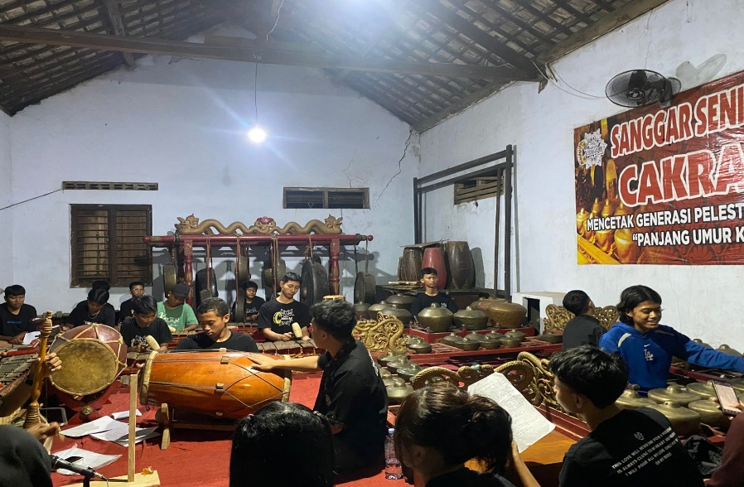
Figure 4. Learning Activities in Regular Class C

The closing activity occupies the final 10-15 minutes of the Regular Class C learning session and begins with an evaluation. The evaluation of the day's learning outcomes is conducted through a reflective discussion between the instructor and the students regarding the aspects that still need improvement. According to the students, the most common difficulties involve maintaining focus and concentration while remembering instrumental patterns, particularly for the structural gamelan instruments and the bonang, as these require a higher level of concentration. The instructor then provides guidance and strategies to help students improve their focus and concentration by developing a sufficient understanding of the counting patterns for each structural instruments, as karawitan learning requires not only memorization but also an understanding of the rhythmic counting patterns of each instrument. The instructor's evaluation continues by addressing the general issues encountered during the learning process, which mainly concern the correction of playing techniques, ensemble cohesion, and musical dynamics that still require improvement. Futhermore, the instructor emphasizes the importance of developing musical sensitivity so that students can perfom the gamelan with greater appreciation and expression.
During the closing activity, the instructor also provides appreciation by praising the students' progress throughout the practice session. In addition, the instructor summarizes the material covered during the meeting and explains the material to be studied in the following session. The evaluation in Regular Class C consists of two categories: major (class) evaluation and minor (individual) evaluation. The major evaluation assesses the overall class performance, including ensemble cohesion, musical dynamics, and tempo accuracy among the instruments. Meanwhile, the minor evaluation focuses on individual students by assessing instrumental tachnique, the accuarcy of playing patterns, participation, and discipline. Following these evaluations, the instructor and students engage in a discussion regarding the aspects that need to be improved and further developed.

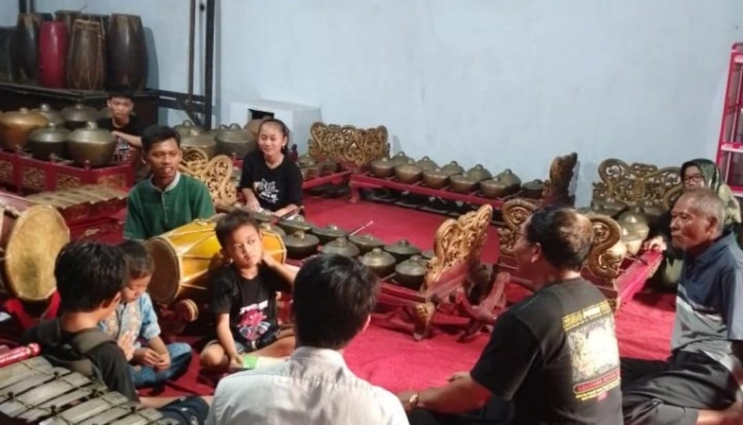
Figure 5. Evaluation Activities in Regular Class C

Before conluding the session with a collective prayer, the instructor leads a practice known as the ”Sumpah Menabuh” (playing oath), which requires all students to return the gamelan mallets to their designated places and neatly arrange them at the end of every learning session. Although this practice appears simple, it is intended to cultivate students' sense of responsbility and awarness in maintaining the gamelan instruments. The learning session is then concluded with a collective prayer as an expression of gratitude for the smooth implementation of the learning activities.

3.2 Discussion
Based on the findings of this study, karawitan learning in Regular Class C at Cakra Aji Karawitan Studio is not merely a training activity but demonstrates a structured learning process and instructional approach that are consistently implemented in every learning session. The first teaching method applied was analyzed using the lecture method theory proposed by Majid (2013:138), which defines the lecture method as a means of delivering extensive informational material, including concepts, definitions, and principles. Based on this theory, the implementation of the lecture method in Regular Class C was found to be effective as an initial step in providing students with a theoretical foundation and an understanding of the structure of gendhing. In addition, the lecture method enables students to establish better communication with the instructor, thereby fostering a closer learning relationship. The application of the lecture method is also adapted to the instructional needs of each class within the studio, whether to support practical skill development or to prepare students for final performances and karawitan events.
The demonstration method was analyzed using the demonstration theory proposed by Syaiful (2008:210), which defines demonstration as a process of provoding examples that enable learners to imitate and reenact all aspect related to the learning material through a systematic procedure, thereby facilitating the learning process and achieving the intended instructional objectives. The implementation of the demonstration method in Regular Class C provides students with an initial understanding of technical skills before they engage in ensemble practice. Therefore, the use of the demonstration method effectively supports practical learning by emphasizing the direct application of gamelan instruments as the primary learning media.
After implementing the lecture and demonstration methods, the learning process is reinforced through the drill method, which involves the gradual epetition of learning materials to strengthen students’ practical skills. The drill method was analyzed based on the theory proposed by Sagala (2005:2017), who defines the drill method as a teaching method that emphasizes repeated practice and is generally used to develop proficiency and skills in the material being learned. The implementation of the drill method in Regular Class C demonstrates that the learning process involves repeated practice of the ladrang material, covering each section of the composition, including the buka, umpak, and suwuk, or one to two complete cycles of the gendhing performance. This repetitive practice servers to strengthen students’ memory, deepen their technical abilities and playing patterns on each instrument, and improve their performance skill, ensemble cohesion, discipline, and concentration.
A fundamental principle of the learning process is the implementation of clearly defined instructional stages to ensure that learning activities achieve the intended outcomes. The stages of learning activities were analyzed based on the theory proposed by Majid (2013:104), which consist of theree phases: 1) preliminary activities, (2) core activities, and (3) closing activities. In Regular Class C, the preliminary activities include a joint prayer, attendance, motivation, and an explanation of the learning materials to be studied. In addition, at the beginning of each semester, the instructor and students engage in discussions and review the new learning materials to establish a shared understanding of the instructional content. The core activities focus on in-depth learning through practical instruction using gamelan instruments and the implementation of the demonstration and drill methods. Furthermore, the instructor applies the rolling technique to maximize students’ understanding of the ladrang material. Based on the implemenetation of the core learning activities in Regular Class C, the findings are consistent with Majid’s theory regarding the core stage of learning, which includes the development of knowledge, attitudes, skills, learning methods, and the use of instructional media. Howver, one aspect not mentioned in the theory is the implementation of the rolling technique during practical activities. This practice serves as a distinctive feature and an instructional innovation in the studio, making the learning process more varied, reducing students’ boredom, and creating a more enjoyable and engaging learning environment.
The final stage consists of the closing activities, which include class and individual evaluations, a summary of the lesson, discussion, appreciation of the students’ learning achievements during the session, and conclude with a joint prayer. In addition, there is a difference that is not mentioned in Majid's theory regarding the evaluation process implemented in the learning activities. In Regular Class C, the evaluation consists of two types: individual evaluation (minor evaluation) and class evaluation (major evaluation). These evaluations are intended to provide a comprehensive assessment of both students’ learning progress and the overall learning process between the instructor and the students. Although this evaluation system differs from Majid's theoretical framework, it complements the findings presented in this study and may serve as a reference for learning practices in art studios, particulary at Cakra Aji Karawitan Studio.
Based on the theoritical discussion of theaching methods and the stages of the learning process, it can be concluded that both have a closely interconnected relationship in supporting the implementation of karawitan learning in Regular Class C in a structured and systematic manner. This learning process imphasizes direct interaction between the instructor and the students, thereby enabeling karawitan instruction to achieve its intended learning objectives.

4. CONCLUSION

Referring to the research findings and discussion regarding the implementation of karawitan learning in Regular Class C at Cakra Aji Karawitan Studio, Tulungagung Regency, it can be concluded that the learning process is implemented in a structured manner with a primary focus on the mastery of gendhing ladrang. The implementation encompasses two main aspects: the stages of the learning process and the teaching methods employed. Throughout the learning process, the instructional material is delivered gradually to provide students with a comprehensive understanding of the structure of the gendhing ladrang being studied, as well as the playing patterns of each gamelan instrument. In addition, to facilitate students' learning, the instructor applies several teaching methods, namely the lecture method to provide an initial understanding and introduce the learning material, the demonstration method to model playing techniques directly, and the drill method through repeated ensemble practice to reinforce the learning material while strengthening coordination among the gamelan instruments. As a non-formal institution with competence in karawitan education, Cakra Aji Karawitan Studio organizes the Regular Class C curriculum with a focus on mastering gendhing in the ladrang from through clearly structured learning stages consisting of preliinary activities, core activities, and closing activities. These learning stages enable both the instructor and the students of Regular Class C to understand the material progressively, thereby facilitating the archievment of the intended learning objectives.

Thus, it can be concluded that the learning process in Regular Class C is implemeneted in a structured manner through the stages of preliminary, core, and closing activities. The learning process is also supported by the implementation of the lecture, demonstration, and drill methods, which effectively develop students’ conceptual understanding, technical knowledge, and practical skills. The learning outcomes in Regular Class C, which focus on gendhing ladrang material, enhance students' abilities to play and perform various gamelan instruments across different types of gendhing, particularly gendhing ladrang. Futhermore, the learning process also contributes to the preservation and appreciaction of traditional Javanese performing arts.

AUTHOR'S CONTRIBUTION

The first author served as the principal investigator and was responsible for all aspects of the research, including conceptualization, methodology development, data collection and analysis, and manuscript preparation from the initial draft to the final revision. The second author served as the supervisor by providing guidance and oversight throughout the research process, validating the research findings, and contributing through manuscript riview and editing.

THANK YOU

The researcher would like to ecpress his deepest gratitude to all parties who have provided opportunities, assistance, support, guidance, and valuable contributions throughout the research process, enabling this study to be completed successfully. Special appreciation is extended to:
- Drs. Bambang Sugito, M.Sn., my thesis supervisor, who always mode time for my guidance, criticism, and constructvie input.
- Dr. Subianto Karoso, M.Kes., as the first examiner, who gracioulsy provided guidance, valuable feedback, suggestions, and constructive advice throughout the research process.
- Anbie Haldini Muhammad, S.Sn., M.A., as the second examiner, who gracioulsy provided guidance, valuable feedback, suggestions, and constructive advice throughout the research process.
- Totti Wahyu Bathara, M.Sn., the owner of Cakra Aji Karawitan Studio, who generously served as a resource person and provided valuable information for this research.
- Yuli Widan Santoso, S.Sn., the instructor at Cakra Aji Karawitan Studio and a resource person, who willingly shared valuable insights and responded to the questions posed during this research.
- The management of Cakra Aji Karawitan Studio, for providing the researcher woth the opportunity to conduct the research directly at the studio.
- The students of Regular Class C, for their willingness to participate in this research nad for providing the researcher with the opportunity to be directly involved in the learning process, thereby offering valuable experience throughout the course of the research.

REFERENCE
Andi, Setiawan. (2017). Belajar dan Pembelajaran. Ponorogo: Uwais Inspirasi Indonesia.
Dewi, E. R. (2018). Metode Pembelajaran Modern Dan Konvensional Pada Sekolah Menengah Atas. PEMBELAJAR: Jurnal Ilmu Pendidikan, Keguruan Dan Pembelajaran. 2(1), 44.
Dewantara, K. H. (2013). Pendidikan: Bagian I. Yogyakarta: Universitas Sarjanawiyata Tamansiswa (UST-Press).
Djamarah, S. B. & Zain, A. (2010). Strategi Belajar Mengajar. Jakarta: Rineka Cipta.
________, Syaiful Bahri. (2008). Strategi Belajar Mengajar. Jakarta: PT. Rineka Cipta.
Djiwandono, W, E, S. (2008). Psikologi Pendidikan. Jakarta: Grasindo
Esterberg, Kristin G. (2002). Qualitative Methods in Social Research, New York: MC. Graw Hill.
Gulo, W. 2002. Strategi Belajar Mengajar. Jakarta: Grasindo.
Huda, Miftahul. (2015). Model-Model Pengajaran dan Pembelajaran. Yogyakarta: Pustaka Belajar.
Hadi, Sutrisno. (1986). Metodologi Research. Yogyakarta: Andi Offset.
Indonesia. 2003. Undang-Undang Republik Indoneia Nomor 20 Tahun 2003 tentang Sistem Pendidikan Nasional.
Irawan, A. P. M. (2025). “Aktualisasi Sanggar Baladewa Sebagai Sanggar Seni Karawitan di Kota Surabaya”. Surabaya: Skripsi FBS Universitas Negeri Surabaya.
Jazuli, M. 2008. Paradigma Kontekstual Pendidikan Seni. Semarang: Unesa University Press.
Majid, A. (2013). Perencanaan Pembelajaran Mengembangkan Kompetensi Guru. Bandung: PT Remaja Rosdakarya.
Mulyasa. (2009). Menjadi Guru Profesional Menciptakan Pembelajaran Kreatif & Menyenangkan. Bandung: PT Remaja Rosdakarya.
Prasetya, B, H., Haryono, T. & Simatupang, L, L. (2011). Habitus, Ngeng, dan Estetika Bunyi Mleset dan Nggandhul pada Karawitan. Paradigma: Jurnal Kajian Budaya. 1(2). 152-167.
Pujiwiyana. (2010). Pembinaan Paguyuban Seni Tradisional. Yogyakarta: Penerbit Elmatera.
Rokhayatun, S, T. & Jatilinuar, K, R, S. (2022). Pemetaan Pola Tabuhan Bonang Penerus: Sebuah Upaya Pelestarian Karawitan Gaya Yogyakarta. Jurnal Pengetahuan, Pemikiran dan Kajian Tentang Bunyi. 22(1), 1-14. DOI: http://dx.doi.org/10.33153/keteg.v22i1.4146.
Rusman. (2011). Model-Model Pembelajaran. Jakarta: PT. Raja Grafindo Persada.
Sagala, S. (2005). Konsep dan Makna Pembelajaran. Bandung: CV Alfabeta.
Setyawan, A, D. & Pangestuti, G. (2020). Implementasi Pendidikan Karakter Melalui Ekstrakulikuler Karawitan di SD N 2 Balong. Jurnal Pendidikan Ke-SD-an. 6(3), 914-918. DOI: https://doi.org/10.30738/trihayu.v6i3.8152.
Soeroso. (1986). Karawitan Jawa. Yogyakarta: Departemen Pendidikan dan Kebudayaan.
Sugandi, A. & Haryanto. (2003). Teori Pembelajaran. Semarang: IKIP.
Sugestiyo, W. (2020). “Penerapan Metode Pembelajaran Seni Tari Pada Kelas B Di Sanggar Raff Dance Company Surabaya. Surabaya: Skripsi FBS Universitas Negeri Surabaya.
Supanggah, R. (2007). Bothekan Karawitan II: Garap. Surakarta : ISI Press Surakarta.
Suyatno. (2004). Teknik Pembelajaran Bahasa dan Sastra. Surabaya: SIC.
Teguh. (2017). Ladrang Sobrang Laras Slendro Patet Nem. Jurnal Seni Pertunjukan. 10(2), 103-112. DOI: https://doi.org/10.24821/resital.v18i2.2447.
Wicaksono, B. S. & Handayaningrum, W. (2021). Pembelajaran Ekstrakulikuler Karawitan Banyuwangi Di SD Negeri Kepatihan Banyuwangi. Jurnal Pendidikan Sendratasik. 10(1), 93-108. DOI: https://doi.org/10.26740/jps.v10n1.p93-108.
Wiryopranoto, S. (2017). Perjuangan Ki Hajar Dewantara: Dari Politik Ke Pendidikan. Jakarta: Museum Kebangkitan Nasional, Direktorat Jendral Kebudayaan, Kementerian Pendidikan dan Kebudayaan.
Yohana, I. (2023). Metode Jigsaw Dalam Pembelajaran Karawitan Di Sanggar Karawitan Setyo Manunggal Kabupaten Mojokerto. Jurnal Pendidikan Sendratasik. 12(2), 384-393. DOI: https://doi.org/10.26740/jps.v12n1.p18-30.

