

E-ISSN 2338-6770

Tanggal pengajuan : -
Tanggal revisi : -
Tanggal diterima : -
Alamat Korespondensi:
Studi Thailand, Fakultas Seni,
Universitas Chulalongkorn 254 Phaya Thai Rd, Wang Mai, Pathum Wan, Bangkok 10330. E-mail:
6688031022@student.chula.ac.th

Author et al., Journal of Sendratasik Education (2025) https://doi.org/10.26740/vt.v1n1.p1xx-1xx
DANCE STUDIO MANAGEMENTRAFF DANCE
COMPANY(RDC) IN SURABAYA CITY

Elvina Dewi Artanti ¹, Trisakti²

1State University of Surabaya, Surabaya, Indonesia
2Unesa University, Surabaya, Indonesia
Email:elvina.22094@mhs.unesa.ac.id

Abstract: This study aims to describe the dance learning management at the Raff Dance Company Surabaya Dance Studio, which includes planning, organizing, implementing, and supervising. The study used a qualitative approach with descriptive methods. Data collection techniques were carried out through observation, interviews, and documentation. The research subjects consisted of the studio leader, trainers, administrators, and students. Data analysis was carried out through the stages of data reduction, data presentation, and drawing conclusions. The results of the study indicate that the dance learning management at the Raff Dance Company Dance Studio has been implemented quite well. Planning is carried out through the preparation of learning programs, dance materials, practice schedules, learning methods, and supporting activities that are adjusted to the age and abilities of students. Organization is carried out through a clear division of tasks within the studio's organizational structure. The implementation of learning is carried out routinely through dance practice activities, learning make-up and hair buns, creation of works, performances, certification, and the use of digital media as a means of promotion and documentation. Supervision is carried out directly by the leaders and trainers through learning evaluations, monitoring organizational activities, facilities and infrastructure, and performance evaluations. The implementation of these management functions supports the creation of a directed learning process and plays a role in the preservation and development of East Javanese dance arts.
Keywords: Learning Management, Dance Studio, Dance Arts, Non-formal Education, Raff Dance Company.

Abstract: This study aims to describe the management of dance learning at Raff Dance Company Dance Studio in Surabaya, covering planning, organizing, implementation, and supervision. The research employed a qualitative approach with a descriptive method. Data were collected through observation, interviews, and documentation. The research subjects consisted of the studio leader, instructors, administrators, and students. Data analysis was conducted through data reduction, data presentation, and conclusion drawing. The findings indicate that the management of dance learning at Raff Dance Company has been implemented effectively. Planning activities include the preparation of learning programs, dance materials, training schedules, learning methods, and supporting activities adjusted to students' ages and abilities. Organizing is carried out through a clear division of duties within the studio's organizational structure. The implementation of learning is conducted regularly through dance training, make-up and hairdressing classes, creative dance production, performances, certification programs, and the use of digital media for promotion and documentation. Supervision is conducted directly by the studio leader and instructors through learning evaluations, monitoring of organizational activities, facilities and infrastructure, and performance evaluations. The implementation of these management
© 2023 The Author. This open access article is distributed under the Creative Commons Attribution
licens
e
.
(
C
C
-
B
Y
-
N
C
-
S
A
)

4
.0.

functions supports a structured learning process and contributes to the preservation and development of East Javanese dance arts.
Keywords: Learning Management, Dance Studio, Dance Education, Nonformal Education, Raff Dance Company.

INTRODUCTION

Indonesia is a country with a rich cultural diversity, one of which is the arts. Art is an integral part of culture, serving as a means of expressing the aesthetic values inherent in society. One art form that continues to thrive today is traditional dance. Dance is a form of expression expressed through body movement and facial expressions, possessing aesthetic value (Yoyok, 2006). Dance serves not only as a medium of entertainment but also plays a role in cultural preservation and character development for the younger generation.
Education plays a crucial role in transmitting cultural values to society. In addition to formal education, cultural transmission is also carried out through non-formal education. Non-formal education is an educational activity conducted outside the school system to meet the learning needs of people of various ages (Syaadah, 2023). One form of non-formal education that plays a role in preserving arts and culture is the dance studio.
Dance studios provide a platform for the community to learn, develop, and preserve traditional dance. According to Hartono (1984), art studios are a necessary resource for the community, artists, and government in their efforts to develop the arts in Indonesia. Similarly, Dewi (2018) states that art studios are a place where groups of individuals gather to carry out various artistic activities, including dance. Through various learning activities, training, creation, and performances, dance studios contribute to enhancing the creativity and skills of students.

Author et al., Journal of Sendratasik Education (2025)

https://doi.org/10.26740/vt.v1n1.p1xx
-
1
xx

The success of a dance studio in maintaining its existence is inseparable from the implementation of good management. Management in non-formal education includes the processes of planning, organizing, implementing, and monitoring carried out systematically to achieve organizational goals effectively and efficiently. According to G.R. Terry in Hasibuan (2014), management is a process consisting of planning, organizing, directing, and monitoring to achieve specific goals through the utilization of human resources and other resources. Meanwhile, William J. Byrnes, (2022:15) explains that management is the process of planning, organizing, coordinating, directing, controlling, and supervising, carried out effectively and efficiently to achieve organizational goals. In the context of the performing arts, management serves as a crucial instrument for optimizing all of an arts organization's resources so that activities can run sustainably (Handayaningrum, 2018).
One dance studio that still actively preserves traditional dance in East Java is the Raff Dance Company. Founded in 1994 by Arif Rofiq, the studio focuses on traditional dance instruction, organizing performing arts events, documenting works, and training. The Raff Dance Company has a structured learning system based on the age and ability level of students. Furthermore, the studio holds annual evaluations in the form of a level-up exam that assesses aspects of wiraga, wirama, and wirasa as indicators of mastery of dance learning materials.
The Raff Dance Company's excellence lies not only in its learning system, but also in its ability to maintain its presence amidst the development of the creative industry. The studio actively organizes performances, participates in various competitions, collaborates with instructors from outside the region, and develops dance works that highlight local culture. These various activities demonstrate organizational management that supports the sustainability of learning programs and cultural preservation.
The Raff Dance Company's continued existence for over three decades makes it an interesting study from the perspective of nonformal education management. The management applied in program planning, resource organization, learning activity implementation, and program evaluation are crucial factors in maintaining the studio's sustainability. Therefore, this study aims to analyze the management of the Raff Dance Company in maintaining its existence as a non-formal educational institution in the field of traditional dance.

Theoretical basis Studio Management
Management is a process involving planning, organizing, implementing, and supervising to achieve organizational goals effectively and efficiently. In the context of the performing arts, management is understood as the process of planning, organizing, directing, and supervising all activities carried out within an arts organization (Hasibuan in Handayaningrum, 2018). Management functions not only to regulate the course of activities but also to optimize existing resources so that organizational goals can be achieved sustainably (Septica & Handayaningrum, 2020).
According to Murgianto (in Handayaningrum & Soeyono, 2019), the term management is often interpreted as coaching, leadership, management, and administration. In line with this opinion, G.R. Terry (in Hasibuan, 2014) defines management as a process consisting of planning, organizing, directing, and supervising carried out to achieve goals through the utilization of human resources and other resources. Meanwhile, Byrnes (2022) explains that management is the process of planning, organizing, coordinating, directing, controlling, and supervising carried out effectively and efficiently to achieve predetermined organizational goals.
Management functions include planning, organizing, implementing, and supervising. Planning is the initial stage, which involves establishing organizational goals and strategies to achieve them (Robbins & Coulter). Organization is achieved by assigning tasks, authority, and responsibilities to all involved parties to ensure activities are carried out in a focused manner. Implementation is the implementation phase of the plan, while monitoring and evaluation are conducted to assess the level of goal achievement and to provide a basis for program improvements in the following period. The implementation of these management functions is a crucial factor in supporting the effectiveness of studio management while maintaining the continuity of arts education (Ramadhan & Handayaningrum,
2020).
In this study, studio management is understood as the process of planning, organizing, implementing, and supervising implemented by

the Raff Dance Company Dance Studio in managing learning activities, program development, and preserving traditional dance arts in order to maintain its existence as a non-formal educational institution.

Learning
Learning is a process designed to support and facilitate learning activities in students. Winkel (1991) explains that learning is an action designed to support the learning process by considering various events that influence students' learning experiences. Meanwhile, learning is a complex process that occurs throughout life and is characterized by changes in behavior, both in aspects of knowledge (cognitive), skills (psychomotor), and attitudes and values (affective) (Nara, 2011). Thus, learning is not only oriented towards the transfer of knowledge, but also on the development of abilities and the formation of students' character.
According to Gagne (1985), learning is the systematic arrangement of various events so that the learning process can take place effectively and achieve the expected results. In line with this opinion, Winkel (1991) stated that learning is an effort to create external conditions that support the learning process so that students can obtain optimal learning experiences (Nara, 2014). In the context of a dance studio, learning is realized through structured training activities, the provision of dance materials, movement practices, and evaluations that aim to develop students' knowledge, skills, and appreciation of the art of dance (Handayaningrum, 2023).

Non-formal education
Non-formal education is a form of education provided outside the formal education system with the aim of providing learning services tailored to the needs of the community. In its implementation, nonformal education requires systematic management so that the learning process can take place effectively and efficiently. Non-formal education management includes planning, implementation, evaluation, and continuous program development activities to achieve predetermined educational goals (Chong, 2002). According to Sewang (2015), educational management is a series of activities carried out to organize, utilize, and optimize various educational resources, both human resources and other resources, in order to improve the quality of educational services.
One of the main characteristics of non-formal education is its flexibility and community-based nature. Learning programs can be tailored to social, cultural, and economic conditions, as well as student needs, making them more contextual than formal education. In addition to focusing on knowledge development, non-formal education also focuses on skills development, life skills development, community empowerment, and student self-development. Therefore, its management must be adaptive, participatory, and responsive to changing community needs.
The success of non-formal education is influenced by several managerial aspects, namely planning, implementation, evaluation, and continuous development. Planning is carried out by considering student needs, learning objectives, available resources, and the methods and media to be used. Furthermore, the implementation of learning must be able to create practical, contextual learning experiences and involve active student participation. Evaluation is necessary to assess the achievement of learning objectives and serves as a basis for program improvements in the following period (Putra, 2017). Meanwhile, continuous development is carried out through improving educator competency, updating learning materials, and adapting to technological developments and community needs (Roja & Salim, 2023).
This research demonstrates that dance studios are a form of nonformal educational institution that serves as a means of learning, skills development, and the preservation of arts and culture. Therefore, the effective implementation of non-formal education management is a crucial factor in supporting the sustainability of learning programs and maintaining the existence of the Raff Dance Company as an arts educational institution.

Framework of thinking
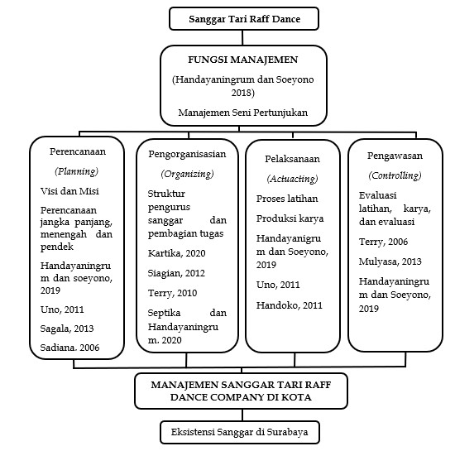
Figure 1.Framework of thinking

METHOD
This study uses a descriptive qualitative approach to understand and describe the management of the Raff Dance Company Dance Studio in maintaining its existence as a non-formal educational institution. A qualitative approach was chosen because it provides an in-depth overview of the phenomenon under study through data collection in the form of informants' words, actions, and experiences (Fadilla, 2023).
The research was conducted at the Raff Dance Company dance studio located in Surabaya and Sidoarjo, with learning centers spread across the Cak Durasim Cultural Park, City of Tomorrow (CITO) Mall, and Trans Icon Mall Surabaya. The research location was selected based on the studio's success in maintaining its existence for more than three decades as a dance arts education institution. The research was conducted over a five-month period, from July to November 2025.
The data sources in this study consist of primary and secondary data. Primary data were obtained directly through observation, interviews, and documentation, while secondary data were obtained from books, journals, documents, and various other relevant literature sources. Research informants included studio leaders, managers, trainers, and students involved in learning activities at the Raff Dance Company.
Data collection techniques included non-participant observation, in-depth interviews, and documentation studies. Observations were conducted by directly observing the learning activities and studio management without participating in the ongoing activities. Interviews were conducted to obtain information regarding the planning, organization, implementation, and supervision processes applied in studio management. Meanwhile, documentation was used to supplement the research data in the form of organizational structures, activity schedules, activity photos, and other supporting documents.
Data validity was tested using technical triangulation and source triangulation. Technical triangulation was conducted by comparing data obtained through observation, interviews, and documentation. Source triangulation was conducted by comparing information obtained from various informants to ensure the consistency and credibility of the research data.
Data analysis used the Miles and Huberman interactive model (Sugiyono, 2019), which includes three stages: data reduction, data presentation, and conclusion drawing. Data reduction was performed by selecting and focusing data according to the research objectives. The data was then presented in a systematic narrative description to facilitate interpretation. The final stage involved drawing conclusions based on the research findings, which had been analyzed continuously.

RESULTS AND DISCUSSION Overview of Raff Dance Company
The Raff Dance Company is a non-formal dance education institution located in Surabaya. Founded in 1994 by Arif Rofiq, the studio was originally named Citra Studio Tari. It later became Raff Dance Company after a change in its organizational structure. The name Raff, taken from the founder's name, serves as the institution's identity, a continuing development to this day.
As a non-formal educational institution, the Raff Dance Company serves as a platform for the preservation, development, and learning of dance, particularly traditional East Javanese dance. In addition to providing dance training, the studio actively organizes performances, creates dance works, and participates in various activities that support the development of arts and culture. These activities are one of the studio's efforts to maintain its existence amidst the development of the creative industry and the changing interest of the younger generation in traditional arts.
At its inception, the Raff Dance Company only offered classes to teenage students. However, growing public interest in dance education prompted the studio to open children's classes in 2000. This development demonstrates the studio's ability to adapt its learning programs to the community's needs while expanding the reach of its educational services.
[Placement of Image 4.1 Students of the Raff Dance Company Dance Studio]
Students at the Raff Dance Company consist of groups of children and adolescents divided into several levels. The learning process focuses not only on mastering dance techniques but also on instilling character values such as discipline, responsibility, courage, and teamwork. Each lesson begins with a warm-up to prepare students physically for the dance material being taught.
To support the learning process, the Raff Dance Company routinely creates new dance works annually, involving instructors in the creative process. Learning materials are tailored to the age and ability levels of the students. In addition to dance lessons, the studio also offers support classes such as makeup and bun-making to enhance students' competency in the performing arts.
All programs and activities are guided by the studio's vision and mission. The Raff Dance Company's vision is to become one of the best dance studios in Indonesia, particularly in East Java. Its mission is to be active, creative, and innovative in developing the art of dance and to play an active role in assisting the government in preserving and promoting Indonesian culture internationally.
[Placement of Image 4.2 Vision and Mission of the Raff Dance Company]
This vision and mission not only serve as guidelines for developing work programs but are also reflected in the organization's identity, embodied in the studio's logo. The Raff Dance Company logo represents the values of creativity, cultural preservation, professionalism, and organizational sustainability. These values serve as the foundation for the studio's various educational and arts development activities.
The Raff Dance Company's success in maintaining its existence for over three decades demonstrates the existence of a sustainable management system. This existence is demonstrated not only by the number of students and ongoing learning activities, but also by the studio's ability to develop programs, create works, and establish relationships with various parties who support the preservation of dance. This condition serves as the basis for further analysis of the implementation of management functions, including planning, organizing, implementing, and supervising at the Raff Dance Company.

Planning in the Management of the Raff Dance Company Dance Studio
Based on the research results, the Raff Dance Company Dance Studio has goals that are not only oriented towards entertainment (entertainment), but also on the preservation of traditional East Javanese dance, character building of students, increasing professionalism in the field of dance, and strengthening the institution's image in the community. These goals are realized through various learning programs, art performances, dance creation, and active involvement in cultural activities at the local and national levels. The success of the studio in maintaining its existence is supported by structured management, the availability of adequate facilities and infrastructure, and a financial management system managed professionally by the studio management.
The research results show that the planning function is the primary foundation in the management of the Raff Dance Company. All programs and activities are aligned with the studio's vision: to become one of the best dance studios in Indonesia, particularly in East Java. This vision is supported by a mission to actively, creatively, and innovatively develop dance and participate in efforts to preserve and promote Indonesian culture at the national and international levels.
The planning implemented by the Raff Dance Company includes long-term, medium-term, and short-term planning. Long-term planning is aimed at strengthening the studio's position as a non-formal educational institution that plays a role in preserving arts and culture while developing human resources in the field of dance. This effort is carried out through continuous student development, improving the quality of dance works, and expanding collaborative networks with various parties that support arts and culture development.
In its medium-term planning, the studio is focusing on organizational development towards a more professional arts institution. Strategies include strengthening human resource quality, standardizing learning systems, developing trainer competencies, and digitizing dance archives to document and preserve the studio's intellectual property. Furthermore, the studio is striving to expand partnerships with government agencies, educational institutions, and the tourism sector through participation in cultural festivals and utilizing digital media to enhance its performance.brand awareness.
The findings indicate that planning at the Raff Dance Company has reflected the management function as stated by G.R. Terry in Hasibuan (2014), namely as a process that begins with setting goals and preparing strategic steps to achieve them. Clear planning provides direction for all studio activities so that the programs implemented are not only oriented towards dance learning activities, but also towards organizational development and sustainable cultural preservation. Thus, planning is one of the important factors that supports the success of the Raff Dance Company in maintaining its existence as a non-formal educational institution in the field of dance. Raff Dance Company Dance Studio Management Organization
Organization at the Raff Dance Company is achieved through a clear division of tasks and responsibilities among each member of staff, according to their respective functions. The organizational structure serves as the foundation for implementing the studio's programs, ensuring that all activities run smoothly and effectively.
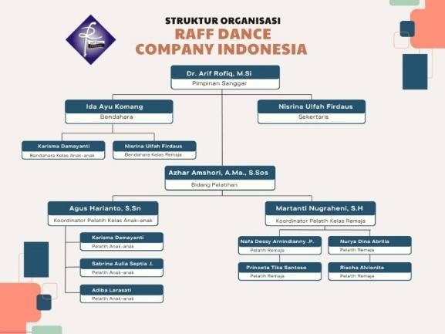
Figure 2.Organizational Structure of Raff Dance Company
Based on the research results, the studio leadership plays a key role in directing organizational activities, making strategic decisions, collaborating with external parties, and overseeing all implemented programs. In carrying out their management functions, the leadership is responsible for planning, organizing, implementing, and supervising studio activities.
Financial management is carried out by a treasurer, who is responsible for managing the income and expenditure of the studio's funds. In addition to the main treasurer, there are treasurers in each class who assist with student cash management and report periodically to the central treasurer. Meanwhile, the secretary is responsible for organizational administration, data archiving, activity scheduling, and documenting meeting results.
In the training area, the administrators are responsible for developing learning programs, determining dance materials, and monitoring the progress of trainers and students. Learning activities are also supported by children's and youth class coordinators, who are responsible for organizing practice sessions, coordinating instructors, and ensuring that the learning process follows the established program.
These findings indicate that the Raff Dance Company's organization has implemented a clear and structured division of tasks. This supports the effective implementation of the studio's programs and facilitates coordination among members in achieving organizational goals.

Implementation of Raff Dance Company Dance Studio Management
Management at the Raff Dance Company is carried out based on a pre-planned program. Activities include accepting new students, dance training, creating works, digitizing, collaborating, certification, staging, and implementing the curriculum and teaching methods. All of these activities aim to support the learning process and develop students' potential in the field of dance.
New student admissions are held annually and are open to children and teenagers interested in dance. Registration involves filling out a form containing student and parent information as part of the studio's administrative process.
Training is the main activity, held routinely three times a week, on
Wednesdays, Saturdays, and Sundays. Each session lasts approximately two hours and begins with a warm-up or physical exercise to prepare the students physically. The material presented is dominated by traditional East Javanese dance, supported by lessons on makeup and costume use. In addition to developing dance techniques, the training activities also instill the values of discipline, responsibility, cooperation, and a love of regional culture.
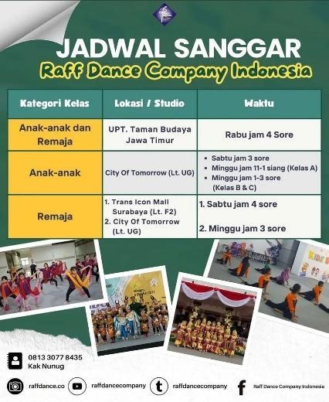
Figure 3.Raff Dance Company Dance Studio Practice Schedule
As part of its creative development, the Raff Dance Company regularly creates dance works and operettas featuring Indonesian folklore. These works are presented in engaging and contemporary performances. Some of the works previously performed include:Deer Steals Cucumbers, Ande-Ande Lumut, Conch and the Witch Grandmother, as well as The Adventures of Timun Mas. One of the proud achievements is the performance of a children's opera.Golden Snail and the Witch Grannyat TMII Jakarta.
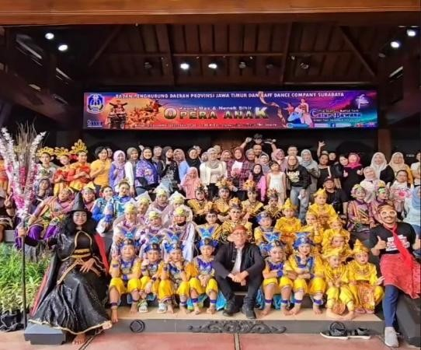

Figure 4.Documentation of Children's Opera Performance
Studio studios are also leveraging technological advancements through the digitalization of their activities. Social media platforms like Instagram, TikTok, YouTube, and Facebook are used for promotion, communication, information, and documentation. Through social media, the public can learn about studio activities, practice schedules, new student registrations, and even their various achievements.
In its implementation, the Raff Dance Company also collaborates with various parties, such as government agencies and cultural institutions, as needed. This collaboration takes the form of workshops, training, and performances that support the preservation of arts and culture.
In addition to routine practice, the studio also conducts periodic competency exams as a form of learning evaluation. Students who meet the assessment standards will receive a certificate and can advance to the next level. To enhance their performing experience, students are also frequently involved in various performances outside the studio, thereby developing their skills and confidence.
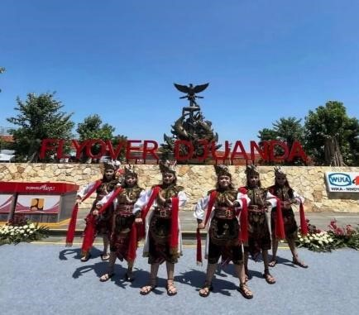

Figure 5.Performances Outside the Studio
The Raff Dance Company's curriculum is structured in stages based on the age and abilities of the students. The material provided focuses not only on mastering dance techniques but also encompasses cultural understanding, character development, makeup, and performance preparation. Students are divided into children's and teen classes, each with its own level of development.
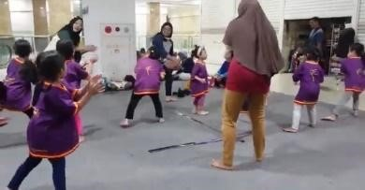

Figure 6.Children's Class Routine Practice
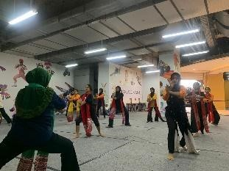

Figure 7.Teen Class Routine Training
The learning methods used include demonstrations, hands-on practice, movement repetition, and guidance from trainers. In children's classes, learning methods are tailored to the developmental stage of the students through play-based approaches and movement exploration. Meanwhile, in adolescent classes, learning emphasizes technique mastery, character development, group collaboration, and independent development of work at the assistance level.
Management at the Raff Dance Company has been running according to the planned program. Activities are not only focused on improving dance skills but also on developing students' character, creativity, and cultural understanding as part of efforts to preserve traditional dance.

Raff Dance Company Dance Studio Supervision
Supervision is a management function aimed at ensuring that all programs and activities run according to established plans. Based on research findings, the supervision system at the Raff Dance Company Dance Studio is implemented directly by the studio leadership across all aspects of activities, from the learning process and organizational management to performances. Supervision is conducted to maintain program quality and ensure the studio's goals are optimally achieved.

Arts Education Supervision
Oversight in the arts education sector is carried out through periodic learning evaluations, conducted every six months. These evaluations aim to measure student development during the dance training process. Aspects assessed include movement technique mastery, material understanding, discipline, expression, and emotional expression in performing the dance work.
In addition to regular evaluations, trainers also provide direct feedback during the training process. Through this mechanism, students can assess their progress and address any identified deficiencies. For trainers, evaluation results serve as a reflection for adjusting teaching methods and materials to more effectively achieve arts education goals.

Organizational and Infrastructure Supervision
Supervision is also carried out over the management of the studio's organization and infrastructure. The studio leadership directly monitors the implementation of the management's duties, particularly those related to administration and financial management. This oversight aims to maintain administrative order and ensure that funds are used in accordance with the studio's operational needs.
Furthermore, the facilities and infrastructure used in practice and performances are also subject to oversight. Regular inspections are conducted on practice rooms, costumes, dance props, and various other supporting equipment to ensure they remain in suitable condition.

Performance Supervision
Performance supervision is carried out throughout the entire performance process, from preparation to execution. After the performance, the leaders and coaches evaluate the students' performances to identify strengths and areas for improvement.
In addition to evaluating students, the studio management also holds evaluation meetings to discuss the implementation of activities, any challenges encountered, and any improvements needed for future activities. Through these evaluations, the studio can continuously improve the quality of its performances and maintain established learning standards.
Overall, supervision at the Raff Dance Company is carried out through direct observation, periodic evaluations, and coordination between management. This oversight system plays a crucial role in maintaining the quality of learning, organizational effectiveness, and the sustainability of the studio's programs, thus supporting the studio's existence as a non-formal dance educational institution.

CONCLUSION
The dance learning management at the Raff Dance Company has implemented management functions that include planning, organizing, implementing, and supervising the implementation of dance arts education. Planning is carried out through the preparation of learning programs, materials, practice schedules, and supporting activities that are aligned with the studio's vision and mission. Organization is carried out through a clear division of tasks and responsibilities for each administrator and trainer so that studio activities can run in a coordinated manner. The implementation of learning is carried out through routine practice, performances, creation of works, use of digital media, collaboration, and evaluation of student competencies. Supervision is carried out directly by the studio leader through learning evaluations, supervision of organizational activities, facilities and infrastructure, and implementation of performances. This supervision serves to ensure that all programs run according to the established objectives. The implementation of these management functions supports the sustainability of dance learning, the development of student abilities, and the preservation of traditional East Javanese dance. The success of the Raff Dance Company in maintaining its existence demonstrates that structured management is an important factor in the development of non-formal educational institutions in the field of dance.

AUTHOR CONTRIBUTION
Provide a brief and clear description of each member's contribution and role in the research.
This does not apply if the research involves a single member or if there are no study members. Thank-you note
The author expresses gratitude to the presence of Allah SWT for all His grace and gifts so that this article can be completed well. The author also expresses gratitude to Mrs. Dr. Sn. Retnayu Prasetyanti Sekti, M.Si. as the lecturer in charge of the Sociology Anthropology of Art course who has provided guidance, direction, and insight during the lecture process so that the author can understand and study art phenomena from a sociological and anthropological perspective.

The author also expresses his gratitude to the Undergraduate Program in Drama, Dance, and Music Education at Surabaya State University for providing the opportunity and learning facilities that supported the preparation of this article. He also extends his gratitude to the various parties who assisted, both directly and indirectly, in completing this assignment.

The author acknowledges that this article still has limitations. Therefore, constructive criticism and suggestions are highly appreciated for the improvement of future scientific works.

REFERENCE
Byrnes, W. J. (2022). MANAGEMENT AND THE ARTS. by Routledge.
Chong, D. (2002).Arts Management. Routledge.
Dewi, V. N. (2018).MANAGEMENT OF THE TAYUB ADI LARAS PERFORMING ARTS IN TALOK VILLAGE, TUREN DISTRICT, MALANG REGENCY.
Handayaningrum, W. (2023). PERFORMING ARTS PRESERVATION MANAGEMENT THROUGH ARTS STUDIO IN EAST
JAVA.Headmaster Strengthening.
Ramadhan, K., & Handayaningrum, W. (2020). ARTS EDUCATION
MANAGEMENT FOR STREET CHILDREN IN THE PENSI STUDIOS,
BONDOWOSO REGENCY.Journal of Dance and Dance
Education, 9(2), 206–218.
Septika, R. R., & Handayaningrum, W. (2020). MANAGEMENT OF THE CHANDRA KIRANA TRADITIONAL ARTS ASSOCIATION AT STATE
MIDDLE SCHOOL 1 KERTOSONO.Journal of Dance and Dance
Education, 9(1), 95–110.
Sugiyono. (2019).Quantitative, Qualitative, and R&D Research Methods. Alfabeta. Bandung (p. 133).

