
Development of a Digital-Based VIDEO TUTORIAL for the Dance “LENGGANG SURABAYA” as Dance Learning in the Studio


E-ISSN 2338-6770

Date of submission :-
Date of revision :-
Date received :-

Correspondence Address:
Gedung T11lt 2 Prodi. Pendidikan Sendratasik, Fakultas Bahasa dan Seni Universitas Negeri Surabaya, Kampus Unesa Lidah Wetan, Kecamatan Lakarsantri, Surabaya, Jawa Timur 60213

Virdha Annora Zavira¹, Setyo Yanuartuti²

1Surabaya State University, Surabaya, Indonesia
2 Unesa University, Surabaya, Indonesia
Email: virdha.22040@mhs.unesa.ac.id1, setyoyanuartuti@unesa.ac.id2

Abstract: The research was conducted because the teaching of Lenggang Surabaya dance in several studios is still facing challenges due to the lack of complete digital teaching media, making it difficult for students to understand movement details, memorize sequences, and match movements with the music rhythm. This study aims to describe the development process, produce quality instructional video media, and find out its practicality in dance learning at studios. This research uses the ADDIE development method, which includes the stages of analysis, design, development, implementation, and evaluation. The research subjects consisted of pre-teen and teen students at the Brangwetan studio. Data collection was carried out through observation, interviews, questionnaires, and documentation. The study results showed that the instructional video developed received a very feasible validation score of 89.13% and was very practical with a score of 86.36%. Therefore, the Lenggang Surabaya dance instructional video is effective for supporting dance learning, enhancing students' creativity, and helping preserve local culture.

Keywords: Development, Learning Media, Video, Lenggang Surabaya Dance

1. INTRODUCTION
The Lenggang Surabaya dance is a traditional welcoming dance from Surabaya, created by Dimas Pramuka Admaji in 1995. This dance is an adaptation that develops traditional arts like the Tanda’an Dance (Ledek Tayub) and Madura Sandur. Lenggang is performed by several female dancers moving gracefully and beautifully, showcasing smooth, orderly, and neat movements that symbolize beauty and harmony. It was originally created to enliven Surabaya’s anniversary celebrations, based on a request from the mayor of Surabaya at the time. The Lenggang Surabaya dance is important to be taught in studios because it serves as a means of preserving local culture while also passing on Surabaya's identity values to the younger generation amidst globalization. Mastering this dance also equips students to perform at various art events and become cultural ambassadors introducing Surabaya's uniqueness to the wider public, including in competitions like the 2025 Indonesian Children's Expression Stage at Cak Durasim Cultural Park.
Learning the Lenggang Surabaya Dance in several studios faces major challenges, mainly the lack of structured digital teaching media. The available video media are short versions and don’t include the names or techniques of each movement style completely. The teaching methods are still traditional—mostly demonstration—which makes practice less efficient. There’s also limited practice time due to school schedules, so students easily forget and instructors have to repeat the material. Many students haven’t reached the desired quality of movement or synchronization with the music because the movements are fast and complex. Naysilla, a student at Brangwetan studio, said, 'I often forget the material when the lesson ends and don’t really master the techniques that have been taught at the studio, because the variations of the Lenggang Dance are quite varied and a bit complicated for me' (Naysilla, interview September 7, 2025). That statement was also added by one of the leaders of the Brangwetan studio, “actually, students are quite interested in learning on their own via their phones, but the tutorial videos on YouTube are only short versions and don’t fully cover the names of each part” (Ari Mukti, interview, January 16, 2026). As a result, about 75% of students have low understanding and their performances are often not optimal.
In today's digital era, where technology has become an integral part of daily life, developing learning media that is more interactive, structured, and easily accessible is very necessary to improve the quality of the learning process at the Studio. To address this issue, innovation is needed in the use of learning media that can boost student engagement. One alternative that can be used is digital-based tutorial videos for the Lenggang Surabaya dance. Digital-based tutorial videos have the advantage of combining various multimedia elements such as text, images, and audio, and come with navigation features that allow interaction between students and the learning material. Digital-based tutorial video learning media allows students to understand material both visually and through audio, making it easier to grasp and clarify the lessons. In addition, video media can be used as a flexible learning tool, accessible repeatedly according to students' needs, which fosters greater interest and enthusiasm in the learning process (Sari, 2021:1). Tutorial video media is a learning tool that combines audio and visual elements to deliver learning messages in a systematic and structured way. According to Riyana (2007), this media presents concepts, principles, procedures, and applications of knowledge through a series of moving images accompanied by sound, helping students to understand the material. Tutorial videos are usually designed to resemble a live teaching process by a tutor who provides detailed step-by-step guidance, making it easier for students to understand the material independently.
The development of digital technology has opened up new opportunities in the process of learning dance. In many studios, limited practice time, participant absences, and variations in instructor skills often hinder the achievement of optimal dance techniques and interpretations. To address these challenges, this study developed a digital-based dance tutorial video for “Lenggang Surabaya” as an alternative learning tool in studios. The aim of the research is to produce an effective, easily accessible video learning media that offers something new through detailed visual guidance covering movement techniques, choreography structure, and expressive aspects, so that students can learn dance both independently and with guidance. In addition, the study evaluates the feasibility and practicality of the product as well as its impact on students' understanding and dance skills. It is hoped that this media can minimize issues of ineffective learning in the studio, address attendance problems and limited practice time, as well as improve the overall quality of dance learning; at the same time, it is open for the wider public to access so that “Lenggang Surabaya” can be learned outside the Surabaya studio environment.
The use of interactive media has been proven to increase students' motivation, participation, and learning outcomes. However, the use of digital-based tutorial videos needs to be designed properly so that it is not one-sided. Therefore, media development must pay attention to the principles of interactive learning design, such as presenting material systematically, providing exercises, and giving feedback to students. With good design, digital-based tutorial videos can be a solution to enhance students' understanding of the Tari Lenggang Surabaya material in dance learning. Based on this explanation, this study aims to describe the process, describe the quality of the media, and describe the effectiveness of developing digital-based tutorial video learning media for Tari Lenggang Surabaya in dance learning at the studio.

2. METHODS
This study uses research and development (R&D) to create learning media in the form of tutorial videos for the Lenggang Surabaya dance. Sugiyono (2018) argues that research and development is a research model aimed at producing new products, which are then tested for feasibility and practicality with the hope of improving the developed product. The development model used refers to the ADDIE model, which consists of five stages: analysis, design, development, implementation, and evaluation (Branch, 2009).
The analysis stage is carried out to identify problems and learning needs through observations, interviews with the studio leaders, instructors, and students, as well as the learning process in the studio to find out their level of understanding of the Lenggang Surabaya Dance material. The analysis results showed that students had difficulty understanding the Lenggang Surabaya Dance material and there were limitations in media and learning hours. The design stage was carried out by designing the structure and appearance of learning media tailored to the characteristics of the students and the material. According to Branch (2009), the design aims to create meaningful learning experiences through engaging presentation strategies, communicative visual design, and interaction that encourages user involvement. The digital-based Surabaya Lenggang Dance tutorial video is designed to include movement variations systematically and completely, equipped with visual and audio elements, as well as interactive features like navigation. At this stage, a validation questionnaire is also designed for media validators, content validators, and language validators. The development stage is the process of creating the digital-based tutorial video using the Davinci Resolve platform. The resulting product is then validated by media, content, and language experts to assess its feasibility. The validation results are used as a basis for revising the media. The implementation stage is done through trials with students of Brangwetan studio in the Pre-Teen and Teen classes. At this stage, the media is used in learning activities to see how well it can be implemented and how users respond. The evaluation stage is carried out formatively at each stage of development based on input from validators and trial results, so that media suitable for use in learning at the studio is obtained. The research questionnaires used include validation sheets from content and media experts, as well as questionnaires for studio leaders, trainers, and students, which are arranged using a 4-point Likert scale. Data collection techniques are carried out through observation, interviews, questionnaires, and documentation as support.
The data obtained were analyzed using qualitative and descriptive quantitative analysis techniques. Qualitative data, such as suggestions and feedback from validators, were analyzed descriptively, while quantitative data were analyzed by calculating the percentage of scores to determine the feasibility and effectiveness of the learning media. The scores obtained were then summed and the percentage calculated using the formula:

Precentage = The Score Obtained x 100%
Maximum Score

3. RESULTS AND DISCUSSION

3.1 Results

Development Process of Digital-Based Lenggang Surabaya Dance Tutorial Videos as Dance Learning in Studios
The development process of the learning media for Surabaya Lenggang Dance tutorial videos was carried out using the ADDIE model, which includes five stages: analysis, design, development, implementation, and evaluation. At the analysis stage, it was found that learning Surabaya Lenggang Dance in some studios faced obstacles due to the lack of complete digital teaching media, making it difficult for students to understand movement details, memorize sequences, and synchronize movements with the music rhythm. Observations showed that 75% of students had trouble learning the Surabaya Lenggang Dance material. In the design stage, the media structure was created, including selecting media, content, interactive navigation, and a video scenario in the form of a storyboard. The application chosen by the researcher is Davinci Resolve. This app will make the video editing process easier by focusing on visual aspects, readability, and interactivity. At this stage, validation questionnaires are also designed for media experts, content experts, and language experts, as well as questionnaires for students and trainers. The development stage produces a product in the form of a digital-based Tari Lenggang Surabaya tutorial video, complete with audio, animation, and quizzes with feedback. Here’s an overview of the Tari Lenggang Surabaya tutorial video media:

Table 1. Video tutorial media display of the Lenggang Surabaya dance

No. | Tampilan | Keterangan
1. | 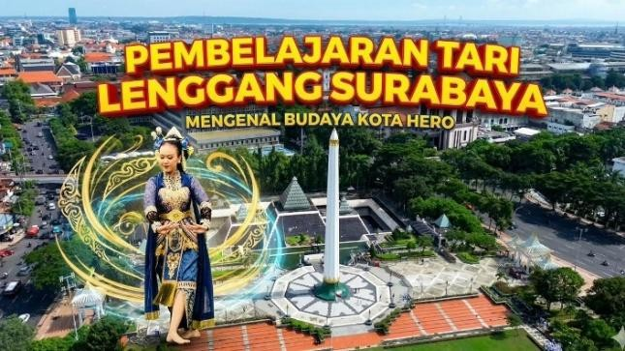 | The display on the initial video cover shows an interesting image and presents the title of the Lenggang Surabaya dance learning video in each of its parts.
2. | 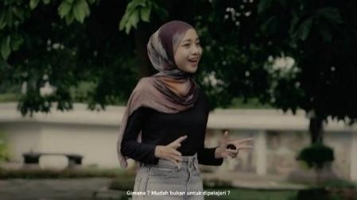 | The opening greeting and the introduction of the topic to be discussed use a narrator's voice, while the setting used is an open area.
3. | 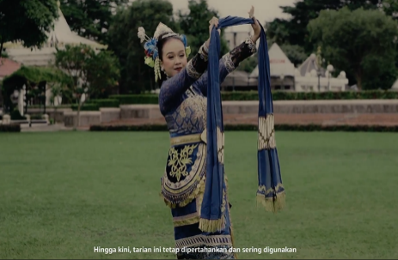 | Video Display Part 1: Introduction to the Introduction of Lenggang Surabaya Dance (Interpretation Similarities), Interpretation of Supporting Elements of Lenggang Surabaya Dance.
4. | 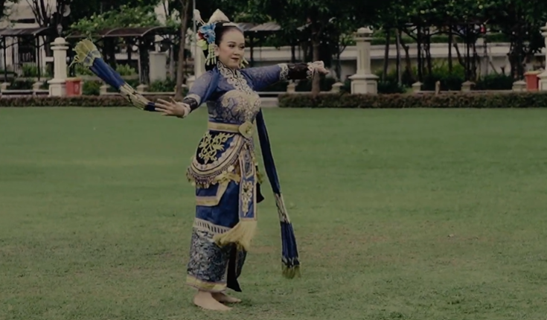 | Video Display Part 2: The Lenggang Surabaya Dance performance from beginning to end using supporting elements like costumes, makeup, and accompaniment.
5. | 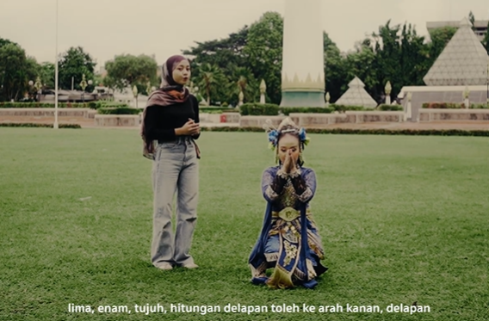 | Video Display Part 3: Tutorial of Various Forward Movement Techniques at the Goal, Left Naji Connector, Sembahan, Shoulder Movement Nyirig, Layar-layaran, Left Push Insert Connector, Hand Snatch Nyempurit, Seblak Sampur Connector, Body Shake Gejug Nggelebag, Nyiji Movement.
6. | 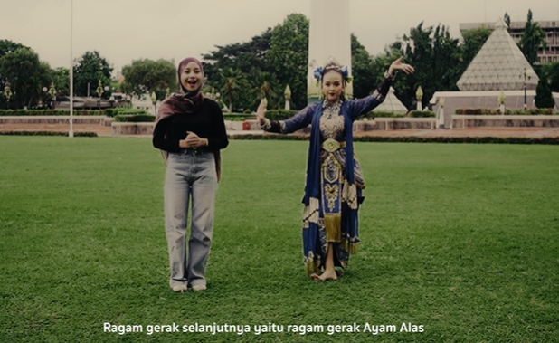 | Video Display Part 4: Tutorial on Movement Techniques Sir-Kosir, Jogetan Egol Ngolong Sampur, Ayam Alas, Jogetan Lenggang, Petik Tanjung Ulik Mburi, Bubaran Gawang, Connecting Singget Tanjak.
7. | 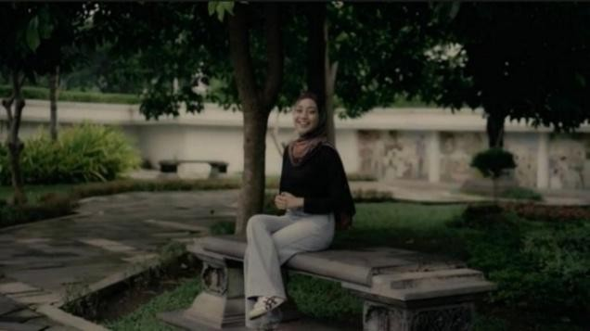 | Video Display Part 4: Tutorial on Movement Techniques Sir-Kosir, Jogetan Egol Ngolong Sampur, Ayam Alas, Jogetan Lenggang, Petik Tanjung Ulik Mburi, Bubaran Gawang, Connecting Singget Tanjak.
8. | 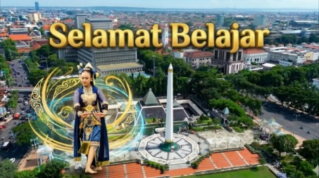 | The final video cover display shows an interesting image and features the text 'happy learning'.

The media was then validated by media experts, subject matter experts, and language experts. The implementation stage was carried out with pre-teen and teen students at the Brangwetan workshop, involving 13 students. The learning took place over three sessions using digital-based tutorial videos, and the students showed enthusiasm and active participation in the learning activities. The evaluation stage was conducted at each stage of the media development process. The evaluation results were used to revise the media for better optimization.

The Feasibility of Digital-Based Lenggang Surabaya Dance Tutorial Video as Dance Learning in Studios Reviewed from Media Graphics, Material, and Language
Table 2. Media Expert Validation Result: Tri Cahyo Kusumandyoko, S.Sn., M.Ds.

No | Assessment Aspects | Score | Max  Score
1 | Image quality consistency in the video | 4 | 4
2 | Appropriate lighting during recording | 4 | 4
3 | Accuracy of camera angles | 4 | 4
4 | Consistency of image composition | 3 | 4
5 | Stable camera movement | 3 | 4
6 | Smooth transitions between angles or shots | 4 | 4
7 | Speed of movement in the video | 4 | 4
8 | Video editing | 3 | 4
9 | Sound quality | 4 | 4
10 | Balanced audio volume between music and other sounds | 4 | 4
11 | Synchronization between dance movements and music accompaniment | 3 | 4
12 | Navigation buttons or features are easy to use | 4 | 4
13 | Practicality of each part of the video | 3 | 4
14 | Proportional duration | 4 | 4
15 | Attractive initial screen design | 3 | 4
16 | Color display and graphic elements | 4 | 4
17 | Video identity display | 3 | 4
18 | Video format easily playable on devices | 4 | 4
19 | Practical video media | 3 | 4
Amount |  | 68 | 76

The media expert validation results received a score of 68 out of a maximum score of 76, with an eligibility percentage of 89.47%, so it falls into the 'very eligible' category.

Table 3. Material Expert Validation Result: Dra. Enie Wahyuning Handayani, M.Si.

No | Assessment Aspects | Score | Max Score
1 | Creative and innovative | 3 | 4
2 | Material relevance | 4 | 4
3 | Accuracy of historical information | 4 | 4
4 | Orderliness of material presentation | 3 | 4
5 | Material structure | 4 | 4
6 | Integration of verbal and visual motion explanations | 4 | 4
7 | Clarity of material delivery | 3 | 4
8 | Material variety | 3 | 4
9 | Can be used as a guideline | 3 | 4
10 | Shows background | 3 | 4
11 | Explains types of movements | 3 | 4
12 | Accuracy of movement technique | 4 | 4
13 | Accuracy of movements with music | 4 | 4
14 | Accompaniment Expression skills | 4 | 4
15 | Accuracy of transitioning from one movement to the next | 4 | 4
16 | Contains complete material | 3 | 4
17 | Accuracy of presentation | 4 | 4
18 | Instructions for repeating the material | 3 | 4
Amount |  | 63 | 72

The validation results from the material experts scored 68 out of a maximum score of 72, giving it an eligibility percentage of 87.5%, so it falls into the 'very eligible' category.

Table 4. Language Expert Validation Result: Dr. Abdul Kholiq, S.Pd., M.Pd.

No | Assessment Aspects | Score | Max Score
1 | Appropriateness of using traditional art terms | 4 | 4
2 | Language accuracy | 3 | 4
3 | Consistency of language | 4 | 4
4 | Clarity of content delivery | 4 | 4
5 | Readability of text | 3 | 4
6 | Appropriateness of language | 4 | 4
7 | Compliance with Indonesian language rules | 3 | 4
8 | Effective language | 4 | 4
9 | Integration of spoken and visual movement | 4 | 4
Amount |  | 33 | 36

The validation results from the linguists scored 33 out of a maximum score of 36, giving it an eligibility percentage of 91.67%, so it falls into the 'very eligible' category.
Table 5. Final Media Eligibility Score

No | Assessment Aspects | Score | Max Score
S | Media Validator | 68 | 76
2 | Content Validator | 63 | 72
3 | Language Validator | 33 | 36
Amount |  | 164 | 184

The final recap of validation by media experts, material experts, and language experts scored 164 out of a maximum score of 184, with a feasibility percentage of 89.13%, so it falls into the 'very feasible' category.

The Practicality of Digital-Based Video Media Tutorials for Lenggang Surabaya Dance as Dance Learning in Studios According to Students, Studio Leaders, and Coaches

Table 6. Student Survey Results

No | Assessment Aspects | Score | Max Score
1 | Interest increased | 47 | 52
2 | Learning is engaging | 43 | 52
3 | Understanding interpretations | 47 | 52
4 | Media is not boring | 43 | 52
5 | Creative and imaginative | 43 | 52
6 | Easy to learn | 46 | 52
7 | Can be used anytime, anywhere | 47 | 52
8 | Easy to apply | 49 | 52
9 | Language is easy to understand | 44 | 52
10 | Can be used without supplementary teaching materials | 41 | 52
Amount |  |  | 86,73%

The average percentage result from the percentage scores of each point is 86.73% with the predicate 'Very Practical'.

Table 7. Results of the Studio Leader Survey: Ari Mukti Selijorini, S.Pd.

No | Assessment Aspects | Score | Max Score
1 | Interest increased | 3 | 4
2 | Learning is engaging | 4 | 4
3 | Understanding interpretations | 3 | 4
4 | Media is not boring | 4 | 4
5 | Creative and imaginative | 3 | 4
6 | Easy to learn | 3 | 4
7 | Can be used anytime, anywhere | 4 | 4
8 | Easy to apply | 4 | 4
9 | Language is easy to understand | 4 | 4
10 | Can be used without supplementary teaching materials | 3 | 4
Amount |  |  | 87,5%

The average percentage result from the percentage scores of each point is 87.5% with the rating of 'Very Practical'.

Table 8. Survey Results of Coach Difa Pusparini, S.Pd.

No | Assessment Aspects | Score | Max Score
1 | Interest increased | 3 | 4
2 | Learning is engaging | 3 | 4
3 | Understanding interpretations | 3 | 4
4 | Media is not boring | 4 | 4
5 | Creative and imaginative | 4 | 4
6 | Easy to learn | 4 | 4
7 | Can be used anytime, anywhere | 4 | 4
8 | Easy to apply | 3 | 4
9 | Language is easy to understand | 3 | 4
10 | Can be used without supplementary teaching materials | 3 | 4
Amount |  |  | 85%

The average percentage of the scores for each point is 85% with a rating of 'Very Practical'.

Table 9. Final Score of Media Practicality

No | Assessment Aspects | Score | Max Score
1 | Student Response | 45 | 76
2 | Studio Leader Response | 35 | 72
3 | Coach Response | 34 | 36
Amount |  |  | 86,36%

The final recap results from students' responses, the studio leader, and the coach scored 114 out of a maximum score of 132, with a feasibility percentage of 86.36%, falling into the 'very feasible' category.

3.2 Discussion

The study shows that interactive PPT learning media developed using the ADDIE model can help tackle issues in dance learning at the Brangwetan studio, especially for the Lenggang Surabaya Dance material. During the analysis phase, it was found that learning with little media lowered students' motivation and understanding. This totally aligns with learning theories that say learning that doesn't actively engage students is usually less effective.
During the development stage, the media is designed by combining visual, audio, and interactive elements. Presenting the material systematically, along with navigation features and interactive quizzes, has been shown to boost student engagement. This shows that interactive media can create a more meaningful learning experience.
The validation results from media experts, material experts, and language experts show that the media falls into the very feasible category, reaching a final score of 89.13%. This indicates that the media meets the aspects of material suitability, presentation systematics, display quality, and accurate language use. This finding aligns with the notion that good learning media should be organized systematically and match the characteristics of the students.
The practicality of the media, which reached a final score of 86.36%, shows that using digital-based tutorial videos can boost students' understanding, interest, and activeness in learning at the studio. Students not only receive the material passively from the instructor but can also improve their understanding independently, in line with constructivist theory.
Even so, this study has limitations because the trial was only conducted on a limited scale. Therefore, it is recommended that future research test the media on a larger scale and use more comprehensive learning outcome measurements.

4. CONCLUSION

Based on the research results and discussion, it can be concluded that the learning video media for the Tari Lenggang Surabaya dance was successfully developed using the ADDIE model, which includes the analysis, design, development, implementation, and evaluation stages. During the development stage, the product was prepared based on students' needs, validated by media, material, and language experts, and revised according to the input from the validators until it produced learning media suitable for use. The quality of the Tari Lenggang Surabaya learning video was considered very feasible with a final score of 89.13%. This result shows that the developed media can support dance learning, particularly in helping students understand movements, enhance imagination, creativity, and dance skills. In addition, this video is also considered very practical with a final score of 86.36%, meaning it is easy to use, easy to understand, and meets the needs of students, studio leaders, and instructors.

AUTHOR'S CONTRIBUTION

The first author of this article is the main researcher who was directly involved in the entire research process, from designing the concept, developing the methodology, collecting and analyzing data, to writing the manuscript from the initial draft to the final revisions. Meanwhile, the second author acted as a mentor who provided guidance and supervision throughout the research, validated the research results, and offered feedback through the manuscript review and editing process.

THANK YOU

With expressions of appreciation and hope, the Author would like to thank everyone who has contributed to this research, including the supervising lecturers, studio leaders, respondents, and other colleagues. The help and support provided have been very valuable. The Author hopes that the results of this research can contribute to improving the quality of dance education and can be useful to the wider community.

REFERENCE

Achmadi, A., and Prasetyo, Y. 2023. Feasibility of Material, Media, and Language Aspects in Textbook Development. Jurnal Pendidikan Seni Log, 5(1), 12–23. (https://ejournal.unibabwi.ac.id/index.php/semnassenalog/article/download/158/114/279).
Arsyad, A. (2019). Learning Media. Depok: Rajawali Pers.
Asyhar, R. (2012). Creatively Developing Learning Media. Jakarta: Directorate General of Higher Education, Ministry of National Education.
Bastoni, P., and Sulistyowati, E. 2021. Validity and Practicality of Android Application Learning Media. UIN Suska Riau Repository.
Constructivism Theory According to Jean Piaget. 2025 (https://id.scribd.com/document/716629136/Teori-Konstruktivisme-Menurut-Jean-Piaget).
Daryanti, D. (2019). The role of media in learning arts, culture, and skills. Edukatif Journal: Journal of Educational Sciences, 1(2), 123–135. https://edukatif.org/index.php/edukatif/article/view/46
Hastuti, W., & Sulistyowati, E. (2024). Interactive multimedia as a medium for learning traditional dance.
Implementation of Constructivist Learning Theory in the Views of Jean Piaget and Lev Vygotsky. 2021. Bina Nusantara University (BINUS), Elementary School Teacher Education Program. (https://pgsd.binus.ac.id/2021/12/07/implementasi-teori-belajar-konstruktivisme-dalam-pandangan-jean-piaget-lev-vygotsky/).
Jannah, M., and Fauzi, A. (2023). Data from Validation by Subject Matter Experts, Media Experts, Language Experts, and Education Practitioners. Educational Journal.
Sari, N. (2021). The Effect of Video-Based Learning Media on Students' Learning Interest.
Sari, P., & Kusuma, I. W. (2021). Dance education learning model for elementary school/Islamic elementary school students. Journal of Basic Education, 12(1), 67–78. https://media.neliti.com/media/publications/55899-ID-none.pdf
Shofa, A. M. I. A., Kodir, A., Alfaqi, M. Z., and Subekti, A. (2019). Wanua Nusantara: The Practice of Instilling Pancasila Values Among Young Generations. Journal of Praxis and Social Dedication, 2(1), 1(http://journal2.um.ac.id/index.php/jpds/article/view/6755/3788).
Slameto. 2010. Learning and the Factors That Influence It. Jakarta: PT. Asdi Mahasatya
Soedarso. 2006. Trilogy of the Art of Creating Existence and the Usefulness of Art. Yogyakarta: Publishing Agency.
Soehardjo. 2012. Art Education: From Concept to Program Book One. Malang: Bayumedia Publishing.
Sudjana, Nana. 2013. Basics of the Teaching and Learning Process. Bandung: Sinar Baru Algesindo Offset.
Sugiyono. 2018. Quantitative, Qualitative, and R&D Research Methods. Bandung: Alfabeta.
Suharto, Ben. 1985. Jacqueline Smith: Dance Composition A Practical Guide for Teachers.

Winaryati, E., Musarif, M., Mardiana, & Suwahono. (2021). Circular Model of RD&D (Educational and Social RD&D Model). KBM Indonesia Publisher.
Zamsiswaya, Z., Syawaludin, S., and Syahrizul, S. 2024. Development of the ADDIE Model (Analysis, Design, Development, Implementation, Evaluation). Tambusai Education Journal, 8(3), 46363-46369. (https://jptam.org/index.php/jptam/article/download/22709/15494/38554).

