
THE APPLICATION OF DEMONSTRATION METHOD FOR THE SONG “YAMKO RAMBE YAMKO” IN THE KIDUNG ARUTALA CHOIR AT WARU STATE HIGH SCHOOL NO. 1, SIDOARJO


E-ISSN 2338-6770

Date of submission :-
Date of revision :-
Date received :-

Correspondence Address:
Gedung T11lt 2 Prodi. Pendidikan Sendratasik, Fakultas Bahasa dan Seni Universitas Negeri Surabaya, Kampus Unesa Lidah Wetan, Kecamatan Lakarsantri, Surabaya, Jawa Timur 60213

Martynda Elfrida Donna Rossa ¹, Senyum Sadhana ²

1Surabaya State University, Surabaya, Indonesia
2Surabaya State University, Surabaya, Indonesia
Email: martynda.22084@mhs.unesa.ac.id, senyumsadhana@unesa.ac.id

Abstract: This study aims to analyze the application of the demonstration method in the Kidung Arutala choir practice at Waru Sidoarjo State High School 1 for the song “Yamko Rambe Yamko.” The study employs a descriptive qualitative approach, with the choir members and the choir director as the subjects. Data were collected through observation, interviews, documentation, and literature review, then analyzed through data reduction, data presentation, and drawing conclusions using source and technique triangulation validity tests. The results of the study indicate that the demonstration method effectively enhances members’ activity, engagement, and understanding of vocal and musical techniques. Choir members actively participated by observing, imitating, and practicing the techniques demonstrated by the coach. Improvements were observed in the behavioral, affective, and psychomotor domains, including discipline, cooperation, responsibility, articulation, breath control, intonation, and musical expression. The method was implemented through step-by-step guidance, repeated demonstrations, and individual and group approaches. Thus, the demonstration method proved effective in improving the vocal and musical abilities of the members of the Kidung Arutala choir.

Keywords: Demonstration Method, choir, vocal techniques, Yamko Rambe Yamko

1. INTRODUCTION
Choral Music Choral music is a form of vocal art performed in a group by combining various types of voices into a single, cohesive harmony. In practice, choral music not only requires individual singing ability but also demands cooperation, vocal balance, rhythmic precision, and musical harmony among members. Choral music is also known as a “choir,” a term derived from Dutch. Generally, a choir can be understood as a vocal music ensemble consisting of a number of singers who perform songs harmoniously under the direction of a conductor. The development of choral music has been ongoing since ancient times and has continued to evolve in line with cultural developments and the needs of society. In ancient Greece, choral music was used in religious rituals and theatrical performances. From the Middle Ages through the Renaissance in Europe, choral music flourished through polyphonic music, which introduced the concept of harmony across multiple vocal layers. Entering the Baroque era, the use of accompanying instruments began to be integrated into choral performances, giving rise to major forms of musical works such as cantatas and oratorios. In modern times, choral music is no longer limited to church music but has expanded into various musical genres such as classical, pop, jazz, and folk songs.
The development of choral music in Indonesia has shown significant progress. Choral groups have flourished not only in church settings but also in schools, universities, arts communities, and independent organizations. Various choral festivals and competitions held at the regional, national, and international levels have helped drive improvements in the quality of choral groups in Indonesia. Today, choral music has become a key medium for developing students’ talent, creativity, and character in the field of music. The city of Surabaya is one of the areas in East Java where choral music has developed quite rapidly. Various choral festivals and competitions are regularly held and attended by choral groups from diverse backgrounds, ranging from schools to the general public. One major event that has garnered significant attention is the Surabaya World Choral Festival, which features participants from various countries. This situation demonstrates that Surabaya has an active musical environment that supports the development of choral art.
In the field of education, choir activities play a vital role as a means of developing students’ musical abilities, creativity, discipline, cooperation, and sense of responsibility. Through choir activities, students not only learn singing techniques but also come to understand the values of togetherness and unity. Therefore, the learning process in choir activities requires appropriate methods to ensure that learning objectives are optimally achieved. Teaching methods are one of the key factors determining the success of the learning process. Choosing the right method can help students understand the material more effectively. Conversely, using an inappropriate method can lead to low student engagement and poor comprehension. In music education, particularly in choral activities, teaching methods must provide hands-on experience so that students can concretely grasp vocal and musical techniques. One teaching method considered effective in choral activities is the demonstration method. The demonstration method is a teaching approach in which a specific process or skill is demonstrated directly to students. In this method, the coach or teacher provides an example of the correct technique, after which students observe, imitate, and practice it directly. The demonstration method is considered relevant in choral instruction because singing cannot be learned through theory alone. Vocal techniques such as breathing, articulation, intonation, resonance, expression, and voice production require concrete examples to make them easier for students to understand. Through demonstrations, students can see and hear firsthand how these techniques are applied in actual singing.
In addition, the demonstration method can also increase students’ active engagement in the learning process. Students do not merely listen to the teacher’s explanations but are also directly involved in practical activities. This engagement helps students understand the material more deeply and creates a more meaningful learning experience. In the context of music education, the demonstration method has the advantage of directly linking theory with practice. This method helps students understand musical techniques through concrete experiences, thereby making learning more effective. Previous studies have shown that the demonstration method can increase students’ interest in learning, motivation, and abilities across various fields of arts education. One regional song frequently used in choral music instruction is “Yamko Rambe Yamko,” which originates from Papua. This song has a strong rhythmic character and distinctive musical expression, making it a popular choice for both choral instruction and performances. When performing this song, choir members must master rhythmic precision, intonation, articulation, dynamics, and vocal harmony.
The use of the demonstration method in teaching the song “Yamko Rambe Yamko” is considered highly relevant because the song requires mastery of vocal techniques and good musical interpretation. Through demonstrations, the instructor can model how to perform the song correctly so that students can understand the appropriate techniques and expressions. This study was conducted with the Kidung Arutala choir at Waru Sidoarjo State High School 1. Kidung Arutala is one of the school’s active and accomplished music extracurricular groups. This choir was founded in 1994 under the original name Parawatu Choir before eventually changing its name to Kidung Arutala in 2021. The name Kidung Arutala carries a profound philosophy. The word “Kidung” means song, while “Arutala” means moon. Together, these two words convey the meaning “Song of the Moon.” This philosophy reflects the choir’s musical spirit and identity in its creative work.
Kidung Arutala is under the guidance of music teachers at Waru State High School No. 1 and is supported by coaches who are alumni of the school and former members of the choir. Support from alumni is one of the key factors in maintaining the choir’s existence and quality. As one of the school’s active extracurricular activities, Kidung Arutala has achieved various accomplishments in the field of choral music. These achievements demonstrate that the group has a well-structured rehearsal system and consistently developing musical abilities. Furthermore, the alumni’s involvement in the rehearsal process demonstrates the group’s strong organizational continuity. During rehearsals, choir members are divided by voice type—such as soprano, alto, tenor, and bass. This division is intended to facilitate the learning process according to the characteristics of each voice type. Each voice section is guided by an artistic team tasked with helping members understand the song material.
The rehearsal methods used in Kidung Arutala focus not only on theoretical learning but also on hands-on practice. The coaches demonstrate vocal techniques, music notation, and song interpretation step by step. The members then imitate and practice the techniques that have been demonstrated. During the rehearsal for the song “Yamko Rambe Yamko,” the demonstration method was implemented in several stages. First, the coach and the artistic team demonstrated the musical notation and vocal techniques slowly, according to each vocal section. Second, the members imitated the material that had been demonstrated. Third, all vocal sections were combined to build harmony and cohesion. Nevertheless, the choir rehearsal process was not without various challenges. Some issues identified during rehearsals include lack of intonation accuracy, unclear articulation, poor breath control, and a lack of musical expression. These problems indicate the need for a teaching method that can help students understand vocal techniques more effectively. The use of the demonstration method is considered one solution capable of addressing these problems. Through direct examples from the coach, choir members can grasp vocal techniques more easily. Additionally, this method also helps improve discipline, cooperation, and member engagement during the rehearsal process.
Research on the application of the demonstration method in the Kidung Arutala choir is important because there has not been much research specifically examining the application of the demonstration method in high school choir activities. This study is expected to provide insight into the effectiveness of the demonstration method in improving students’ vocal and musical abilities. Additionally, this study is also expected to contribute to the development of music education, particularly in extracurricular choir activities. The research findings can serve as a reference for arts and culture teachers, choir directors, and other researchers in developing more effective, creative, and practical teaching methods.
In general, this study focuses on the application of the demonstration method in rehearsals for the song “Yamko Rambe Yamko” with the Kidung Arutala choir at Waru Sidoarjo State High School 1. This study examines the process of applying the demonstration method, the results of its application on the members’ vocal and musical abilities, and the obstacles encountered during the rehearsal process. The research approach used is a qualitative approach with a descriptive method. This approach was chosen because the study aims to describe the phenomenon in depth based on real conditions in the field. Research data were obtained through observation, interviews, and documentation.

Research Questions
- How is the demonstration method applied in the Kidung Arutala choir rehearsal process at Waru State High School No. 1?
- What are the results of applying the demonstration method on the vocal and musical abilities of the members of the Kidung Arutala choir at Waru State High School No. 1?

Research Objectives
- To describe the application of the demonstration method in the rehearsal process of the Kidung Arutala choir at Waru State High School 1.
- To analyze the results of applying the demonstration method on the vocal and musical abilities of the members of the Kidung Arutala choir at Waru State High School 1.

Theoretical Framework

This study uses the demonstration method as the primary theoretical framework for analyzing the rehearsal process of the song “Yamko Rambe Yamko” by the Kidung Arutala Choir at Waru Sidoarjo State High School 1. According to Sanjaya (2016), the demonstration method is a teaching method in which a process or skill is demonstrated directly so that students can observe, understand, and practice the material presented. In choral instruction, the demonstration method is applied by the conductor providing examples of vocal techniques—such as breathing, articulation, intonation, dynamics, and expression—which the choir members then follow through imitation and gradual practice.
In addition, this study also employs the concept of choral learning, which explains that choral singing is the activity of singing in a group with specific vocal parts to produce harmonious sounds. According to Prier (2011), the success of a choir is determined by each member’s ability to master vocal techniques, maintain accurate intonation, achieve vocal balance and cohesion, and interpret songs effectively. Therefore, a systematic rehearsal process is a crucial factor in improving the musical quality of choir members.
Through the theory of the demonstration method and the concept of choral learning, this study analyzes the application of the demonstration method in rehearsals for the song “Yamko Rambe Yamko,” based on the stages of the rehearsal process, the coach’s delivery of the material, the responses of the choir members, and the results achieved in improving the vocal abilities and musicality of the members of the Kidung Arutala Choir at Waru Sidoarjo State High School 1.

2. METHODS
Qualitative research is a research procedure that produces descriptive data in the form of spoken or written statements, as well as observed behavior, from research subjects (Robert Bogdan, 2007). This indicates that qualitative research focuses on meaning, processes, and understanding of a phenomenon. This study was conducted using a qualitative approach. This approach allows researchers to understand the research problem and provide descriptive explanations. It also enables researchers to gather more information, understand the context, and comprehend the phenomenon under study. Descriptive qualitative research aims to collect information that is accurate, detailed, up-to-date, and verifiable in terms of its authenticity.
This study aims to determine the results of applying the demonstration method to a choir group. Currently, there is a wide variety of methods used in choir training; therefore, this study focuses specifically on the demonstration method, which will be applied to the Kidung Arutala choir group at Waru State High School 1. Consequently, this study employs a qualitative descriptive approach.

3. RESULTS AND DISCUSSION

3.1 Results
The use of the demonstration method in the Kidung Arutala choir rehearsals at Waru Sidoarjo State High School No. 1 was implemented to improve the vocal skills, musical understanding, and active engagement of choir members in performing the song “Yamko Rambe Yamko.” Rehearsals are held regularly every Monday and Wednesday under the guidance of the conductor, who serves as the learning facilitator. Under certain circumstances, such as in the lead-up to a competition or performance, rehearsal time is extended to improve the members’ readiness. The selection of the song “Yamko Rambe Yamko” was based on its rhythmic character, dynamic tempo, clear articulation, and expressive elements, which are well-suited for training vocal techniques and choral harmonization. This song is also considered effective for training the choir members’ cohesion, vocal balance, and musical interpretation. Before practice begins, members are divided by voice type—soprano, alto, tenor, and bass—and are then provided with sheet music in numerical notation as teaching material. The demonstration method is applied through vocal warm-ups, the coach providing examples of singing techniques, and hands-on practice by the choir members. The coach demonstrated the song material step by step, after which the members imitated the coach and corrected their mistakes based on the guidance provided. The learning material focused on basic vocal techniques and song interpretation.
The Kidung Arutala choir practice at Waru Sidoarjo State High School No. 1 employs the demonstration method as the primary approach to vocal instruction to improve the members’ vocal technique, active participation, and musical understanding in performing the song “Yamko Rambe Yamko.” Before practice begins, the coach develops a systematic lesson plan that includes practice objectives, learning materials, and adjustments to the material based on the choir members’ abilities. The rehearsal material focused on mastering vocal techniques, such as breathing, articulation, intonation, dynamics, and vocal harmonization. During the session, the conductor demonstrated vocal techniques and song interpretation directly so that members could observe, imitate, and practice the correct techniques. In addition to mastering basic vocal techniques, the rehearsals also emphasized the emotional understanding and interpretation of the song through adjustments to tempo, dynamics, expression, and emotional delivery in accordance with the character of the song “Yamko Rambe Yamko.” Choir members were also trained to recognize and correct vocal technique errors through guidance and evaluation from the coach.

Theoretical Learning Materials:
- Understand the basic concepts of vocal technique in choral singing, including breathing, articulation, intonation, and resonance, through demonstrations.
- Understand and apply expression, interpretation of songs, stage presence, and singing etiquette in accordance with the character of the songs demonstrated by the instructor.
- Understand musical elements, such as melody, rhythm, tempo, dynamics, and harmony, and be able to apply them in choir practice.
- Be able to sing the song “Yamko Rambe Yamko” harmoniously according to the soprano, alto, tenor, and bass voice parts by imitating and practicing the instructor’s demonstration.

Practical Learning Materials:
- Vocal technique exercises through demonstrations covering diaphragmatic breathing, clear articulation and diction, accurate intonation, and enhanced vocal resonance.
- Exercises in song interpretation and expression through the instructor’s demonstration, covering expression, dynamics, and emotional interpretation in accordance with the character of the song “Yamko Rambe Yamko.”
- Singing exercises, both individually and in groups, emphasizing cohesion, vocal balance, and harmonization in choral performances.

During the Kidung Arutala choir rehearsals at Waru Sidoarjo State High School No. 1, which utilized the demonstration method for the song “Yamko Rambe Yamko,” several challenges were identified that affected the improvement of the members’ vocal and musical abilities. These challenges are to be expected, given that the rehearsal process involved members with diverse backgrounds in terms of ability, experience, and level of musical understanding. Therefore, identifying the challenges that arose is crucial as part of evaluating the results of the demonstration method’s implementation. This allows the conductor and researcher to formulate appropriate solutions to enhance the effectiveness of the rehearsals and improve the members’ vocal and musical abilities. The challenges identified in this process were then classified into two categories: those originating from the coach (as the facilitator in the demonstration process) and those originating from the choir members as participants in the rehearsal.
“In my opinion, the demonstration method is fundamental to choral training. Singing isn’t just about theory it’s about feeling, technique, and physical habits. Many aspects such as vocal placement, resonance, articulation, and even musical expression are easier to understand when the instructor demonstrates them directly. Through demonstrations, participants can ‘imitate the correct technique’ rather than just visualizing verbal instructions. This is especially helpful for developing a consistent vocal tone within the group.” (Interview with Bintang Artsena J, April 26, 2026). “The demonstration method actually works very well for us at Kidung Arutala. From there, we were finally able to grasp and understand the material the coach presented directly whether it was vocal techniques, dynamics, notation, etc. Compared to learning or reading sheet music on our own, which might take quite a long time not to mention that the tempo and notation might not align with the coach’s preferences.” (Interview with Achmad Dhani R, May 1, 2026)

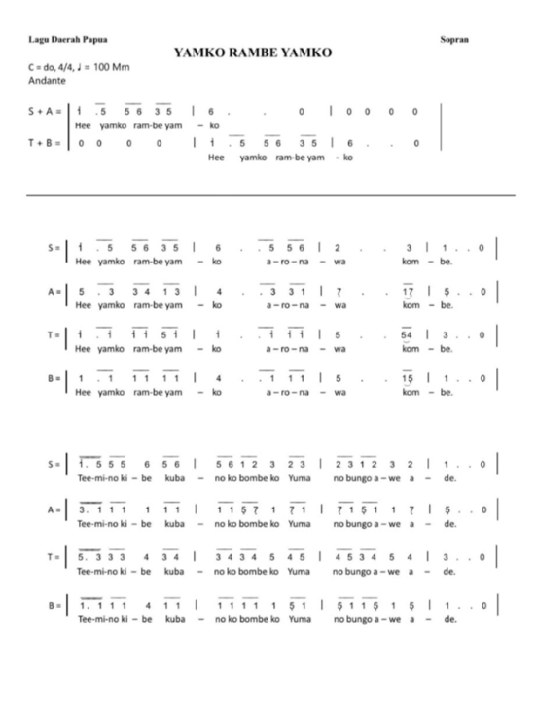
Figure 1. Full score for the song “Yamko Rambe Yamko”

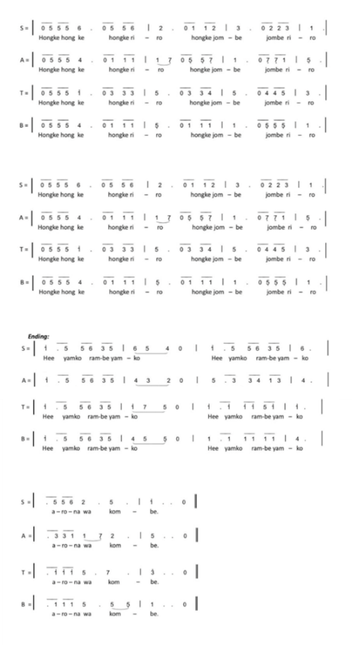

3.2 Discussion
Research findings indicate that the demonstration method is an effective approach in choral instruction because it provides a concrete learning experience. Through demonstrations, members not only receive theoretical explanations but also observe examples demonstrated by the coach, then imitate and practice them directly. This process helps members understand vocal and musical techniques, allowing mistakes to be corrected immediately through guidance and feedback during practice.
The demonstration method is also supported by the results of interviews with the conductor and choir members. The choir director stated that demonstration is a fundamental method in choral instruction because vocal techniques, resonance, articulation, and musical expression are easier to understand through direct examples than through verbal explanations alone. Choir members also noted that the demonstration method helps them grasp the material, vocal techniques, dynamics, and notation more quickly than when studying notation on their own.
The use of the demonstration method has a positive impact on three domains of learning. In the cognitive domain, participants are able to understand the basic concepts of vocal technique and connect theory with practice through observation and imitation. In the affective domain, the demonstration method fosters attitudes of discipline, responsibility, cooperation, and mutual respect throughout the rehearsal process. Meanwhile, in the psychomotor domain, members demonstrate improved skills in applying breathing techniques, articulation, intonation, and musical expression when performing the song “Yamko Rambe Yamko.”
Nevertheless, the study also identified challenges stemming from differences in the abilities, experience, and musical understanding of each choir member. These factors affect the pace at which the material is mastered, requiring the coach to provide repeated demonstrations and more intensive guidance to members who are struggling. However, through ongoing evaluation, these challenges can be minimized so that learning objectives are still achieved.
Overall, the research findings indicate that the use of the demonstration method in rehearsals for the song “Yamko Rambe Yamko” improved the vocal skills, musicality, and teamwork of the members of the Kidung Arutala Choir at Waru Sidoarjo State High School No. 1. These findings indicate that the demonstration method is suitable for use as a vocal learning strategy in choir extracurricular activities because it effectively integrates knowledge, attitude, and skills in a balanced manner.

4. CONCLUSION

Based on the research findings, the use of the demonstration method in the Kidung Arutala choir practice at Waru Sidoarjo State High School No. 1 for the song “Yamko Rambe Yamko” proved effective in improving the vocal and musical abilities of the choir members. The demonstration method provides a more concrete learning experience through the process of observing, imitating, and directly practicing vocal techniques, enabling members to better understand the learning material. The application of this method not only improves technical singing skills such as breathing, articulation, intonation, resonance, and musical expression but also has a positive impact on the development of attitudes and cooperation among choir members. Through a structured, active, and collaborative rehearsal process, members demonstrate overall improvement in the cognitive, affective, and psychomotor domains.

In addition to being relevant to the needs of music education, the use of the demonstration method is also in line with the principles of the Merdeka Curriculum, which emphasizes active and collaborative learning and reinforces the Pancasila Student Profile. Therefore, the demonstration method can serve as an effective and practical alternative teaching method for choir activities at the high school level. It is hoped that this study will serve as a reference for arts and culture teachers, choir directors, and future researchers in developing more innovative, creative, and sustainable vocal instruction.

AUTHOR'S CONTRIBUTION

This research was conducted independently by the author. The author was responsible for selecting the research topic and collecting data through observation, interviews, and documentation. In addition, the author was responsible for analyzing the data and drafting the entire research article.

THANK YOU

The author gives thanks to Allah SWT for all His mercy and blessings, which have enabled this article to be successfully completed. The author would also like to express gratitude to Mr. Senyum Sadhana, S.Sn., M.Pd., the thesis advisor, for his unwavering patience in guiding the author and for providing constructive criticism and advice throughout the writing process.

The author would also like to express gratitude to the Bachelor’s Degree Program in Drama, Dance, and Music Education at Surabaya State University for providing the opportunity and learning facilities that supported the writing of this article. The author would also like to thank the various parties who have helped, both directly and indirectly, in the completion of this work.

REFERENCE
This section provides examples of writing citation sources. Everything on this list can be tracked in the body of this template article to learn how to write an in-text quote. References must consist of 80% relevant and current primary sources (journal or conference articles from the last 5-10 years). References must be written in APA style and using Mendeley Software.

Apel, W. (1969). Harvard Dictionary of Music. Harvard University Press (Belknap Press).
Arikunto, S. (2013). Research Procedures: A Practical Approach. Rineka Cipta (Jakarta).
Arsyad, A. (2017). Instructional Media. Rajawali Pers.
Baba, M. A. (2017). Research Data Analysis. Aksara Timur.
Booth, A., Sutton, A., & Papaioannou, D. (2012). Systematic Approaches to a Successful Literature Review. Sage Publications Limited.
Creswell, J. W. (2014). Research Design: Qualitative, Quantitative, and Mixed Methods Approaches (4th ed.). Sage Publications Limited.
Gasong, C. L., Tinggi, S., Kristen, A., & Negeri, P. (2023). Cantata Deo: Journal of Music and the Arts. The Quality of Church Choirs Versus “Competition” Choirs. Cantata Deo: Journal of Music and the Arts, 1(1), 40–46.
Hylton, J. B. (1995). Comprehensive Choral Music Education. Prentice Hall / Schirmer Books.
Kaestri, V. Y. (2015). The Combination of Notes from a Harmonic Perspective and Its Application to College Students. PROMUSIKA: Journal of Music Research, Performance, and Composition, 3(2), 149–162.
Karl-Edmund Prier, S. (2011). Music Dictionary. Center for Liturgical Music.
Karya, J., Pendidik, I., Jkipp, M. I., & Kaisari, D. (2024). The Demonstration Method in Science Education: A Qualitative Study of Fourth-Grade Students’ Interest in Learning. Journal of Scientific Works by Elementary and Islamic Elementary School Educators and Practitioners (JKIPP). Journal of Scientific Works by Elementary and Islamic Elementary School Educators and Practitioners (JKIPP), 3(2), 65–73.
Lapian, F. T. P. & A. (2020). Application of the Imitation and Drill Methods in the Manado Independent School Choir. Clef: Journal of Music and Music Education, 1(1), 11–21.
Miles, M. B., Huberman, A. M., & Saldaña, J. (2014). Qualitative Data Analysis: A Methods Sourcebook. Sage Publications Limited.
Neuman, W. L. (2014). Qualitative and Quantitative Approaches (7th ed.). Pearson Education.
Nyoman, A. N. (2024). The Integration of Art and Sociology: The Influence of Art Education on Developing Creative Imagination. Journal of Multidisciplinary Education, 7, 107–114.
Piston, W. (1987). Harmony (5th ed.). W. W. Norton & Company.
Putra, A., & R. A. (2017). Learning Outcomes in Civic Education Using the Demonstration and Discussion Methods. Journal of Civic Education, Vol. 4, No. 2, September 2017, 4(2), 85–100.
Rina, C., Endayani, T. B., & Agustina, M. (2020). The Demonstration Method to Improve Student Learning Outcomes. Al-Azkiya: Journal of Elementary School Education, 5(2), 150–158.
Robert Bogdan, S. K. B. (2007). Qualitative Research for Education: An Introduction to Theories and Methods (5th ed.). Pearson (Allyn & Bacon).
Rosfiani, O., Fauzi, M. A., Jakarta, U. M., Selatan, T., Belajar, M., & Bermakna, P. (2025). The Demonstration Method in Islamic Education to Motivate Students and Provide Meaningful Learning. Pedagogy: Scientific Journal of Education, 11(2), 228–234.
Sanjaya, W. (2016). Learning Strategies Oriented Toward Educational Process Standards. Kencana (Prenada Media Group).
Sihombing, L. B. (2017). Singing Methods for Folklore/Ethnic Songs in Choral Music. Generasi Kampus (Medan State University), 7(2), 247–259.
Sugiyono. (2019). Quantitative, Qualitative, and R&D Research Methods. Alfabeta.
Sumiati, A. &. (2016). The Effectiveness of the Experimental Method in Chemistry Instruction at State High School 2 Yogyakarta. Journal of Mathematics and Science Education, 15(2), 83–92.
Wahyuni, D. (2022). The Influence of Reading Interest and Learning Motivation on Student Academic Achievement. Edutama Education Journal, 9(2), 231–240.
Yahyar Erawati, Nurnaningsih, E. N. (2018). Application of the Demonstration Method in Dance Education for Class VIIc. KOBA Journal, Volume 5, No. 2, Volume 5(02), 10–21.
Zain, S. B. D. & A. (2010). Teaching and Learning Strategies. Rineka Cipta.

