AN ANALYSIS OF THE SPEAKING MATERIALS IN “ENGLISH ALIVE 2” TEXTBOOK FOR THE ELEVENTH GRADERS OF SENIOR HIGH SCHOOL

Febriyan Dwi Cahyono dan RahayuKuswardany
S1- English Education, Language and Art Faculty, Surabaya State University

Abstract
The objectives of the study are to describe the presentation of speaking materials in “English Alive 2” textbook for the eleventh graders of Senior High School based on the criteria of a good textbook proposed by Savignon, to describe the relevancy of the speaking materials in “English Alive 2” published by Yudhistira for the eleventh graders of Senior High School to the 2006 English standard competence and to describe the sequence of speaking materials in “English Alive 2” published by Yudhistira for the eleventh graders of Senior High School to the 2006 English standard competence. Based on the analysis,the researcher found that the presentation of the textbook was arranged to meet the criteria proposed by Savignon. The researcher also found that the relevancy of the speaking material was quite in line to the 2006 English Standard Competence, but there were some competence that was not in line to the 2006 English Standard Competence. The reasons were the textbook did not present the material in the speaking ability. Another reason was the textbook did not provide the material for the certain competence. For the sequence of the speaking material in the textbook, the researcher found that the sequences are not in line compared to the 2006 English Standard Competence.
Keywords:analysis, textbook, eleventh graders, speaking material.

INTRODUCTION
Nowadays, English has become an important aspect in everyday life. Indonesian government realizes that English has an important role, whether in business area or education. Many job requirements require the applicant to have a good speaking and a good writing of English. In learning English, there are four main skills that need to be taught. Those are reading, speaking, listening, and writing. There are many media to help the teacher conducting his or her teaching activity in a classroom. There are many publishers that have published English textbooks for the eleventh grader students of Senior High School. This study is intended: (1) to describe the presentation of speaking materials in English Alive 2 textbook for the eleventh graders of Senior High School based on the criteria of a good textbook (2) to describe the relevancy of the speaking materials in English Alive 2 published by Yudhistira for the eleventh graders of Senior High School to the 2006 English standard competence and (3) to describe the sequence of speaking materials in English Alive 2 published by Yudhistira for the eleventh graders of Senior High School to the 2006 English standard competence.

RESEARCH METHODOLOGY
The main objectives of this study were to describe the presentation of the speaking materials in the “English Alive” textbook for eleventh graders of Senior High School, to analyze the speaking indicators in the textbook based on 2006 English Standard Competence and to analyze the sequence of the speaking materials based on 2006 English Standard Competence. The textbook is written by Dra. Tri Indaryati, M.Hum., and edited by EkoMarsudiono, S.Pd. The object of the study was an English textbook for the eleventh graders’ of Senior High School entitled “English Alive 2” published by Yudhistira. The data of this study were all the speaking materials presented in the textbook entitled “English Alive 2” for the eleventh graders of Senior High School. The materials in this textbook were in the forms of dialogs, information about certain event, activities, instruction, pictures, and photographs. This study was only focused on the presentation of the speaking materials, analyzing the relevancy of the speaking materials to the 2006 English standard competence and analyzing the sequence of the speaking materials to the 2006 English standard. The data were speaking materials taken from the first and second semester in the textbook. This study was designed to use descriptive qualitative on which the result of analysis is in the form of words or pictures rather than numbers (Bogdan andBilkn, 1992). This study also belonged to a documentary analysis since the researcher analyzed the data or text derived from the textbook (Gerald, 1992). The researcher was the main research instrument and used observation sheet and checklist to help him in analyzing the data.

RESULT AND DATA ANALYSIS
The first discussion is regarding the presentation of the “English Alive 2” textbook. Dealing with the presentation of the textbook, the researcher uses the criteria which are taken from Savignon. To analyze the presentation of the textbook, there are three criteria that the researcher used. Those three criteria are the materials should be attractive, using photographs, drawings, charts, and colors, the materials should encourage the learners to seek language samples outside the book and outside the classroom, and the materials should encourage learners to use the language in daily life.
First criterion of good speaking material is that the materials should be attractive, using photographs, drawings, charts and colors. This criterion is needed in order to invite the learners to browse, ask questions, and start a conversation and to avoid boredom. And for this criterion the researcher found that in chapter one there is one picture accompanying the speaking material. This picture has a relation to the speaking material which is about how to interview a person or an applicant. And the dialog itself shows the learners of the expressions from opening to how to close a conversation. The picture shows that the interviewer is getting ready to interview an applicant by shaking her hand, As shown by the following figure:
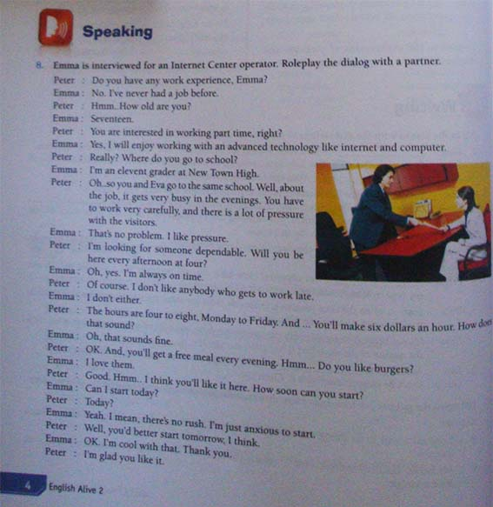

Aside from that, the researcher found that not all of the speaking material in the textbook is arranged based on the first criterion of good speaking material. Based on the findings, there are two reasons. The first one is that because the author of the textbook does not write the speaking material where it should have been written, as found in chapter 2B, 3B, 5B, 6B, 7A, 8A, 8B, 9A, 9B, 10A and 10B. Another reason is that the author combines the speaking skill with another skill, as found almost in every chapter in this textbook.
The second criterion is the materials should encourage the learners to seek language samples outside the book and outside the classroom. This criterion will not only provide the learners with the examples, but also the learners can be encouraged to seek another form of language sample like the one provided by the textbook in speaking material. In this criterion, the researcher found that the material can encourage the learners to seek language samples outside the book and outside the classroom. As it shown by the following picture, the exercises can give the learners a chance to create other new examples. The material requires the learners to practice first, and then they are required to continue the same way as the example has provided but the material also asks the learners to use any modern devices or technology as topic. By making a new topic, the learners can make a conversation based on what they have learned in advance. Not only that, the learners can find another expression that has the same meaning as the one they have learned in advance, as shown by the following figure:
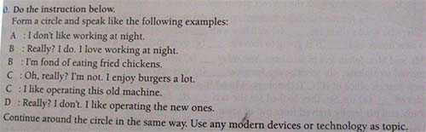

Furthermore, the researcher also found that there are some of the speaking materials that are not arranged based on the second criterion. This is because the author of the textbook does not provide speaking material, as found in chapter 2B, 3B, 5B, 6B, 7A, 8A, and 9B.
The third criterion is the materials should encourage learners to use the language in daily life. This criterion is useful if the textbook presented some examples which can be used by the learners when they need to speak the language in their daily life. Looking at the instruction of the extract of the speaking material below, the learners can practice the dialog with their friends then the learners will know that the way of using an expression of interviewing someone is like the example provided. Another one that proves the speaking material on this chapter can encourage the learners to use it in daily life is that they need to make another expression based on the topic like modern devices or technology as follows:
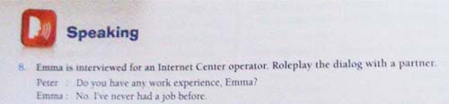

Moreover, the researcher also found that there are some of the speaking materials that are not arranged based on the third criterion. This is because the author of the textbook does not provide speaking material and it is found in chapter 2B, 3B, 5B, 6B, 7A, 8A, and 9B.
Second, not all of the speaking competencies are provided by the textbook. The researcher found that some of the speaking competencies are presented not in the speaking activity, but in the other skill. The researcher also found that some of the speaking competence has no speaking activity in the textbook.
Third, the researcher found that the sequence of all the speaking material in the textbook are not arranged based on the 2006 English standard competence. For example, the speaking materials which are supposed to be put in the first unit are not present. Instead, the speaking material is put in unit five. Another example is that the researcher found the competence of giving advice in unit 4B, the next competence according to the 2006 English standard competence is giving a warning, should be put in unit 5A. But, the researcher found the competence for giving a warning is in unit 4A.

Conclusion
The purposes of this study are to analyze the presentation of the speaking material presented in the textbook entitled “English Alive” for the eleventh graders of senior high school, to analyze the relevancy of the speaking material presented in the textbook to the 2006 English standard competence, and to analyze the sequence of the speaking material presented in the textbook to the arrangement of the 2006 English standard competence. Based on those purposes, there are several conclusions that can be drawn.
The first conclusion is regarding the presentation of the “English Alive 2” textbook. Dealing with the presentation of the textbook, the researcher uses the criteria which are taken from the expert. To analyze the presentation of the textbook, there are three criteria that the researcher used. Those three criteria are the materials should be attractive, using photographs, drawings, charts, and colors, the materials should encourage the learners to seek language samples outside the book and outside the classroom, and the materials should encourage learners to use the language in daily life.
First criterion of good speaking material is that the materials should be attractive, using photographs, drawings, charts and colors. This criterion is needed in order to invite the learners to browse, ask questions, and start a conversation and to avoid boredom. Not all of the speaking material in the textbook is arranged based on the first criterion of good speaking material. Based on the findings, there are two reasons. The first one is that because the author of the textbook does not write the speaking material where it should be written, as found in chapter 2B, 3B, 5B, 6B, 7A, 8A, 8B, 9A, 9B, 10A and 10B. Another reason is that the author combines the speaking skill with another skill, as found almost in every chapter in this textbook.
The second criterion is the materials should encourage the learners to seek language samples outside the book and outside the classroom. This criterion will not only provide the learners with the examples, but also the learners can be encouraged to seek another form of language sample like the one provided by the textbook in speaking material. Based on the findings, this criterion is fulfilled by most of the speaking materials found in the textbook. But, there are some of the speaking materials that are not arranged based on the second criterion. This is because the author of the textbook does not provide speaking material, as found in chapter 2B, 3B, 5B, 6B, 7A, 8A, and 9B.
The third criterion is the materials should encourage learners to use the language in daily life. This criterion is useful if the textbook presented some examples which can be used by the learners when they need to speak the language in their daily life. This criterion is also fulfilled by most of the speaking material in the textbook. But, there are some of the speaking materials that are not arranged based on the second criterion. This is because the author of the textbook does not provide speaking material and it is found in chapter 2B, 3B, 5B, 6B, 7A, 8A, and 9B.
Second, not all of the speaking competencies are provided by the textbook. The researcher found that some of the speaking competencies are presented not in the speaking activity, but in the other skill. The researcher also found that some of the speaking competence has no speaking activity in the textbook.
Third, the researcher found that the sequence of all the speaking material in the textbook are not arranged based on the 2006 English standard competence. For example, the speaking materials which are supposed to be put in the first unit are not present. Instead, the speaking material is put in unit five. Another example is that the researcher found the competence of giving advice in unit 4B, the next competence according to the 2006 English standard competence is giving a warning, should be put in unit 5A. But, the researcher found the competence for giving a warning is in unit 4A.

Suggestion

According to the findings of the study, some suggestions are given in this part. The suggestions are directed to the authors who compose and arrange the speaking material in the textbook entitled English Alive 2, the teachers who have been or will be using the speaking material in the textbook as their learning material, and also to the researchers who are interested in the same field of study. The suggestions are:
1. The authors who compose and arrange the speaking materials should look at the arrangement of 2006 English Standard competence. This will give the speaking material in the textbook be more suitable both for the teacher who uses it as a tool in teaching and learning process and learners who use it as a guidance in learning. Moreover, the arrangement of the competencies in the speaking materials should be arranged based on the 2006 English standard competence. It is needed to make the textbook more appropriate to the 2006 English standard competence.
2. The authors should provide the speaking material based on the speaking competence and activity.
3. The teacher should modify the arrangement of the speaking material in the textbook. This is because the arrangement of the speaking material is not sequenced with the 2006 English standard competence.

REFERENCES
Bailey, K. M. 2005. Practical English Language Teaching: Speaking. Singapore: McGraw-Hill.Harmer
Brown, H. D. 1994. Teaching by Principle: an Interactive Approach to Language pedagogy. New Jersey: Prentice Hall
Brown, J. D. 1995. The Elements of Language Curriculum.United States of America: Heile and Heile Publisher
Grant, Nevoille. 1987. Making the Most of Your Textbook. Longman: New York
Harmer, Jeremy. 2002. How to Teach English : An Introduction to the Practice of English Language Teaching. Longman
Mufida, Isnaini. 2008. A Study on Speaking Materials of The Bridge English Competence: English Textbook and its Relevance to Standar Isi 2006. Unpublished Thesis: UniversitasNegeri Surabaya
Nunan, David. 1991. Language Teaching Methodology: A Textbook for Teachers. Prantice Hall: Britain
PemerintahRepublik Indonesia. 2005. PeraturanPemerintahNomor 19 tahun 2005 TentangStandarKompetensiLulusanUntukSatuanDasardanMenengah (dokumendalam Compact Disc). Tidak Ada Penerbit
Pratiwi, R. E. 2008. An Anlysis of the Compatibility of the Textbook “Star Idola” with the School Level-Based Curriculum. Unpublished Thesis: UniversitasMuhammadiyah Surakarta
Resmi, N C. 2012. An Analysis of Speaking Materials in “Developing English Competencies” Textbook for the First Grade of Senior High School Students Published by the National Education Department. Unpublished Thesis: UniversitasNegeri Surabaya
Richards, J. C. 2001. Curriculum Development in Language Teaching. Cambridge University Press
Richards, J. C. 2008. Teaching Listening and Speaking: From Theory to Practice. Cambridge University Press
Sari, P. N. 2012.An Analysis of Speaking Materials based on the 2006 Standard Competence on English Textbook entitled “Win the Day for SMK, Second Edition” for Eleventh Graders Published by Unesa Press. Unpublished Thesis: UniversitasNegeriSurabaya.
Suhertini. 2009. An analysis of Speaking Materials in “Smart Steps” English Textbook Published by Ganeca Exact for the Eighth Graders of SMP Negeri 1 Sukodono, Lumajang. Unpublished Thesis: UniversitasNegeri Surabaya
Susanto. 2010. Silabusdan RPP. Surabaya: FakultasBahasadanSeniUniversitasNegeri Surabaya

