THE EFFECTIVENESS OF A BOARD GAME FOR TEACHING SPEAKING TO THE SEVENTH GRADERS OF MTs. NU TERATE GRESIK
Niswatul Khusnah dan Kusumarasdyati
S1- English Education, Language and Art Faculty, Surabaya State University
Abstract
Speaking is one of the four skills that should be mastered by students. Whereas, most of the speaking class activity is lack of media. This research provided a board game as media for teaching speaking. Kipple (1984) used it for communicative fluency in classroom speaking activity. This research is conducted to find the significant difference in speaking ability of expressing likes and dislikes between the students who were taught by using a board game and those who were taught without using a board game. It is also purposed to find out the students’ responses toward the effectiveness of a board game in teaching speaking. Some of reasons why a board game is chosen are the advantage of a board game and the ease of a board game when it is conducted in speaking class activities. A board game enables to encourage students’ speaking confidence, develop students’ speaking fluency, and encourage the development of short conversation. In application, a board game can be arranged easily, based on the students’ material. This research is an experimental research that takes population and sample in MTs. NU Terate Gresik. The population of this study was the seventh graders of MTs. NU Terate Gresik while the sample of this study, which taken by using cluster random sampling, are VII C (as experimental group) which got treatment and VII E (as control group) which did not get the treatment. Each group consists of 38 students. There are two instruments to collect the data; they are test and questionnaire. T-test formula is used to analyze the test instrumen, whether, the questionnaire instrument, percentage formula is used. The result is the critical value for rejecting the null hypothesis at p ≤ .001 df 74 is 2.38 and the result of t-test is 4.56. It means that t-test is larger than critical value (4.56>2.38). It can be said that null hypothesis was rejected. Meanwhile, the result of the questionnaire shows most students responded enjoyed, were motivated and helped in speaking English by using a board game.
Key Words: Speaking, Teaching Speaking, Likes and Dislikes Expression, and a Board Game.

INTRODUCTION
English learning process comprises four skills of English; listening, speaking, reading and writing. This research focuses on speaking skills. Nunan (1999:225) stated that someone considered knows a foreign language, if she or he is able to speak with that language. Simply, a student considered understand English if she or he is able to speak in English.
In fulfilling students’ communicative competence in speaking, English teacher needs to provide good speaking class activities. Unfortunately, the class activities needed is rarely found in formal English classes. In a situation of speaking class activity, the teacher reads a dialogue and the students are asked to repeat after the teacher. Sometimes, the students are invited to come forward in pairs, and read the dialogue in their book. Even, the teacher emphasizes on grammar and vocabulary of students’ workbook while students are listening to the teacher’s explanation. It shows that speaking class activity does not provide chance for oral interaction yet. Certainly, these classroom speaking activities cannot support the students’ communicative competence, or even, to attain the purpose which is explained before.
Regarding to those classroom speaking activities problems, researcher proposes a board game as media to teach speaking. A board game is a game played in a special designed board. The design can be adapted with the students’ English lesson. It is inspired from Kipple (1984) that used the 'Values Topics' board game. He used it for communicative fluency in classroom speaking activities. In this game, players take turns throwing the dice and talking about the topic specified in the squares on which they land. A board game is also supported by Jones (2005) in http://iteslj.org/Techniques/Jones-LessonsIntoGames.html. He stated that this game can be used to warm up, to get students into pairs or partners to review vocabulary or idioms, to practice minimal pairs, to practice compound and complex sentence, adjectives, verb forms, and other grammar items. Simply, a board game can be used for any lesson in speaking class. It is chosen because it is one of the communication games. As the communication game, a board game can also provoke communications among students frequently depend on information gap.
Based on the theoretical framework above, the researcher is interested in conducting a study dealing with a board game to teach speaking. The researcher chooses MTs. NU Terate Gresik. The school is chosen because it does not use a board game as media in speaking class activity before. The study will be focused on KD. 9.2. That is;
“mengungkapkan makna dalam percakapan transaksional (to get things done) dan interpersonal (bersosialisasi) sangat sederhana dengan menggunakan ragam bahasa lisan secara akurat, lancar dan berterima untuk berinteraksi dengan lingkungan terdekat yang melibatkan tindak tutur: meminta dan memberi pendapat, menyatakan suka dan tidak suka, meminta klarifikasi, dan merespon secara interpersonal.”

In this research, the researcher only focuses on likes and dislikes expression. The implementation of a board game in speaking class activity is expected to give better competence of speaking ability for the seventh graders of MTs. NU Terate Gresik.
Based on the background of the study above, the research questions are formulated as follows:
- Is there any significant difference in speaking ability of expressing likes and dislikes, between the students who are taught by using a board game and those who are taught without using a board game?
- What is the students’ response toward a board game in teaching speaking?
Based on the research questions that have been stated previously, the objectives of the study are:
- To find out whether there is a significant difference in speaking ability of expressing likes and dislikes between the students who are taught by using a board game and those who are taught without using a board game.
- To find out the students’ response toward a board game in teaching speaking.
They are some underlying theories related to the study. It is divided into five subchapters. They are: speaking, the teaching speaking, likes and dislikes expression, media, and a board game.
Speaking is one of skills that must be learned by all students when they are learning English. Our curriculum clearly states that speaking is one of the skills of learning English (Standard Isi, 2006). Moreover, speaking is the indicator that someone can be considered knows a language which is important to be learnt as important as listening, reading and writing (Nunan, 1999:225). The students need speaking skill to give messages in several speech acts such as how to introduce their selves, expressing their feels, handling guests, asking and giving command, apologizing in term of education. They can create an intricate web of meaning in which sentences have special relationship to each other. They can also develop the general messages into specific one to deliver it clearly to the listeners.
Brown (2007:327-330) classified classroom speaking performance into six types. They are: imitative, intensive, responsive, transactional, interpersonal and extensive. The researcher includes speaking of likes and dislikes expression into an interpersonal dialogue. It is because the students have to express their feel in liking and disliking.
Likes and dislikes expression is stating an expression to interlocutor as the speaker response or view about liking or disliking something. It carries out more for the purpose of maintaining social relationship than for the transmission of facts and information. Here are some example by using likes and dislikes expression;
A : Do you like reading books?
B : Yes, I do. I like it a lot.
A : What kinds of books do you like?
B : I like storybooks, such as Aladdin, Malin Kundang and Cinderella.
(Wardiman, et al, 2008)
In this research, the researcher classifies a board game as visual media. A board game is media which can be seen and touched by the students. It is played by using a designed board. Gibson (1996) stated that using a board game to teaching speaking has some advantages and disadvantages. The disadvantage of this game is it needs much time in preparing turns topic of a board game when there are some topics in a meeting. Besides, the teacher provides another board for another topic, it will spend much expense. Whereas, the advantages of a board game in teaching speaking is enable to encourage students’ speaking confidence. It stated that because weaker or less confident students have a chance to prepare what they are going to say. It can also develop students’ speaking fluency. In the group, it can encourage the development of short conversation after each student answer the follow up questions.
The application of a board game in teaching speaking, especially in expressing likes and dislikes are as follows:
- The researcher explains lists expressing likes and dislikes.
- The students are asked to work in pairs.
- The researcher passes the printed rules of the game, a board, markers and a dice for each group, then explains the rules one by one and assures that all students understand the rules by doing a short simulation.
- The researcher provides 10 minutes for students to play the game. In this time, the researcher checks the students’ work.
- For 10 minutes later, the students are asked to make a dialogue in pair by using likes and dislikes expression.
- In the latest 20-30 minutes, the students are pleased to come forward for presenting the dialogues in pairs, by turns.

RESEARCH METHODOLOGY
Since a board game is a new speaking classroom activity in MTs. NU Terate Gresik and it has not been implemented before in teaching learning process especially in teaching speaking expressing likes and dislikes, the researcher chooses experimental as the research design. It is in line with Singh (2006) who states that experimental research is a research that the researcher is seeking to evaluate something new or something that has never been existed before. Basically, experimental research is a study that attempts something new.
In this research, the population was the seventh graders of MTs. NU Terate Gresik which consists of five classes; they are VII A, VII B, VII C, VII D and VII E. After choosing the population and listing all the members of the population, then randomly the samples was selected. The samples were VII C and VII E. Then, in order to determine which one of the experimental and which one of the control class, random assignment was used. The result was that VII C was taken as the experimental class and VII E was taken as the control class. Each class consists of 38 students.
In experimental research, instrument is a tool used to collect data in order to overcome the research question. The researcher uses tests and questionnaire as the instruments.
There was a test which was done twice in different time for both the experimental and control groups. The first was a pre-test and the second was a post-test. The pre-test was done before the experimental group got the treatment. It was conducted to know the previous ability of both the control and the experimental groups. In pre-test, they were asked to perform dialogue of expressing likes and dislikes entitled: “My Favorite Meals”. They were asked to work in a group. Pre test was used to measure the students’ speaking ability before giving treatment.
Like pre-test, post-test was done for both experimental and control groups. The test was given after the experimental group got treatment. In the post-test, they were also asked to perform dialogue of expressing likes and dislikes entitled: “My Favorite Meals” and the students worked in group. It was purposed to know the students’ achievement after treatment was conducted.
Before conducting pre-test, the researcher should conduct try out of the test sheet. There are three purposes why the try out was conducted. First, it is done to enable the researcher to get the appropriate test that is suitable for students’ level. Second, it is to inform the researcher about the time allocation while the students do the test. The last purpose is to decide whether the test has a good validity and reliability or not.
A test is valid if it is meaningful and useful in terms of the purpose of the test. There are three types of validity. They are content validity, criterion-related validity, and construct validity. This research used content validity. The test can be said valid if it represents the content universe. Ary, et. al. (1985) stated that to have content validity, the test or instrument should represent the content universe.
To gain content validity, the researcher matched with the curriculum. Expressing likes and dislikes is one of the basic competences for the seventh graders of junior high school in even semester. It belongs to basic competence 9.2 (KD. 9.2). It can be said that it fulfilled content validity.
As a complement of validity is reliability, it is an important element to measure the quality of the test. In this research, inter raters was used to find the reliability of the test. It was used to measure the consistence of the test. There are two people scoring the test who compute relations between the scores of the test. In this research the researcher asked the English teacher of MTs. NU Terate Gresik as a partner.
To measure the reliability of the test sheet, the researcher used pearson product-moment correlation (Bartz, 1976:195). The result of the reliability was 0.75. It could be said that the test had high positive reliability. The researcher also used inter-rater to gain scores from the students’ performances. Thus, the test instrument was reliable.
To answer the second research problem, questionnaire was needed in order to know the percentage of the students’ responses toward this media. In this research, the researcher adapted the questionnaire sheet which taken from Anandya (2010). There are three main topics occurs in the questionnaire sheet. They are the students’ interest towards a board game as media for teaching speaking, the ease of the students in producing dialogues through the media, and the students’ understanding towards the media. Then, it was formulated to be ten questions.
The students’ speaking tests were evaluated by using oral language scoring rubric. Then, the scores are analyzed statically by using procedure of t-test formula since the result of the study is determined by the comparison of the pre-test and post-test (McMillan, 1992:174).The steps are as follows:
- Tabulating the scores from pre-test and post-test of each group.
- Computing Mean
X = ∑X
N
X = mean
∑X = the sum of students’ scores
N = the number of observations
- Computing Standard Deviation
S = √∑X²- X²
N
S = standard deviation
∑X² = the sum of the squared score
X² = the mean of the distribution
N = the number of observations
- Computing Standard error of the differences
S_{D} = √N₁ S₁² + N₂ S₂² ( 1 + 1 )
^{X} N₁ + N₂ – 2 N₁ N₂
SD_{X} = standard error of the difference
S₁ = the standard deviation of the first sample
S₂ = the standard deviation of the second sample
N₁ and N₂ = the sizes of the respective samples
- Computing degree of freedom
N1+N2-2
- Computing t-test
t = X₁ – X₂ – 0
S_{Dx}
- Consulting t-table
- Determining the significance difference
If the t > t_{.001,} , it means that there is a significance different. But, if the t < t_{.001,} it means that there is no significant difference.
To analyze the students’ responses, the researcher used the following formula:
Percentage =
the number of students’ answer each question x 100%
the number of the students

RESULT AND DISCUSSION
In this section, the result of the research and the discussion are explained
The effectiveness of a board game
The table below shows the result of a board game effectiveness
Table: 1 The Result of t-test
Class | N | Mean Pretest | Mean Posttest | SD | SD_{x} | t.001 | t-value | Signi  ficant
Experimental | 38 | 70.31 | 81.41 | 8.48 | 3.34 | 2.38 | 4.56 | significant
Control | 38 | 69.91 | 66.20 | 10.19
To ensure whether a board game as media in teaching speaking is effective or not, t-test calculation is used to calculate the score of students in the post test. T-test can be used to test hypothesis about differences between two means (Bachman, 2005:235). There are some steps which are taken into account. Firstly, means of the post test from the two classes has to be defined. The others are the standard deviation, standard error of the differences, and the t-test .
The table above shows that the mean of both groups is not exactly the same. Pre test mean of the experimental group is 70.31, while the control group is 69.9. It shows that the mean score of the experimental group is a little bit higher than the control group. While the post test mean of the experimental group is 81.41, while the control group is 66.20. It shows that the experimental group is higher than the control group. If the table above is compared with the pre test score, it shows that experimental group’s score is increased but control group’s score is decreased such as the following table:
Table 2: The Comparison Mean between Experimental Group and Control Group
Group/Test | Pre Test Mean | Post Test Mean
Experimental Group | 70.31 | 81.41
Control Group | 69.91 | 66.20

From the table above, it can be seen that there is increasing mean of the experimental group. The increasing mean of the experimental group above proves that a board game can improve the students’ speaking ability. Meanwhile to know whether the score improvement is significant or not the researcher measures it by using independent sample t-test. As stated before, this research is done to find out the significant difference between the students that used a board game in learning speaking (experimental group) and the students who learnt without a board game (control group). It is proven in their post test scores after the treatment. From the calculation of t-test, it shows that t-value is 4.56, which is higher than t-table 0.001 which is 2.378. It means that the difference of mean between experimental and control groups after the treatment is significant. So, the alternative hypothesis is accepted. It is stated that there is significant difference in speaking score between students who learnt by using a board game and those who did not.

The students’ responses towards a board game
The chart bellow shows the comparison of the students’ responses towards a board game. It consists of the result of percentage of question number 1, 2, 3 and 4.

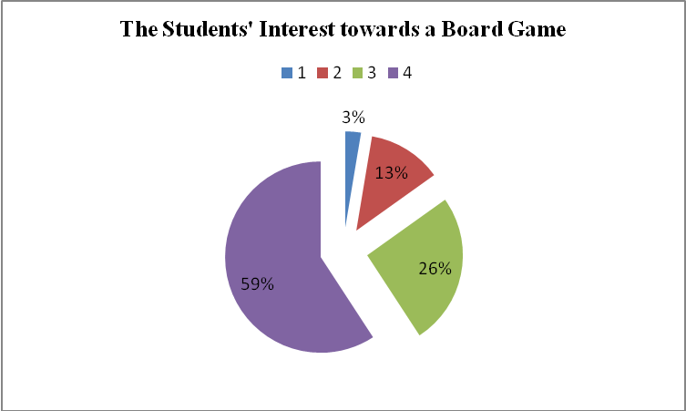
The chart above shows that 2,63 % of students is less interested, 12,50 % of students is interested enough, 25,66 % of students is interested and 59,21% of students’ responses is very interested with a board game.
Whereas, the chart bellow shows the comparison of the students' ease of producing dialogue through a board game. It consists of the percentage result of question number 5, 8, and 10. It can be read from the chart that 4% of students gets less ease, 8 % of students gets enough ease, 34 % of students gets ease, and 54 % of students gets much ease of producing dialogue through a board game. Here are the charts.
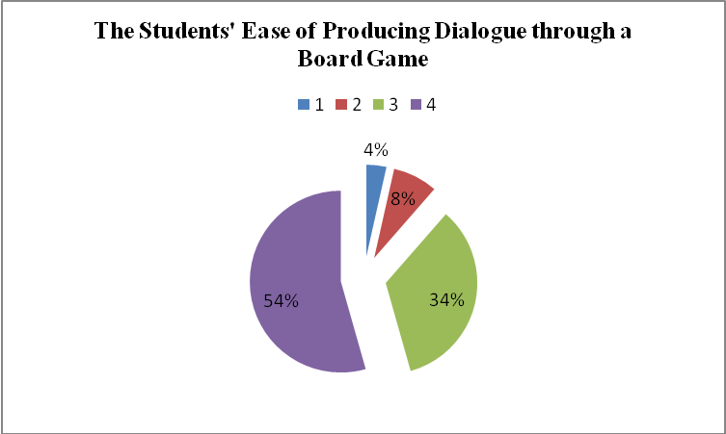
On the other hand, the students’ understanding toward a board game is shown as the following chart.

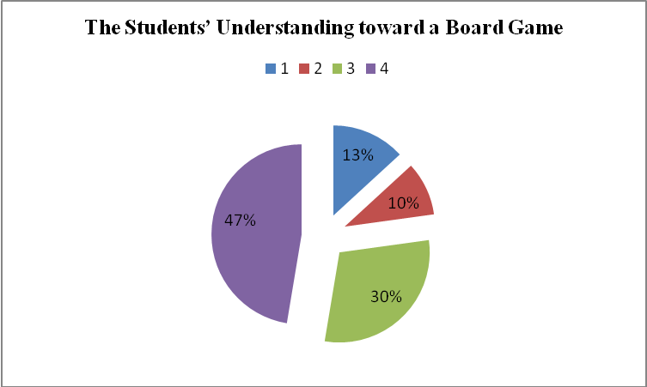

Based on the chart above, 13% of the students is less understanding towards a board game, 10 % of the students is understand enough, 30 % of the students is understand and 47 % of the students is very understand.
Simply, based on the tables and charts above, most students respond that a board game is very good media of speaking. They enjoyed, were motivated and were helped in speaking expressing likes and dislikes by using a board game as media in speaking.
The result of posttest shows that there are differences in the mean values of experimental and control groups in which the mean of experimental class is higher than control class. On the other hand, the analysis of t-test, alternative hypothesis is accepted. It indicates that there is significant difference between the students in experimental and control classes. Thus, a board game is effective media to improve speaking skill context. So, the advantages of a board game as Gibson (1996) stated is proven. It can encourage students’ speaking confidence, develop students’ speaking fluency, and encourage the group in developing a short conversation after each student answers the questions occurred.
Based on the theory, the researcher conducted the dialogue in interpersonal type, (Nunan, 1991) as in (Brown, 2007). It led how the students became interlocutor about their own felt and expressing what they felt in preferring something.
In pre test the students got less confidence, fluency, and difficult to interact with others. On the other hand, their speaking skill does not fulfill elements of speaking as Harmer (2001:269) stated. The students cannot perform their language features and mental or social processing well. It is as like as memorizing a strange text without understanding what they mean.
While the treatment, the researcher gave the media before they were asked to perform the dialogue. In the first and the third treatment the researcher used an adapted board game. In the second treatment, an adopted media was used. In this session, some students got confused about some vocabularies occurred in the media. So, the researcher explained it before playing the game.
In post test the students in experimental group mostly began performing dialogues with good interaction, had expressive device and sometimes used negotiation language. It means that they start to get good language features and mental or social processing.
It is different from the control group. Most of the students cannot improve their speaking skill. Moreover, some of their dialogue cannot be understandable by his or her interlocutor. It means that a language processing is less in control group (Harmer:2001).

CONCLUSION AND SUGESTION
The analysis of the research finding in the previous chapter shows that a board game is effective media. The hypothesis was tested by using t- test comparing the scores of post test between control and experimental class. The result rejected to accept null hypothesis and accepted alternative hypothesis at p ≥.001. It means that there is significant difference between experimental and control classes.
The result of questionnaire showed that most of the students’ responses were in the level of advance (option 4). The students’ responses toward a board game are very interested, motivated, understandable and helpful.
At last, it is suggested for English teacher in Junior High School to use some media especially a board game in improving students speaking skill so the students can be confident in interacting to each other by using target language. They also enjoy the learning process, understand the material well and can explore their ideas in speaking. The other researchers are suggested to develop the use of a board game as media in teaching speaking. It is also recommended for them to continue this research which is related to the other media in teaching speaking in order to reach the best pedagogic outcomes in learning English.

REFERENCES
Anandya Pratama, Vierma. 2010. The Effectiveness of Using Sentence Variety as Writing Strategy to Teach Writing Descriptive Text for Students in Senior High School. S-1 Unpublished Thesis. Unesa

Ary, Donald,et al. 1985.Introduction to Research in Education. Canada: CBS CollegePublishing.

Bartz, A.E. 1976. Basic Statistical Concepts in Education and the Behavioral
Sciences Minneapolis: Burger Pub Co.

Brown, H. Douglas. 2007. Teaching by Principles: An Interactive Approach to Language Pedagogy Third Edition. New York: Longman

Harmer, Jeremy. 2001. The Practice of English Language Teaching, third
edition. England: Longman

Jones, Tamara. 2005. Ten Ways to Turn Lessons into Games. The Internet TESL Journal retrieved from http://iteslj.org/Techniques/Jones-LessonsIntoGames.html

Klipple, Friederike. 1984. Keep Talking, Communicative Fluency Activities for
Language Teaching. Cambridge: Cambridge University Press

McMillan, James H. 1992. Educational Research, Fundamental for Consumer. Virginia: Harper Collins Pulisher.

Nunan, David. 1999. Second Language Teaching and Learning. Boston: Heinle&
Heinle Publisher

Standard Isi.Standard Kompetensi Lulusan Mata Pelajaran Bahasa Inggris (SD/MI,SMP/MTs, SMA/MA/SMK).2006.Departemen PendidikanNasional

Suyanto, K. K. E. 1995. Instructional Media for Young Learners of EFL. Journal
of English Language Education, Vol. I(1)

Gibson, Gerry. 1996. It's on the Cards: Adapting a Board-game Communicative Activity. The Internet TESL Journal retrieved from http://iteslj.org/Techniques/Gibson-BoardGame.html

Wardiman, Artono, et al. 2008. English in Focus: For Grade VII Junior High School (SMP/MTs). Jakarta: PusatPerbukuanDepartemenPendidikanNasional

