EFL LEARNERS’ PERCEPTIONS ON THE USE OF IDIOMS IN DAILY CONVERSATION

Musyaifi Abdillah
English Department, The Faculty of Language and Art, Universitas Negeri Surabaya
e-mail: musyaifiabdillah@mhs.unesa.ac.id

Abstrak

Ada banyak peserta didik EFL berpikir bahwa idiom sangat sulit untuk dipahami baik dari berbicara dan menulis karena disebabkan oleh beberapa faktor yaitu: kurangnya kosakata baru, latar belakang budaya yang berbeda dan strategi yang sedang dihadapi oleh EFL leaners. Secara umum idiom terlihat mudah dipelajari atau dipahami. Namun, ini bukan masalahnya. Sebuah idiom adalah kombinasi dari kata-kata yang maknanya terintegrasi dan tidak dapat ditafsirkan secara langsung, tetapi dapat ditafsirkan bersama dengan kalimat. Lazar (1996) menyatakan bahwa bahasa kiasan adalah area yang sering diabaikan dalam pengajaran kosa kata. Studi ini mengacu pada persepsi peserta didik EFL tentang penggunaan idiom dalam penggunaan sehari-hari yang membuat pelajar sulit dalam memahami dan menggunakan idiom.Penelitian kuantitatif digunakan dalam proses pengumpulan data dan meminta peserta didik EFL untuk menjawab kuesioner untuk mengidentifikasi persepsi mereka terhadap penggunaan idiom dalam hal berbicara dalam kehidupan sehari-hari mereka. Subjek dipilih di antara 35 peserta didik EFL ESC di jurusan Bahasa Inggris dari Universitas Negeri Surabaya. Temuan penelitian ini diklasifikasikan menjadi dua istilah yaitu penggunaan idiom dengan cara dan kesulitan. Cara mengacu pada bagaimana peserta didik EFL mempersepsikan strategi mereka dalam memahami idiom dalam penggunaan sehari-hari. Sedangkan kesulitan mengacu pada bagaimana EFL pelajar belajar dalam memahami ekspresi idiomatik.Berdasarkan persepsi peserta didik EFL tentang penggunaan idiom dalam percakapan sehari-hari bahwa sebagian besar siswa tidak memiliki strategi, tidak pernah mempraktikkan idiom dalam berbicara dan mengalami kesulitan, mereka menganggap bahwa idiom tersebut sulit diterapkan dalam percakapan sehari-hari. Sementara itu, beberapa dari mereka memiliki strategi sendiri dalam mengatasi kesulitan dan menerapkan idiom dalam penggunaan sehari-hari. Strategi mereka adalah belajar melalui media sosial, puisi, novel, film, dan terjemahan google. Peneliti menyarankan bahwa pelajar EFL perlu belajar tentang idiom secara mendalam mengenai pengaruh dan pentingnya penggunaan sehari-hari dalam percakapan.
Kata kunci: Idioms, Pelajar, Persepsi, Strategi – Strategi

Abstract
There are many EFL learners think that idioms are very difficult to understand both from speaking and writing due to caused by several factors namely: the lack of new vocabulary, different cultural backgrounds and strategies which are being faced by EFL leaners. In general idioms look easy to learn or understand. However, this is not the case. An idiom is a combination of words whose meanings are integrated and cannot be interpreted directly, but can be interpreted together with sentences. Lazar (1996) states that figurative language is an area often neglected in the teaching of vocabulary. This study refers to EFL learners’ perceptions on idioms usage in daily use which makes learners difficult in understanding and using an idiom. Quantitative research was used in the process of collecting data and asking EFL learners to answer the questionnaires to identify their perception toward the usage of idioms in terms of speaking in their daily life. The subject was chosen among 35 EFL learners of ESC in English department from State University of Surabaya. Findings of this research are classified into two terms those are the idioms usage in manner and hardship. Manner refers to how EFL learners percieved their strategy in comprehending idioms in daily usage. While hardship refers to how EFL learner’s challenges in comprehending idiomatic expressions. Based on the result, EFL learners’ perceptions of idioms usage in daily conversation that most of the students have no strategy, have never practiced idioms in speaking and have difficulty, they consider that the idioms are difficult to apply in daily conversation. Meanwhile, some of them have their own strategies in overcoming difficulties and applying idioms in daily use. Their strategies are learning through social media, poetry, novels, films and google translation. The researcher suggests that EFL learner need to learn about idioms deeply regarding to the influence and importance of the idioms daily usage in conversation.
Key words: Idioms, EFL learners, Perceptions, Strategies

INTRODUCTION
Speaking is a productive skill in which people are able to speak because of the adequacy of input such as vocabulary and having a well communicative skill. When speaking, vocabulary that is used is simple, communicative, and interesting in order to create a good and amusing conversation. To make a better and more interesting communication, idiom should be included in the conversation. Idiom is the most interesting and creative vocabulary or expression that cannot be understood from the meaning of each word but it has different meaning of its own, for example: Don’t be a guy of curiousity kill the cat or don’t be a guy of a chicken wing. Mostly, people are trying to translate the word chunk by chunk. However, the word must be translated in whole words. The meaning of each idiomatic expression can be identified to which figurative meaning by looking at a whole text, and the level of meanings better to be mapped by a conventional way rather than arbitrary way. Princeton (cited in Ambrose, 1993) stated that idioms is a unique expression in English such as idioms, clichés and slang. The use of preposition belongs to idiomatic expressions. Idioms are the linier interaction which is happening between speaker/writer and hearer/reader, and the meaning of it cannot be defined literally Moon (1998). Because idiom influences communicative skill, it should be learned by learners.
However, learning idiom is not as rocket science as learning vocabulary that is usually used in daily conversation. Idioms are more complex because it has the meaning by its own. And it is different from daily vocabulary. Idioms are very complex so there are problems which are usually faced by EFL learners when they are learning idioms. First problem is the EFL learners are feel uncomfortable when using idioms in daily use. Secondly most of the teachers do not teach idioms so the EFL learners only use simple grammar and vocabulary. Thirdly, the teachers do not encourage EFL learners to practice using idioms with them. The EFL learners can be more understood than words of idiom which it can be usefull for their productive skill. A study of idiomaticexpressions Cooper ( cited in Utami, 2014) shows that language learners had a special language problem bececause the figurative meaning was unpredictable, for example : “Hold your horses” I am coming. In another study by Meryem (2010) stated that English leaners who learned idioms find difficulties in guessing the appropriate meaning of idiomatic expressions.
Sasson (2007) had found that there were some steps of the new acquisitions of vocabulary. Firstly, the EFL learners were noticing many new words with the help of more capable adults either the parents or teachers. Secondly, the step is the EFL learners recognizing the word with help of capable adult. Thirdly, the words were indentifying by their own. The last is the EFL learners either acknowledge new vocabularies or producing it.

Lazar (1996) stated that figurative languages was an area which often rejected in theteaching of vocabularies. In same thought, this study was conducted by reseacher to investigate the difficulty which faced by EFL learners in comprehending English idiomatics.
According to Irujo (1986) Idiomatic expressions are "conventional expressions" that meanings cannot be established spontaneously and cannot be translated one by one. Because they are very different from ordinary figurative expressions both parables and metaphors. An idiom is an expression consisting of two or more words. That often happens from proverbs and other expressions, both oral and written. In other words, pupils cannot deduce the meaning of figurative language both written and from translation. As the essence of its meaning does not lead to the actual intended meaning.
Along the same thought, there are lot of focus on the learning of idioms for pupils after being recognized that idioms are always played in English learning Irujo (1986). Another study was devoted for explaining the process of EFL idiomatic and the role of native people in the process of study Kellerman (1983). The EFL Learners are not only being helped in better communication, but also being helped in learning the culture and society of the target language. Also, Elkilic (2008) stated that English is wealthy in idioms and learning them is the essence of the language. Related to the use of idioms, Stight (1979) argued that the use of idioms in appropriate ways are the most important point in learning English language.
EFL perceptions in idioms
There are common perceptions that the more idioms learners must know, the bigger problems got by the learners. The learners get stuck either in comprehending idioms or speaking using idioms as the lack of practice. Moreover, reseacher claimed that they do not have the same culture as well as the native’s culture, idioms are being hard to understand by EFL learners as the lack of the cultural background. According to Jiang (2000) stated that language is the gate of cultures, in the same sight it can be seen by people through cultures and languages. However, the view point of learning idioms, namely “combinatory possibilities”, must be considered by EFL learners. According to Moon (2006), some linguistics call the term as “lexical phrases” or “lexical items”, while others prefer the term “piece of words chunks” of language.

RESEARCH METHODOLOGY
Dealing with the reaseach questions, the quantitative reseach is used as the reseach design, it would be used to answer the research questions. The research design was chosen since the research was administered to measure the EFL leaners perceptions on idioms usage in daily conversation at ESC level 5. For the sake of linking the clear results of measuring perceptions of EFL learners it allows foreign language researchers to overcome the lack of validity in measuring the perception of foreign language understanding learning (Horwitz et al., 1986).
In the same vein, there were 13 questions. First, the 10 of the questions aimed to ask the EFL learners about statements and contain Never, Rarely, Sometimes,Very often and Always. The last, 3 of them regarding the personal opinions of EFL that related to their methods and strategies.
This research was conducted in group of ESC (English Speaking Community) level 5 in English department State University of Surabaya due to the ESC programme always be held in English Department every year located in Surabaya, East Java, Indonesia where the researcher resides. Conducting this research in UNESA eases the researcher to gather information from the subjects.
The EFL students of English major were selected from english department State University Of Surabaya. However, the number of the subject were 35 EFL learners of ESC level 5 which contain 5 groups of ESC learners, the reason why the researcher chose them because it could make easier for the researcher to gather a lot of sources and informations from them.
The instrument which was used to get the data in this research were qestionnaires. In this research, the questionnaire asked participants to answer some questions in English of learning idiomatics and the role idiomatics play in learning for learners. Meanwhile, for the sake of specifying questionnaires, the researcher gave and spread the questionnaires on the spot directly to EFL learners. There are about thirteen questions, ten of them were about statements which could be answered by EFL Never, Rarely, Sometime, Very often and Always those statements represent the EFL perceptions both in manner and hardship and three quiestions were about “personal opinion about idioms”. The respondenses were chosen carefully for asnwering the questionnaires. The questionnaires were distributed to 35 EFL learners and the data were collected, arranged and analyzed to portrait acceptable conclusions.
The first aim was to find out how their various learning experiences, second the researcher asked the learners about their perceptions and perspectives on idiomatics and their strategies of learning idiomatic in English; traditionally or modern conceptual metaphor strategy.
To collect the data, all the 35 EFL learners of English enrolled in Speaking Community at State University of Surabaya were asked to complete the questionnaires, the reason why the reseacher took 35 EFL learners because by taking 35 learners it was easy for the reseacher for sorting the questionnaires. The subjects were asked to portrait how often they use and hear English idioms. Students give researchers a way to see nonverbal expressions, decide who interacts with whom, understand how students communicate with their partners and check how much time they spend on various activities.
In the same vein, the reason the researcher only took the questionnaires because by using questionnaires the respondenses were able to answer the questions needed by the researcher . Thus, it is also very easy for the subject to be examined.
The researcher will explain the result of the research about the questionnaires which have given to the EFL learners about the perceptions on the use of idioms in daily conversation.

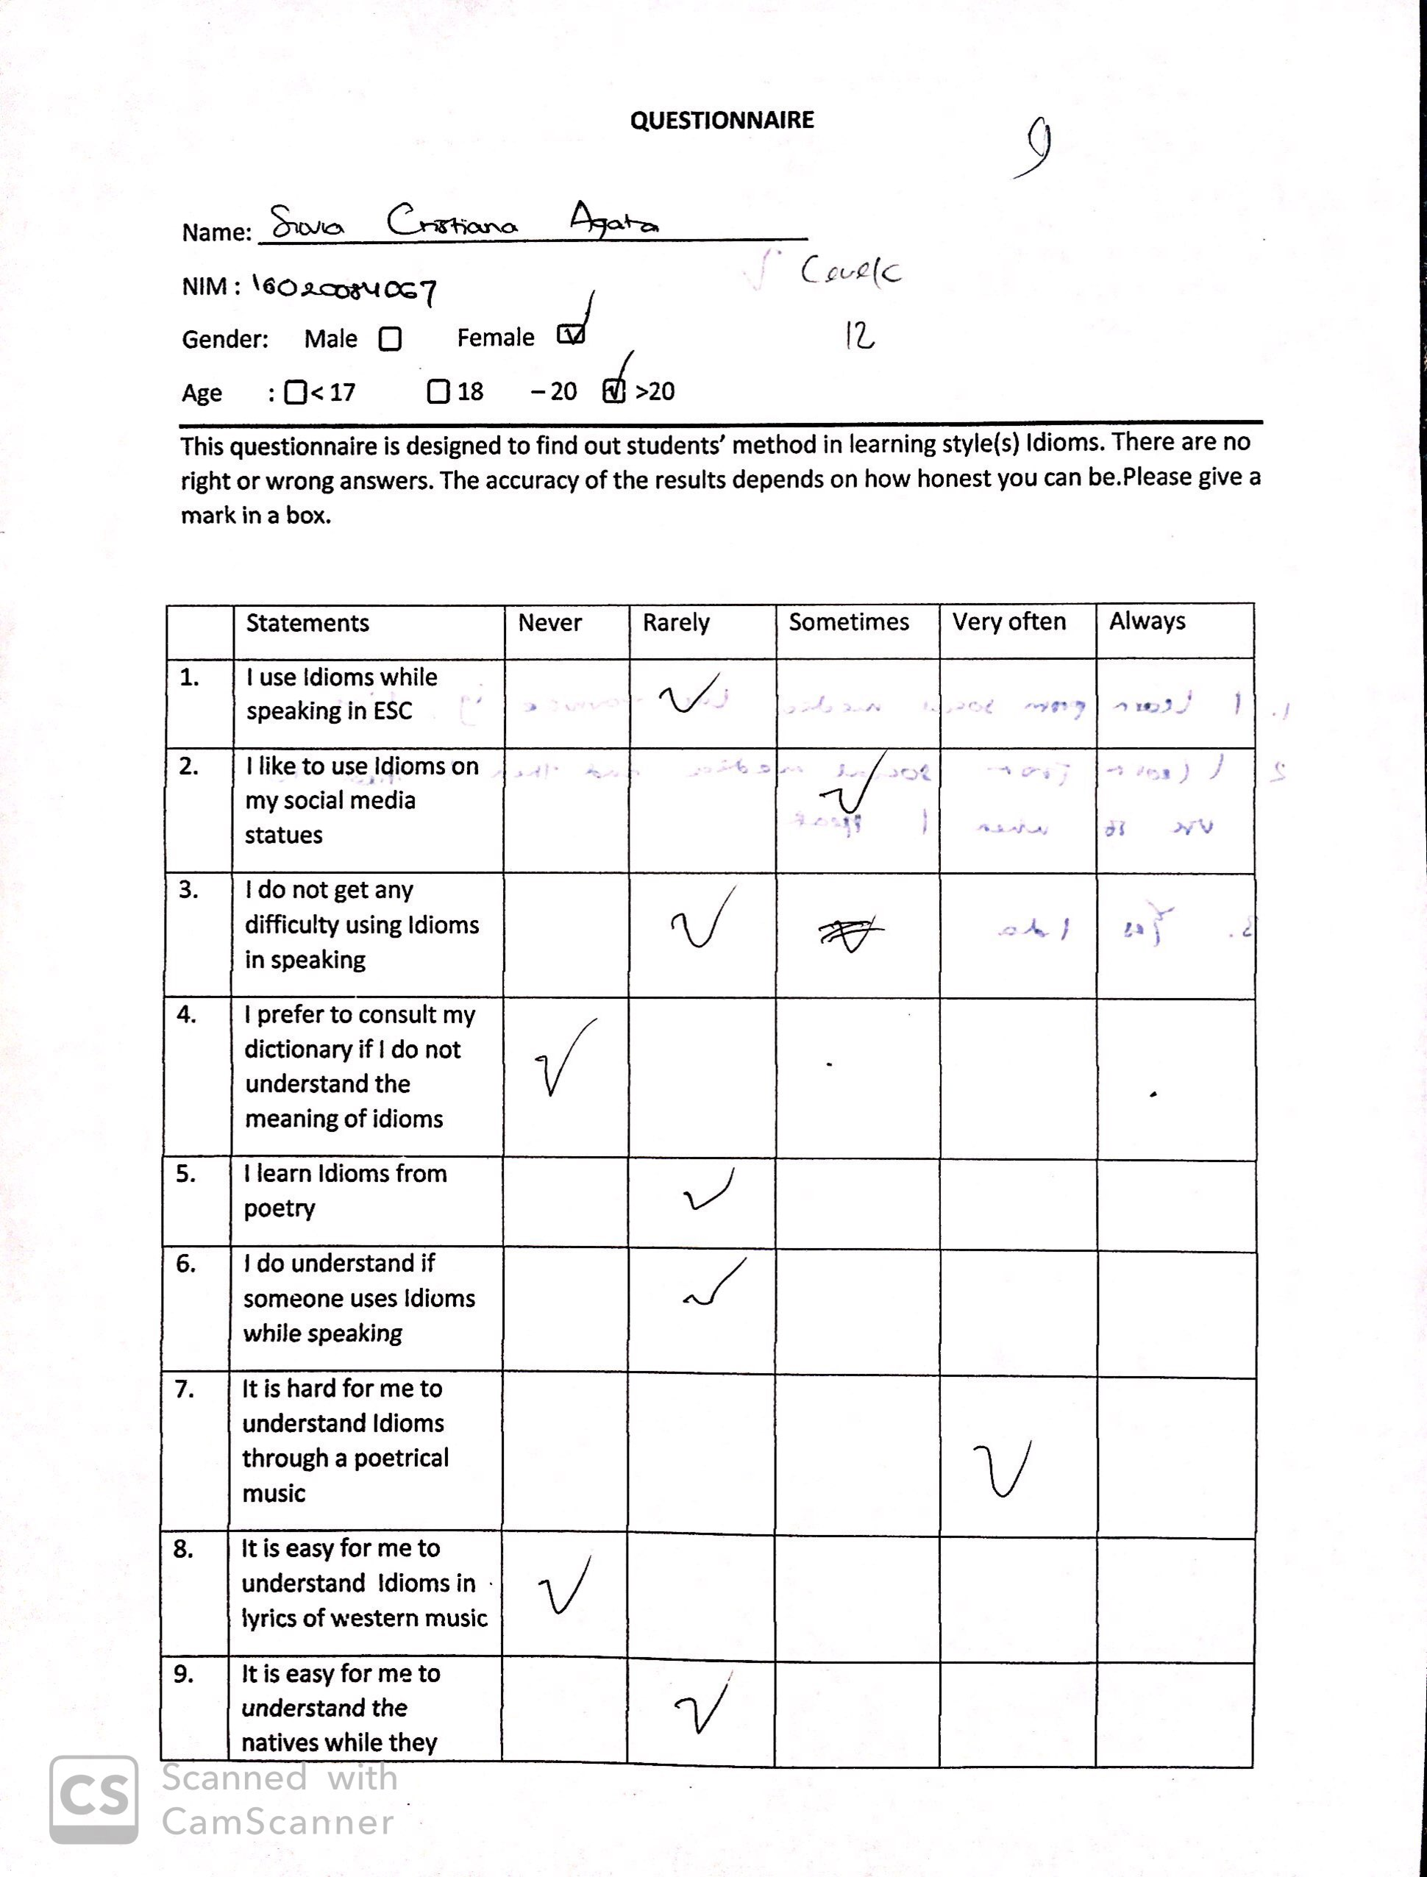
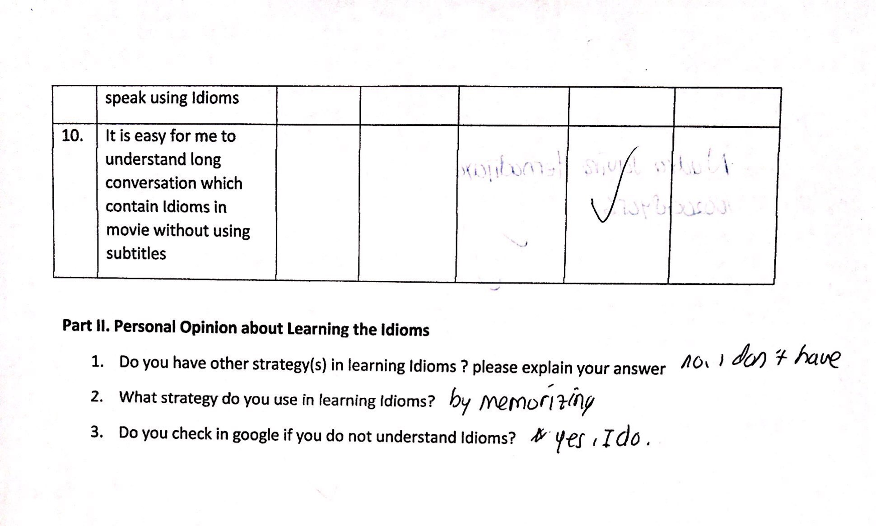
The First Questionnaire 1.1

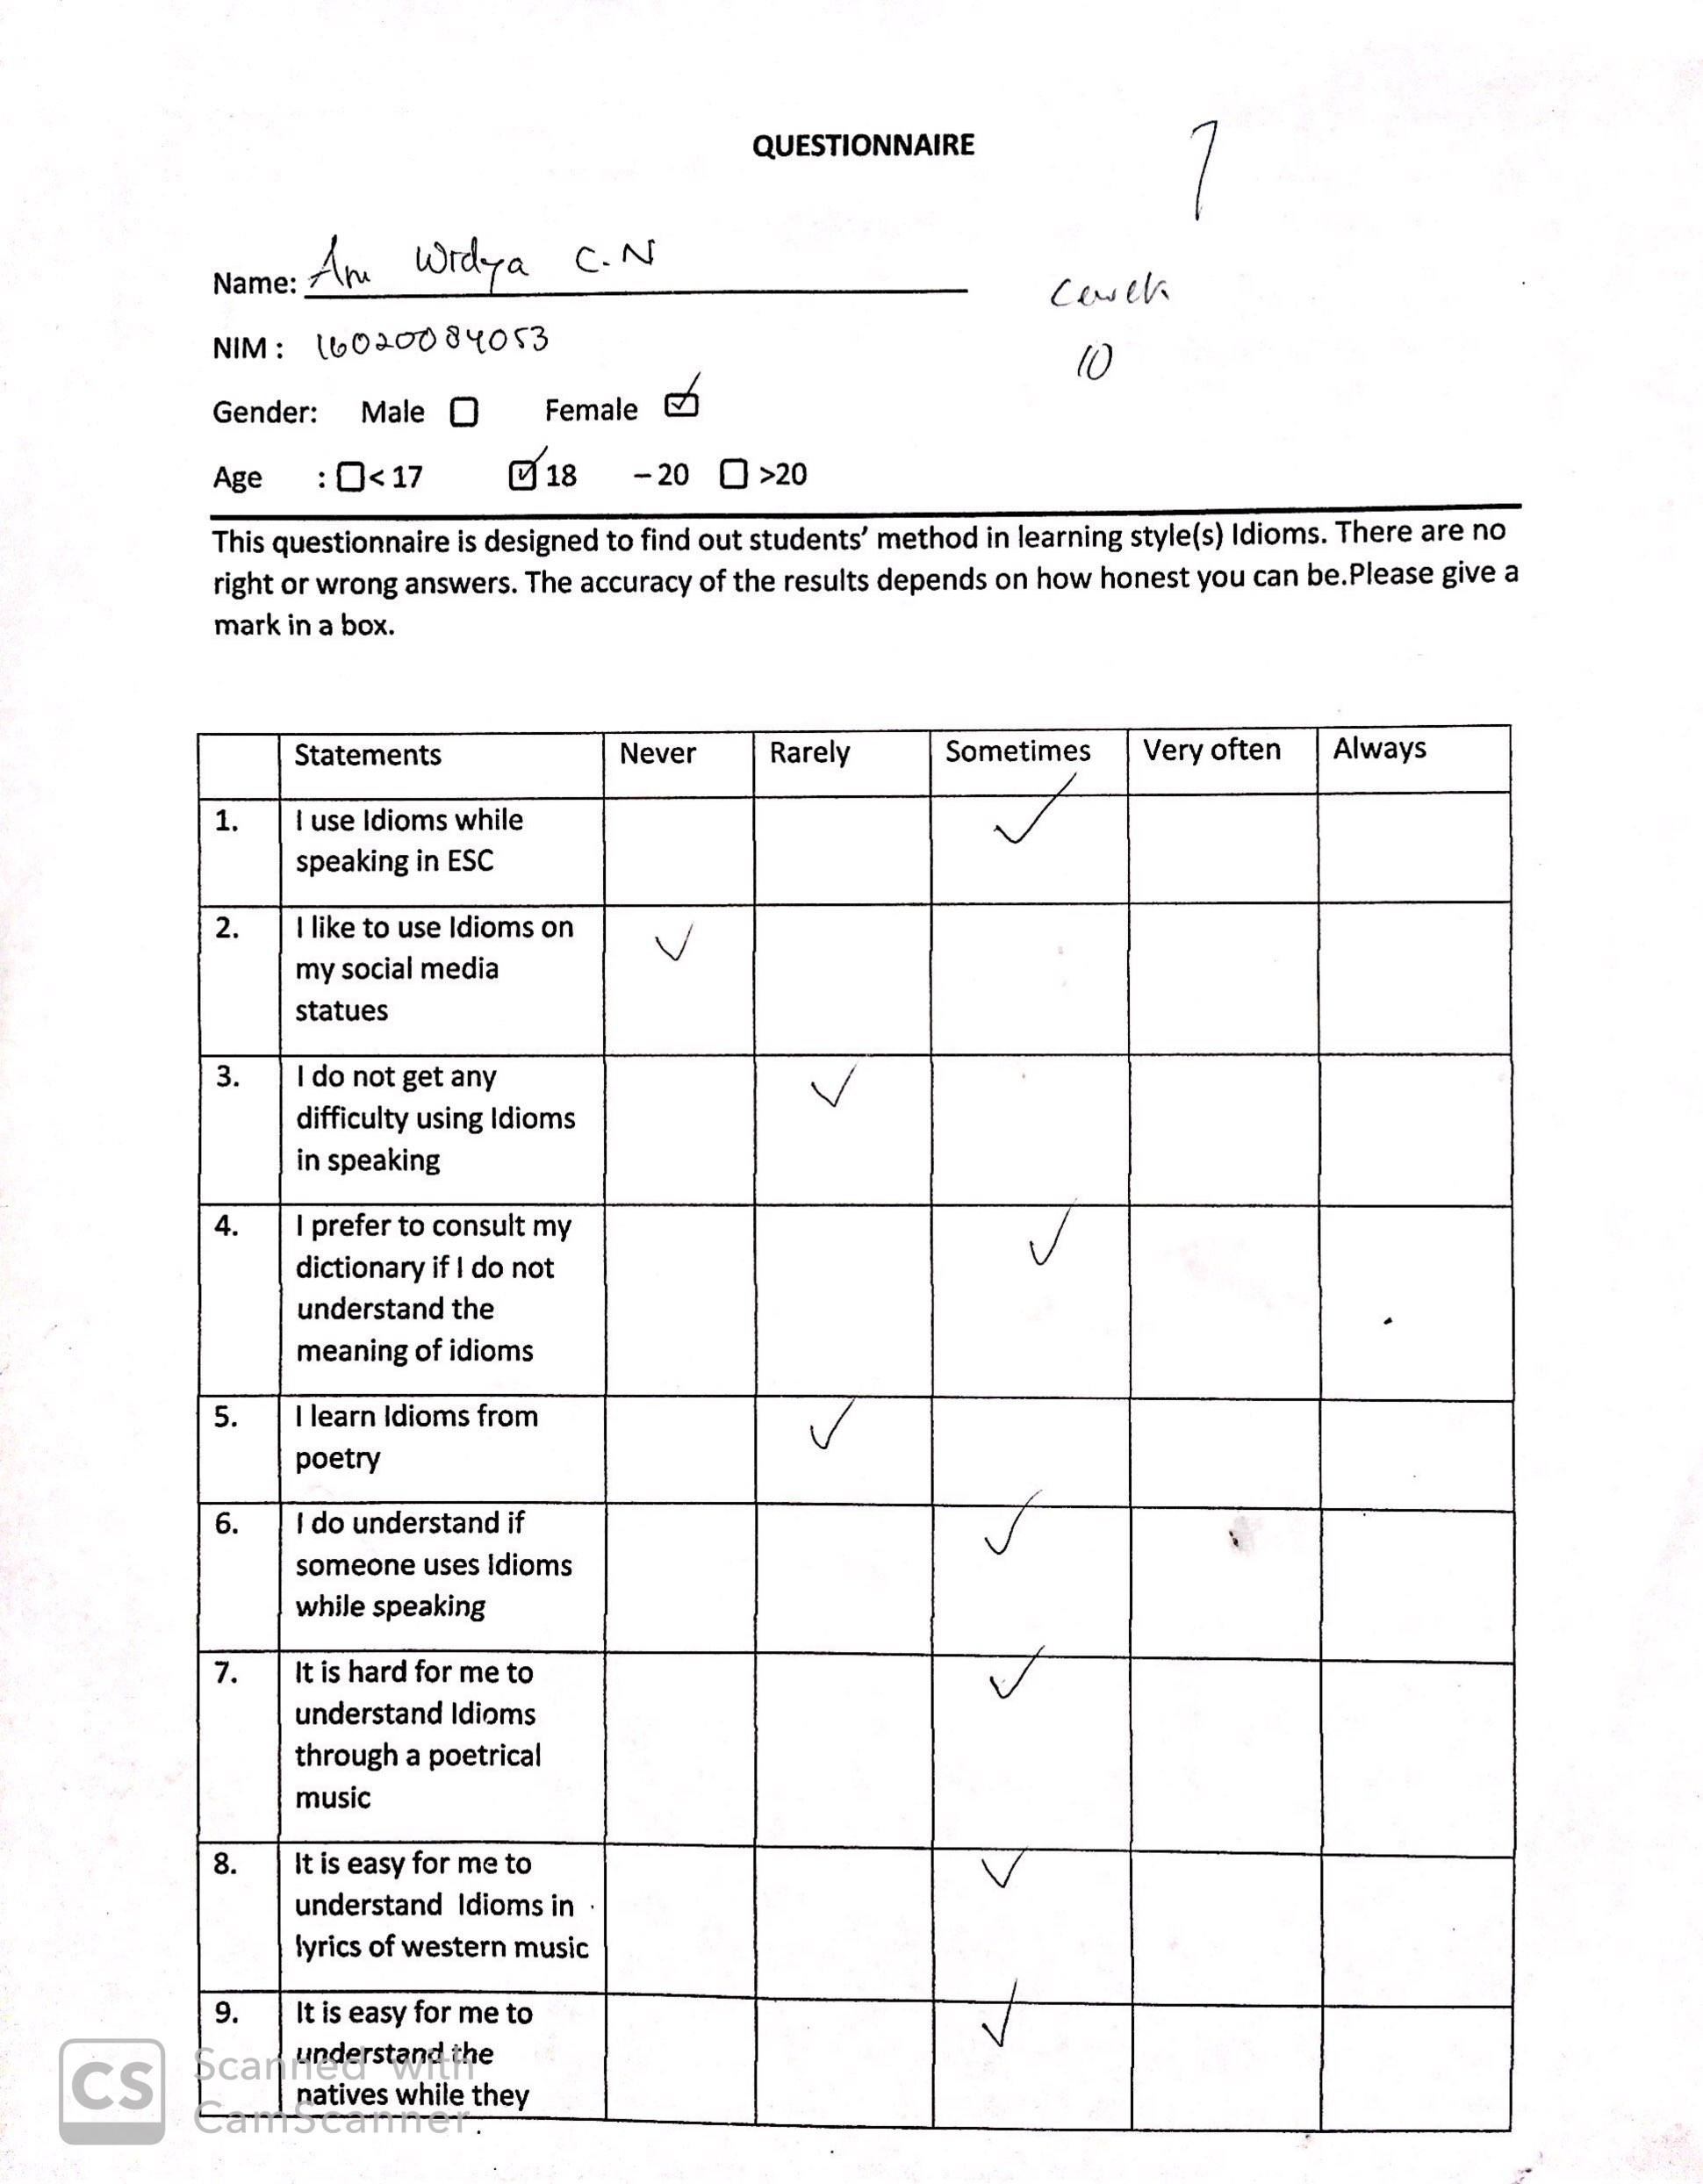

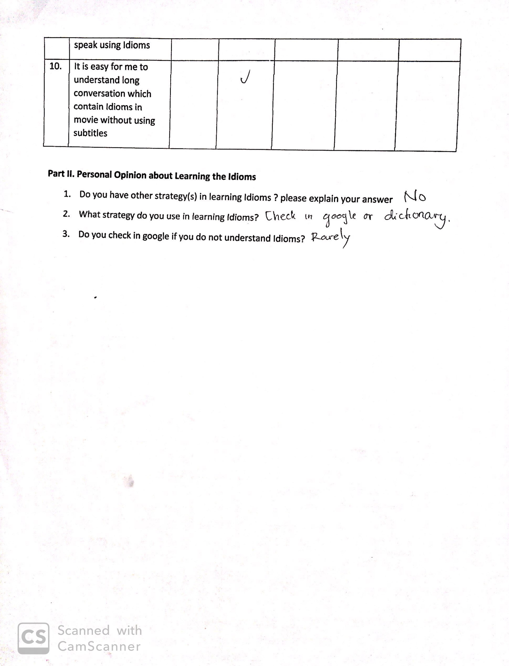
The Second Questionnaire 1.2

RESULT AND DATA ANALYSIS

Back to the research question of the study that questioning EFL learners’ perceptions level on comprehending and using idioms. Researcher has found that the level of EFL perception’s in regards of english idioms classified as manner and hardship. Manner refers to how EFL learners percieved their strategy in comprehending idioms in daily usage. While hardship refers to how EFL learner’s challenges in comprehending idiomatic expressions. The findings of this study have actually met reasercher’s expectation about EFL leaners perception on idiom usage in daily conversation. In advance, according to the result, samples of the study mostly select “sometimes” statement on each alternative item of the questionnaire. Thus, researcher considers that the recent samples of the study have lack of vocabulary and local culture interference. Saleh & Zakaria (2013) claimed that culture back ground and vocabulary size recognition can be determined as two of fundemental factors that influence EFL learners idiomatic comprehension.
The analysis of EFL perception of idioms yielded in average level on each alternative of the questionnaire. Among 35 samples in this study, most of them selected “ sometimes” statement of questionnaire alternative. Specifically, the questionnaire consist of 5 alternatives which is ranging from never (1); rarely (2); sometimes (3); very often (4); always (5).
According to the questionnaire, researcher found two categories which consist of “manners” and “hardships” underlying fundamental problems of EFL perceptions on idiom usage in daily conversations. More specifically, the variable of “manners” depicted by the question number 1,2,4 and 5. Meanwhile, the rest number of questionnaire represents “hardship” variable. Figuring this issue, the reseacher provided the result of the questionnaire computations, as follow:

Chart 1. Percentage Of EFL Idioms Perception based on the first variable (Manner & Hardship)
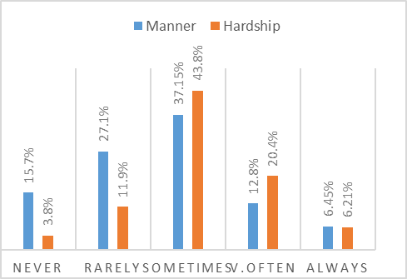
More specifically, the analysis of the EFL perceptions on idioms usage in daily conversation yielded the “Manner” for Never 15.7%, Rarely 27.1%, Sometimes 37.15%, Very often 12.8% and always 6.45%. For the hardship yielded for Never 3.8%, Rarely 11.9%, Sometimes 43.8%, Very Often 20.4% and Always 6.21%
The question (Q) number 1, 2, 4, 5 belongs to manner. The Q1 related to“using idiom while speaking”, the Q2 related to “using idiom on social media” , the Q4 is “ to consult the dictionary if do not know idioms”, and the last Q5 “learning idiom from poetry”. Meanwhile, the hardship is worded by the following question. The Q3 “don’t get difficulty using idioms”; Q6 “don’t understand if someone uses idiom”; Q7 “it’s hard to understand idiom through poetrical music; Q8” easy to understand idiom in lyric”; Q9” easy to understand native speaks using idiom”; Q10” easy for me to understand idiom in movie”.
In the same vein, the answers of manner which has been chosing by EFL leaners of 37.15% pointed out that EFL students loved to choose “Sometimes” which means “ EFL learners were indecisive using idiom while speaking”and “always consult to dictionary” while they were in ESC club of speaking, for the hardship of 43.8% it portrayed that EFL students were indecisive which means they cover up the weakness that they did not truly understand due to the lack of vocabulary.
The percentage of manner “always” 6.45% depicts that some EFL learners who truly have problems in methods of comprehend idioms since idiomatic expressions are not rocket sciences to interpret because of the minimum size of vocabularies. Even if they recognized the literal meaning of it. Interestingly, the percentage of hardship “always” 6.21% revealed that the lack of vocabulary likely affect them in understanding idiomatic expression. Compared to Saleh et al. (2013) showed that most students responded regarding the difficulty that idioms were not taught by teachers in the class

From the point of view of EFL learners’ perceptions of idioms usage in daily conversation, it can be concluded that most of the students have no strategy, have never practiced idioms in speaking and have difficulty. As the result, they consider that the idioms are difficult to apply in daily conversation. Meanwhile, some of them have their own strategies in overcoming difficulties and applying idioms in daily use. The strategies they do are by learning through social media, poetry, novels, films and google translation.
In terms of idioms difficulties, the introduction of idiomatic expressions in classroom and their figurative language are being the factors, such as the teacher have to be able to introduce the basic introduction of idiomatic and apply it in daily usage. Additionally, either the lack of cultural background or the low frequent of vocabulary were the factors that influenced the EFL learners in understanding the idioms.
CONCLUSION AND SUGGESTION
Conclusion
The results of this research showed that most of EFL learners at UNESA which grouped in ESC level 5 understimate the English idiomatic expressions. They tended to underestimate the importance of idiomatic expressions usage in daily conversation. As the result, almost half of the current samples were found that EFL learners do not have any particular habit in using idiomatic expressions for daily conversation. For instance, they inclined picking up “Sometimes” as the alternatives answer. Researcher stated that the phenomenon caused by the lack of self-automous learning about idiomatic expressions among ESC level 5 member. Their lack of self-automous learning about idiomatic expressions triggered students to answer questionnaires less honest and less objective.

Suggestions
Related to the conclusion, it suggest what EFL learners’ can get from their perceptions on idioms, they should be able to explore idiomatic expressions deeply, vividly in comprehending idioms and do not underestimate idiomatic expressions in daily usage.Thus, there are many EFL learners who are reluctant to open up their mind in evaluating themselves in comprehending idiomatic. So, they cover up their weaknesses either in comprehending or interpreting idiomatic expression.

References
Ambrose, J. (2003). Why Idioms are Important for English Language Learners.Mikolaiv State Pedagogical University.
Cooper, T. C. (1998). Teaching idioms. Foreign language annals, 31(2), 255-266.
Elkılıç, G. (2008). Turkish students’ understanding of transparent and opaque idioms in English in reading as well as in speaking. Dil ve Dilbilimi Çalışmaları Dergisi, 4(2).
Horwitz, E. K., Horwitz, M. B., & Cope, J. (1986). Foreign language classroom anxiety. The Modern language journal, 70(2), 125-132.
Irujo, S. (1986). A piece of cake: /Learning and teaching idioms. ELT journal, 40(3), 236-242.
Jiang, W. (2000). The relationship between culture and language. ELT Journal, 54(4), 328- 334. Oxford University Press.
Kellerman, E. (1983). Now you see it, now you don‟t. In S. Gass, & L. Selinker (Eds.),. Language transfer in language learning Rowley, MA: Newbury House.
Lazar, G.(1996). Using figurative language toexpand students' vocabulary. ELT journal.
Meryem. (2010). Problems of Idioms in Translation. Journal of English Language, 7(2), 16-18.
Moon, R. (1998). Fixed idioms and expressions in English: Clarendon Press: Oxford, UK.
Moon, R. (2006).Vocabulary connections: Multi-word items in English. In N. Schmitt & M. McCarthy (Eds.),Vocabulary:Description,Acquisition and Pedagogy (pp. 40-63). Cambridge: Cambridge University Press.

Saleh, N., & Zakaria, N. (2013). Investigating the difficulties faced in understanding, and strategies used in processing, English idioms by the Libyan students. International Journal of English Language and Translation Studies, 1(2), 69-91.
Sasson. (2007). four main stages of new vocabulary acquisition.
Stight, T. G. (1979). Educational uses of metaphor. In A. Ortony (Ed.),. Metaphor and thought (2nd ed., pp. 474-485).

