
THE “MBUJANG” DANCE WORK IN DRAMATIC FORM AS A VISUALIZATION OF THE PROCESS OF SELF DISCOVERY

Adam Musthofa¹, Dra. Jajuk Dwi Sasanadjati, M.hum².
State University of Surabaya, Surabaya, Indonesia
Email: adam.20063@mhs.unesa.ac.id. jajuksasanadjati@unesa.ac.id.



E-ISSN 2338-6770

Submitted date : -
Revised date : -
Accepted date : -

Corresponence Address:
Thai Studies, Faculty of Arts, Chulalongkorn University 254 Phaya Thai Rd, Wang Mai, Pathum Wan, Bangkok 10330. E-mail: 6688031022@student.chula.ac.th
Abstract: The Mbujang dance work is a dramatic visualization of teenagers' search for identity through reflection on the choreographer's empirical experiences. The character of Bujang Ganong in Reyog Ponorogo art is used as a basis for exploring movements to describe the emotional and social dynamics experienced by teenagers in the process of growing up. The purpose of this work is to present a symbolic representation of the journey of adolescents in finding their identity. The creation method uses Jacqueline Smith's Construction I, which includes the stages of initial stimulus, dance type, presentation mode, improvisation, evaluation, selection, and motif discovery. These stages are applied systematically to produce a complete choreography. The result of this creation is embodied in the dramatic dance work Mbujang, which combines the distinctive movements of Bujang Ganong with contemporary processing. This work depicts the struggles of teenagers between anxiety, social interaction, and the effort to find balance within themselves. Elements of tradition and modernity are combined through movement, music, and artistic design, resulting in a new expression that is contextual to the lives of today's teenagers. The work Mbujang is expected to enrich the repertoire of dramatic dance art as well as serve as a reflection for individuals to understand the importance of the process of searching for one's identity.

Keywords: Dramatic dance, search for identity, youth, Bujang Ganong, Mbujang

1. INTRODUCTION

Adolescence is an important phase in human life, marked by physical, emotional, and social changes. At this stage, individuals are in the process of searching for their identity and forming their character. Inner struggles, the desire for freedom, and the search for direction in life are often part of the dynamics experienced by teenagers. This phenomenon can be understood as a challenging and meaningful process towards adulthood.
In the context of self-discovery, cultural symbols can be a relevant source of inspiration to represent the dynamics of adolescence. One such symbol is the character Bujang Ganong, a figure in traditional performances known for his energetic, agile, humorous, and vibrant movements. This character is often interpreted as a representation of a young soul that is brave, intelligent, and dynamic in facing various situations. These traits are in line with the struggles experienced by teenagers in determining their identity.
The dance work Mbujang was born from reflections on this phenomenon as well as the choreographer's experiences. The character of Bujang Ganong was used as a starting point in exploring movements combined with contemporary physical exercises to create dramatic expressions. This work visualizes the dynamics of youth through emotional and symbolic atmospheres that depict the search for identity. The combination of traditional elements and their development is intended to bring new relevance to the younger generation, while also showing that traditional figures can still be understood in the context of today's life.
The urgency of this work lies in its effort to provide a space for reflection for teenagers on the importance of the process of finding one's identity. Through artistic expression, Mbujang is not only an aesthetic presentation, but also a medium of symbolic communication that raises socio-psychological themes of adolescence. Thus, this work is expected to enrich the repertoire of dramatic dance and contribute to the development of traditional performing arts contextualized with contemporary issues.

2. METHOD
The creation of the Mbujang dance work uses Construction Method I as proposed by Jacqueline Smith (1985). This method was chosen because of its systematic and detailed stages, which make it easier for choreographers to find, process, and arrange movements into a complete dramatic dance composition. Smith (1985:20–32) explains that this method includes initial stimulation, exploration, improvisation, evaluation, selection and refinement, and motif formulation. Each stage serves as a conceptual framework that guides the creation of Mbujang as a dramatic dance work.
a) Initial Stimulus
Stimuli are the starting point that sparks creative ideas. Smith (1985:20) states that stimuli can be auditory, visual, ideas, touch, or kinesthetic. In Mbujang, the initial stimulus arises from the choreographer's personal reflections on his life experiences. His turbulent teenage years, from involvement in promiscuous social circles to the urge to search for meaning in life, gave birth to a new awareness that led to a process of self-identity exploration. Art then emerged as a transitional space that paved the way for growth and deeper self-knowledge. The cultural proximity to Ponorogo, a city synonymous with Reyog, reinforces this creative stimulus. The character Bujang Ganong, with his clever, energetic, and vibrant personality, becomes the most representative symbol to describe the dynamics of adolescence. This character not only serves as an icon of tradition but also as a mirror of the choreographer's inner journey in the process of finding his true self.
b) Exploration
Exploration is carried out to discover movements and atmospheres that match the concept of the work. Hadi (2007:66) explains that exploration is a process of investigation that allows choreographers to explore various sources of inspiration, both from personal experience and the surrounding environment. In Mbujang, exploration is directed at finding movements that can express the confusion, inner turmoil, spirit, and hopes of youth. The choreographer reexamines the movements of Bujang Ganong through documentation, childhood experiences, and direct observation of Reyog Ponorogo performances. The philosophical values contained therein are then combined with personal experiences, resulting in a movement vocabulary that is rooted in tradition but remains open to contemporary interpretations.
c) Improvisation
Improvisation serves to enrich exploration through bodily spontaneity. Smith (1985:31) refers to improvisation as the process of bringing imaginary images into tangible form, which allows for the birth of authentic new movements. In Mbujang, improvisation is used to express the emotional dynamics of youth: from confusion, anxiety, anger, and rebellion to calmness and self-acceptance. The movements that emerge are not merely imitations of the traditional Bujang Ganong form, but also the choreographer's personal bodily response to inner experiences. In this way, improvisation gives birth to movements that are honest, personal, and rich in drama.
d) Evaluation
Evaluation is an important stage for reviewing the results of improvisation and exploration. Smith (1985:31) emphasizes that evaluation aims to perfect the work through observation and critical consideration. In Mbujang, evaluation is carried out repeatedly on aspects of movement, composition, expression, and harmony with supporting elements such as music, makeup, props, and lighting. The evaluation process is not carried out individually. The choreographer involves the dancers in the principle of "second eyes," which is to give each other feedback and corrections to improve the quality of the work. In addition, collaboration with music composers is realized in the dol tinuku process, or the process of giving and receiving ideas that produce musical accompaniment in harmony with the dramatic atmosphere of the work.
e) Selection and Refinement
Selection is carried out to choose the movements that are most relevant to the idea of teenagers' search for identity. Smith (1985:32) explains that selection and refinement aim to clarify technique while strengthening expression. In Mbujang, the selected movements are sorted based on clarity of meaning, strength of expression, and suitability to the dramatic flow of the work. The refinement stage is carried out by arranging the tempo, level, space, and dynamics to compose a coherent dramatic structure: starting from inner turmoil, the search for direction, emotional conflict, to the discovery of identity. The choreographer also provides room for interpretation for the dancers through the principle of "bring it according to your body," so that each individual can interpret the movements according to their body type. This makes the work not only structured, but also presents authentic expressions.
f) Motif
Motifs are simple movement patterns that form the basis for choreography development. Smith (1985:32) refers to motifs as the starting point for movement that can be further developed into the distinctive characteristics of a work. In Mbujang, the movement motifs are inspired by the character of Bujang Ganong, such as jumps, acrobatic movements, comical facial expressions, and lively tempo. These motifs are then combined with contemporary movements sourced from the choreographer's bodily experience, resulting in a new form that is rooted in tradition while also expressing modern nuances. Motifs not only bind the composition together, but also serve a symbolic function to depict the journey of youth, from anxiety to self-balance. Thus, motifs reinforce the aesthetic identity of Mbujang's while also emphasizing the dramatic value it seeks to convey.

3. RESULTS AND DISCUSSION

Results
- Theme
According to Sal Murgianto (1983:87), themes arise from the total experience of a choreographer, who then carefully studies the possibilities of expressing them through movement. The theme raised in Mbujang's work is the search for teenage identity. This theme stems from the choreographer's reflection on his personal experiences during his teenage years, which were full of emotional struggles and a search for meaning in life. The character Bujang Ganong was chosen as a symbol capable of representing the spirit, agility, ingenuity, and turmoil of the young soul.

- Title
The title is an identity that implies the content of a work of art. Murgianto (1983:93) states that the title must be concise, clear, and original, so that it can help the audience interpret the work. The title Mbujang was chosen to emphasize the phase of life of adolescents or bachelors who are in the process of searching for their identity. This title also represents the work's closeness to the character Bujang Ganong, who is the main source of inspiration for the exploration of movement.
- Synopsis
A synopsis is a brief description of the main points of a work. In the Mbujang dance, the synopsis summarizes a teenager's emotional journey of self-discovery.
"Running, searching, tossed about by self-doubt.
Deep and deep. Turmoil always colors...
Sometimes on target, sometimes lost.
Yes, this search will continue along with footsteps that never want to stop... Toward a true life...”
- Scenario
A dance work has a scenario to describe each scene, making it easier to understand the narrative or description in each scene. Below is the scenario table for the Mbujang dance work

Tabel 1. Scenario of Mbujang dance work

NO | SCENE | SUB THEME | MOTIVATION | ATMOSTPHERE | DURATION
1 | INTRODUCTION | THE PHASES OF ADOLESCENCE | A depiction of the phases of life, including sadness and happiness, two issues that always accompany life. | Deep, Tense | 3 – 4  Minutes
2 | SCENE 1 | EMOTIONAL AND SELFISH NATURE  EMOTIONAL | Describes the behavior and traits of teenagers in search of their identity. | Happy, Deep | 3 minutes
3 | SCENE 2 | INTERNAL CONFLICT  AND  ENVIRONMENT | Describing  how negative behavior and traits will only cause one to sink deeper into  reality. | Tense | 2 minutes
4 | SCENE 3 | CONTROL  SELF / CLIMAX | Describes  self-control, emotional awareness, recognizing oneself  oneself | Tense, Enthusiastic | 5 – 7  minutes
5 | SCENE 4 ENDING | PENCAPAIAN,  KEBAHAGIAN | Describing something achievement of self-identity, there is happiness when we can recognize ourselves, we can be | Enthusiasm, cheerfulness, humor | 7 minutes

- Dance Type
The choreographer has determined the dance type in this Mbujang dance work to be dramatic dance. This type is used because it is considered appropriate for the main concept, which is not to tell a story. With the dramatic type, the choreographer emphasizes movement expression, the interaction of the dancers with the stage space, and the ability to convey emotional and symbolic experiences implicitly to the audience.
- Presentation Mode
According to Jaqueline Smith, translated by Ben Suharto, presentation modes are divided into two types: representative and symbolic (Suharto, 1985:29). In this work, the choreographer uses symbolic and representative forms or modes. The aim is to better bring out symbols or representations of the choreographer's sensitivity and awareness in expressing an event throughout their empirical experience in the search for identity. Thus, in the production, there is freedom of movement, similar to the forms of reality in the real world, which will strengthen the expression of ideas in the process of searching for identity.
- Movement techniques
Technique is an effort to organize and execute the entire dance process, both physically and mentally, which dancers must master, including skills in form, medium, and instruments (Hadi, 2015:49). In the dance work Mbujang, the choreographer developed movement techniques rooted in the role of Bujang Ganong in the art of reyog ponorogo, with adaptations and improvisations to suit the choreographic concept. This process involves exploration of the body, processing of floor patterns, and use of props, so that dancers not only master the movements technically, but are also able to express the motivation and meaning behind each movement. This approach allows for the creation of attractive, dynamic movements that demand high stamina, while still maintaining the characteristics of tradition as the foundation of the choreography.
- Style
In Mbujang dance works, the style of movement reflects the choreographer's journey in exploring bodily experiences and the search for identity, which is influenced by cultural values and traditions (Hadi, 2014; Suharto, 2010). The main inspiration is Bujang Ganong, which is combined with contemporary influences to create a balance between traditional forms and modern expressions (Hawskin, 2012; Murgianto, 2018). This movement style becomes the choreographer's personal statement, allowing dancers to convey personal expressions relevant to current conditions, resulting in works that are dynamic, expressive, and relevant in the context of modern dance.
- Dancers
In Mbujang, dancers act as a medium for expressing ideas and interpretations. The choreographer uses six male dancers as symbols of the six spiritual directions, namely East, West, North, South, Up, and Down, which represent various aspects of human life. The dancers' movements reflect the human journey of understanding each direction to achieve spiritual balance.
- Tata rias dan Busana
The Mbujang dance, makeup and costumes are important elements in representing the journey of self-discovery. Minimalist makeup, even without powder, emphasizes the authenticity of the dancers' expressions and inner journeys, with stage lighting that enhances their facial expressions. The costumes are used symbolically. At the beginning of the performance, the dancers wear black singlets and beige komprang pants, symbolizing the adolescent phase (ignorance and flexibility) in the search process. As the dance progresses, some dancers begin to wear partial Bujang Ganong attributes, indicating an ongoing process of identity transformation. Meanwhile, one dancer retains the initial costume, symbolizing an individual who has not yet found their true identity.
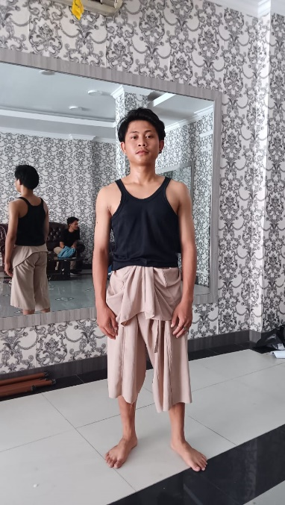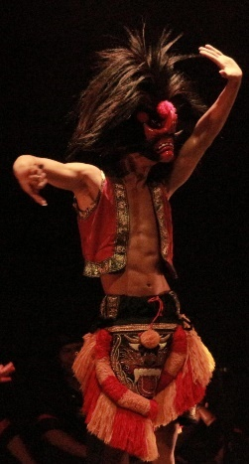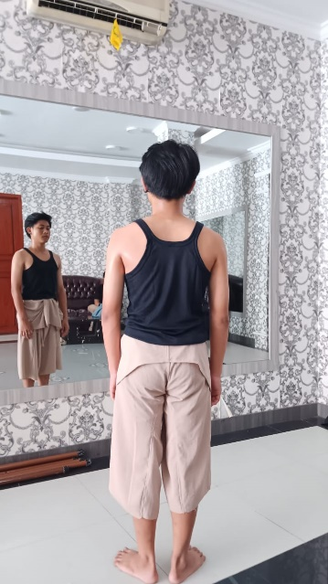
At the end of the performance, one dancer exits wearing the full Bujang Ganong costume, marking the achievement of full self-awareness. This gradual transformation not only enhances the visuals of the performance but also conveys the philosophical meaning of the human journey from ignorance to finding one's true identity.

- Companiment
The music in the Mbujang dance piece serves as a dramaturgical support and accompaniment to the dancers' movements, combining internal and external music (Murgianto, 1983). The internal music comes from the dancers' bodies, such as foot stomps, hand claps, or vocals, to create expressive interactions in certain scenes. External music consists of MIDI and live music, which are selected to support the dynamics of the performance and the symbolic message of the work. MIDI music is used from the beginning to the climax, combining traditional Reyog instruments, such as drums and slompret, with modern instruments such as keyboards and saxophones. This combination creates a dynamic and experimental feel, depicting the early stages of the dancer's search for identity and inner conflict. Towards the end of the performance, there is a transition to live music, using a full Reyog gamelan to bring a sacred and authentic feel, marking enlightenment and awareness in the spiritual journey. Through the combination of internal and external music, as well as the integration of traditional and modern instruments, the musical accompaniment in Mbujang not only supports the dance movements but also reinforces the dramaturgical message, creating an expressive and meaningful auditory experience for the audience.
- Props

Props in dance are tools that support movement and the visualization of meaning. In Mbujang, the props used include Bujang Ganong masks, both finished and unfinished, as well as singlets. The masks reinforce the character and identity of the dancers, while the singlets allow freedom of movement. These two props support the smooth running of the performance and reinforce the meaning of the movements being performed (Hadi, 2014; Murgianto, 2018).

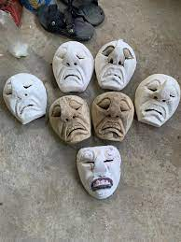
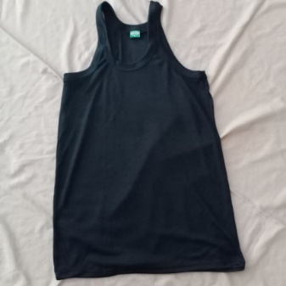
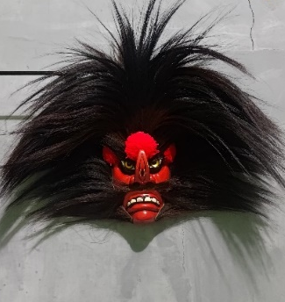

- Tata Teknik Pentas

Props in a dance work must be carefully considered, and their presence must support the achievement of the message, meaning, and impression of the dance work by the audience. Props themselves are a medium used for dancing during the performance, because of their identity as tools or media, the meaning of their presence is functional (Hidajat, 2017:89). The Mbujang dance work uses a proscenium stage without a fixed setting in it. There is also special lighting such as footlights as a supporting element for each scene.

3. DISCUSSION
The Mbujang dance work raises the theme of self-identity search, which is relevant to the experiences of teenagers. The choreographer presents the emotional journey of teenagers in facing challenges and identity turmoil through variations of large and small movements as well as high and low levels. The asymmetrical floor patterns and synchronized and alternating techniquesrepresent the uncertainty and social interactions of adolescents. The symbolic makeup and costumes support expression and freedom of movement. The props used reinforce the narrative, while the proscenium stage and dynamic lighting create an emotional atmosphere. The music, which combines traditional and modern instruments, adds depth to the theme of the search for identity. Overall, Mbujang attempts to visualize the journey of adolescents' search for identity through a combination of movementstage design and music creates a work that is both entertaining and thought-provoking, highlighting the importance of the process of finding one's identity.

4. CONCLUSION
The dance work Mbujang is an exploration of the human journey in search of identity and balance in life. The choreographer expresses his ideas through the use of six male dancers who symbolize six spiritual directions and the combination of traditional Bujang Ganong elements with contemporary elements. Each element, such as movement, music, makeup, costumes, props, and floor patterns, supports each other to convey the message of the search for identity and the connection between humans and the universe. The transformation of costumes and the use of props reinforce the visualization of an individual's journey from the phase of searching to full self-awareness. This work shows a dynamic and expressive process of achieving identity while combining traditional and modern values, resulting in a performance that is full of meaning and relevant to current social developments.

REFERENCE

Muhammad, Ali. & Mohamad, Asrori. 2006. Psychology of Adolescents. Yogyakarta: Pustaka Pelajar.

Budiman, Dani Setyawan. 2022. Karya Tari Buruh The Body: The Process of Creation Through the Interpretation of Power Relations Power in the Relationship of Ebeg Art. Solo. Indonesian Institute of the Arts Surakarta.

Dibia, I Wayan, et al. (2006). Dance Art Book for Grade VII. Jakarta: Ministry of National Education.

Elizabeth, R. Hayes. 1964. Dance Composition and Production. New York: The Ronald Press Company.

Febriyantoro, Rizky. 2021. Doxa Dance Work (Laku of the Spiritual Bujannganong Dancer). Solo. Indonesian Arts Institute of the Arts of Indonesia Surakarta.

Hadi, Sumandiyo. 2014. Choreography Form – Technique – Content. Yogyakarta: Cipta Media_____2007. Dance Text and Context. Yogyakarta: Pustaka Book Publisher.

Hawkins, Alma M. 1988. Creating Through Dance. New Jersey: Princeton Book Company, A Dance Horizon Book. ___2003. Moving According to the Heart. Translated by I Wayan Dibia. Jakarta: Ford Foundation and Indonesian Performing Arts Society.

Hidajat, R. (2001). Solo Choreography. Jakarta: Ministry of National Education.

Miroto, Martinus. 2022. Dance Dramaturgy. Yogyakarta: ISI Yogyakarta Publishing Agency, UPT Library ISI Yogyakarta, Institute of Indonesian Arts.

Milasari, Eny K. 2021. Dance Teacher's Guidebook. South Jakarta: Publishing Center of the Standards, Curriculum, and Assessment Education, Ministry of Education, Culture, Research, and Technology.

Murgiyanto, Sal. 1983. Basic Knowledge of Dance Composition. Dance Composition. Jakarta.

Rahmi, Harfi M. 2019. Who Are You? Central Java: Great Children of Indonesia.

Smith, Jacqueline. 1985. Dance Composition Translation Ben Suharto. Yogyakarta: Ikalasti Yogyakarta.

Sedyawati, Edi et al. 1986. Basic Knowledge of and Some Dance Issues.
Jakarta: Directorate of Arts, Jakarta Arts Development Project Jakarta, Department of Education and Culture.

Sulaiman. 2023. Tubuh Cantrik. Solo. Indonesian Institute of the Arts Indonesia Surakarta.

