@r al., Solah Journal of Performing Arts (20254)
https://doi.org/10.26740/vt.v1n1.p1xx- 1xx

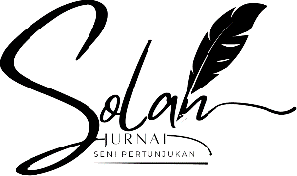



E-ISSN 2338- 6770

Submitted date : - Revised date : - Accepted date : -

Correspondence Address: Thai Studies, Faculty of Arts,
Chulalongkorn University 254 Phaya
Thai Rd, Money Mai, Pathum Wan, Bangkok 10330. Email: 6688031022@student.chula.ac.th

INTRODUCTION

WORK THE "PANGIKET" DANCE AS A VISUALIZATION OF THE MEANING OF YELLOW FOOD IN TAKIR PLONTHANG THROUGH A DRAMATIC DANCE TYPE
Danu Soleh Cahyono 1 , Dr. Setyo Yanuartuti, M.Si. 2

State University of Surabaya, Surabaya, Indonesia
E-mail: danu.21003@mhs.unesa.ac.id. setyoyanuartuti@unesa.ac.id

Abstract : The Pangiket dance work is a dance work that visualizes the meaning of yellow coconut leaves as human self-control. This dance work is based on the Ngetung Batih tradition in Dongko District, Trenggalek Regency, where this tradition is a traditional ritual to welcome the month of Suro which is full of spiritual, social, and moral meanings. One of the important elements in this ritual is the takir plonthang with yellow coconut leaves as a binder, which is interpreted as a symbol of human self-control. This meaning became the inspiration for the creation of the Pangiket dance work. The choreographic concept departs from the urgency of the value of self-control which is increasingly neglected in the younger generation amidst the rise of negative behavior. The process of creating this dance work uses Jacqueline Smith's construction method 1 through the stages of initial stimulation, exploration, improvisation, evaluation, selection, and refinement. The form of presentation combines dramatic style with representative and symbolic modes. Other supporting elements such as costume and makeup take inspiration from Javanese aesthetics. Furthermore, this dance work is performed on a proscenium stage using various lighting systems, such as 64-par, LED par, and Fresnel. The Pangiket dance work is expected to be both a spectacle and a guide, with the main message being the importance of self-control, balance, and community, and to achieve harmony and happiness in life.
Keywords: Pangiket, Yellow Leaf, Self-control, Dramatic

Ngetung Batih is a traditional ritual in Dongko District, Trenggalek Regency. The community believes this ritual welcomes the month of Suro , or the Islamic New Year. It also serves as a means of cleansing oneself of negative traits. Ngetung Batih can be interpreted as "Ngetung" meaning counting and "Batih" meaning member . family. Means Ngetung inner is ceremony customs Which intended for count member family in every family. Until To this day, the Dongko people still preserve this tradition because of its many sacred values and prayer symbols. This can be seen in the ubarampe. or offerings Which used. Ubarampe Alone is a medium of prayer that connects humans with God, which has spiritual values, guidance, action, and morals. One of the obligatory ubarampe that must be prepared is a takir plonthang , which is believed to be symbol application prayer man to Which Maha Power. In addition, the takir plonthang is filled with rice, srondeng , chicken eggs, and dried tempeh, representing the diverse nature and character of humans. And, the container ( takir ) for the dish. Which shaped rectangle long made from leaf banana with tied with yellow coconut leaves on the outside.

© 2023 The Author(s). This open access article is distributed under a Creative Commons Attribution ( CC-BY- NC-SA ) 4.0 license.

The takir (yellow coconut leaf) binding is closely related to the meanings of life for humans. Besides functioning as a rope to tie the takir to prevent the filling from spilling, in Javanese culture, the coconut leaf is interpreted as... as true light or light, Where man in fact only seeking harmony of the human soul in the form of NUR or light from the Most Gracious God (Ratnasari, Susilo 2022). Yellow coconut leaves in the world of marriage are interpreted as a high ideal to achieve divine light accompanied by clear feelings of heart, especially for the two prospective brides and grooms, because in essence, someone who carries out a marriage is beginning For open sheet Which new And Starting a new life. The above interpretation is a concept where traditions or customs emerge from societal habits closely related to religious and sacred beliefs. The yellow coconut leaves found in the takir plonthang symbolize human self-control, as the leaves bind various human traits, including aluamah (goodness), supiyah (supiyah), mutmainah (compassion), and anger.

Young coconut Which tie (character) control self with young coconut Yellow lies somewhere between these two meanings. According to Goelmen (in Sari, 2013), self-control is the management of conditions, self-control, vigilance, and innovation that can be handled emotionally and appropriately before achieving a goal. This is similar to the yellow coconut leaf, where the leaf is interpreted as the true nur or divine light that is solely the goal of humans to achieve blessings. Self-control is also defined as take action Which done somebody in a way aware, without harming others so that he can adapt to the norms in his environment. In life, man very need self -control or self-control so that things that can harm oneself do not happen and person other. Especially in era moment This very Lots teenager indifferent to their self-control attitude which gives rise to reprehensible acts, such as violence, gambling, free sex, drunkenness, motorcycle gangs, even drugs, as in the news currently circulating, namely news about a City Bike (CB) motorcycle club community.

This incident has recently become a trend on social media, where the community used a minimarket as a resting place in an inappropriate way, because in this case there were dozens of young people. Which where they fulfil hallway mini Market until creating unsuitable conditions. They not only sat but also lay on the minimarket floor, their conditions dirty, even muddy footprints unavoidable, making the minimarket unsuitable. We can underline this incident: characteristic control self very important implanted on every human being especially a teenager.

The concept of the work that will be realized by the choreographer regarding the implementation of the meaning of yellow coconut leaves, where this element is a depiction of self-binding or self-control of humans, because of their nature. start from in content We Already awarded four The characters are aluamah, supiah, wajibmainah, and anger. These binders are used to create harmony, balance, and harmony. as well as happiness between individual One with Which other. Moreover, life in a community has a significant influence on a teenager. Therefore, the yellow coconut leaf becomes the choreographer's primary focus, representing human self-control.

From the above presentation by the choreographer visualize to in The dance form "Pangiket" is expected to serve as guidance and entertainment, based on the meaning of the yellow coconut leaf as human self-control. Because every human being faces different problems in life, self-control is necessary to achieve harmony, balance, harmony, and happiness throughout life.

METHOD

Methods in the work dance This use method construction 1 Which in create by Jcqueline Smith as a development of the creative process. This method has a specific structure contained in the construction method 1 which includes several steps, namely, initial stimulation, determining the type of dance, composing the presentation method, exploration, improvisation, evaluation, selection and refinement. This creation method is used as an approach technique to determine the process of forming a dance work. From this approach, the choreographer creates a work design and applies the method to the creation of this work.
- Initial Stimulus
Work dance pangiket is form visual idea idea from young coconut Yellow symbolizes human self-control. The idea for this idea emerged from a choreographer who participated in the traditional Ngetung Batih ceremony. Based on these experiences and observations, the choreographer then conducted a deeper search, research, and observation of the ceremony. After this process, the specific idea emerged in the form of yellow coconut leaves as a symbol of Human self-control. The young leaves are an essential part of the ubarampe takir plonthang, where they are used to tie the takir plonthang to prevent the filling from spilling out. However, more than just a binding function, young leaves have a deeper meaning. Janur is interpreted as sejatine nur, meaning that every human being solely seeks nur (light) or revelation from Almighty God.
The choreographer linked the young coconut leaf (janur) to human self-control. This is urgent because of the current phenomenon of teenagers who are indifferent to their inner nature, lacking self-awareness, which results in negative behavior and actions. Violence, brawls, drunkenness, gambling, and many other negative behaviors result. Therefore, the choreographer used the young coconut leaf as a reflection of the meaning of self-control for teenagers.
- Exploration
Exploration is the initial stage in the process of creating a dance work. This exploration means that movement is explored through predetermined ideas. After passing the initial stimulation stage, which involves observing phenomena, urgencies, traditions, and events, the choreographer then conducts a deeper search to express the work.

into a visual form that can convey these ideas. The visualized forms are symbols of body movements based on local traditions. These symbols are crucial in this work because they determine how the audience can understand and even interpret the meaning conveyed in Tati's work.
- Improvisation
Freedom of movement is an important point in improvisation to foster creativity and new, expressive awareness (Hadi, 2014:77). Freedom of movement Which appear from process This shaped symbols by adapting the meaning of the ideas and concepts. Some the symbol that appears, namely symbol of praying, symbol of togetherness, symbol of pangiket , and a symbol of self-reflection. This symbol becomes a spark when choreographers and dancers improvise. It creates ideas for movement, guesswork, and broader movement without any significant limitations. The properties become something new as a reinforcement in this work while still undergoing processing that is adjusted to the specified ideas.
- Evaluation
The evaluation stage is carried out by the choreographer after completing the exploration and improvisation stages, from which new movement motifs and symbols emerge. Evaluation is used as a prejudice in considering determinations, whether in terms of material or form, which is obtained from experience or feelings (Smith, 1953:31). Method Which used by choreographers through direct observation of dancers when trying to move based on the results of exploration and improvisation, direct evaluation is carried out because of the effectiveness of the practice and the alignment of each movement made by the dancers. In addition, the choreographer conducts evaluation through video recording in each process, observing deficiencies, levels, compositions, forms of movement that are not yet appropriate, both in terms of the unity of the dancers and in accordance with the ideas.
- Selection and refinement
This stage aims to perfect the work that has been created, through the process of observing each movement, property, setting, and floor pattern so that the choreographer can identify weak points and deficiencies in each particular section. Selection and refinement here are not only done directly, but the choreographer uses a discussion method with the dancers, so that the feeling of each dancer's movement and the possibilities that exist. What happens on stage becomes the subject of selection by the choreographer. In addition to the movement forms, the choreographer also considers the use of settings and props to refine the dance work's design.

RESULTS AND DISCUSSION

Results

    - Theme
The theme of this work is self-control. Self-control is a human ability to regulate emotional stress so that it has a positive impact on the tasks being carried out, understand what is in one's heart, and not have high expectations regarding the achievement of a goal . appear through observation as well as The choreographer's understanding of the meaning of the yellow coconut leaves that bind the takir plonthang. This has a strong connection, that in reality, humans, starting from the womb, must have their own character, symbolized through the filling. Which is in takir plothang. By Because Humans must have self-control to regulate their character, such as emotion, feeling, desire, And objective so that created harmony, balance, harmony, and happiness in the journey of human life which is symbolized by the yellow coconut leaf.
    - Title
The title is a work's identity. It can be determined by the content or main theme of the work. The title should be concise and clear so that the audience can grasp its meaning (Murgiyanto, 1983:93).
This dance piece is titled Pangiket. Pangiket , or a binder, is an object that functions as a connector between one object and another, thus forming a unified whole. For example, rope, rubber, rattan, and so on can be used. In this Pangiket dance piece , the choreographer uses the meaning of binder as a representation of an object that... can control self man. Object the functioned as a binder or link between the characters possessed by humans so that harmony, balance and harmony are created.
    - Synopsis
A synopsis is defined as a summary of the content and intent of a dance work, both concretely and abstractly, as presented by the choreographer. The synopsis of the Pangiket dance work is as follows:
Humans live above decrees plhontang Which have various characters or characteristic with control lust, heart, thought as well as feelings so that they are not misused. Wherever humans walk, they will not lose their way. Hoping that "Janur" is the true Nur as a ray of Yang's light Maha Power so that, can come true harmony soul man .
    - Type or Kind of work
On work dance Pangiket This use type dance dramatic. The dramatic type is type which disclose something idea with very strong, has an alluring power, and the conflict that arises comes from between individuals (Suharto, 1985:27). The use of this type really supports the choreographer in delivering content And idea work dance Which created. The delivery of the content and ideas is realized using several elements, such as dynamics, rhythm, and tempo to create a more engaging and engaging atmosphere. In this dance work, the choreographer will create the atmosphere in each scene with the aim of conveying his idea. Wrong One implementation type dramatic in Pangiket's work is found in the anti-climax or ending section, where the atmosphere created depicts togetherness, harmony, harmony, and balance symbolized through genduren or kenduri.
    - Workflow
The plot of a work is a series of events arranged from the beginning from the beginning until end story so that content And meaning from work can be become One unity Which intact. Meaning Which realized on The work has varying moods, with the aim of bringing out the dynamics and dramatic patterns of the scenes created so that they don't seem monotonous. The following is the plot used in Pangiket's work :
No | Scene | Scene Motivation | Atmosphere | Information
1. | Introduction | The depiction of groups with differing characters and dispositions symbolizes a lack of harmony, balance, concern, and solidarity among the people. | Tense, Grand, Boisterous | In the introductory scene, the movements used are symbolic representations with the motivation of the division between each individual.
2. | Scene 1 | The depiction of humans as a promiscuous breed with diverse character traits. One of the traits featured is anger. | Tense, a Little Chaotic, and Broken | In scene 1, the choreographer creates this through abstract movements in contrast to the play of blarak properties or coconut leaves that are still intact.
3. | Scene 2 | A depiction of self-reflection on conditions that have been experienced previously, through an approach (prayer) towards God Almighty. | Agung, Deep | In this scene 2, the choreographer embodies the form of body movements with symbols of prayer, remembering God Almighty.
4. | Scene 3 | A depiction of a community group in the process of searching for the true light or seeking the light of God from the Almighty. | Quiet, Relaxed, Togetherness | In scene 2, the choreographer symbolizes through symbolic representative movements with repetition techniques or repetition of the dancer's footwork and space.
5. | Ending | The depiction of community togetherness through the symbol of genduren or kenduri for the sake of a common goal in order to achieve balance, harmony, togetherness and harmony. | Full of hope, sacred | At the end of this scene, the choreographer presents the property of blarak or coconut leaves which are used on the head as a symbol of balance in human life and also the genduren or kenduri activity as a symbol of togetherness and harmony.
Table 1. Work flow in the Pangiket dance work

    - Presentation mode
Mode presentation is business choreographer For presenting dance works with a match between content and form through detailed and original symbols. In presenting dance works, both representative and symbolic presentations can be used (Smith, 1985:29). In this dance work choreographer combines between mode presentation representative and symbolic presentation mode.
The embodiment of real movement is obtained from the application of self-control attitudes in a society. Meanwhile, the application of the representative mode is presented through the depiction of human self-control. Which is description from young coconut yellow on tarkir plonhang. In symbolic mode, the application of these symbols is realized through various form, Wrong the only one symbol control self. Symbol this is realized with a dancer Which bring blarak or leaf a whole coconut on the head while stepping forward without dropping the blarak . The realization of these symbols is used by the choreographer as expression idea idea Which later can open thought, interpretation, and the audience's imagination of the Pangiket dance work .
    - Technique
Technique is defined as an effort to process both mentally and physically. The aesthetic experience gained by dancers can be used For create choreography with skills technique These include instrument techniques, form techniques, and medium techniques (Hadi, 2015:49). In the body-as-instrument technique, the choreographer expresses his or her ideas through the dancer's body. This technique is created through the free exploration of body movements according to the given motivation. From exploration movement Which created the Then selected to form the techniques and movement qualities needed in creating this work, which include flexible movements, staccato movements , abstract movements, jumping movements, and floor movements.
The choreographer also provided movement motivation, drawing on traditional movements combined with Western influences. In this dance, the choreographer's technique is the essence of Jaranan Turonggo movement. Yakso in the form of strength foot, strength hand, balance, and tranquility. Where technique the combined on management space and properties in the show.
    - Style
Style is defined as a form of pattern in a new work with its own identity or characteristics to make it appear more attractive. This style is part of several factors such as body type, historical categories, personality, and cultural values that are used as a reference for expressing body movements (Hadi, 2014:53).
The style of character that emerges is in the form of experience and choreographer's observation towards togetherness, interaction and harmony of Javanese traditions. The application of this style is then expressed through the choreographer's body movements, drawing on his experience as a jaranan dancer. The essence of jaranan movement itself is the value of strength, balance, resilience, And calm. So that in This work has its own originality as Pangiket's work.
    - Dancer
The choreographer in the Pangiket dance work uses seven dancers. person. Choreographer own interest on number seven which has the meaning of pitulungan or assistance . Javanese society believes that lift seven have values Which can used by a leader to guide his people as a form of positive energy to increase harmony among each individual (Boanergis et al, 2019:59). The choreographer used seven dancers, divided into four female dancers and three male dancers, aiming to embody the content and ideas of how life in society is not only about men or women, but everyone lives in a relationship and interaction with each other.
    - Stage Design Techniques
Stage technique is a supporting component in a dance performance, including stage form and lighting. In this dance work use form stage proscenium, Because serving can watched from the front, besides that the purpose of using a proscenium stage is to distribution between area Which weak with the area that strong, forming floor patterns created by the choreographer. Apart from the stage design, another component used in the performance is the lighting design .
In this work, the use of lighting is not only used as illumination, but also has several functions, namely the choreographer uses the lighting as a focus on an object, the lighting as a supporter of the atmosphere based on the type of color used according to the needs of the choreography, the lighting is used as an amplifier in each scene that is to be presented. The application of stage design techniques in this work covering responsible, Which Wrong the only one namely choreographer creating a spatial pattern depicting a staircase as a symbol of the process toward Sejatine Nur, or the light of Almighty God. Therefore, the staging technique in this work is crucial, as it can reinforce the elements the choreographer wishes to embody.
    - Makeup and Fashion
On work dance Pangiket order make-up And fashion customized with The type and mode of presentation used. The book written by Supriyono entitled "Stage Makeup" explains that: In symbolic representational style makeup, the character is emphasized through lines on the face using... choice color Which needed, as well as style hair also adapted to fashion as a reinforcement in character which was delivered (Supriyono, 2011:87).
    - Accompaniment
In the art of dance, it feels incomplete if there is no connection with musical accompaniment. Formation connection the in basic by The same source, namely rhythmic instinct and human drive. A dance performance uses music sourced from both internal and external sources. Internal music comes from the dancers themselves, while external music comes from outside the dancers (Murgiyanto, 1983:43-44).
The music or accompaniment in "pangiket" is digital music using electronic media. This use of music is enhanced by modern illustrations combined with Javanese gamelan music. The instruments recorded include violin, piano, flute, slompret, strings, cello, kenong, kempul, gong, and the addition of Javanese vocals.
    - Property
In work dance Pangiket property dance Which presented aims to strengthen the dancers and in terms of concept. The properties used in the form of blarak or leaf coconut intact Which later placed on the dancer's head. Choreographer picking leaves coconut intact because so that it is linear and forms an integral part of the yellow coconut leaf. In addition, the Takir plontang is also presented with the aim of being a symbol of ubarampe Which will be presented later on the genduren scene or feast.

Discussion
In creating this dance work, the choreographer narrowed down several main aspects to find the specifications for this work. The aspects that became the basis for the creation of this work were two main aspects, namely the focus of the work with the elaboration of the focus of content and focus of form. In the focus of content there is a description of the theme that will later appear sub-themes packaged in the form of predetermined scene scenarios, while the focus of form will describe the elements and elements present in its visual application. From this explanation, the elements and elements present in the Pangiket dance work are as follows:
    - Content description
The focus of the content in this work is the yellow coconut leaf as a meaning of human self-control by taking the values and symbols of tradition in the Ngetung Batih traditional ceremony. This interpretation is important because of the phenomenon in society, where people, especially teenagers, have a sense of indifference towards self-control, for example, they engage in drunkenness, drugs, violence without knowing the consequences they will face. On the other hand, if teenagers can control themselves by engaging in positive activities, their achievements will certainly be better. So self-control becomes a theme in the creation of the Pangiket dance work .
    - Form Description
Pangiket dance work was created through a process of analysis, research, and observation, strengthened by Soedarsono's theory, quoted from Hera (2018:392), which explains that dancers, dance movements, makeup and costumes, musical accompaniment, stage floor patterns, and the audience are important elements that make dance a complex performance. In the Pangiket dance work , the choreographer applies these elements into the form of his presentation, with the following description:
      - Description movement
Movement is the most important element in a dance work. Body movement is the primary medium for conveying an idea. In this dance work, the idea is conveyed by visualizing the meaning of the yellow coconut leaf as human self-control through movement forms developed based on the values of traditional ceremonies. Ngetung Batih customs include praying, gathering, sitting together, and a sense of reverence. These values then give rise to new movements in the Pangiket dance, incorporating several techniques, including staccato, breathing, vocal, runoff, backroll, jumping, floor, body contact, and locking.
      - Pattern floor
Floor patterns are defined as a form of formation to provide a design in the form of space, varied lines, with high skills, spatial patterns can have a higher aesthetic value (Taupik, et al., 2023). In this work, the choreographer visualizes the form of floor patterns with horizontal lines with the development of varied movement patterns to create interesting patterns. Spatial patterns are formed by utilizing parts of the stage, both the center, front right corner, front left corner, and so on. In forming these spatial patterns, the choreographer develops the form of large and small spaces as well as the application of levels and the direction of the dancers' faces.
      - Dance accompaniment
The music or accompaniment in "pangiket" is digital music using electronic media. This use of music is enhanced by modern illustrations combined with Javanese gamelan music through a recording process. The instruments recorded include violin, piano, flute, slompret, strings, cello, kenong, kempul, gong, and the addition of Javanese vocals. The purpose of this use is to ensure the character in this work has its own style while still being rooted in the art of jaranan and the traditional ceremony of ngetung batih.
      - Tata make-up And fashion
The make-up in this dance work uses adult male and female characters aged around 26-45 years, the application of this age as a symbol of where humans are at an ideal age and have a high level of maturity. Work tall. Character Which brought is man and adult women, so the color combination for eyebrows uses a pencil eyebrows colored black, eyeshadow chocolate
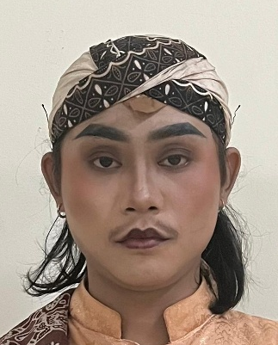
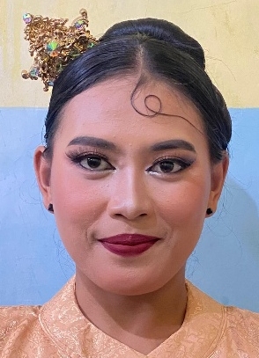
Pangiket's work :
Picture 1. Cosmetic Female Picture 2. Male Makeup
Pangiket Dance Work Pangiket Dance Work
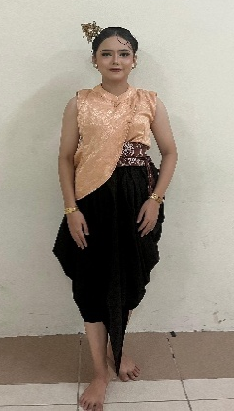
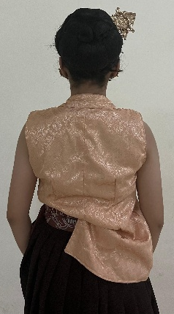
The costume used is a development of the short-sleeved beskap in cream. Then the bottoms worn namely development from trousers Aladdin with Brown . This application is used to add a soft impression to the clothing and facilitate the dancers' movements. order fashion on work dance Pangiket :

Picture 3. Women's Costume Picture 4. Women's Costume
Front back
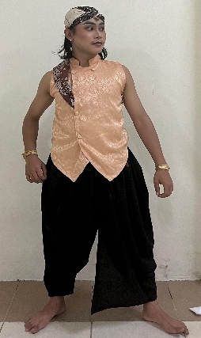
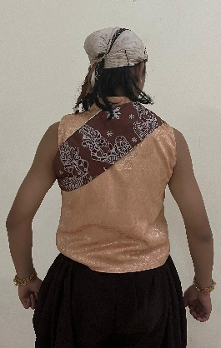

Picture 5. Front Male Costume Picture 6. Back Male Costume
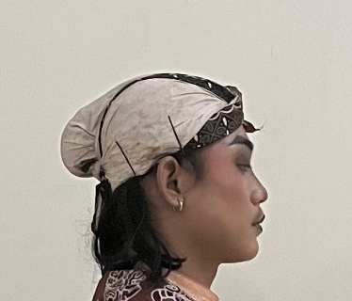
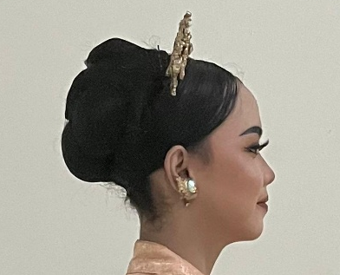
The male dancers wear a blangkon (a traditional Javanese headdress) on their heads. The dancers also wear a bun at the back. This attire is intended to represent Javanese society . order hair on work dance Pangiket :
Picture 7. Women's Head Makeup Picture 8. Men's Head Makeup

      - Property And settings
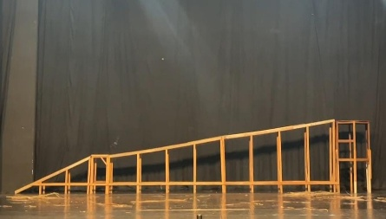
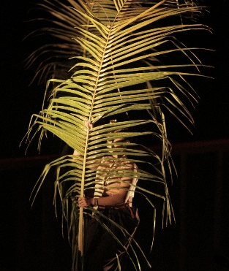
In work dance Pangiket property dance Which presented aims to strengthen the dancers and in terms of concept. The properties used in the form of blarak or leaf coconut intact Which later placed on the dancer's head. Choreographer picking leaves coconut intact because so that it is linear and forms an integral part of the yellow coconut leaf. In addition, the Takir plontang is also presented with the aim of being a symbol of ubarampe Which will be presented later on the genduren scene or feast. The following are the properties in the Pangiket dance work :
Picture 9. Property work dance Pangiket Picture 10. Setting of the work dance Pangiket

CONCLUSION
The Pangiket dance was born from a reflection on the Ngetung Batih tradition in Dongko District, Trenggalek Regency. This tradition holds profound meaning, particularly through the symbolism of the yellow coconut leaves (janur kuning) on the takir plontang (a traditional Indonesian traditional dance), which not only serves as a binding element for ritual offerings but also represents human self-control. The yellow coconut leaves are interpreted as "sejatine nur," or divine light, which is the goal of human life in achieving harmony, balance, and shared happiness. This philosophical value served as the foundation for the Pangiket dance.
The meaning of yellow coconut leaves as self-control is then linked to the social phenomenon occurring among today's youth, where many are indifferent to self-control, leading to negative behavior. Through this dance work, the choreographer seeks to present a reflection and moral message that humans must truly be able to control their inner character, whether in the form of anger, lust, or desire, in order to live in harmony with spiritual and social values. Thus, Pangiket is not only a work of art, but also a medium of guidance for the younger generation.

REFERENCE

Daryanti, Nurjannah. (2021). An Analysis of Urf on the Janur Tradition Yellow In Wedding Customs Java In Regency Lawu East. Makassar: Student Scientific Journal of Comparative Schools.
Goleman, Daniel. (2001). Emotional Intelligence: Why EQ is more important than IQ. Jakarta: Gramedia Pustaka Utama Publisher.
Hadi, Y. Sumandiyo. (2007). Study Text And Contacts . Yogyakarta: Library Book Publisher. 1- 133.
Hadi, Y. Sumandiyo. (2014). Choreography: Form-Technique- Content. Yogyakarta: Creation Media.
Murgiyanto, S (1983). Choreography Basic Knowledge of Composition. Jakarta: Department of Education and Culture. 1-153.
Ratnasari, Susilo. (2022). Tradition Ngetung Mother Suranan In Dongko Village, Dongko District, Trenggalek Regency (Folklore Study). Surabaya: Baradha Online Journal.
Sari, Y. K.. (2013). Influence Control Self And Learning Behavior on the Level of Understanding of Introduction to Accounting (Empirical Study on Accounting Study Program Students, Faculty of Economics, Padang State University). Electronic Journal of Padang State University.
Smith, J. (1985). Dance Composition: A Practical Guide for Teacher. Translation: Ben Suharto. Yogyakarta; Ikalasti Yogyakarta. 1- 125
Supriyono. (2011). Tata Make-up Stage. Poor: Bayumedia Publishing.
Yanuartuti, Wulan.(2017). “Travesti” (Visualization of Struggle) Life Tandak Ludruk in Work Dance). Surabaya: Solah.

