
THE CHOREOGRAPHY PROCESS OF LALOBEREN DANCE BY FEBRIA IKA RUSTIYANA IN SUMENEP REGENCY

Hoirun Nisak ​​Wulandari1,Prof. Dr. Trisakti, M.Si².
State University of Surabaya, Surabaya, Indonesia
E-mail: hoirunnisak.20006@mhs.unesa.ac.id.trisakti@unesa.ac.id



E-ISSN 2338-6770

Submitted date: -
Revised date : -
Accepted date : -

Correspondence Address:
Thai Studies, Faculty of Arts, Chulalongkorn University 254 Phaya Thai Rd, Wang Mai, Pathum Wan, Bangkok 10330. E-mail:6688031022@student.chula.ac.th
Abstract:The Laloberen dance is inspired by the Rokat Laloberen ritual tradition, a thanksgiving tradition as a form of fulfilling wishes or vows by the Madurese community. The purpose of this study is to describe in depth the choreographic process and form of the Laloberen dance work by Febria Ika Rustiyana. This research approach uses a qualitative descriptive method with a choreographic approach. Data collection techniques include direct observation, interviews with informants, and documentation. The results of this study show the process of creating the Laloberen dance work through the stages of exploration, improvisation, composition and evaluation. The exploration of Laloberen dance movements is carried out by observing and combining elements of Madurese dance movements which are developed into new movements. The improvisation process is carried out by creating new movements spontaneously and creatively. At this stage the choreographer transfers the movements to the dancers, then develops them as needed. Composition is done by arranging movements and floor patterns and arranging all supporting elements such as music, costume, and properties after the exploration and improvisation process. The evaluation stage selects by changing, adding and correcting the combination of basic elements such as movement, space, time, energy, and floor patterns and costumes. The predetermined design form is expressed in the media in the form of movement, floor patterns, music, make-up, costume design, properties and stage design. The distinctive feature of the Laloberen dance lies in the replica of the scene when pulling the ketupat lober which contains yellow rice and a number of coins and a boat procession, so that when the work is displayed it is able to present the Rokat Laloberen traditional activities. This research is expected to provide a motivation to produce good and quality works for those who want to process and work so as to create more creative works, as well as provide suggestions for the preservation and development of dance arts in Madura.

Keywords: Choreography Process, Dance Work Form, Laloberen Dance, Dance Art.

1. INTRODUCTION

The creation of dance works can essentially be inspired by various things, including social conditions in society, existing traditional arts, and even the pure ideas of the creator. These ideas are usually obtained through sensory sensitivity, such as what is seen, heard, and felt, which then develops into visual and ideational stimuli. Indonesia itself has a rich diversity of dances, where each region displays unique movements and meanings according to its culture. East Java is one of the provinces with a strong and diverse artistic tradition. In addition to traditional dances, the government also provides creative spaces, for example through dance festivals, dance performances, and dance competitions aimed at facilitating artists in creating new works. These activities encourage the birth of creative dance, namely dance works composed by combining elements of culture, rituals, and regional social conditions to appear fresher, more attractive, and more easily accepted by the community. Creative dance is not only a means of preservation, but also an innovation that can be performed, competed in, and taught in schools and the community.
One of the dance creations inspired by social activities such as rokat tase', one of the customs of the residents of Kalianget Timur village, Tarebung hamlet, is to carry out the rokat tase' traditional ceremony. Based on interviews with the choreographer, this activity is carried out at the beginning of the year every January or February which is believed to be a good month to carry out their gratitude to God Almighty for the blessings and sustenance given to them. The dance work inspired by rokat tase' is the laloberen dance, the laloberen dance is a dance inspired by the rokat tase' tradition in Kalianget Timur village. This dance work was created by one of the choreographers in the East Java area of ​​Sumenep Regency, namely Febria Ika Rustiyana in 2019, an alumnus of the Department of Dance Music Education, State University of Malang who currently works as a teacher at SMA Negeri 2 Sumenep. This dance work is a representation of the spirit of the Kalianget villagers in living their lives and a depiction of the rokat tase' traditional event. This activity is seen as an obligation that must be carried out because it is closely related to beliefs and cultural values ​​that have been passed down through generations. For the people of Kalianget village, the rokat tase' ceremony is not merely a ceremony, but a tangible expression of human gratitude to the Creator for all the blessings He has given. This gratitude is especially expressed for the abundance of marine products, which are the primary source of livelihood for the fishing community, and for the safety they enjoy while at sea and sailing.
The creation of dance works that originate from the social culture of the community plays a crucial role because it not only displays movement but also conveys the meaning contained within it and has its own weight of delivery, especially in the packaging of the dance work presentation that includes the content and meaning behind the idea. In order for this message to be conveyed well, a choreographer needs to deepen the idea through direct involvement in community life, for example through observation, interviews, or participating in traditional activities. This aims to ensure that the resulting dance work has a strong identity and is able to represent cultural values ​​in depth.Based on the aim of conveying a meaning about customs in society, it is interesting that in choreography, both the form and structure are very complex to explore.As in the process of creating the Laloberen dance, the choreographer in his discovery of the form of the choreography to be used as the identity of a new work needs to be directly involved, so that the work created is not only beautiful in form, but also full of cultural values ​​and the philosophy of the community.
The uniqueness of the Laloberen dance is reflected in the way this work represents the community's goals in carrying out this tradition, while also depicting part of the series of processions found in the implementation of the Rokat Tase' traditional ceremony. What makes it interestingin this work lies in the properties and some movements displayed, such as at the end of the dance section where the procession of pulling the topak lober containing yellow rice and several coins and continued with two dancers showing movements by carrying a boat containing fruits, vegetables, chicken, incense and a small tray containing 5 colored rice that indicates the direction of the wind and in the form of flowers. As in the activity of pulling the topak lober then the boat procession in the rokat tase' traditional ceremony. The topak lober is pulled together before the procession, the contents of the topak lober in the form of yellow rice and several coins are believed to be lucky objects by the local community and the community flocks to take them, especially children. The boat is paraded to the middle of the sea to be floated, but before the boat reaches the middle of the community flocks to take the contents in the boat to indicate gratitude for the abundance of gifts given by God Almighty to the village.

2. METHOD
This research uses a qualitative descriptive approach research method.Data obtained from informants was collected through direct observation, interviews, and documentation to better understand the data collected in the field. This research is qualitative and does not use numerical data. The results are presented descriptively in the form of words and sentences that aim to answer the research problem formulation.
The data sources used in this study are primary and secondary. Primary data is data obtained directly from the main source, Mrs. Febria Ika Rustiyana, the owner of the studio and the creator of the Laloberen dance. Meanwhile, secondary data comes from documentation such as photographs, video recordings, and document archives belonging to the Creative Art Center studio. Data collection was carried out through observation, interviews, and documentation techniques. To maintain data validity, source triangulation techniques and methods were used to ensure the research results have a high level of reliability.
Data analysis is conducted from the beginning of the research to the end, with the stages of data reduction, data presentation, and conclusions or verification.makes it easier for researchers to find additional research data, while data presentation is done descriptivelyby describing or simplifying. Conclusions are drawn to understand the meaning of the data collectedto ensure that the data obtained is valid and understandable.

3. RESULTS AND DISCUSSION
  - Laloberen Dance Choreography Process
The creation of this dance work is based on the choreographer's desire to create a new dance work inspired by existing dances in Madura. The story raised in the Laloberen dance is inspired by the Rokat Laloberen tradition, a ritual held once a year in a certain month, which is in one of the Sumenep Regency, namely, East Kalianget Village, Tarebung Hamlet. The Laloberen dance is a ritual dance created as entertainment. The Laloberen dance involves stages ranging from prayer, presentation of offerings, to a procession of boats that are set afloat to the sea as a form of gratitude and complement to the hajat taken from the Rokat Laloberen procession. In the Laloberen dance directly adopts elements from the Rokat Laloberen procession for example, prayer offerings, presentation of offerings, and the procession reflect the actual ritual, where people gather, bring offerings, and carry out the topak lober procession. These movements were then developed and adapted to meet the needs of the dance. The Laloberen dance is designed as a group dance danced by 11 people, including 9 female dancers and 2 male dancers who depict the atmosphere and character of the local community when carrying out the Rokat Laloberen tradition.
Exploration is the initial stage in the choreography process, the results of the exploration that has been discovered, then applied to the dancers. The exploration of Laloberen dance movements is carried out through a creative process that focuses on developing body movements to create a dance form. This process begins with careful observation by identifying the movement elements of Madurese dance that serve as the main source of inspiration, then developed through improvisation involving exploration of rhythm, level dynamics, and space. This process not only aims to discover new movements, but also to broaden insights into how the body can be used as a means of expression in this dance. Through the exploration process, a dancer can explore various ideas, assess the potential of body movements in depth, and combine these elements into a harmonious and unified composition. The exploration of movement carried out is not only a form of creativity, but also to preserve Madurese cultural identity through an innovative dance approach.
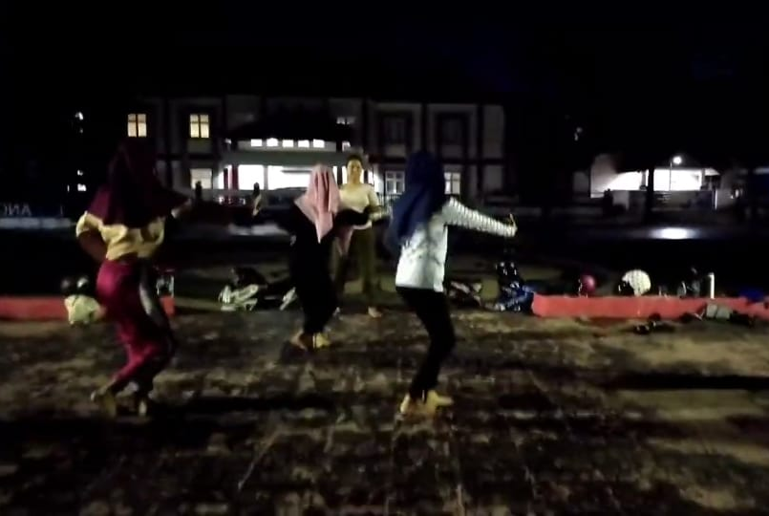
Figure 1 Exploration of Laloberen dance movements
(Doc. Creative Art Center 2021. Source.
https://youtu.be/oxIozPq2F68?si=wi_aAyEuvuo9dg73)
Improvisation can also be called the trial and error or spontaneity stage. The movements used are simple ones that develop from existing movements.Movement improvisation in Laloberen's dance work is an important process that allows the choreographer to explore freedom in creating movement.and important elements that bring an expressive and dynamic dimension to the performance. In improvisation, body movements do not only follow existing patterns, but also emerge from spontaneous impulses, intuition, and creativity from within the choreographer and dancer. This improvisation process becomes a bridge between the Madurese dance elements, which are the main inspiration, and movement innovations that provide a modern touch to the dance composition. At this stage, Febria Ika Rustiyana as choreographer continues to provide direction and transfer movements spontaneously to the dancers to avoid misunderstandings when improvising in creating the Laloberen dance work, which can then be developed by the dancers as needed. The movement structure composed by Mrs. Febria Ika Rustiyana is a unified series of dances that are united, with the characteristics of agile, graceful and energetic movements. After finding the movement, Febria Ika Rustiyana directly transfers the movement to the dancers. For Febria Ika Rustiyana, finding even the smallest movement is immediately taught to the dancers, because she has a weakness for forgetting movements (interview with Mrs. Febria Ika Rustiyana,January 6, 2024).
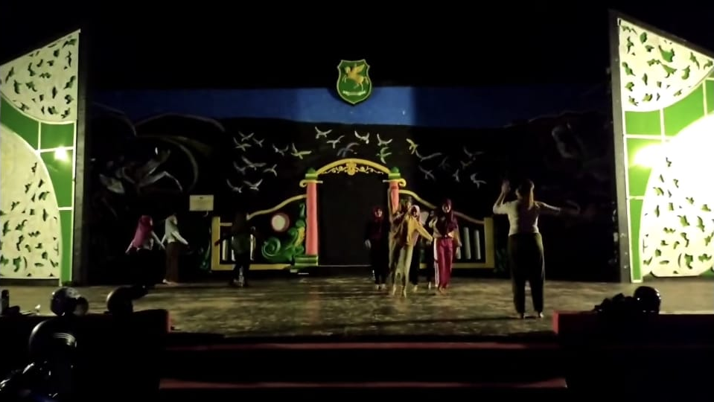
Figure 2 Improvisation of Laloberen dance movements
(Doc. Creative Art Center 2021. Source.
https://youtu.be/oxIozPq2F68?si=wi_aAyEuvuo9dg73)
Dance composition is done by arranging movements that have been produced through a process of exploration and improvisation. Febria Ika Rustiyana tries to find a compositional form by arranging movements into a dance or choreography. This stage is the most complex part because it involves the process of selecting, evaluating, and arranging movement motifs to form a complete work of art, known as the choreography process. The composition in the Laloberen dance work also considers the integration of supporting elements, such as music, costumes, and lighting, so as to produce a complete and unified performance. All of these elements are arranged with the aim of creating a visually stunning dance. In composing movements, of course, creating floor patterns at the same time, this is not only done to facilitate memorization of the movement motifs that have been composed, but also to provide variation to the movements and are designed in such a way as to provide interesting visualizations and guide the audience in following the presented storyline.
The evaluation begins with correcting the combination of basic dance elements, such as movement, space, timing, energy, and floor patterns and costumes, to ensure that all parts support each other when combined into a presentation. The choreographer has a need to see whether the desired form is in accordance with what is imagined in the heart and the choreographer must play a major role in the assessment process. Through this comprehensive evaluation, Mrs. Febria Ika Rustiyana can make improvements or adjustments, so that the resulting dance work is visually stunning. This process is intended to ensure that there is harmony and harmony between the movement and other supporting elements, resulting in a complete and danceable performance.
  - Laloberen Dance Work Form
    - Movement
Dance movements can be soft, dynamic, strong, or light, according to the characteristics of the dance being performed. In each movement, the dancer utilizes various body parts, such as the hands, feet, head, and the entire body, to create appropriate expressions. In line with the opinion of Jacqueline Smith (1985) who stated that movement is a very broad and diverse form of communication language. The patterns or variety of movements contained in the laloberen dance work are not just ordinary body movements, but present a number of movement motifs that are the result of the main exploration to convey certain meanings and symbols, with the opening movement, prayer offerings, pulling the lober topak, and the boat procession that is carried out at the end of the dance.
    - Floor pattern
The floor patterns in the Laloberen dance utilize diverse and dynamic patterns. These patterns are designed in various variations, such as straight, circular, and diagonal patterns, which create harmony between the dancers' movements and the spatial arrangement on stage. The use of planned and varied floor patterns will create interesting dancer formations, so that the performance does not seem monotonous and is more comfortable for the audience to enjoy. The number of dancers in a dance performance influences the arrangement of the floor patterns. Dance works generally use an odd number of dancers because it is easier to arrange positions and form formations on stage compared to an even number of dancers. Some floor patterns in the Laloberen dance attempt to reflect the authentic conditions of the rokat tase' Laloberen tradition.
    - Musical accompaniment
The musical accompaniment to this dance work is presented with a finished tong-tong musical accompaniment in the form of a recording recorded using a music application. The accompanying musical instruments are tongtong, bass sak, bass air, pekkeng, kendang, kenong, gong, bol, tramtam, tambourine, saronin, trumpet, cekcer. Based on an interview with Mrs. Febri as the choreographer of the laloberen dance, it was revealed that in the process of working on the laloberen dance, existing or finished Madurese tong-tong music was used, then recorded and re-processed to be arranged according to the choreographer's wishes. In this tong-tong musical accompaniment, there is an additional vocal medium specially arranged by the choreographer. This selection was considered according to the choreographer's needs to strengthen the movement and expression needs in the laloberen dance work.
    - Cosmetic
The makeup in the Laloberen dance is adapted to the attire worn, with a predominance of green, which symbolizes fertility. Laloberen makeup is synonymous with Madurese culture, reflecting elegance and beauty, emphasizing the gentleness, modesty, and assertiveness of Madurese women.
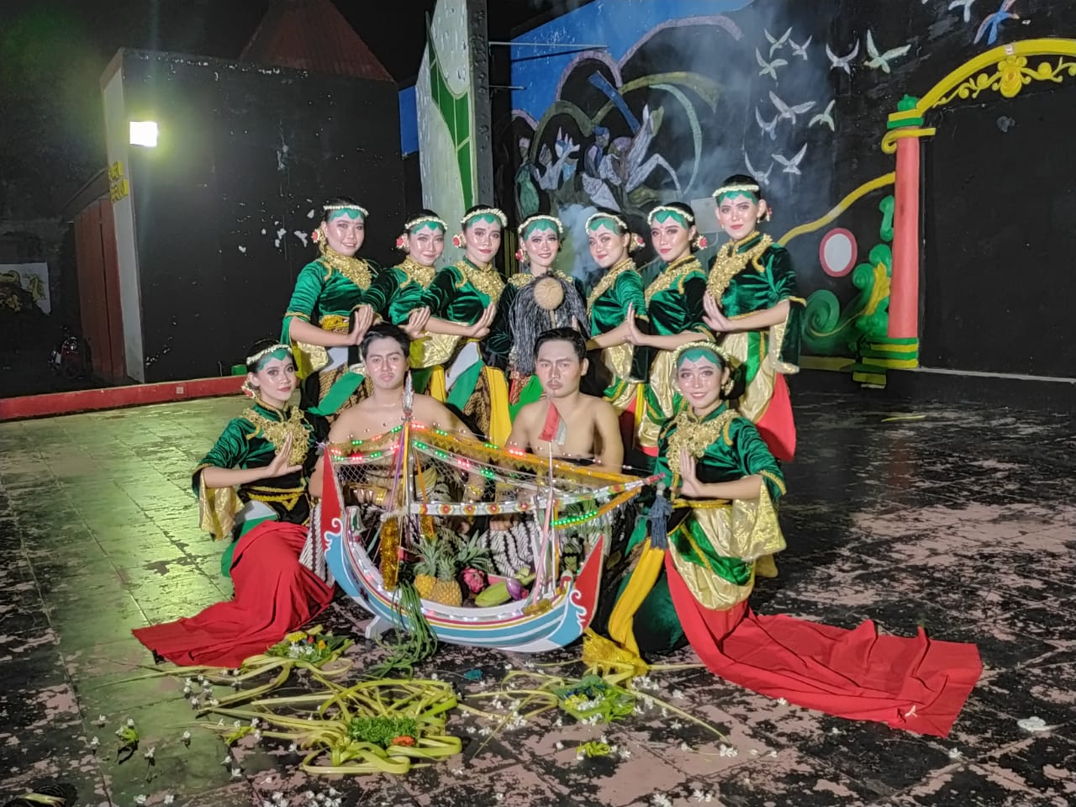

Figure 3 Laloberen dance make up
(Doc. Creative Art Center 2021)
The overall make-up combined with the bright and striking costumes is used to create a harmony that not only attracts the attention of the audience, but also emphasizes the Madurese cultural identity which is full of bright colors, polite, and charming.
    - Fashion
The Laloberen dance uses simple costumes with dominant green and yellow colors. The choreographer chose green because it fits the chosen theme, namely Rokat Tase' (sea alms) which symbolizes fertility, while yellow symbolizes prosperity. The choice of these two colors as Laloberen dance costumes is because it looks fresher and more luxurious with a combination of gold. Laloberen dance costumes include a kemben, kebaya and velvet pants, plain red rapek, right and left side batik rapek, sampur, front and back belt, bun, bun accessories, jasmine accessories, necklace.
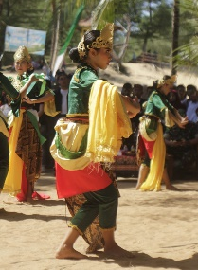

Figure 4: Laloberen dance costume
(Doc. Creative Art Center 2021)
    - Property
These props serve as symbols that reinforce the meaning of additional movements, and they must be chosen and used appropriately to fit the context of the dance. Props used in the Laloberen dance include boats, banana and coconut leaf bases, ketupat (rice cakes), coconut shells (symbolizing spirits), and incense.
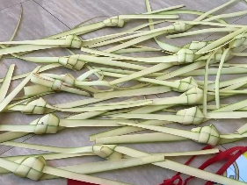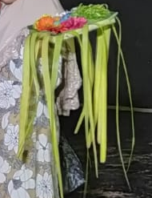

Figure 5: boat properties, tupat lober, offerings, coconut shell (jin)
(Doc. Wulan 2024))
    - Stage design

The selection of the stage type and the arrangement of supporting elements of the performance serve to emphasize the character of the movement, clarify the visual focus, and provide an area where both the audience and the performers can engage in and enjoy the performance. The creation of works of art is essentially not limited by space and time, but its presentation requires adjustments when the work is performed in various types and conditions of performance spaces.

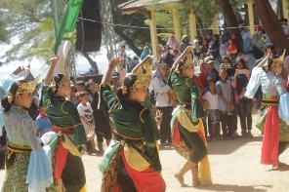

Figure 5: boat properties, tupat lober, offerings, coconut shell (jin)
(Doc. Creative arts center 2020))
The outdoor performance of the Laloberen dance requires adjustments to the conditions of the performance space. The performance takes place in an open area in the early afternoon, making use of natural lighting. Furthermore, the number of dancers is adjusted to accommodate the relatively limited performance area and the close proximity of the audience, creating a more direct interaction between the dancers and the audience.

4. CONCLUSION

Based on the research results, it can be concluded that the Laloberen dance work created by Febria Ika Rustiyana is a representation of the Rokat Laloberen Traditional Ceremony which functions not only as entertainment, but also as a medium for preserving cultural values, local beliefs, and the identity of the Madurese people. The choreography process includes stages of exploration, improvisation, formation, and evaluation that demonstrate creative processing based on tradition with an innovative approach. The form of presentation is adapted to the context of outdoor performances and supported by elements of group choreography, musical accompaniment, floor patterns, makeup and costumes, properties, and integrated stage design to create a harmonious and meaningful performance unity.

REFERENCE

Hadi Sumandiyo Y. 2011. Choreography (Form-Technique-Content). Yogyakarta: Cipta Media.
Hadi, Sumandiyo. 1996. Basic Aspects of Group Choreography. 39-40 Yogyakarta: Manthili Yogyakarta ----- 2007. Text Study
Hawkins, A. (2003). Moving with the heart: a new method of creating through dance. Jakarta: Ford Foundation and Indonesian Performing Arts Society.
Hawkins, Alma (translated by Sumandiyo Hadi). 1990. Creating through dance. Yogyakarta: Indonesian Institute of the Arts
Soedarsono, M, R, 1977. The Existence of Indonesian Performing Arts. Press. Yogyakarta.
Sugiyono. 2015. Quantitative, Qualitative and R&D Research Methods (22nd ed.). Alfabeta.
Smith, Jacqueline 1985. Dance Composition, Yogyakarta; Ikalasti
Wijaya, Christianti Mediana. 2019. The Creative Process of Creating the Suramadu Dance Work by Diaztiarni at the Tydif Studio in Surabaya. Thesis. Surabaya: Department of Dance and Performing Arts, FBS Unesa.

