Lutfi Annisa Putri, Solah Journal of Performing Arts (2025)
https://doi.org/10.26740/vt.v1n1.p1xx-1xx




PRODUCTION PROCESS OF THE SONG "SELEH" BY HR SUKOCO ON THE DIGITAL MUSIC PLATFORM
Lutfi Annisa Putri1, Arif Hidajad.2

E-ISSN 2338-6770

Submitted date : - Revised date : - Accepted date : -

Corresponence Address: Thai Studies, Faculty of Arts,
Chulalongkorn University 254 Phaya
Thai Rd, Wang Mai, Pathum Wan, Bangkok 10330. E-mail: 6688031022@student.chula.ac.th
1State University of Surabaya, Surabaya, Indonesia 2Unesa University, Surabaya, Indonesia
Email: lutfi.22076@mhs.unesa.ac.id, @unesa.ac.id.

Abstract: : Heru Sukoco, a newcomer musician from Ponorogo who creates original songs, one of which is entitled Seleh. He successfully produced the song Seleh independently through three stages, namely pre-production, production, and post-production. The purpose of this study is to find out how Heru Sukoco's process of producing music up to the stage of marketing songs on digital music platforms. This study uses a descriptive qualitative method with data collection techniques through interviews with informants, observations, and literature studies. The data obtained were then analyzed by reduction and triangulation, and presented in narrative form. To ensure the credibility of the data, data verification and validation were carried out. This study resulted in a description of the production process to the marketing process of the song Seleh carried out by Heru Sukoco through stages starting from pre-production, production, to post-production which includes the process of arrangement, tracking, recording, mixing, and mastering, until entering the digital music platform.

Keywords: Production Process, Song Marketing, Seleh Song, Heru Sukoco, Digital Music Platform

INTRODUCTION

Music production is the process of creating a piece of music using audio recording technology to create a product that is ready to be heard and has a market value. Songs that are 3-5 minutes long must go through a fairly long production process. It starts with the search for ideas and concepts, writing lyrics, determining chord progressions, and the production process. In the music production process, ideas can develop widely, because the production process involves various supporting factors, such as A&R, arrangers, sound engineers, and even performers who provide various contributions and innovative ideas at each stage, thus allowing the music to be more objective and accepted when released to the public. Timur.
© 2025 The Author(s). This open access article is distributed under a Creative Commons Attribution (CC-BY- NC-SA) 4.0 license.

Digitalization has had a significant impact on human resources, as evidenced by the emergence of many musicians with new styles eager to showcase their work to a wider audience. Looking at current music trends, songwriting is inextricably linked to popular cultures. Consequently, a consumerist lifestyle can influence the development of music in Indonesia, particularly in East Java.
In East Java, many musicians come with their own characters, such as those currently widely known among the public, namely musicians named Deny Caknan and the late Didi Kempot who came from Ngawi. Ponorogo is also a regency in East Java that has produced several musicians, however, there are still many songs that have been created but have not made it to the recording studio or digital streaming platforms. However, this does not close the opportunity for other Ponorogo musicians to create works that can be distributed to digital music platforms such as Heru Sukoco. Heru Sukoco is one of the newcomer musicians from Banjarejo Village, Pudak District, Ponorogo Regency who has succeeded in creating original songs to be able to establish a record label and distribute his work on digital music platforms. Heru Sukoco or often called HR Sukoco, began his journey in the field of music creation in 2019. With various travel experiences and processes that he went through while pursuing his hobby in music, he was able to create original songs.
HR Sukoco's songs have been released and are officially copyrighted. His work has been distributed on digital platforms such as YouTube, Instagram, TikTok, Spotify, and others. He released two albums between 2022 and 2024. The first, titled "SIGRAPIC," contains 11 songs. The song, "Seleh," served as a sample for research into the process of music production and distribution.
The reason researchers are interested in studying Heru Sukoco's production and release process is because he is a newcomer musician with over 20 songs and copyrights that have been published on digital music platforms. He even has his own record label, HR Sukoco. The reason I chose Seleh as a sample in this study is because this song has a different character compared to Hr Sukoco's previous compositions.

Based on the research background, the researcher became interested in examining how the production process of original songs until they entered digital music platforms, as carried out by HR Sukoco. In the process of searching for information and data related to the production process to the distribution stage, the author conducted interviews with sources, namely the object itself, with Heru Sukoco, interviews with other parties such as arrangers, and direct observation while witnessing how the production process is carried out by Heru Sukoco.

METHOD
This study used qualitative descriptive analysis, producing descriptive data based on the information and data obtained. The collected data consisted of descriptive sentences and non-numerical images. The data came from interviews, official documents, and documentation (Moleong, 2006: 11). This method produced data in the form of written or verbal narratives from other individuals and witnessed behavior (Moleong, 2006: 4). Once the data was obtained, it was analyzed, then described, and conclusions were drawn to answer the formulated problems.
In the study, entitled "The Production Process of the Song Seleh by HR Sukoco on a Digital Music Platform," the researcher applied a descriptive qualitative method, then analyzed and described the situation that had been directly observed in detail, and concluded to answer the formulated problem. The conclusions given were based on existing facts without manipulation. The research object did not rely on numerical measurements or did not focus on numbers, then the data obtained could not be quantified, and could help researchers dig deeper into a research topic..
The qualitative method employed by the researchers began with meetings with several sources related to the research topic. These sources included the primary source, HR Sukoco, the songwriter, and Hermawan, the arranger. The researchers then conducted interviews at different times and locations. In addition to the interviews, the researchers also directly observed the production and release process of HR Sukoco's songs.

Researchers use data analysis techniques focused on research results that are non-numerical and systematic. The steps used are data reduction, data presentation, and data verification. The main criteria for a study include validity, reliability, and objectivity. Validity refers to the suitability of the data obtained to the research subjects and the data provided (Sugiyono, 2015: 117).
Data is considered valid if it does not differ from the reality presented by the researcher and occurs in the research object. This research can be accounted for through the use of triangulation methods. In credibility testing, this means verifying data from various sources using different methods and at different times. (Sugiyono, 2015: 127). The main purpose of data validity is to ensure that the research results reflect the actual reality of the object being studied. This can be enhanced through triangulation methods. (Patton: 1003).

RESULTS AND DISCUSSION

The Production Process of HR Sukoco's Song Seleh on the Digital Music Platform
The song "Seleh" is a single released by Heru Sukoco, a musician from Ponorogo Regency. It was written in late 2024 and depicts the process of tawakal (religious surrender). Heru Sukoco conducted the entire production and distribution process independently. Heru Sukoco presents the song with a different dynamic than most other songs, as he explains that the use of Javanese gamelan instruments is a way to realize the song's concept, which contains spiritual values ​​emanating from the instruments. Although the process is carried out independently, Heru Sukoco still follows a structured procedure to produce a perfect work. Heru Sukoco's distribution and publication process is structured and involves distributors, often referred to as aggregators.
Before a song or album is released and enters the entertainment industry, several stages must be completed. These stages include pre-production, production, and post-production. It is important to explain this as part of the process of Seleh's journey to digital platforms. The following are the results of the data obtained:

Pre-Production
Pre-production is the first stage before the production process begins. The initial steps typically involve writing and directing the music composition. This process typically begins with songwriting, writing lyrics, then developing the song's structure, and finally creating harmonies. According to Heru Sukoco, it takes him about a week to create lyrics, determine the chord progression, and finalize the dynamics and harmonies. (Interview, May 15, 2025).
This song was created based on personal experience, explaining that it was inspired by feelings and life experiences that required him to navigate a crossroads and a religious journey. The song is presented with a distinct nuance, using gamelan instruments, which have a distinctive spiritual character. In the initial development of "Seleh," he used an acoustic guitar. (Interview, May 15, 2025).
Regarding determining the concept and theme, he employed a strategy of developing ideas and creativity, as this is a crucial stage. After finding a suitable theme and concept, the next step was to create the song's structure. This structure is also crucial, as it facilitates the process of focusing on the concept. The first step in the song's structure is the intro, verse, chorus, bridge, and outro. After defining the structure, the next step is developing ideas and developing the lyrics/verses by compiling a list of words and phrases that convey an emotional message. The next step after creating the structure and lyrics is creating a demo before moving on to the arrangement stage. This demo requires a mobile device to temporarily record the vocalist's voice, which is then recorded along with the guitar. The next step was for Heru Sukoco to independently research the composition.
After brainstorming the composition, he contacted and collaborated with Hermawan, the arranger and music producer. Heru Sukoco then discussed the compositions he would use for the song.
After discussing the song composition, they agreed to record a second guide. Afterward, they would listen to the recording, which they called a listening session. Heru Sukoco didn't do many retakes at this stage, as he was already satisfied with the recording.

This recording process is carried out flexibly because they carry out the production process independently, where this process does not have standard rules, this does not mean that Heru Sukoco records freely without paying attention to the factors that influence the recording process, but rather Heru Sukoco here plays the role of a musician and also the owner of his own record label named HR Sukoco.
Production
Production or recording is the stage after pre-production. This stage is the foundation of the production process itself, namely creating a rough outline of the song and combining concepts to create a cohesive whole. According to Heru Sukoco, the production process took approximately four hours. However, before recording, Heru Sukoco provided Hermawan with a sample demo of the song. This recorded sample served as a guide, featuring vocals and guitar instruments on a mobile device.
In creating this song, Hermawan used various equipment to support the arrangement process, including a Samson C03 condenser microphone, Yamaha HS80M speakers, a Midi controller using a Yamaha PSRS975 keyboard, a PreSonus 1824C sound card, and more. He also played live instruments, while some used digital instruments. The instruments used in the production of Seleh included: Javanese MIDI Gamelan (Gamelan Etno World 6), String Ensemble (Amadeus), Addictive Drums, Electric Guitar (Ibanez RG250), and more. Heru Sukoco's production process involves several stages, from tracking, recording, mixing, mastering, and rendering.
Tracking
In the production process, tracking is the part that functions as a sound recording tape or magnetic tape in the form of binary/bytes in a data stream that represents one audio or MIDI channel. In this process, Hermawan is responsible for rearranging the musical work in the form of a guide that has been created, as well as determining how the music will be played, such as selecting instruments and writing specific parts for each instrument using the DAW StudioOnePro.

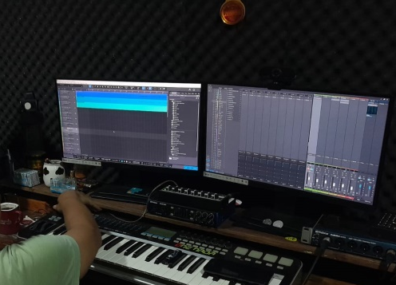
Figure 1. Tracking Placement Process

The recording of the instruments for the song Seleh utilizes a Kontakt library. This Kontakt library offers a wide selection of instruments that can be used directly. However, as Hermawan noted, not all instruments included in the arrangement are digital instruments from the Kontakt library. He added that the process still requires a player to fill in some parts, such as a guitar player. This is because, while composers and arrangers consider taste and feel, digital instruments are not always able to accommodate the wishes and concepts desired by the musician/composer.

Recording
Recording is the stage of activities and equipment involved in the process of recording and playing sound or audio (Bartlett 2009:590). The recording process is the second stage after tracking. This stage begins with the recording of the instrument audio. This instrument audio recording was done by Hermawan himself using instruments found in the Kontakt library, and operated using a MIDI controller. In addition to being an arranger, Hermawan is also a keyboard player, so not only uses digital instruments, but he also fills some of the melodies in the song arrangement with his keyboard skills.
After Hermawan recorded the track, Hendra, the guitarist, played a guitar solo. This solo provided a complementary melody. Before recording the vocals, Hermawan and the other members discussed the audio. If any parts were deemed missing, Hermawan would use overdubbing techniques. Overdubbing is a separate recording technique where new recordings are added to previously recorded sessions or tracks. This technique can be called patching or adding recordings to maximize the desired concept.

Overdubbing is a separate recording technique where new recordings are added to previously recorded sessions or tracks. This technique can be called patching or adding recordings to maximize the desired concept.
After the audio recording process is complete, the next stage is vocal recording. Lutfi, the lead vocalist for the song "Seleh" was involved in this vocal recording process. Hermawan stated that this vocal recording process is usually more complicated, as it requires careful consideration of the surrounding environment and ambient sounds. Furthermore, room placement, recording equipment position, and other factors also play a significant role..


Figure 2. Vocal Recording Process
Before recording, Hermawan will ensure the microphone is properly positioned and turned on. After the vocal recording is complete, the next step is to carefully listen to the recording. At this stage, the composer and arranger will examine the balance between the vocals and the audio. If it's not quite right, overdubbing techniques, as previously described, will be used to maximize the recording..
Mixing
Mixing is the process of combining two or more different tracks into a cohesive or balanced whole. The mixing process occurs after tracking and recording. Mixing is the balancing process of combining two or more tracks to produce a cohesive audio result.

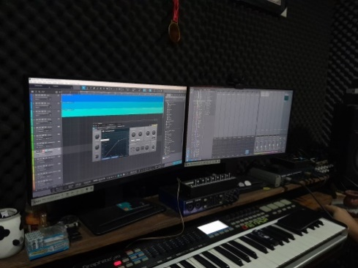
Figure 3. Mixing Process

Mastering

The mastering process involves editing out the noise and arranging the songs in the desired order, adjusting or editing the fade-in/fade-out. The next step is to ensure that each song has the same loudness and tonal balance.

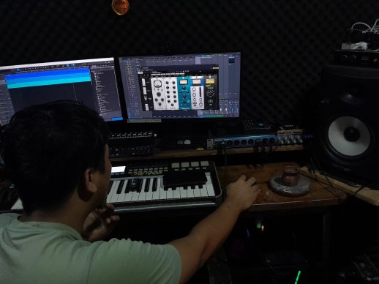
Figure 4. Mastering Process

Rendering

Rendering is the process of converting one audio format to another in a DAW or hard drive recorder. Examples include mixing multitrack recordings into 2-channel WAV, AIFF, rm, or MP3 files. Converting tracks in real time to tracks with embedded effects, converting MIDI tracks to audio tracks, and merging multiple clips into a single track. Rendering is the final stage of the production process; the final output is exported to a desired file format.
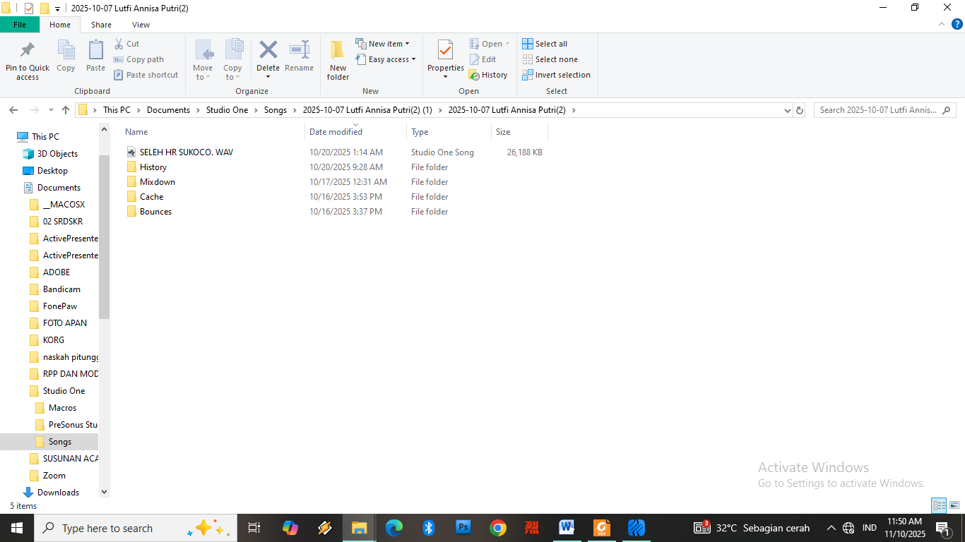
Figure 5. Audio Format

Music Marketing
Music marketing and distribution is the final stage after pre-production and production. This stage involves many factors, including both internal and external considerations. Internal factors include the quality and specifications of the song, whether it meets pre-market targets, and establishing consistent branding. External factors also include market segmentation and target analysis, competitor analysis, consumer tastes and behavior, and digital technology developments.
As Heru Sukoco did, his strategy in this process involved commercial marketing. He chose this strategy because, he believes, it focuses on the distribution process through digital media, thus requiring a supporting department or distributor, such as a music aggregator.
Digital Marketing Collaboration
Digital marketing collaboration is a form of cooperation carried out by one party with another. In the distribution process, Heru Sukoco requires a digital distributor, namely a music aggregator. Initially, Heru Sukoco said that he distributed independently and self-taught by collaborating directly with IDEMusic as an aggregator. Heru Sukoco revealed that in Ponorogo there was still minimal information regarding the appropriate methods and structures for distributing products in the form of songs, then how to guarantee the authenticity and security of these products, and on the other hand, he also thought about how his works were also legally protected, that was what made Heru Sukoco decide to collaborate with IDEMusic. Heru Sukoco registered himself as a record label because Heru Sukoco already had more than one song work. Before entering into a contract agreement, the next condition was to send 3 to 5 original song samples.

The next step after confirmation is to offer applicants a partnership contract, subject to the applicable terms and conditions. The first party is the music recording company, product owner, and copyright holder, while the second party is a Digital Content Management company responsible for distributing, monetizing, and managing content assets within the Digital Service Provider (DSP).

In this agreement, the first party guarantees the legality of the content, including copyright, related rights, and agreements with parties involved in production. Other provisions state that the first party is the technical implementer for uploading content, except for content that must be submitted to the second party.
Social Media Publications
This social media publication is a mandatory step, because it is a form of appreciation from interactions with listeners and fans. In addition, non-commercial marketing on social media can generate a positive response from the audience. Another goal of this social media marketing is to brand the artist profile or on the product of the song that has been released, which will be aimed at the general public as a form of approach and introduction online and also as a form of promotion. This is done by Heru Sukoco and his team by creating profiles on social media such as Instagram, TikTok, Facebook, and so forth, with the arrangement and branding of attractive profiles.
Social Media Marketing and Promotion Results
The marketing and promotion of Seleh's song on social media has garnered views and a wide audience. On YouTube, it has 2.64 thousand subscribers, with over 3.2 thousand views and 93 comments. On TikTok, it has 2.45 thousand followers, with 232.7 thousand views, 6,000 likes, and over 600 comments.

4. CONCLUSION

Based on the results of research that has been carried out regarding the production process of the song Seleh until it entered the digital music platform as conducted by Heru Sukoco which was conducted through an interview process with Heru Sukoco regarding how the production stages started from the pre-production stage which includes the song creation process, then production which includes tracking, recording, mixing, mastering, and rendering to post-production.

The post-production stage, which is the process of distributing music through digital music platforms, involves collaborating with music aggregators. This is where we can see the differences in how each musician produces and distributes a song. Heru Sukoco can be considered an independent musician who adapts to the structure of a typical record label, but he currently owns his own record label, HR Sukoco.

In this study, it can also be concluded that technological developments have a big influence on the existence of musicians who come to bring their work, as happened in Ponorogo, they enthusiastically introduced their work through digital media that can be accessed by anyone and anywhere..

The distribution process carried out by Heru Sukoco is also one of the distribution procedures that is comfortable and guaranteed security, where in its distribution, Heru Sukoco is under the auspices of a special department tasked with protecting the integrity and security of original works from creators and copyright owners, namely an aggregator. To market music widely in this digital era, good and wise strategies are essential to reach the target market of the music industry itself. This is also supported by the importance of building relationships with music lovers.

AUTHOR CONTRIBUTIONS

The author was directly involved in all stages of the research, from planning and field data collection to data analysis and writing. Observations and interviews were conducted to obtain in-depth and credible data related to the production process of the song "Seleh" and its distribution on digital music platforms. The author was also fully responsible for collecting data related to the production process of the song "Seleh" by Heru Sukoco, including its release and marketing on digital music platforms.

ACKNOWLEDGMENTS

REFERENCE

Praise and gratitude to Allah SWT for all His grace and guidance, enabling the author to complete this article successfully and on time. This article was made possible thanks to the support and prayers of the author's family and friends. Therefore, the author would like to express his gratitude to all parties involved in the preparation of this article.

Armstrong, G., Adam, S., Denize, S., & Kotler, P. (2015). Principles Of Marketing. Australia: Pearson.
Bartlett, B., & Bartlett, J. (2017). Practical Recording Techniques. Routledge New York.
Burgess, R. J. (2014). The History Of Music Production. New York: Oxford University Press.
Coronin, C. (2014). Digital Music Distribution. Copenhagen Businness School.
Galuszka, P. (2015). Music Aggregators and Intermediation. International Journal of Communication.
Izhaki, R. (2017). Mixing Audio Concept. New York: Routledge.
Lestari, N. D., & Sitasi, C. (2019). Proses Produksi Dalam Industri Musik Independen Di Indonesia. Jurnal Komunikasi.
Moleong, L. J. (2006). Metodologi Penelitian Kualitatif. Bandung: PT. Remaja Rosdakarya
Murphy, S. T. (2015). Independent Music Marketing In The Digital Age. Southern Cross University
Puput, & Arya. (2023). Proses Produksi Musik pada Lagu Tyok Satrio. Journal of Music Science, Technology, Institut Seni Indonesia Denpasar, 161.
Sawyer, H., & Katz, B. (2010). From Demo To Delivery The Proesss of Production. United States of America: Elsevier Focal Press.
Sugiyono. (2013). Metode Penelitian Pendidikan Pendekatan Kuantitatif Kualiltatif dan R&D. Bandung: Alfabeta.

Sugiyono. (2015). Memahami Penelitian Kualitatif. Bandung: Alfabeta.
Zagorski, T., & Frith. (2016). The Art Of Record Production. New York: Routledge

