Mochamad Rafli Wisnu Triwijaya et al., Solah Journal of Performing Arts (2026)
https://doi.org/10.26740/vt.v1n1.p1xx-1xx


The Process of Creating the Syaga Sinatriya Dance by Mochamad Rafli Wisnu Triwijaya and Virdha Annora Zavira


Mochamad Rafli Wisnu Triwijaya¹, Welly Suryandoko²

1Universitas Negeri Surabaya, Surabaya, Indonesia 2Universitas Negeri Surabaya, Surabaya, Indonesia
Email: mochamadrafli.22028@mhs.unesa.ac.id , wellysuryandoko@unesa.ac.id

ABSTRACT: The Syaga Sinatrya dance was created by two choreographers, Mochamad Rafli Wisnu Triwijaya and Virdha Annora Zavira, and won first place in the 2024 Bengkulu University National Student Art Week (PEKSEMA) creative dance competition. This work was inspired by the figures of Raden Arjuna and Dewi Wara Srikandi, who are known for their warrior spirit. Thus, the meaning of “Syaga Sinatrya” is the alertness of a soldier who is always self-aware in order to prepare both his mind and body for the battlefield. This report aims to describe the dance creation process carried out by the choreographer in the dance Syaga Sinatrya. It uses the creative process method (Hadi, 2016), which classifies four stages, namely exploration, improvisation, composition (formation), and evaluation. The Syaga Sinatrya dance represents the alertness of soldiers in fighting the conflicts within their souls and bodies. It is performed by three female dancers and two male dancers, in an East Javanese style, specifically that of the Arek ethnic group. The makeup uses stage makeup, kutungan costumes and shorts, and other supporting components dominated by red and gold colors, symbolizing strength and spirit. The dance props use modified cundrik gendewa, performed on a proscenium stage, supported by Fresnel lighting and LED par lights. The dance accompaniment uses recordings of titilaras pelog gamelan instruments and modern music.

Keywords: Creation Process, Presentation Process, Creative Dance, Syaga Sinatrya

INTRODUCTION

The Syaga Sinatrya dance was created by two choreographers, Mochamad Rafli Wisnu Triwijaya and Virdha Annora Zavira. This work is a form of East Javanese dance adapted from two central characters in wayang, Raden Arjuna and Dewi Wara Srikandi, who are known for their chivalrous spirit. Syaga Sinatrya is a combination of two words, namely "syaga," which is adapted from the word siaga, meaning readiness or alertness, and "sinatrya," which comes from the root word satria, meaning a warrior. The meaning of "Syaga Sinatrya" is a representation of the alertness of a warrior who is always self-aware in order to prepare both his soul and body for the battlefield.
These two puppet characters are the inspiration behind the dance piece titled "Syaga Sinatrya." Both are considered symbols of knighthood and resurrection, due to the role of knights in balancing life and acting on the battlefield. Although based on the gentle nature of Arjuna and the feminism of Srikandi, both will display a brave and tough knightly attitude when facing and being on the battlefield. The knightly figures depicted to deepen the characters are not only portrayed as strong and tough, but more than that, this work also represents how gender equality between women and men has the same characteristics, both in treatment, ideas, and even position. Knights are those who are not only skilled at fighting enemies, but also capable of fighting their own thoughts and souls, because a knight's greatest enemy is not an enemy, but their own thoughts and selves. For this reason, this work presents the figure of a knight as the idea behind the characters of Arjuna and Srikandi, which is expected to represent the behavior of modern humans today.
The Syaga Sinatrya dance is a group dance creation inspired by the knightly spirit of Arjuna and Srikandi, two figures known as war generals. This dance is presented in an East Javanese style, specifically that of the Arek ethnic group, developed based on the imagination, motivation, and character of the choreographer. Another background that gave rise to the idea for this work was that the dance was created for a competition with the requirement that the dance work be based on Indonesian cultural traditions. Two central figures in the puppet show were chosen as the basis for the idea.
The creative process that produced spectacular performances in movement and props was a fresh innovation. The exploration of movement using traditional dance as the basis for ideas, which were then reinterpreted into a creative dance style, resulted in unique dance works that underwent renewal. The creativity and innovation of the work, rooted in tradition while considering ethical and aesthetic values, earned it the title of Best Champion 1 in the Bengkulu University National Student Art Week (PEKSEMA) 2024 in the creative dance competition category. This event serves as a platform for students to express their artistic talents and achieve national recognition, organized by Bengkulu University online. The topic in this report is worth examining or researching as it can serve as a creative source for those undertaking the process of creating dance works, particularly by focusing on the creative process of the work and drawing inspiration from the motivation of a soldier. This dance work also maximizes the creative process of its multifunctional properties, which have an attractive appeal in its performance presentation. Additionally, this report has not been researched before, so it is hoped that it can be used as literature to enrich reading materials in the Drama, Dance, and Music Education Study Program at Surabaya State University.

Method

The process of creating a dance work cannot be separated from the sources of inspiration that form the basis for the emergence of an idea for the work. Inspiration from an object captured by the human senses becomes the main source and determinant of the process of creating a dance work. Inspiration can give rise to ideas, enthusiasm, or motivation in activities, Smith (1985: 21). Syaga Sinatrya's dance work was inspired by several types of stimuli, such as conceptual stimuli, visual stimuli, and auditory stimuli that are closely related to the choreographer's daily activities.
The process of creating dance works is also known as the choreography process. According to Hadi (2016), there are four stages of creativity in this process, namely the exploration stage, improvisation, composition or formation, and evaluation. The exploration stage focuses on discovering movement motifs and elaborating on the movements that have been discovered. Next, the improvisation process is divided into two, namely free improvisation that is not bound by a specific theme and directed improvisation that moves according to a theme determined by the choreographer. The composition or formation stage requires the choreographer to be able to interpret ideas based on movements and other supporting components in the dance work. This process ends with an evaluation stage to reevaluate the weaknesses or strengths of the dance work that has been created.
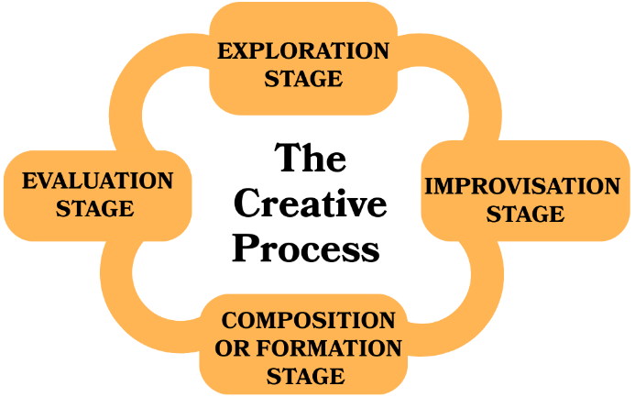

The Creative Process of Syaga Siantrya's Dance Work

RESULTS AND DISCUSSION

The Process of Creating a Work
Development techniques in dance performance art are related to the creative process carried out by a choreographer. Therefore, a choreographer's creative ability undergoes a process of renewal or innovation that has not been previously discovered or is rarely found in dance works. The creative process then becomes a framework for a choreographer in realizing the choreography creation process. In this study, the theory used to develop creative process techniques is the theory proposed by Hadi (2016), which classifies the creative process into four main stages: exploration, improvisation, composition (formation), and evaluation.
- Exploration Stage
The creation of Syaga Sinatrya's dance work began with the choreographer's initial idea to create a dance work that highlights the character of a knight soldier. The main background for its creation was as a competition entry for the National Student Art Week (PEKSEMA) event at Bengkulu University in 2024, one of the theme requirements being a new dance work rooted in the tradition of Indonesian cultural (traditional dance). This movement exploration combines the movements of male and female dancers with a distinctive East Javanese style in a dynamic and harmonious 3 manner, enabling the creation of representative movements as well as new movements. At this stage, the choreographer developed the movements using specially made props, namely modified gendewa and cundrik, to facilitate the exploration of the movement space to be created.
- Improvisation Stage
The improvisation stage is a stage that provides space for choreographers to imagine, make selections, and create as a result of the previous stage, namely exploration. Hawkins (2003: 29) argues that the improvisation stage can provide greater opportunities for imagination, spontaneity, and selection of movements in the exploration stage. The improvisation stage in Syaga Sinatrya's work occurs when the choreographer adjusts and develops the movements that were previously arranged in the exploration stage, which are stimulated through the tempo or rhythm of a movement or accompanying music. The improvisation carried out by a choreographer in this work is done in two ways, namely guided improvisation and free improvisation.
- Composition or Formation Stage
The next stage, composition or formation, is the stage of arranging the movements that have been produced through the stages of exploration, improvisation, and evaluation. This stage includes evaluation, arrangement, and simplification/organization of movement motifs into a complete whole, commonly referred to as choreography (Hadi, 2012:78-79). The composition stage in the process of creating Syaga Sinatrya's dance work is carried out by adjusting the dance to the music or dance accompaniment, where the two must complement and complement each other. In this process, it is possible to cut or develop dance movements to suit the theme or character of the dance, so that it is in accordance with what the choreographer wants based on the previously designed concept.
- Evaluation Stage
The final stage is evaluation. According to Smith (1985: 31), evaluation is a stage that serves as a basis for consideration or correction after improvisation, both in terms of material and form, which has been obtained after going through the exploration and improvisation stages. Syaga Sinatrya dance makes adjustments to the performance and costumes based on experience and knowledge. The evaluation stage is the choreographer's experience in assessing and selecting the variety of movements that have been produced previously in the exploration and improvisation stages. Syaga Sinatrya dance makes adjustments to the performance, costumes or dance attire, makeup, dance accompaniment, props, and lighting to be used. This is done to ensure that the form and content presented are in accordance with the theme and concept created. This evaluation stage forms a series of movements which are then developed into a variety. If it is felt that the dance accompaniment, tempo, or transitions between movement patterns are not comfortable, the choreographer needs to make adjustments, either by , reducing, adding, or developing so that the dancers feel comfortable when performing the dance. Once it is deemed comfortable and forms a complete whole, a dance work and dance accompaniment with harmony are formed.

The Form of Syaga Sinatrya Dance

Theme

The theme in dance is a reference to the story used to bring the audience to a common understanding. The theme can be taken from events or stories which are then elaborated into a storyline as the framework for a work (Maryono, 2010:53). In the Syaga Sinatrya dance, the theme of knighthood is carried out with the spirit of a knight as a commander in battle. This knight is represented by two puppet characters, Raden Arjuna as the male dancer and Dewi Srikandi as the female dancer.

Title

A title is a name that provides an overview and becomes the identity of a work of art. In dance, titles are used to stimulate the audience to interpret the story within. The dance work "Syaga Sinatrya" is formed from two words, namely "Syaga," which is synonymous with "alert," and "Sinatrya," which is synonymous with the word "knight." Therefore, "Syaga Sinatrya" means the alertness of a knight. The complete meaning of "Syaga Sinatrya" is the alertness of a knight on the battlefield and his readiness to face the problems within himself.
- Synopsis

A synopsis is a summary of the content of a dance performance, so that the audience can understand the storyline conveyed by the dancers through their movements. The following is a synopsis of the dance performance Syaga Sinatrya.

Determination, enthusiasm, and persistence on the battlefield are depicted in the movements of a Satriya.

"Mikul Duwur Kanggo Negara"

Sinatrya is dignity, Sinatrya is attitude, Sinatrya is the determination within a person to be alert and vigilant

Storyline/Scenario

The dance work Syaga Sinatrya is a dramatic dance. The dramatic elements conveyed in this dance work use the story and rhythm of the main dance accompaniment as a reinforcing force. The dramatic plot is presented in a double cone shape with the aim of creating a more perfect main anti-climax.

The following is an overview of the plot or scenario incorporated into the work "Syaga Sinatrya":
No | Scene | Motivation | Description | Process
1 | Introduction | An introductio n to the figure of the knightly soldier who embodies the qualities of possessing the agility and strength to confront the conflicts within his soul and body. | Built with a strong atmosphere (sigrak). This scene emphasizes the introduction of the soldier's character by providing a focal point through level movements. This supports the audience's comprehensio n as a form of introductory scene. | In this introduction process, the choreographer wants to provide a brief but concise description so as to give a spectacular touch as a bridge to provide understanding to the audience. Initially, the dancers perform movements that tend to be in harmony with wide transitional hand movements. Then, one female dancer with a high level of difficulty and four dancers with a low level of difficulty are highlighted as a form of character emphasis. Next, there is a lifting movement that lifts a female dancer as a symbol of strength.
2 | Scene 2 | A depiction of a group of knights preparing for training and battle. | The atmosphere was created with powerful and lively music. This supported the movement created by the choreographer , which depicted a series of stories about the preparation process for competition. | The movements are presented in sync with the East Javanese dance style. The choreographer explores movements that focus on the remo dance as the main basis, but then modifies and explores them based on his creative style. There are movements that focus on the center point as a representation of the unification of strength in preparation for a soldier. This culminates in a movement where one of the female dancers is lifted, focusing on the point of battle. Within this, there is also a canon movement with a vertical floor pattern.
3 | Scene II | Description When the knight soldiers undergo the gladhen process, a conflict arises between the soul and the body, which then causes a downfall. However, in the end, they rise up to fight the conflict. | The tense atmosphere then turns to sadness before transitioning to a festive mood. In this scene, the knights are experiencing a conflict between their souls and bodies, causing them to fall into despair, supported by the exploration of the props used by the dancers. However, at the end of , they rediscover their spirit so that they can rise up to fight their doubts and conflicts. | This scene focuses on the use of movement exploration and props as choreographic tools to represent this scene. The props used by the dancers not only serve as aesthetic elements, but also provide a clear picture to support the storyline contained within. In this scene, several sequences of movements are again displayed in a , with a focus on the central point. The collapse is depicted when one of the dancers (Tya) performs a reactionary arrow movement, causing the other four dancers to fall with independent exploratory movements. This scene also explores the props during the transition from intact gendewa props to modified cundrik gendewa props, with the transition being drawn out. The movements are not too fragmented, representing a rise from despair that forms harmony.
4 | Scene III / Closing | The process of uniting the energy of the knights to form the best figures and show their readiness to fight on the battlefield. | Built with a tense atmosphere, as a manifestation of the unification of energy within each individual to form a unified group of knights who are ready to fight at , and resolve the conflicts within themselves. | In the closing process, the choreographer focuses on group patterns. There were not many fast-paced movements, but rather a focus on two male dancers who performed a series of questions and answers in the form of an exploration of combat. Until one of the male dancers (Rafli) uttered the word "Jurit," then the three female dancers approached a single point in the pattern until all the dancers uttered "Tandya" as a sign of readiness and the closing of the work.

- Makeup & Costumes
Syaga Sinatrya's work uses stage makeup that emphasizes strong characters in every detail. This is based on the concept of dance works that emphasize the spirit of knights. The application of makeup on male and female dancers does not differ significantly, coupled with the use of eyeliner to give a strong effect to the characters of the dancers in accordance with their inner spirit.

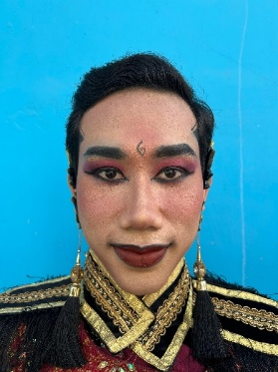  Figure 1 Male Dancer Makeup | 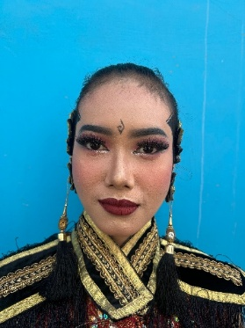  Figure 2 Female Dancer Makeup
The costume design in this dance work is a development of traditional costumes created with the aim of renewing their arrangement. Designed with a songket top and knee-length satin pants, this costume gives an impression of strength and agility.

.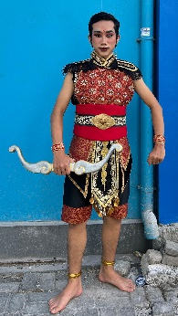 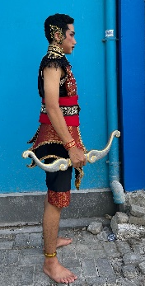 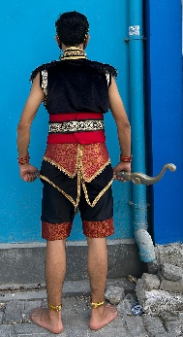 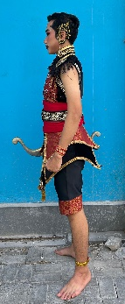
Figure 3 Male Dancer Costume

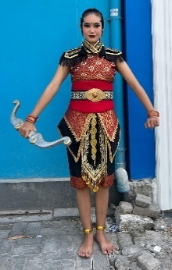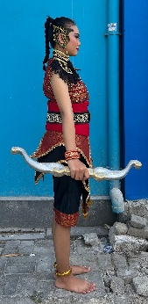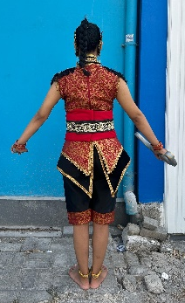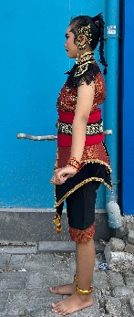
Figure 4 Female Dancer Costume

- Properties
The dance props used in Syaga Sinatrya's dance work are modifications of the gendewa (bow and arrow) and cundrik (a sharp weapon similar to a keris but shorter). These two weapons are often used by Raden Arjuna and Dewi Srikandi, who are the main characters in this dance work. In addition, these props were chosen because they have strong symbols in depicting the figure of a knight, so they can provide an initial impression or trigger for the audience. This work uses modified props that combine the gendewa and cundrik, both of which are combined into one complete prop that can be detached and attached, giving the choreographer the freedom to explore movements using the props.

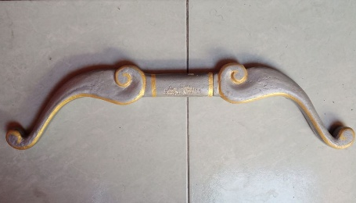  Figure 5 Complete Gendewa Prop | 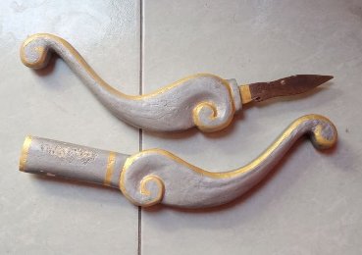  Figure 6 Modified Gendewa Cundrik Prop
- Stage and Lighting Techniques
The choreographer chose a proscenium stage to perform this dance piece. This type of stage is similar to a framed stage, allowing the audience to clearly see the performance inside through the proscenium frame or arch (Leitermann, 2017). The frame is fitted with a screen or curtain that separates the performance area from the audience, allowing the audience to comfortably watch the performance from one direction. This means that changes made within the enclosed stage area can be done without the audience's knowledge. This type of stage provides ample space and optimal viewing range for Syaga Sinatrya's dance works. This stage makes it easier for choreographers to explore space, one of which is floor patterns, by optimizing clear patterns and providing a dramatic impression.
The application of lighting in a dance performance plays an important role as one of its supporting media. Lighting also functions as an identity in the performance, not only as illumination, but also as a meaning or symbol in its visualization. Syaga Sinatrya's dance performance uses two types of lights, namely fresnel and par led, each of which has a function . Fresnel lights, or general lights, are used for lighting with a yellow color and are positioned above the front of the stage. Meanwhile, par LED lights can produce colors to support the visualization of the atmosphere and are positioned at the top front, right and left wings, and rear. This type of light mainly serves to illustrate the atmosphere of the story so that through colors,
- Dance Accompaniment
Syaga Sinatrya's dance work is accompanied by East Javanese gamelan with a pelog tuning system, then combined with modern music through a recording process. The following are the details of the gamelan and musical instruments used in the process of arranging the accompaniment for Syaga Sinatrya's dance work, including demung, saron, peking, bonang barung, slenthem, kempul, gong, East Javanese kendang and its kalih, gender, and keyboard. The collaboration between gamelan music and modern musical instruments is a form of collaboration that creates innovation based on renewal in the accompaniment of this dance work. This musical fusion is expected to provide a wide reach to its audience, thereby encouraging the growth of musical accompaniment that evolves with the times.

CONCLUSION

The creative process development techniques used in the creation of this dance work refer to the creative process theory described by Hadi (2016), which classifies four stages: exploration, improvisation, composition (formation), and evaluation. The exploration stage is a process of exploring ways to translate the choreographer's thoughts and imagination into ideas for the work, both in terms of movement and other supporting elements. The 10 improvisation stage focuses on developing the movement motifs that have been explored and producing new ideas. The composition stage is the final stage, in which the material is selected and filtered, and spectacular or surprising elements are added to the work. The evaluation stage is a stage of correction or consideration of the material of the work, allowing for additions or reductions.
Syaga Sinatrya's dance work is divided into four major scenes. The opening scene, which introduces the knights, serves as a powerful introduction (sigrak). Scene I depicts the soldiers' preparations in a powerful and festive atmosphere, scene II shows the conflict between the soul and the body, visualizing a tense, sad, and festive atmosphere, and scene II/ending depicts the determination of the knights. This closing scene is built with a tense atmosphere so that it is expected to give strength to the ending of the story. This dance work uses a type of stage makeup whose main function is to give firmness and strengthen the characters as well as the lines on the face. The costumes in this dance work consist of a songket top and knee-length black satin pants. The dance props in this work are modified versions of a gendewa (bow and arrow) and a cundrik (a sharp weapon similar to a keris but shorter) . This performance uses a proscenium stage with lighting that utilizes two Fresnel lamps and LED par lights.).

AUTHOR CONTRIBUTION

The main author is fully responsible for the entire process of writing this article to explore "The Process of Creating the Syaga Sinatriya Dance by Mochamad Rafli Wisnu Triwijaya and Virdha Annora Zavira." The author followed all stages of the creative process until it was compiled into a work and this article. In addition, other authors played an active role in discussions about the content of the article, gave final approval for the proposed research, and ensured that the article met research and publication ethics standards.

ACKNOWLEDGMENTS

Praise and thanks be to God Almighty for His grace and guidance, the author was able to complete this article well and on time. This article was completed thanks to the support and prayers of the author's parents, family, and friends. The author would like to thank all those involved in the writing of this article.

REFERENCE

Ambar Sari, Y., Studi Seni Tari, P., & Psikologi dan Humaniora, F. (n.d.). Hasil Interpretasi Problematika Kesetaraan Gender dalam Proses Kreatif PenciptaanTari. Dance and Theatre Review, 6(2), 92-98.
Anjali, S., & Soemaryatmi, S. (2022). REFLEKSI PENCIPTAAN TARI NYI PANDANARAN PRAJURIT PEREMPUAN. Greget: Jurnal Kreativitas dan Studi Tari, 21(2), 204-214.
Atikoh, A., & Cahyono, A. (2018). Proses Garap Koreografi Tari Rumeksa di Sanggar Tari Dharmo Yuwono Kabupaten Banyumas. Jurnal Seni Tari, 7(2), 66-74.
Gita. (2022). Proses Kreatif Dalam Pembelajaran Koreografi Berbasis Kearifan Lokal. In Prosiding Seminar Nasional Bahasa, Sastra, Seni, Dan Pendidikan Dasar (SENSASEDA) (Vol. 2, pp. 1-12).
Kepenarian, K. S. (2017). Karya Tari Srikandhi Senopati ( Gubahan Nanuk Rahayu ) Karya Tari Srikandhi Senopati ( Gubahan Nanuk Rahayu ).
Manganti, G. S. (2024). Srikandi Sebagai Inspirasi Dalam Penggarapan karya Hrusangkali Kandi oleh Pragina Gong. Dance and Theatre Review, 7(2), 110-117.
Mayangsari, Yatim, H., & Saenal, S. (2023). Proses Penciptaan Tari Dalam Pembelajaran Seni Budaya Pada Siswa Kelas Xii Di Upt Sma Negeri 3 Takalar. (Doctoral dissertation, Fakultas Seni dan Desain).
Penelitian, J., Budaya, S., Endah, H., Program, U., Seni, S., Fakultas, T., & Pertunjukan, S. (n.d.). Proses Kreativitas Dalam Penciptaan Tari Srimpi Pudyastuti.
Pengetahuan, J. I., Seni, K., Rosmiati, A., & Rafia, I. (2021). Bentuk tata ruang pentas panggung proscenium di gedung wayang orang Sriwedari Surakarta. Ekpresi Seni, 23(2), 348-363.
Pratiwi, A. S., Respati, R., & Giyartini, R. (2020). Teori Tari Kreasi. PEDADIDAKTIKA: Jurnal Ilmiah Pendidikan Guru Sekolah Dasar, 7(3), 257–266.
Rochayati, R. (2025). Pendidikan seni: Ilmu pengetahuan dalam ruang lingkup penciptaan karya tari. PPSDP Undergraduate Journal of Educational Sciences, 2(2), 288–304. Seminar Nasional Pendidikan, Hukum, Ekonomi, Sains, dan Teknologi (SENAPHEST), Universitas PGRI Palembang.
Sela, W., Kurnia, M., Ratna Sari, D., Seni Pertunjukan, P., & Kunci, K. (2023). Proses Kreatif Penciptaan Tari Lime Gades Rengkek. In | ANTHOR: Education and Learning Journal (Vol. 2).
Semarang, U. N., Seni, P., Proses, T. :, Tari, K., Yang, K., Pada, B., Berdasarkan, T., Pendukung, U.-U., & Rochayati, R. (n.d.). Prosiding Seminar Nasional Pascasarjana. http://pps.unnes.ac.id/pps2/prodi/prosiding-pascasarjana-unnes
Seni Tari, J., Nur Kasih Kusuma Putri, N., Handayaningrum, W., Wahyuni, E., & Pascasarjana Pendidikan Seni Budaya, P. (2022). Heri Lentho Seniman Surabaya: Biografi dan Proses Kreatif. Joged, 20(2), 165-177.
Wibowo, A. K. (2022). Estetika Garap Tubuh dan Properti dalam Karya Tari Gandhewa Raga. Acintya, 14(2), 205-211.

